The flexural response of large scale steel-framed composite glazing panels

Keywords
Adhesively-bonded sandwich structure, composite action, composite glazing panel, glass, shear lag.

Abstract
Novel composite glazing panels provide an opportunity to significantly reduce the weight and depth of glazed facades and simultaneously minimize the visual and spatial bulkiness of conventional facade framing systems. However the mechanical response of these novel composite glazing panels is poorly understood and there is no published data on the flexural response of large scale panels. In this research, medium scale (700-mm long and 300-mm wide) and large scale (3500-mm long and 1500-mm wide) composite glazing panels were fabricated and tested in bending up to failure. Recently developed analytical model for composite sandwich panels was also implemented on the medium and large scale panels. The experimental test data shows that shear-lag effects can be significant in large scale panels and can reduce their effective widths by about 40%. The analytical model provided a good fit of experimental results when the effective width was reduced according to strain gauge measurements. Neglecting shear-lag effect is unsafe and would underestimate deflections and stresses by approximately 40%. Further research is required to quantify the shear-lag effects, and the corresponding variation of effective widths, along the length of composite glazing panels and the influence of load distribution and boundary conditions on the effective thickness of the glass panels.

1. Introduction
Traditionally, glazed curtain wall systems for building envelopes are function-separated layered systems: insulated glazing units clad the building externally and provide transparency and thermal insulation, and bulky metallic profiles protrude into the building to support the cladding, e.g. mullions spanning between floors. In this configuration the glazing units are infill panels attached to the structural frame profiles by means of flexible shear connections resulting in negligible composite action between the frame and glazing. This non-composite configuration is an inefficient use of materials and requires heavy and bulky frames and glazing units.
Alternatively a composite edge-framed glazing configuration could provide a mechanically efficient, slimmer and lighter envelope system. In this configuration the structural frame profiles are sandwiched between, and structurally bonded to, load-bearing glass panes. The structural concept of a composite glazing unit was first explored by Peters (2006) and Wurm (2007) and more recently by Cordero (2015) and Bedon et al. (2018) but none provided comprehensive data from testing and modelling of panels. Extensive data on composite glazing units exists but it is limited to beam configurations, such as those investigated by Correia et al. (2011) and Valarinho et al. (2013). An extensive review of these and other glass beam configurations is provided by Martens et al. (2015). Recently, the authors of this paper have undertaken detailed analytical modelling and significant mechanical testing on composite glazing panels and results from simple small-scale panels (Fig. 1a) were recently published by Pascual et al. (2017a; 2017b). The objective of the present paper is to assess the importance of shear-lag effects (non-uniform axial stresses across the glass width) in up-scaled edge-framed composite glazing panels (Fig. 1b). These effects are particularly relevant for the structural design of novel unitized facade panels with this composite glazing configuration.
This research constitutes an initial feasibility study on the fabrication, testing and modelling of novel composite glazing panels. The paper presents the tests of three up-scaled panels conducted at the University of Cambridge (Nhamoinesu 2015). The panels were simply supported and subjected to out-of-plane bending to failure (Fig. 2). Firstly, the geometry and components of one medium-scale panel (700-mm long and 300-mm wide) and two large-scale panels (3500-mm long and 1500-mm wide) are described. Secondly, the testing and experimental results are described in terms of load-deflection responses at mid-span (for all panels) and strain gauge measurements on glass face sheets (for large-scale panels). Finally, analytical predictions made for the purposes of this study are compared to experimental results.

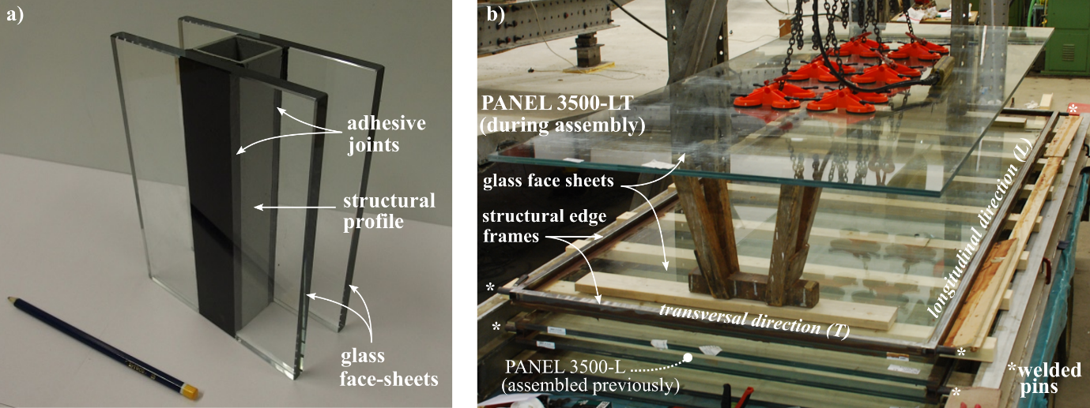

Fig. 1 Composite glazing with (a) small-scale dimensions and central structural profile (published in previous works by Pascual et al. (2017a; 2017b)) and (b) up-scaled dimensions and structural edge-frame (research presented in this paper).

2. Experimental investigation
Three adhesively-bonded edge-framed composite glazing panels were fabricated: one medium-scale panel (700-mm long and 300-mm wide) and two large-scale panels (3500-mm long and 1500-mm wide). The panels were labelled according to their length and the direction of the reinforcing edge-frame: therefore panel 3500-LT was reinforced longitudinally and transversely along its four edges (Fig. 1b), while the panels 3500-L and 700-L were only reinforced longitudinally along the two parallel longer edges.

2.1. Materials and geometry of panels
The reinforcing edge frame consisted of 30-mm wide hollow sections made of mild steel manufactured to British Standard (BS 2010). The face sheets of the medium-scale panel were made of 10-mm-thick monolithic fully toughened glass, and those of the large-scale panels of 21.5-mm-thick laminated heat strengthened glass (with two glass layers and a polyvinyl butyral, PVB, interlayer) – in all cases soda-lime-silica float glass was used manufactured to British Standard (BS 2012), and all glass was heat-treated to relevant standards (BS 2004a; BS 2004b). A two-part acrylate adhesive Araldite A2047 from Huntsman was used to produce a 3-mm thick bond between the edge-frame profiles and glass face sheets – this thickness complies with manufacturer recommendations. The selection of the adhesive and frame material was made on the basis of a wide range of criteria described elsewhere (Overend 2011; Belis 2011) and particularly for high adhesion, strength and ductility in the adhesive joints (Nhamoinesu 2015). The relevant properties of all materials are given in Table 1. The properties of PVB were taken from manufacturer data sheet (Saflex 2018) for the temperature and duration of the tests and those of Araldite A2047 from compression-relaxation tests (Pascual 2017b). The properties of steel were obtained from tensile tests (Tsui 2017) and standard values were considered for glass (Haldimann 2008).

Material | Law σ - ε | E₀ ; E_{y} (MPa) | G₀ ; G_{y} (MPa)
Steel | Bilinear  (σ_{y} = 376 MPa) | 206000; 0 | 79000; 0
Adhesive | Bilinear  (σ_{y} = 10 MPa) | 543; 44 | 190; 15.4
Glass | Linear | 72000; - | 29500; -
PVB | Linear | 1.5; - | 0.5; -

Table 1 Elastic and shear moduli and axial stress (σ)-strain (ε) law considered for the materials of the composite glazing panels tested in quasi-static loading conditions. Note: E₀ and G₀ (E_{y} and G_{y}) refer to elastic and shear moduli before (after) yielding, and σ_{y} refers to mean axial yielding stress.

Prior to the assembly of all panels, steel surfaces were sanded with 220 grit sand paper and steel and glass surfaces were cleaned with acetone. Preparation and assembly of panels was performed in laboratory conditions at 23±2ºC and a relative humidity (RH) of 50±5%. Panels were stored in these conditions for a minimum of 7 days before testing. The dimensions of all components are detailed in Table 2.

Panel | Steel edge frame | Adhesive joint | Glass face sheets
Label | Hollow tube (mm) | Cross-section (mm) | Type | Dimensions (mm)
700-L | 30 x 10 x 1.5 | 30 x 3 | FT-Monolithic | 700 x 300 x 10
3500-L | 30 x 30 x 1.5 | 30 x 3 | HS-Laminated | 3500 x 1500 x (10 + 1.5PVB + 10)
3500-LT | 30 x 30 x 1.5 | 30 x 3 | HS-Laminated | 3500 x 1500 x (10 + 1.5PVB + 10)

Table 2 Dimensions of components in the medium-scale (700-L) and large-scale (3500-L and 3500-LT) composite glazing panels. (FT: fully-toughened glass, HS: heat-strengthened glass)

2.2. Experimental set-up
To minimize viscous effects in the polymeric materials, all the bending experiments presented below were performed at very low strain-rates and therefore in quasi-static loading conditions. The medium-scale panel (700-L) was tested in four-point bending with the loading configuration shown on the left-side of Fig. 2. The loads, totalling 2P, were applied by means of a 150-kN electromechanical testing machine (Instron 5500R) fitted with a steel four-point bending jig (Fig. 2a to 2c). Pure aluminium strips were placed between the glass and the loading and supporting steel rollers to mitigate stress concentrations on the glass. The test was carried up to failure at a displacement controlled rate of 0.75 mm∙min⁻¹ and performed at 23±2ºC and a RH of 50±5%. The vertical deflection at mid-span, w, of the bottom face sheet was measured by a linear variable differential transformer (LVDT). The position of the LVDT and the geometry of the panel are shown in Fig. 2d and Table 3.
The two large-scale panels (3500-L and 3500-LT) were tested using the reaction frame set-up shown on in Fig. 2e. The panels were simply-supported at their four corners (Fig. 2f) – this is representative of support conditions in real-world unitized panels for curtain wall systems. The patch loads, totalling 2P, were introduced by means of four rubber-padded pinned-plates made of steel (150 x 130 x 13 mm³) (Fig. 2g). The loads were applied using a manually controlled hydraulic jack fitted with a 500 kN load cell and introduced at approximate cross-head displacements of 1.5 mm∙min⁻¹ up to first fracture of the glass and then resumed at a faster rate of approximately 3 mm∙min⁻¹. The tests were carried up to failure and performed at 23±2ºC and a RH of 50±5%. The vertical deflections at mid-span, w, on the top face sheet were measured by a compact string pot wire transducer (WT). Seven strain gauges (SG1 to SG7) were bonded on the outermost faces of the glass face sheets to measure longitudinal strains and to evaluate shear-lag effects. The positions of the wire transducer and strain gauges, and the geometry of the panels are shown in Fig. 2h and Table 3.

Panel | Geometry |  |  |  |  | Modelled mechanical properties
Panel | L  (mm) | L_{a}  (mm) | L_{b}  (mm) | W  (mm) | h  (mm) | W_{eff}  (mm) | h_{eff}  (mm) | D_{global}  (∙10⁹ N.mm²) | D_{local}  (∙10⁹ N.mm²) | U  (∙10⁴ N)
700-L | 604 | 100 | 202 | 300 | 10 | 300 | 10 | 77.3 | 4.27 | 111 - 9.2*
3500-L &  3500-LT | 3444 | 610 | 1112 | 1500 | 21.5 | 900 | 15 | 1310 | 44.0 | 420 - 37.4*

Table 3 Geometry (spans, width, glass thickness) and modelled mechanical properties in pre-fracture states: effective width, effective glass thickness (Galuppi 2013) and global and local flexural rigidities and shear stiffness (Pascual 2017a). Note: *after yielding of adhesive.

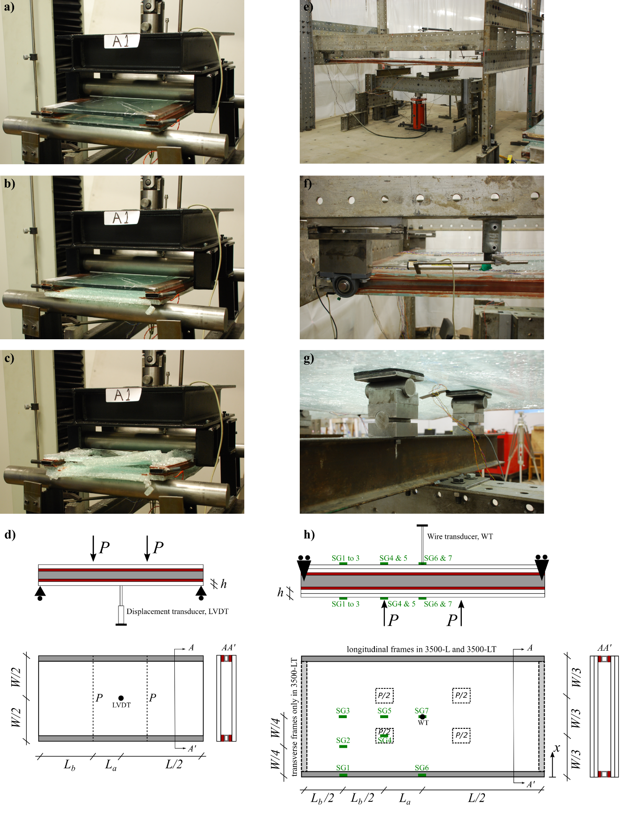
Fig. 2 Bending tests on (left) medium-scale panel 700-L and (right) large-scale panel 3500-LT including (a, e) view on experimental set-ups, (b, f) first fracture of glass, (c, g) second fracture of glass, (d, h) schematic view of set-ups. Note: Detailed views of (f) pin-roller supports translationally and rotationally free about longitudinal and transversal directions and (g) pinned loading blocks (identical set-up used for panel 3500-L).

2.3. Experimental results
The 2P-w experimental curve for the medium-scale panel is shown in Fig. 3a. The panel exhibited a linear response (0a) up to about 20 kN-2.4 mm. This was followed by significant non-linearity (ab) up to 46 kN-12 mm, when the bottom glass fractured (Fig. 2b). The recorded load decreased abruptly due to this fracture (bc) and subsequently increased on a reduced stiffness path (cd) up to about 24 kN-22 mm when the top glass fractured (Fig. 2c). Local whitening of the adhesive near the end supports was observed after the test (Nhamoinesu 2015).
For the two large-scale panels, the 2P-w experimental curves are shown in Fig. 3b. Initially, both panels exhibited very similar, linear and stiff responses (0a) up to about 80% of their maximum capacities. This was followed by fluctuations in the load and significant reductions in stiffness occurred (ab). The maximum capacities 2P (and corresponding w) of 3500-L vs. 3500-LT were 32 kN (43mm) vs. 42 kN (52 mm), therefore showing a significant higher capacity of the 4-edge framed panel at first fracture of glass. Then the recorded loads decreased abruptly in response to glass fracture and were in the order of 10 kN (bc). Subsequently, the loads increased on a reduced stiffness path (cd) up to 18 kN (108 mm) vs. 14 kN (88 mm), when the second glass fractured and the loads dropped (de) – i.e. both panels exhibited substantial post-fracture capacities. For panel 3500-L, fracture occurred first on bottom face sheet (inner pane) and then on top face sheet (outer pane) – and the test was stopped before all panes fractured. For panel 3500-LT, fracture occurred first on top face sheet (both panes), and then on bottom face sheet (inner pane, followed by outer pane). The adhesive joints exhibited local whitening near the end supports – this was more widespread in panel 3500-LT (Nhamoinesu 2015).

Fig. 3 Load-deflection responses at mid-span from tests and Pascual et al. model (2017a) for panels (a) 700-L and (b) 3500-L and 3500-LT (letters and numbers refer to points of interest discussed in the text). Note: layered and post-fracture stiffness coincidentally matched in Fig. 3a.

The two large-scale panels were equipped with strain gauges (SG1 to SG7 on top and bottom glass, Fig. 2h), and the measurements converted into stress are shown in Fig. 4. Firstly, in the initial linear ranges, stresses on top glasses (in tension) were relatively low and evenly distributed across the width of the panels (i.e. negligible shear lag) in comparison with the higher and uneven stresses on the bottom glasses (in compression) where not all the width was fully and equally contributing to resist the internal forces (i.e. significant shear lag) – there the stresses at SG1 were at least three times those at SG2 and SG3. Secondly, the fluctuations in the applied loads corresponded to a significant increase of stresses at SG6 (and decrease at SG7 on bottom glasses), which from then on became the highest recorded stresses. Finally, the stresses at SG6 on the relevant face sheets immediately prior to glass fracture were always above 63 MPa (in tension or compression).

Fig. 4 Experimental stresses and loads for panels (a) 3500-L up to first fracture and (b) 3500-LT up to complete failure. Note: 1) Numbers refer to strain gages (SG) as in Fig. 2 (compression data on SG3 and SG4 in 3500-LT could not be recorded), 2) Reduced stiffness at the origin due to settling of panels (corrected in Fig. 3).

3. Analytical modelling
The pre-fracture mechanical responses of all panels were modelled by means of an analytical approach recently developed by Pascual et al. (2017a) for simply supported adhesively-bonded sandwich panels loaded in four-point bending. This model assumes linear elasticity, a symmetric sandwich assembly and monolithic face sheets with no shear lag. The model accounts for bending and shear deformations about the local and global centroidal axes of the composite panel, and the geometrical compatibility of these deformations depends on a mechanical parameter a² given by Eq. (1):
$$a^{2}=\frac{U}{D_{local}∙\left(1-\frac{D_{local}}{D_{global}}\right)}$$ | (1)
where D_{global} and D_{local} are the global and local flexural rigidities respectively and U is the shear stiffness of the sandwich panel. Detailed information on the analytical solutions of deflections and strains as a function of a² is given in Pascual et al. (2017a).
The large scale panels had laminated face sheets and their monolithic-equivalent thickness in terms of bending stiffness, commonly referred to as effective thickness h_{eff}, was estimated from Galuppi et al. (2013). And their static-equivalent width, accounting for shear-lag effects and commonly referred to as effective width W_{eff}, was calculated from the strain gauge experimental data on bottom glass surfaces. The effective widths were obtained as described in Nhamoinesu (2015) for the shear and bending spans according to Eq.(2):

$$W_{eff}=2∙\int_{0}^{W/2}{\frac{σ(x)}{σ_{max}}∙dx}$$ | (2)

where x is the coordinate across the width (Fig. 2), σ refers to axial stress (in the initial linear responses) and σ_{max} to its maximum value. This equation resulted approximately in 0.45W (shear span) and 0.80W (bending span) and an average constant value of W_{eff} = 0.6W along the full span was adopted in the analytical model – an identical constant width is obtained from Eurocode 4 (BS 2004c). The medium scale panels had monolithic face sheets (i.e. h_{eff} = h) and no shear lag was assumed (i.e. W_{eff} = W). The effective properties, and the resulting global and local flexural rigidities (D_{local} and D_{global}) and shear stiffness (U) according to Pascual et al. model, are reported in Table 3 for all panels.
The model was applied in two load steps: firstly non-yielded materials (01), and secondly adhesive yielded in shear (12) (no yielding of steel was predicted). For panel 700-L, the modelled response, 2P-w, provided a good fit to the experimental results (Fig. 3a). For the large scale panels, the modelled responses followed closely the initial stiffness of the panels for W_{eff} = 0.6W (Fig.3b). The yielding of the adhesive was predicted at 38 kN and largely agreed with the experimental results of panel 3500-LT but overestimated the capacity of panel 3500-L.

4. Discussion
For the large-scale panels, when shear-lag effects were neglected (W_{eff} = W), the Pascual et al. model underestimated the mid-span deflections (Fig. 3b) and the mid-span stresses (checked separately) by approximately 40%. However, when shear-lag effects were considered (W_{eff} = 0.6W), model vs. test results showed a good fit of mid-span deflections in the initial linear range (Fig. 3b), and also of mid-span stresses: 10 vs. 10 / 12 MPa (at 2P = 10 kN, for 3500-LT/-L) and 30 vs. 39 MPa (at 2P = 30 kN, for 3500-LT) – these loads correspond to 25% and 75% of the maximum capacity of the 4-edge framed panel. After the initial linear response, fluctuations in the load were recorded and the tested panels exhibited a loss of stiffness attributed to the yielding of adhesive – this corresponded with the whitening of the adhesive. The model, which assumes uniaxial shear stresses along the bonds due to the longitudinal bending of panels, captures the yield load of the 4-edge framed panel 3500-LT (point a in Fig. 3b). In contrast the transverse bending in panel 3500-L is unconstrained and the adhesive is therefore subjected to in-plane biaxial stresses which causes premature yielding. This explains the lower capacity of the panel and the divergence between test and model results (Fig. 3b). Finally, for both panels the yielding of the adhesive resulted in a redistribution of stresses, i.e. an abrupt increase of stresses at SG6 and decrease at SG7 on the bottom (loaded) glass (Fig. 4), which suggests a shift from plate-like to beam-like behaviour in the direction of the longitudinal frames.
The Pascual et al. model (with W_{eff} = W) provides a good fit for the medium scale panel 700-L (Fig 3a). This indicates that the shear-lag effects and the transverse curvatures are negligible for this panel as it is relatively narrow and is loaded and supported across its whole width. As expected, the step-wise plasticity 2P-w curve produced by the model circumscribes the gradual yielding obtained from the experimental data (Fig 3a). The Pascual et al. model also predicts a stress of approximately 163 MPa in the glass surface at failure load. This is within the range of short-term strengths of fully toughened glass and is therefore plausible (Overend 2012, BS 2017). Furthermore from the initial linear path (01), the degree of composite action (Pascual 2017a) was approximately 90%, as can be seen from the monolithic and layered responses shown in Fig. 3a. An even higher level of composite action can be demonstrated for the large-scale panels, but is not shown here for brevity. This demonstrates the high performance of the acrylate adhesive for steel to glass bonding. It is also evident from Fig.3a that the layered modelled response and the experimental post-fracture stiffness are nearly identical: this is coincidental.

5. Conclusions
This work constitutes an initial experimental research on the flexural behaviour of up-scaled composite glazing panels for building construction, but it provides valuable conclusions, as follows:
1. It is feasible to fabricate large scale, mechanically slim and structurally efficient composite glazing panels. The panels provide composite actions in excess of 90% and are made of a light and rigid frame sandwiched between, and structurally bonded to, glass face sheets.
2. Shear-lag effects can be significant in large scale composite glazing panels. It was shown experimentally that these effects can reduce the effective widths by an average of 40% along the panels.
3. The model of Pascual et al. provides a good fit of experimental deflections and stresses of large scale panels (for effective widths estimated experimentally).
4. Neglecting the reductions of effective widths would underestimate the predicted deflections and stresses by approximately 40%.

This is a pilot study and it inevitably contains some assumptions and uncertainties that merit further detailed research, namely:
1. Shear-lag effects, and particularly the prediction of effective widths W_{eff} and their variation along the length of the panel, require further investigation. Bending tests on composite glazing panels with monolithic face sheets, fully equipped with strain gauges on every glass surface, can provide a more complete understanding on the mechanics of the flexural response of these sandwich components.
2. The contribution of the transverse bending of glass face sheets on the state of stress and the yielding of the adhesive bond requires further research.
3. The effective thickness of laminated glass face sheets h_{eff} has been estimated from the sets of load and boundary conditions given by Galuppi et al. (2013). Further work is required to investigate more precise values of h_{eff} for the load and boundary conditions existing in the composite glazing panels.
4. For practical facade applications, the geometry and materials of the assembly should be selected and tested for the long-term durability of the panels (to thermal loads, solar radiation and humidity).

Acknowledgements
The authors would like to thank the Engineering and Physical Sciences Research Council (United Kingdom) for the financial support of the project with two grants EP/MO 17699/1 and EPSRC IAA Follow-on Fund, and Tata Steel and Permasteelisa S.p.A. for the financial support and in kind support of this research.

Conflict of interest
On behalf of all authors, the corresponding author states that there is no conflict of interest.

References
Bedon, C., Pascual, C., Luna-Navarro, A., Overend, M., Favoino, F.: Thermo-mechanical investigation of novel GFRP-glass sandwich facade components. In: Proceedings of Challenging Glass Conference 6, pp. 501-512, Delft (2018)
Belis, J., Van Hulle, A., Out, B., Bos, F., Callewaert, D., Poulis, H.: Broad screening of adhesives for glass-metal bonds. In: Proceedings of Glass Performance Days 2011, pp. 286–289, Tampere (2011)
BS EN 10305-3:2010: Steel tubes for precision applications. Technical delivery conditions. Welded cold sized tubes. British Standards Institution, London (2010)
BS EN 12150-2: 2004: Glass in building. Thermally toughened soda lime silicate safety glass. Evaluation of conformity/Product standard. British Standards Institution, London (2004a)
BS EN 1863-2:2004: Glass in building. Heat strengthened soda lime silicate glass. Evaluation of conformity. Product standard. British Standards Institution, London (2004b)
BS EN 1994-1-1:2004: Eurocode 4. Design of composite steel and concrete structures. General rules and rules for buildings. British Standards Institution, London (2004c)
BS EN 572-2:2012: Glass in building. Basic soda lime silicate glass products. Float glass. British Standards Institution, London (2012)
BS prEN 16612:2017: Glass in building – Determination of the lateral load resistance of glass panes by calculation. British Standards Institution, London (2017)
Cordero, B.: Unitised curtain wall with low thermal transmittance frame integrated within the insulating glass unit through structural adhesives. PhD dissertation. Universidad Politécnica de Madrid, Madrid (2015)
Correia, J., Valarinho, L., Branco, F.: Post-cracking strength and ductility of glass-GFRP composite beams. Compos Struct. 93(9), 2299-2309 (2011)
Galuppi, L., Manara, G., Royer Carfagni, G.: Practical expressions for the design of laminated glass. Composites: Part B. 45(1), 1677-1688 (2013)
Haldimann, M., Luible, A., Overend, M.: Structural use of Glass. IABSE, Zurich (2008)
Martens, K., Caspeele, R., Belis, J.: Development of composite glass beams – a review. Eng Struct. 101, 1-15 (2015).
Nhamoinesu, S.: Steel-Glass Composite Panels. PhD dissertation. University of Cambridge, Cambridge (2015)
Overend, M., Jin, Q., Watson, J.: The selection and performance of adhesives for a steel–glass connection. Int J Adhes Adhes. 31(7), 587–597 (2011)
Overend. M., Zammit, K.: A computer algorithm for determining the tensile strength of float glass. Eng Struct. 45, 68–77 (2012)
Pascual, C., Montali, J., Overend, M.: Adhesively-bonded GFRP-glass sandwich components for structurally efficient glazing applications. Compos Struct. 160, 560–573 (2017a)
Pascual, C., Nhamoinesu, S., Overend, M.: Mechanically efficient and structurally slim vision panels. In: Proceedings of Glass Performance Days 2017, pp. 37–41, Tampere (2017b)
Peters, S.: Kleben von GFK und Glas fur baukonstruktive Anwendungen. PhD dissertation. Universitat Stuttgart, Stuttgart (2006)
Saflex: Technical Data Sheet. https://www.saflex.com/products/saflex-clear-pvb-interlayer (2018). Accessed 14th December 2018
Tsui, B.: Glass composite struts. MEng dissertation. University of Cambridge, Cambridge (2017)
Valarinho, L., Correia, J., Branco, F.: Experimental study on the flexural behaviour of multi-span transparent glass-GFRP composite beams. Constr Build Mater. 49, 1041-1053 (2013)
Wurm, J.: Glass structures: design and construction of self-supporting skins. Birkhauser, Basel (2007)

