BIG DATA AND URBAN SYSTEM MODEL – SUBSTITUTES OR COMPLEMENTS? A CASE STUDY OF MODELLING COMMUTING PATTERNS IN BEIJING

Li Wan^{1*}, Shuo Gao², Chen Wu³, Ying Jin⁴, Mingrui Mao⁵, Lei Yang⁶
¹ Research Associate, PhD, Martin Centre for Architectural and Urban Studies, Department of Architecture, University of Cambridge. Email: lw423@cam.ac.uk
² Beijing City Quadrant Technology Co., Ltd. Email: gaos@urbanxyz.com
³ Beijing Engineering Research Centre of Urban Design & Urban Renaissance; Beijing Institute of Architectural Design. Email: wuchen@vip.sina.com
⁴ Senior Lecturer, PhD, Department of Architecture, University of Cambridge. Email: yj242@cam.ac.uk
⁵ Beijing City Quadrant Technology Co., Ltd. Email: mmr@urbanxyz.com
⁶ Beijing Engineering Research Centre of Urban Design & Urban Renaissance; Beijing Institute of Architectural Design. Email: yanglei_gis@163.com

* Corresponding author. Address: 1–5 Scroope Terrace, Cambridge CB2 1PX, England

Abstract
The emergence of urban big data is transforming the existing research paradigms in urban studies. New theories and analytical methods are required to meet the methodological challenges. This paper empirically compares a data-driven approach and an urban-system-model approach through a case study of modelling the commuting patterns in Beijing. For the data-driven approach, the novel location-based-services (LBS) data are explored to identify the employment- residence location of the service users. For the modelling approach, a spatial equilibrium model is calibrated for base year 2010 and is used to simulate the commuting patterns for Beijing 2015 based on exogenous development projections. The results of the two approaches are then compared against the benchmark statistics for Beijing 2015. The comparison shows that the LBS data perform better in detecting residence locations than employment locations. The model prediction fits better with the benchmark, while the errors of the LBS data tend to vary significantly across space. For amplifying the LBS sample data to represent the full population, uniform scale factor thus should be avoided. In addition, the ineffectiveness of representing short-distance commuting for the LBS data is revealed by the comparison with the model predicted flows. In light of the strength and weakness of the respective approach, the prospect of a collaborative use of big data and urban system models is explored in the conclusion.

Acknowledgement
For Li Wan and Ying Jin, this research is supported by special fund of Key Laboratory of Eco Planning & Green Building, Ministry of Education (Tsinghua University), China

Keywords
Big data, spatial equilibrium, land-use and transport model, commuting

Introduction
The past twenty years have witnessed the rise of big data as both an academic topic and technology terminology. One of the most vivid definitions of big data is ‘any data that cannot fit into an Excel spreadsheet’ (Batty, 2013). This definition indicates the sheer size of the data and also suggests that new methods are required to process and understand the big data. In the sphere of urban studies, urban transport has been a fertile research field embracing the big data. The application of ICTs (information and communication technologies) in transport system, such as smart card for public transport and real-time traffic monitoring, generates a vast amount of data on a daily basis. Compared with the conventional data sources such as travel survey and census, the transport big data are usually much finer at both spatial and temporal scale, which provide a new perspective to examine the relationship between locations and activities and the interaction with other urban systems. Recent progresses of this research line include using smart card data to identify travel patterns (Seaborn et al., 2009; Kieu et al., 2014; Ma et al., 2017) and understand the urban spatial structure (Roth et al., 2011). The smart card data are also applied to analysis the job-housing balance (Long & Thill, 2015) and the temporal mobility patterns (Zhong et al., 2015; 2016). Among these studies, complex travel behaviours are revealed by the emerging big data at disaggregate level, which the conventional data sources are hardly capable of.
Contrast to the big-data approach, urban system modelling represents another long-standing methodology in urban land-use and transport studies. Among the wide spectrum of urban applied models, the land-use and transport integrated (LUTI) modelling framework has been the mainstream since the early spatial interaction models (Lowry, 1964; Echenique et al., 1990; Wegener, 1998). The incorporation of spatial equilibrium with the LUTI structure represents a significant advancement (Bröcker, 1998; Anas & Liu, 2007; Jin et al., 2013). The spatial equilibrium theory provides a solid economic foundation for quantifying the impacts of urban land-use and transport policies within a circular causality. The LUTI models with equilibrium mechanisms have been widely applied for practical policy studies (Wegener et al., 1991; Volterra & CBP, 2007; Anas, 2013; Jin et al., 2017).
Given the prevalence of the big data, a new form of data-driven empiricism may declare “the end of theory (Anderson, 2008)” for urban studies. This proposition is often accompanied with the claim that “correlation is enough” given that the sheer size of the big data may have already depicted a near-complete answer to the question of interest, which is not possible with models based on aggregate data. This issue is critically discussed by Kitchin (2013; 2014) from an epistemological point of view. New theories and analytical methods are required to meet the methodological challenges posed by the emerging big data (Batty, 2013). Although most discussions have focused on either the data-driven approach or the theory-driven approach, few research compares the two methods in an empirical manner. This paper aims to fill the gap in literature by applying the two approaches on one case study of modelling the commuting pattern in Beijing. A novel source of big data, namely the location-based service (LBS) data collected from individual smart-device users, is explored to identify the employment-residence location of commuters in Beijing 2015. To represent the modelling approach, a LUTI type spatial equilibrium model for Beijing is calibrated for base year 2010 and is used to predict the commuting pattern in 2015. The two derived commuting patterns are then compared against the same benchmark, which is processed from conventional statistic sources. The comparison helps to explore the distinct features of the LBS data as well as the modelling approach in terms of the respective strength and weakness in urban commuting analysis.
The paper is structured as follows. The next section introduces the LBS data and the processing method for identifying the employment-residence locations of LBS users. As opposed to the data-driven approach, Section 3 presents a LUTI type urban spatial equilibrium model developed for Greater Beijing region, which is applied to model the commuting pattern in Beijing 2015. Section 4 compares the results of the two approaches with the benchmark statistics. Section 5 concludes by way of considering the wider implications of the findings.

Location-Based-Service Data Processing
The Location-based service (LBS) data cover a wide range of data sources, but in terms of location acquisition technology, Global Position System (GPS) and mobile positioning are most commonly used (Lu & Liu, 2012). Some LBS data are collected directly from user-end hardware, such as mobile phone or GPS receiver, while some LBS data do not require the positioning hardware on user end, such as the smart card system in public transit. The challenges of the LBS data to urban planning and public management are first discussed by Ahas & Mark (2005) and a more recent review is provided by Lu & Liu (2012).
The Location-based service data used in this paper is an exclusive dataset provided by ‘TalkingData’, a Chinese corporation that provides location-based services to thousands of applications on smart devices, e.g. smartphones and tablets. Established in 2011, TalkingData is currently the biggest third-party LBS provider in China, albeit the Alibaba, Tencent and Baidu are the top three IT corporations who provide location-based services for their own products without using third-party service providers. The LBS data provided by TalkingData are service records of its smart-device application users. LBS provider collects geographic location from the embedded GPS module on smart devices when the service is requested. The prerequisites for collecting the data from users are 1) the LBS application is properly installed, and 2) permission to use the location service on smart device is granted by the user. The LBS data provided include a set of attributes such as unique user and device code, application name, timestamp and some user background information. For disclosure control, all information are anonymously represented with a unique user code, and information that can be used to identify individuals are removed.
The mobile positioning data have been widely used to detect the spatial pattern of people and activities (Ahas et al., 2010; Yuan, Raubal, & Liu, 2012; Steenbruggen et al., 2013). Studies on transport big data have focused on smart-card data (Seaborn et al., 2009; Long & Thill, 2015; Ma et al., 2017), the use of LBS data generated by individual smart devices is rare in literature. Compared with the smart card data, the LBS data has its own distinct features. First, the LBS data collected from individual smart devices is expected to be more accurate in terms of positioning than smart-card data, because it records the exact location of the user rather than the location of the bus/metro stations as in smart-card data. Secondly, as opposed to the smart-card data, the LBS data is not limited to public transit. Nonetheless, the LBS data do not have explicit information on travel mode, route and duration. For smart-card data, the service record is usually collected as location pairs, i.e. the origin and destination of the travel. By contrast, the location information in LBS data tend to be single-ended. To investigate the spatial pattern of LBS users, the employment and residence location thus needs to be derived. In addition, because the LBS data can only be collected from smart devices, the socio-demographic background of LBS users is likely to be more biased among population than the smart-card data. The magnitude and spatial distribution of such bias in the LBS data needs to be investigated empirically.
The LBS data used in this paper is collected during August to October, 2015. The original dataset for Greater Beijing area has a total of 17,000 million records from 16 million devices, implying approximately 11.8 records per device per day on average. Figure 1 presents the spatial distribution of the LBS record data at 9am on a typical weekday in central Beijing.
Figure 1. Mapping of LBS data records at 9am on a typical workday in central Beijing 2015
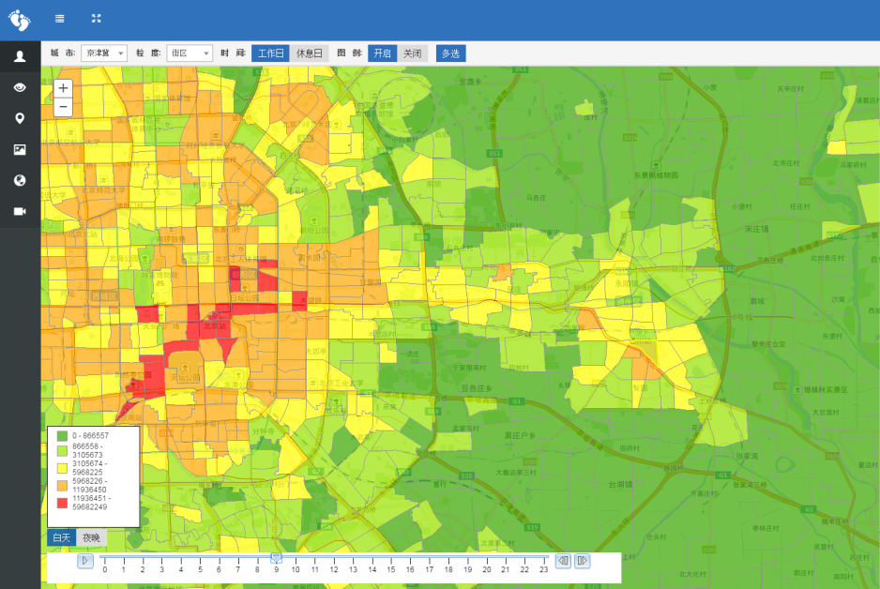

Derive home and workplace from LBS data
LBS data provides detailed location of the users at a specific time of the day. To utilize the data to extract commuting patterns, we first try to identify the “anchor points” of users in space. Anchor points are defined as locations which people tend to stay for a period of time, typically home and workplace. Anchor points reflect the key locations of people’s daily routine, thus can be used to infer their residence location as well as workplace if the person of interest is deemed employed. Although LBS records can be transient in the sense that any single location record may be irrelevant to either the home or workplace of the user, regularly repeated patterns may be detected if the data cover a relatively long period, say a few months. Once regular locational patterns are detected, the user’s employment-residence location pair may be inferred under certain behavioural assumptions.
To detect the employment/residence anchor points, Long & Thill (2015) presents a rule-based approach for processing bus smart-card data for Beijing, where an exclusive parcel-level land use data is applied to enhance the algorithm. Compared with the smart-card data, our LBS data is not relate to certain type of transport mode or activity type. For example, one single locational record in the smart-card data indicates a journey, regardless of origin or destination, but one record in the LBS data does not reflect such. As a result, the rule-based approach based on origin-destination travel data is difficult for processing the LBS data.
As opposed to the rule-based approach, more general methods have been proposed for detecting the anchor points (also named clustering) in big data mining. A survey of clustering methods is provided by Berkhin (2006). Two main methods include the standard k-means method (Lloyd, 1982) and the Density-Based Scanning Algorithm with Noise (DBSCAN) (Ester et al., 1996). Both methods aim to partition observations into distinguishable clusters. The key difference lies in that the k-means method requires an a priori number of clusters (k value), while the DBSCAN method does not require exogenous cluster number. In addition, the DBSCAN method is able to detect noise in data provided that a threshold parameter is set for noise recognition. Due to the advancement in dealing with noise, the DBSCAN method has been widely applied for clustering analysis with big data. Bhaskar & Chung (2015) combine DBSCAN algorithm with the standard k-means clustering to classify passenger segmentation according to their travel pattern and frequency. Ma et al. (2017) develop an extended DBSCAN algorithm which corrects the errors caused by the irregular shape of clusters.
While the DBSCAN method has been mostly applied to passenger travel data, typically smart-card data (Kieu et al., 2014; Ma et al., 2013), its application on LBS data has so far not been reported. Given the distinct features of the LBS data, we empirically compare the k-means and the DBSCAN method in terms of their performance in clustering detection.
We first select the night time (9pm-6am) and daytime (6am-9pm) location records of one valid user. To avoid the inclusion of transient users, we define a user to be valid if the following two criteria are met simultaneously, during the data collection period, 1) the number of days that records appear at both night time and daytime is longer than $N$ days, and 2) the number of record occurrence (i.e. frequency) at both night time and daytime is more than $F$ times per day. Only records of the valid users are selected and used in this research. For valid users, due to the regularity in their night-time and day locations, we further assume that all valid users are employed, and the night-time and daytime records reflect their potential home and workplace, respectively. We report that the selected valid user data has a total 11,520 million records from 8 million devices for Greater Beijing area, implying approximately 16 records per device per day. Because the employment-residence location is processed on a location-pair basis, the derived total number of employed workers is thus equal to the total number employed residents for Beijing Municipality.
The two clustering methods, namely the k-means and DBSCAN method are then applied to identify the anchor point for both night-time and daytime locations. For the k-means method, we specify the number of clusters to be three for both night-time and daytime records. Among the three clusters, we select the top two clusters with the highest frequency to represent the potential anchor points (see Figure 2), and omit the third cluster, which represents the noises. For the DBSCAN method, we define the threshold parameter as the maximum radius within which records can be regarded as one cluster. The distance parameter $D$ is determined by two factors. First, the locational accuracy of the embedded GPS on smart devices. Zandbergen and Barbeau (2011) reports a maximum horizontal error of 30 meters and 100 meters for outdoor and indoor positioning respectively using GPS-enabled mobile phones. Secondly, the spatial catchment of user movement at anchor point, i.e. users may not use the LBS service at exactly their home or workplace, but a place nearby. The authors deem that such spatial variation around anchor point is plausible when gated communities and large-scale building complexes are considered in the metropolitan context of Beijing. The DBSCAN method does not require exogenous input of cluster number. Nonetheless only the top two clusters with the largest number of records are selected as potential anchor points (see Figure 3).
The comparison shows that similar cluster centres are identified by the two methods. For the k-means method, the identified cluster centre is slightly deviated from the perceived location for both night-time and daytime. By contrast the centre identified by the DBSCAN method fits the records better due to its noise detection mechanism. Given the existence of noise in LBS data, the DBSCAN method is thus chosen to identify the night-time (home) and daytime (work) anchor points of our LBS data. The data processing workflow is summarized in Figure 4.
Figure 2. Identified night-time and daytime cluster centres – k-means method
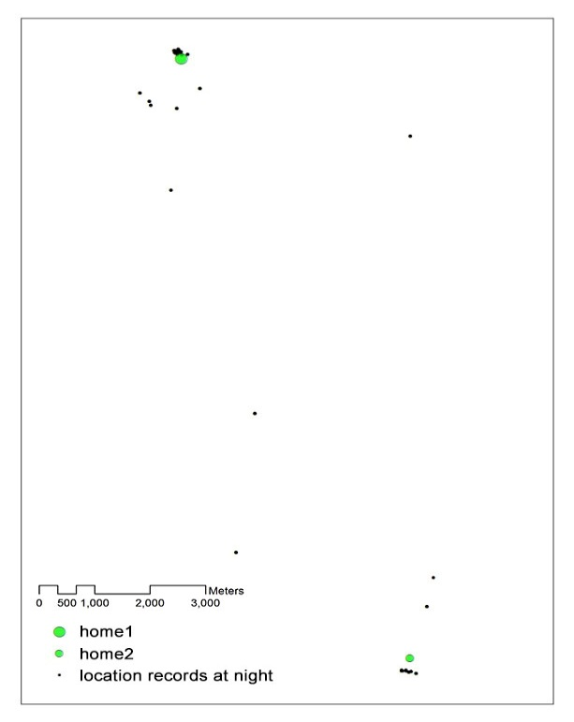 | 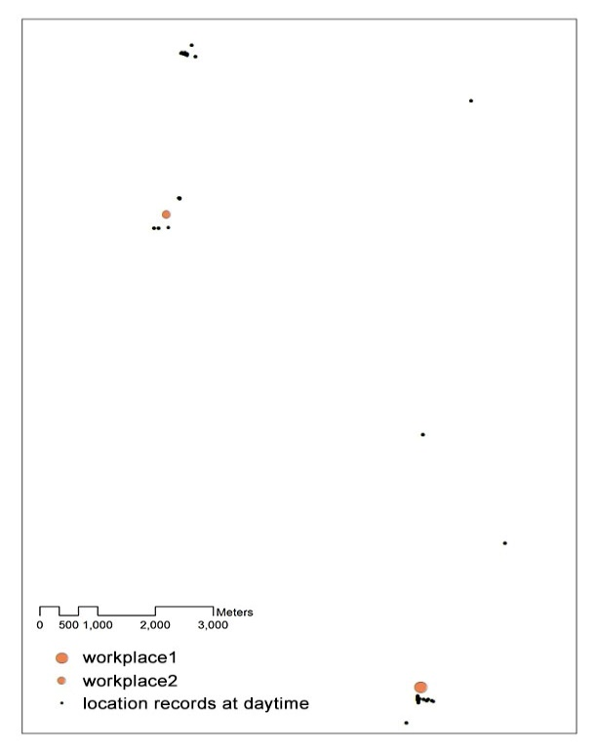

Figure 3. Identified night-time and daytime cluster centres – DBSCAN method
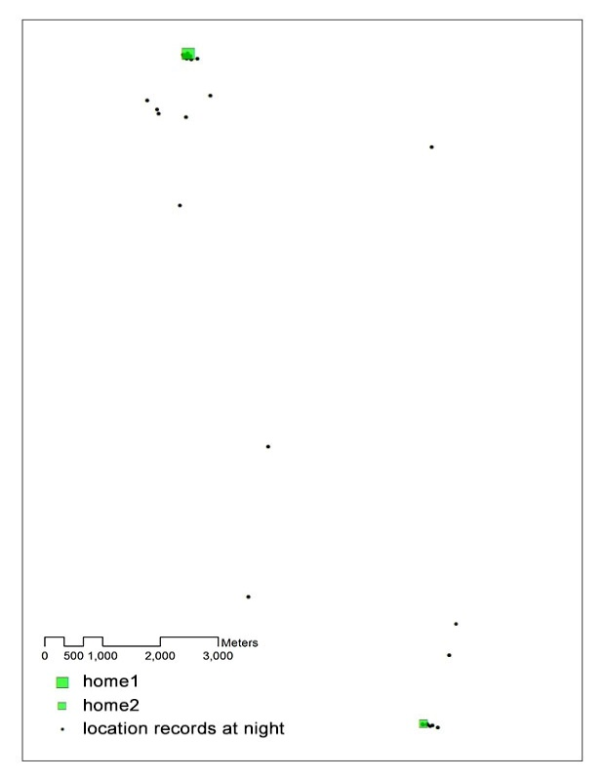 | 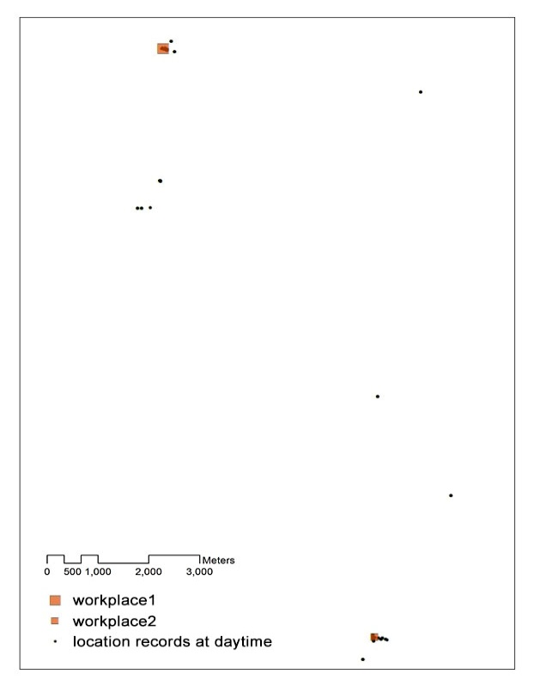
Figure 4. Diagram for processing the anchor points from the LBS data
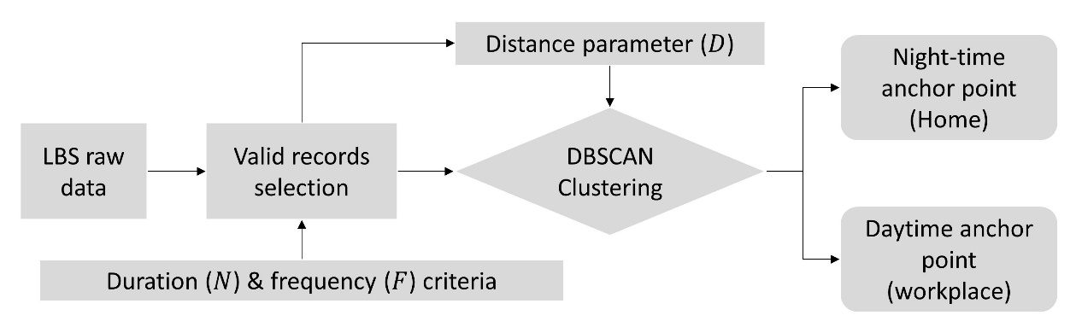

Modelling Commuting Flows
Modelling commuting flows using urban system model requires the model to be first calibrated for a base year before used for prediction. In model calibration, key model parameters are estimated using observed base-year data; the calibrated model is expected to reproduce the observed commuting patter at base year. In the case of Beijing, the census year 2010 is defined as the base year and the year 2015 is set as the forecast year, which is in line with the LBS data. For the base-year calibration, the origin-destination (OD) commuting flows are not available from open sources, such flows thus have to be estimated prior to the model calibration. This section first introduces how the base-year commuting flows are estimated using a discrete choice model with log-linear travel cost function. The estimated flows are then used to calibrate the location choice module in a spatial equilibrium model. The exogenous assumptions for model forecast and the scenario settings are introduced in the end of the section.

Estimating base-year commuting flows
To model the commuting pattern using urban system model, we start from estimating the base year (2010) commuting flow. Two estimation methods can be found in the literature. One is the Fratar method (Fratar, 1954) and its variations (see a review by Horowitz, 2005). The Fratar method estimates the travel flow based on a seed matrix, taking the origin- and/or destination-end number of the trips as constraint. Specifically the Fratar method multiplies the rows and columns of the seed matrix in an iterative manner until the row and column totals agree with the exogenous constraints. Murchland (1966) and Evans (1970) have proven the existence and the uniqueness of the estimated matrix using the Fratar method, provided that the travel volume between all zone pairs is larger than zero. The second method for flow estimation is to use a distribution model, such as the gravity model (Wilson, 1967) or discrete choice model based on random utility (McFadden, 1973). It is assumed that the number of trips between pairs of zones for a particular purpose is proportional to the size of the zone pair and inversely proportional to the travel cost between them.
The key difference between the Fratar method and the model-based approach is that the effectiveness of the Fratar method relies on a good-quality seed matrix to be provided; while the model-based approach does not require such seed matrix. Nonetheless, for the model-based approach, the calibration of the exponential coefficient in the travel cost function still requires some empirical data. For the case of Beijing, because no observed OD data are available to serve as the seed matrix, the model-based method is applied to estimate the base-year commuting flows.
The estimation process starts with defining the travel cost function. City regions with reasonably self-contained commuting catchment today tend to have a radius of 50 km or more. At this metropolitan scale, extensive analyses of travel choices data show that a travel disutility function that is linear to travel costs and times will have great difficulties in representing realistic demand elasticity throughout (Jin et al., 2013). To this end, a log-linear function (Daly & Zachary, 1978) is proposed in order to reflect the realistic travel demand elasticity at city-region level.
$$d_{fij}=a_{f}χ_{fij}+\left(1-a_{f}\right)\ln{χ_{fij}}-a_{f}$$
where $d_{fij}$ is the travel disutility of commuting from zone $i$ to zone $j$ for commuter type $f$; $χ_{fij}$ is the annual commuting time (twice a day, 250 days per year) between zone $i$ and zone $j$ for commuter type $f$; $a_{f}=0.003$ is a log-linear transformation parameter. To demonstrate the non-linear feature of the above function, the log-linear travel disutility is plotted versus the linear counterpart in Figure 5. It shows that the elasticity of the log-linear function varies for different distance ranges. Specifically, the elasticity of disutility with regard to distance is higher for short-distance range (approx. 0-15 km), and becomes lower for long-distance range (approx. > 15 km).
Figure 5. Comparison of travel disutility - log-linear vs linear function
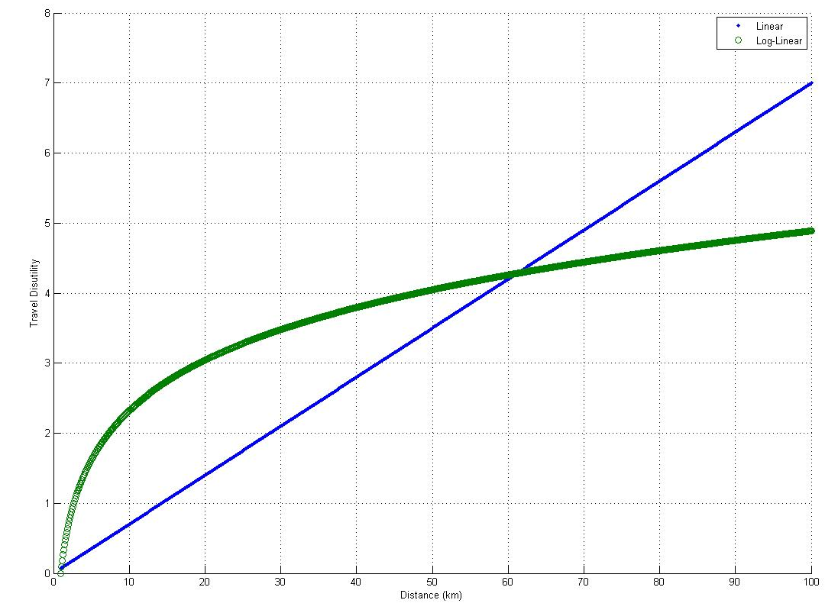
$Linear:y=λx \left(λ=0.07\right)$
$Log_linear:y=ax+\left(1-a\right)\log\left(x\right)-a (a=0.003)$
This travel disutility term enters a multinomial logit model:
$${\tilde{P}}_{fij}=\frac{S_{ij}\exp\left(λ_{f}\left(-d_{fij}+E_{fij}\right)\right)}{\sum_{k,l}{S_{kl}\exp\left(λ_{f}\left(-d_{fkl}+E_{fkl}\right)\right)}}$$
subject to $\sum_{j}{H_{f}{\tilde{P}}_{fij}=}H_{fi|Obs} and \sum_{i}{J_{f}{\tilde{P}}_{fij}=}J_{fj|Obs}$
where ${\tilde{P}}_{fij}$ is the probability of commuter type $f$ choosing residence zone $i$ and employment zone $j$; $S_{ij}=\sum_{m}{b_{mi}}\sum_{k}{B_{kj}}$ is the size term that corrects for the bias introduced by the uneven sizes of zones (M. E. Ben-Akiva & Lerman, 1985), where $b_{mi}$ and $B_{kj}$ is the type-$m$ housing and type-$k$ business building stock (m²) at zone $i$ and $j$ respectively; $λ_{f}$ is the dispersion parameter and $E_{fij}$ is the residual attractiveness term for residence-employment pair choice ($i,j$), which is to be endogenously solved.
In the estimation process, the observed zonal number of employed residents ($H_{fi|Obs}$) and workers ($J_{fj|Obs}$) are exogenous constraints. For any given $λ_{f}$, the $E_{fij}$ is solved subject to the double constraints of $H_{fi|Obs}$ and $J_{fj|Obs}$. Note that solving $E_{fij}$ requires $i*j$ functions while there are only $i+j$ constraints available from $H_{fi|Obs}$ and $J_{fj|Obs}$. Thus we need to reduce the dimension of $E_{fij}$ by defining $E_{fij}=E_{fi}+E_{fj}$, where $E_{fi}$ and $E_{fj}$ are zonal residual attractiveness for residence and employment, respectively. This treatment reduces the number of variables from $i*j$ to $i+j$, thus speeds up the solving algorithm.
The $λ_{f}$ can be solved through an optimization problem, which is defined as:
$$\min_{λ_{f}}\left(\left|\sum_{i,j}{{\tilde{P}}_{fij}{Dist}_{fij}}-{ACD}_{f|Obs}\right|\right)$$
where ${Dist}_{fij}$ is the estimated network distance between zone $i$ and $j$ for commuter type $f$; and ${ACD}_{f|Obs}$ is the observed average commuting distance for commuter type $f$ in Beijing (BTRC, 2010).
The estimated commuting matrices ${\tilde{P}}_{fij}$ can reproduce the average commuting distance that is compatible with the observed travel data in Beijing for 2010. The proposed method provides reasonable approximations when observed OD matrices are not available. The derived commuting matrices are manually verified with modellers’ local knowledge before being used for calibration purpose. The statistics of the estimated commuting matrices of each commuter type for base year 2010 are summarized in Appendix 1.

Location choice within spatial equilibrium
The estimated base year commuting matrices are then used to calibrate a logit type discrete choice model in a spatial equilibrium model. Within the spatial equilibrium framework, producers and consumers are assumed to be profit-maximizing and utility-maximizing, respectively. Employment and residents are both mobile in space, and the associated locational utility is endogenously determined, subject to the simultaneous equilibrium in the product, labour and building floorspace market. In this section, we focus on the employment-residence joint choice for employed residents. Other key equations as well as the equilibrium conditions of the spatial equilibrium model are provided in Appendix 2.
For modelling the employment-residence joint choice, a nested logit model (M. Ben-Akiva, 1974) is developed. This extends the existing spatial equilibrium models such as Anas and Liu (2007) and Jin et al. (2013). Specifically, we partition the employment-residence alternative pairs (total number $N×N$) into $N$ nests according to the workplace, i.e. each workplace$j$ represents a nest that consists of $N$ number of residence location alternatives. The underlying assumption is that, for any given employment location, the residence location alternatives are correlated. The existence of correlations among alternatives can be verified empirically. If the correlation among alternatives is significant, the multinomial logit model is no longer appropriate due to its strict limitation on the univariate structure. More flexible model specifications, such as the nested logit model, should be considered (Train, 2003).
Following the nested-logit structure, the joint probability of employed resident type $f$ choosing to live in zone $i$ and work in zone $j$ is defined as the product of a marginal probability and a conditional probability:
$$P_{fij}=P_{fj}P_{fi|j}$$
where $P_{fj}$ is the marginal probability for consumer $f$ choosing to work in zone $j$, regardless of the residence location, and $P_{fi|j}$ is the conditional probability for consumer $f$ choosing to live in zone $i$, given the chosen employment location $j$. The marginal and the conditional probability are defined as:
$$P_{fj}=\frac{S_{j}exp\left(λ_{f|J}(υ_{fj}+V_{f|j})\right)}{\sum_{k}{S_{k}exp⁡\left(λ_{f|J}(υ_{fk}+V_{f|k})\right)}}$$
$$P_{fi|j}=\frac{S_{i}exp⁡\left(λ_{f|I}υ_{fi|j}\right)}{\sum_{m}{S_{m}exp⁡\left(λ_{f|I}υ_{fm|j}\right)}}$$
where
$$υ_{fj}=\ln{M_{fj}}+ψ_{fj}+E_{fj}+e_{fj}$$
$$υ_{fi|j}={\tilde{U}}_{fi|j }-d_{fi|j}+ψ_{fi|j}+E_{fi|j}+e_{fi|j}$$
$$V_{f|j}=\frac{1}{λ_{f|I}}\ln{\sum_{i∈C_{j}}{S_{i}exp⁡\left(λ_{f|I}({\tilde{U}}_{fi|j }-d_{ij}+ψ_{fi|j}+E_{fi|j})\right)}}$$
$υ_{fj}$ is the employment location utility of zone $j$ for labour type $f$; $υ_{fi|j}$ is the residence location utility of zone $i$ for resident type $f$, given the chosen workplace $j$; $λ_{f|I}$ and $λ_{f|J}$ (${λ_{f|J}}/{λ_{f|I}}∈(0,1]$) are dispersion parameters. $V_{f|j}$ term is called the log-sum or inclusive utility in the literature (Ben-Akiva & Bierlaire, 2003; Train, 2003), which represents the expected utility that employed worker type $f$ in zone $j$ would receive from all residence location choices, no matter which alternative is chosen. This expected utility enters as an explanatory variable into the upper-level employment location model. $E_{fj}$ and $E_{fi|j}$ are zonal residual attractiveness terms.
To calibrate the nested logit model, we make use of the estimated commuting flows for Beijing 2010. The dispersion parameters are first estimated using maximum log-likelihood method. The residual terms are then estimated using standard least squares method, given the estimated dispersion parameters. We report the calibrated dispersion parameters and the goodness of fit statistics in Table 1.
Table 1. Dispersion parameter $λ_{f|I}$ of the location choice model for Beijing 2010
 | Maximum Likelihood Estimation |  | Regression Analysis
Consumer type  $$f$$ | Estimation value  $$λ_{f|I}$$ | Maximized log likelihood | R-squared | Sum of Standard Error (SSE)
2010
$f=1$  High-SEG | 3.0562 | -1.1980e+07 | 0.8824 | 0.0013
$f=2$  Middle- SEG | 3.6920 | -2.2592e+08 | 0.8192 | 0.0054
$f=3$  Low- SEG | 3.3725 | -2.0080e+07 | 0.4643 | 0.0118
Note: we follow the tradition of nested-logit model calibration (Ben-Akiva & Bierlaire, 2003) by normalizing $λ_{f|J}=1$ for employment location choices of all employed residents. Thus only the $λ_{f|I}$ is estimated.

The estimated values of $λ_{f|I}$ are larger than one for all commuter types, which proves the existence of correlation among residence location alternatives. This finding justifies the use of the nested-logit model, instead of the multinomial logit model. In addition, we also find significantly lower R-squared values for the Low-group commuters in 2010. The underlying reason is that the residence locations of the Low group are geographically much more dispersed than the other groups, albeit their average commuting catchment is generally shorter. The Low-group commuters include agricultural workers whose residence location choices are subject to various historical and institutional factors.
Once the base year spatial equilibrium model is calibrated, parameter values are then retained for future model forecast. In forecast mode, the model requires exogenous development projections, such as the total number of employed residents, total building floorspace growth and transport supply. The model then predicts the spatial distribution of employment and residents.

Scenario design for model forecast
The ‘Greater Beijing’ consists of the large city region covering Beijing Municipality, Tianjin Municipality and Hebei Province, which has a total population of approximately 110 million in 2014 across a geographical area of over 216,000 km². The Greater Beijing model represents the city region with a total of 209 model zones (Figure 2). We define the 130 zones of Beijing Municipality as core zones of study and the rest 79 zones of Tianjin and Hebei as peripheral zones. The incorporation of the large city region reflects the government’s policy initiative of promoting regional integration and coordinated development.
Figure 2a: Zoning Map of Greater Beijing (Left).
Figure 2b: Zoning Categories in Beijing (Right).
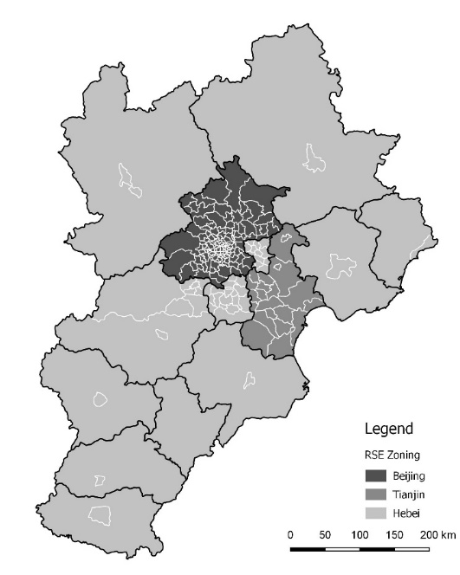 | 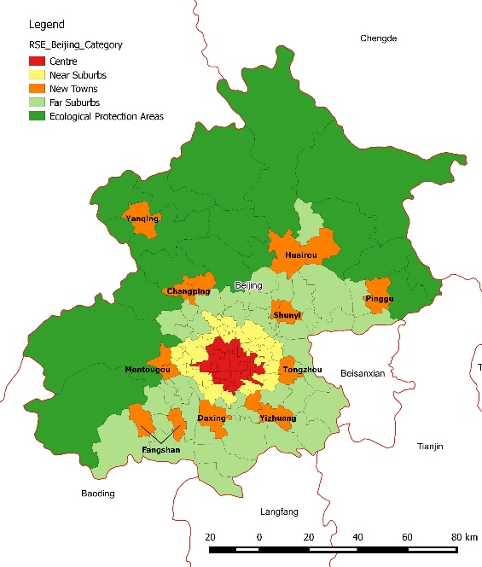
The model forecast is based on the exogenous projections on total population, employment and land-use and transport development. The strategic demographic and floorspace growth assumptions for Greater Beijing 2015 are summarized in Table 2. Note that the assumptions are derived from a priori growth estimations, which include both official and third-party sources. The authors deem that the strategic assumption represents a relatively fast growth trend in Greater Beijing.
Table 2: Strategic demographic and floorspace growth assumptions (Greater Beijing 2010-2015)
Item | 2010  (Base Year) | 2015  (Forecast Year)
DEMOGRAPHIC GROWTH
Total population | 104.55 | 118.13
Annual growth rate per decade | - | 2.5%
Employed residents (million) | 57.74 | 63.85
Annual growth rate per decade | - | 2.0%
Employed-to-total-population ratio | 0.55 | 0.54
BUILDING FLOORSPACE STOCK
Housing floorspace (million $m^{2}$) | 3558.4 | 4659.7
Annual growth rate per decade | - | 5.5%
Business floorspace (million $m^{2}$) | 1154.9 | 1277.0
Annual growth rate per decade | - | 2.0%

Based on the above assumptions, a Trend scenario is then developed, which reflects the observed policy trend in Beijing from 2010. The scenario features an enhanced concentric urban growth pattern with moderate control of floorspace growth in central Beijing. Based on the five zoning categories of Beijing (see Figure 2b), Table 3 summarizes the land-use and transport configurations of the Trend scenario.
Table 3: Summary of scenario settings
Policy Setting | Beijing |  |  |  |  | Rest of Greater Beijing
Policy Setting | Central Districts | Near Suburbs | New Towns | Far Suburbs | EPA* | Rest of Greater Beijing
LAND USE DEVELOPMENT - NATURAL GROWTH
Housing floorspace | ✓ | ✓ | ✓ | ✓ | ✓ | ✓
Business floorspace | ✓ | ✓ | ✓ | ✓ | ✓ | ✓
LAND USE DEVELOPMENT - DISCRETIONARY GROWTH
Housing floorspace | ✕ | ✓ | ✓ | ✓ | ✕ | ✓
Business floorspace | ✕ | ✓ | ✓ | ✓ | ✕ | ✓
TRANSPORT DEVELOPMENT
The access time between zones in Greater Beijing remains the same as in 2010, which implies a proportional transport supply growth with the population growth.
* EPA: Ecological Protection Area

In terms of land use development, we differentiate two types of floorspace growth as follows. Natural growth represents the spontaneous expansions of housing estates and business premises through infilling and densification in existing built-up areas. We follow Jin et al. (2017), assuming that the amount of natural growth is in proportion to existing zonal building stocks and applies to all locations. We further assume that natural growth accounts for 50% of the total projected floorspace growth. The second type is discretionary growth which addresses policy-oriented land development and subject to zoning regulations. In terms of transport development, the same level of network accessibility as in 2010 is assumed for 2015.
To distribute the projected aggregate floorspace growth to zones, a logit-type probability model is developed, which refers to not only the endogenous market variables from the base-year equilibrium, but also the durability of development and one-off policy interventions. The modelled zonal floorspace stock for 2015, together with the projected total employed residents are then used as exogenous inputs to predict the spatial location of jobs and residents and the commuting flows across Greater Beijing in 2015.

Results and Discussion

Benchmark Statistics
To set up a benchmark for comparing the model prediction and the LBS data, we make use of the conventional statistic data for Beijing 2015 (Beijing Bureau of Staistics, 2015). Because no commuting flow data is available from existing data sources, we use the district-level total number of employed residents (ER) and employed workers (EW) as the benchmark values. For employment, total number of employment is only available at the municipal level (11.86 million in Beijing 2015), while the district-level statistics only cover legal-entity and non-agricultural workers, and do not include the self-employed and agricultural workers. To derive the district-level totals, we assume a fixed share of self-employed and agricultural workers (34.5%) in total employment for all districts in Beijing 2015. This share constant is calculated from the municipal-level statistics. For employed residents, we first calculate the percentage share of employed residents among 15-65 year-old permanent residents at municipal level (68.6%) in Beijing 2015. This share is then used to estimate the district-level total number of employed residents. Table 4 presents the estimated district-level employed residents and employed workers in Beijing in 2015. In terms of the EW/ER ratio, the central districts tend to have larger-than-one ratio, implying more jobs than local employed residents. For the whole of Beijing, it is assumed that the total number employed residents equals the number of employment (11.86 million), thus the EW/ER ratio equals one. This assumption ensures that the total number of commuters is identical at both the origin and destination locations, which facilitates the comparison with estimated commuting flows. Note that no observed data for Beijing 2015 are used in either the LBS data processing or model prediction.
Table 4. District-level number of residents and employment in Beijing 2015 (Benchmark)
District of Beijing | Permanent Residents  (10000 persons) | Employed Residents (ER)  (10000 persons) | Employed Workers (EW)  (10000 persons) | EW/ER Ratio
Dongcheng | 90.5 | 46.7 | 100.2 | 2.1
Xicheng | 129.8 | 65.8 | 147.6 | 2.2
Chaoyang | 395.5 | 217.6 | 231.7 | 1.1
Fengtai | 232.4 | 127.1 | 96.9 | 0.8
Shijingshan | 65.2 | 36.0 | 30.3 | 0.8
Haidian | 369.4 | 208.1 | 259.5 | 1.2
Fangshan | 104.6 | 55.8 | 23.3 | 0.4
Tongzhou | 137.8 | 77.5 | 34.5 | 0.4
Shunyi | 102.0 | 56.5 | 71.3 | 1.3
Changping | 196.3 | 108.1 | 44.9 | 0.4
Daxing | 156.2 | 86.3 | 77.1 | 0.9
Mentougou | 30.8 | 16.0 | 8.6 | 0.5
Huairou | 38.4 | 20.6 | 14.6 | 0.7
Pinggu | 42.3 | 22.2 | 19.0 | 0.9
Miyun | 47.9 | 25.2 | 15.9 | 0.6
Yanqing | 31.4 | 16.7 | 10.8 | 0.6
Total of Beijing | 2170.5 | 1186.1 | 1186.1 | 1.0

Comparison - District-Level Totals
Given the district-level ER and EW benchmark, the derived ER and EW from the model and the LBS data are compared in Figure 6 and 7. Note that the LBS data is essentially a sample data in nature thus the processed district-level ER and EW are quantitatively smaller than the benchmark values. The model predicted flows are for the full population. In order to facilitate the comparison, a secondary vertical axis is introduced in the figures for plotting the LBS data.
Comparing the model prediction with the benchmark, a high level of goodness of fit is shown in both ER and EW prediction. Two reasons may contribute to the good performance of the model. First, urban development processes tend to be inertia-prone and path-dependent. Drastic changes may happen at local level but the aggregate spatial pattern would remain relatively stable over a short period of time (five years in our case) in the absence of political or economic shocks. Second, the spatial equilibrium framework captures the aggregate mechanisms of market interactions among agents that are relatively persistent over time. Nonetheless, the model overestimated the total number of ER (14.03 million) and EW (14.00 million) for Beijing 2015, compared with the actual total (11.86 million). In particularly, relatively large overestimation is seen at Chaoyang district for both ER and EW, and at Tongzhou and Changping district for EW. The error is likely to be attributed to the exogenous projection of floorspace growth. The Trend scenario features moderate control of floorspace growth in the centre, while the actual level of planning control in Chaoyang may well be more severe than the scenario. However no housing or business floorspace data is available in Beijing 2015 for verification purpose. In fact acquiring floorspace data for non-census years is very difficult in this particular context.
Figure 6. Comparison of district-level employed residents in Beijing 2015

Figure 7. Comparison of district-level employed workers in Beijing 2015

By contrast, a larger discrepancy is shown between the LBS data and the benchmark ER and EW. To better understand the features of the LBS data, particularly the varying errors among locations, Table 6 further presents the district-level scale factors that may potentially correct the magnitude errors of the LBS data caused by sampling. We define the scale factor as the ratio between the benchmark and the processed ER and EW from the LBS data. We also divide the districts into three categories, which are in line with the masterplan of Beijing.
First, the scale factors vary significantly across locations, which indicates that using one uniform scale factor for the whole study area to amplify the LBS data may be problematic. It is thus suggested that varying scale factors are likely to present when amplifying the LBS data to represent full population. The scale factors need to be examined not only statistically but also geographically. Secondly, for employed residents, the scale factors tend to be smaller in the Central Districts than those in Suburban and Ecological Protection Districts. The authors deem that this factor gradient is reasonable because the sampling rate of LBS data is likely to be higher in relatively more developed central districts, where more people as well as smart devices are concentrated. Thirdly, for employment workers, however, the factor gradient is less significant. In particular, the scale factor for Dongcheng (8.03) and Xicheng (9.96) is much higher than the municipal average (4.76), albeit they are both central districts. It implies that the proposed data processing method for detecting employment locations may be ineffective for some locations. Because such inconsistency occurs even within the same district category, the issue of varying sampling rate is unlikely to be the main cause. One possible reason is that people’s daytime movements tend to be more dynamic and variable than the night time, which makes it difficult to detect a stable workplace using LBS data. In addition, workers without fixed workplace, such as couriers and service contractors, also contribute to the errors.
Table 5. District-level scale factors of the LBS data (Beijing 2015)
 | Scale factor: Benchmark/LBS Data
 | Employed Residents | Employed Workers
CENTRAL DISTRICTS
Dongcheng | 2.80 | 8.03
Xicheng | 3.69 | 9.96
Chaoyang | 3.09 | 3.36
Fengtai | 5.53 | 3.83
Shijingshan | 6.33 | 4.53
Haidian | 5.07 | 6.56
SUBURBAN DISTRICTS
Fangshan | 8.92 | 3.41
Tongzhou | 5.69 | 2.13
Shunyi | 5.09 | 6.67
Changping | 6.27 | 2.10
Daxing | 5.56 | 4.49
ECOLOGICAL PROTECTION DISTRICTS
Mentougou | 8.31 | 3.49
Huairou | 10.29 | 7.25
Pinggu | 11.62 | 10.27
Miyun | 12.29 | 7.57
Yanqing | 16.22 | 11.37
Total of Beijing | 4.80 | 4.76

Comparison – Origin-Destination Analysis
The comparison of district-level ER and EW totals provides an overview of the two derived data for Beijing 2015 against the benchmark. The next step is to extend the discussion by comparing the derived commuting pattern for Beijing 2015 through origin-destination analysis. As no observed OD commuting flows are available from existing statistical sources, thus only the model-predicted flows and the LBS-data flows are compared. Figure 8 presents the scatter plot of the model predicted flows and the LBS data at district-pair level (16 districts in Beijing thus 256 district pairs including intra-district flows, i.e. commuting within the same district). A significant linear correlation is shown between the two derived flows with an R-square value 0.86.
Figure 8. District-level OD pair comparison - Model Predicted vs LBS data

To further investigate the difference between the two derived flows, we select three districts in Beijing as residence locations (i.e. origins) and present the percentage distribution of commuters to all employment destinations including the origin itself in Table 6. The three selected districts cover different location categories in Beijing, namely Xicheng representing the urban core, Tongzhou representing the suburban new town and Pinggu representing the ecological protection area. Due to the sampling nature of the LBS data, we focus on the percentage share by destination, rather than the actual flow volume. As a further exercise, we make use of the network distance/time matrices to calculate the average one-way commuting distance/time for the derived flows, which are presented at the bottom of Table 7. Note that the same transport network and congestion level as used in the model is applied to the LBS data.

Table 6. OD flows comparison for selected districts in Beijing 2015 – Model Predicted vs LBS data
Origin  Destination | Model Predicted |  |  | LBS Data
Origin  Destination | Xicheng | Tongzhou | Pinggu | Xicheng | Tongzhou | Pinggu
Dongcheng | 10.4% | 5.0% | 0.4% | 7.7% | 2.1% | 1.4%
Xicheng | 64.7% | 3.9% | 0.4% | 25.1% | 1.7% | 1.8%
Chaoyang | 4.8% | 19.9% | 0.8% | 17.9% | 15.5% | 9.3%
Fengtai | 4.1% | 1.1% | 0.1% | 14.4% | 2.6% | 2.8%
Shijingshan | 0.4% | 0.1% | 0.0% | 2.7% | 0.4% | 0.7%
Haidian | 14.5% | 1.8% | 0.3% | 17.8% | 2.7% | 3.4%
Fangshan | 0.1% | 0.0% | 0.0% | 1.4% | 0.5% | 0.6%
Tongzhou | 0.0% | 60.5% | 0.1% | 2.2% | 65.5% | 2.5%
Shunyi | 0.0% | 0.9% | 4.7% | 1.2% | 1.2% | 4.3%
Changping | 0.0% | 0.0% | 0.0% | 4.2% | 1.4% | 2.5%
Daxing | 0.7% | 6.4% | 0.0% | 4.1% | 5.5% | 1.9%
Mentougou | 0.1% | 0.0% | 0.0% | 0.5% | 0.2% | 0.2%
Huairou | 0.0% | 0.0% | 0.2% | 0.2% | 0.2% | 0.4%
Pinggu | 0.0% | 0.0% | 91.8% | 0.2% | 0.2% | 67.4%
Miyun | 0.0% | 0.0% | 1.2% | 0.2% | 0.2% | 0.5%
Yanqing | 0.0% | 0.0% | 0.0% | 0.1% | 0.1% | 0.2%
Total | 100.0% | 100.0% | 100.0% | 100.0% | 100.0% | 100.0%
Ave. Commuting Distance (km)* | 5.2 | 13.6 | 14.4 | 16.9 | 20.5 | 35.6
Ave. Commuting Time (min) | 34.8 | 47.6 | 40.7 | 61.4 | 61.6 | 79.0
* Average commuting distance and time is measured from resident locations and is the weighted average over commuters to all employment destinations.

The OD comparison reveals three findings. First, both the model and the LBS data show that the majority of employed residents commute within the residence districts, albeit the percentage share of intra-district commuting varies among locations. For the model predicted flows, the intra-district commuting in both central and rural district is higher than that in suburban new town. For central district where jobs concentrate, local employed residents are likely to work in the centre rather than commuting outward to the suburbs. For far suburbs, although a certain share of residents would still commute to the centre, the majority tends to work locally, particularly the agricultural workers. However, for new towns at intermediate stage of development, local jobs may not be sufficient to support the local labour force, employed residents thus may have to commute to the centre. Meanwhile the new towns also accommodate the workers fled from the centre who cannot afford living in the centre, which together explain the lower share of intra-district commuting for new towns.
Second, the LBS data show much longer distance and time travelled in Xicheng and Pinggu district than the model predicted flows. For the whole Beijing, the average commuting distance (time) given by the LBS data and the model predicted flows is 10.7 km (45.2 min) and 15.3 km (56.5 min), respectively. To articulate the discrepancy, we refer to the municipal transport survey, which provides aggregate transport statistics for Beijing Municipality. According to the latest published survey (BTRC, 2015), the average commuting distance and time in Beijing is 10.1 km and 48 min respectively. Given this data as a benchmark, the LBS data seem to overestimate the commuting catchment. The authors deem that the overestimation is mainly caused by the underestimation of intra-district commuting. To confirm the hypothesis, Figure 9 presents the distribution of commuters by distance travelled (one-way) for the two derived flows. It shows that the LBS data have significantly lower share of short-distance (0-5 km) commuting (29.5%) than the model predicted flows (48.5%). Given the average size of districts in Beijing, these short-distance travels are typically intra-district. In terms of the reason why the LBS data would underestimate the short-distance commuting, one plausible explanation is that the spatial proximity of home and workplace implies that the commuter may be very familiar to the area, which in turn reduces the need for location-based services. The less usage of LBS for short-distance commuters is yet to be confirmed with further studies.
It should be noted that the underestimation of intra-district commuting in the LBS data appears in both central (e.g. Dongcheng) and rural (e.g. Yanqing) locations (see Figure 10), but the source of errors may be different. For central locations, errors may be caused by the ineffectiveness of detecting employment locations; while for rural locations, underestimation may be attributed to the low LBS device usage due to the prevalence of lower-class workers. Interestingly, for some districts like Tongzhou, the share of intra-district commuting given by the LBS data (65.5%) is similar to the model-predicted figure (65.6%). The inconsistency is likely to be case-specific but again it implies the uneven locational bias of the LBS data.
Figure 9. Commuter distribution by average commuting distance - Model Predicted vs LBS data

Figure 10. Share of intra-district commuting - Modelled Predicted vs LBS Data

Thirdly, both the model and LBS data show shorter commuting distance and time for central districts than suburban districts. This is in line with the monocentric employment pattern in Beijing, where many suburban workers who are pushed away from the centre due to high living costs have to commute inwards to the centre on a daily basis. According to the model simulation, the current employment agglomeration in central Beijing is likely to hold in the near future, while strong policy initiative of decentralization is underway. The decentralization scheme may foster employment development in suburban centres and eventually mitigate the super-commuting of suburban residents.
It would be unfair to end here implying that the model predicted flows are better than the LBS data for commuting analysis. In fact, it should be pointed out that the geographical granularity of the LBS data is much finer than the model. The LBS data record accurate user location in a nearly continuous space, while the proposed model is operated on a priori zoning system. Such zoning system tends to be geographically aggregate particularly for spatial equilibrium models in order to reduce the burden on data input and computing. In this paper, the LBS data are aggregated according to the model zoning system as a compromise, such that the results can be readily compared. Nonetheless the LBS data provides a much finer perspective to examine the spatial and behavioural heterogeneity than conventional system models.

Conclusions
This paper has two purposes, 1) empirically comparing a data-driven approach and a system modelling approach in terms of modelling the commuting pattern for Beijing 2015, and 2) identifying the strength and weakness of each approach, including implications for processing the novel Location-Based-Services (LBS) data. The exclusive LBS data used in this research are provided by the TalkingData, a Chinese corporation that provides location-based services to thousands of applications on smart devices in China. The LBS provider collects, under user permission, the geographic location of the user when the service is requested, using the embedded GPS module on smart devices. To obtain stable location patterns of the LBS users, valid records are selected by removing the transient records that do not meet the proposed frequency and duration criteria. The DBSCAN method is then applied to identify the employment and residence anchor point of the LBS users using the daytime and night-time records respectively.
Parallel to the data-drive approach, a LUTI type urban spatial equilibrium model is calibrated for base year 2010 and is used to predict the commuting flows for Beijing 2015. A discrete-choice model with log-linear travel cost function is applied to estimate the origin-destination (OD) commuting flows at base year, which represents a useful alternative when observed OD flows are not available. The model prediction is based on exogenous projections on demographic, employment, land-use and transport development for Greater Beijing 2015.
To establish a benchmark for comparison, district-level totals of employed residents and workers are processed using conventional statistics for Beijing 2015. The comparison shows that the LBS data perform better in detecting residence locations than employment locations. This finding may also be applicable to other type of location-based big data, given the fact that the behaviour pattern at nigh time is likely to be more stable thus recognisable than that at daytime. The comparison also shows that the discrepancy between the LBS data and the benchmark varies significantly among district locations. For amplifying the sample data to represent the full population, uniform scale factor is likely to cause big errors, thus should be avoided. In addition, the ineffectiveness of representing short-distance (0-5 km) commuting for the LBS data is revealed by the comparison with the model predicted flows. The model prediction for Beijing 2015 is compatible with the observed aggregate travel statistics, but in a more informative format, thus provides a useful reference to examine the LBS data.
In light of the findings, the collaborative use of big data and urban system models seems to be a win-win strategy that would enable improvements that neither approach could achieve in isolation. One the one hand, the LBS data, once well processed, can serve as a novel data source for calibrating and validating the models when relevant data are not available from conventional sources. The fine granularity of the big data would also help urban system models to embrace the spatial and behavioural heterogeneity. On the other hand, the predictions made by theoretically sound models provide good reference for investigating the possible errors and biases of the big data as well as integrating the correlations. The findings would in turn shed new light on how such data can be better processed and used. This paper is but a very small and experimental step towards the joint approach.

Appendix 1
Statistics of Estimated Commuting Matrices – Greater Beijing 2010
Commuting Statistics – Greater Beijing 2010 | Beijing | Tianjin | Hebei | Greater Beijing City Region
HIGH- SOCIO-ECONOMIC COMMUTERS
Average commuting distance (km) | 11.0 | N/A* | N/A | 11.0
Average monetary cost (fen = 0.01 yuan) | 306.0 | N/A | N/A | 306.0
Average travel time (min) | 40.0 | N/A | N/A | 40.0
MIDDLE- SOCIO-ECONOMIC COMMUTERS
Average commuting distance (km) | 8.7 | 7.8 | 7.4 | 7.6
Average monetary cost (fen = 0.01 yuan) | 149.2 | 93.2 | 92.7 | 100.0
Average travel time (min) | 35.0 | 26.6 | 26.1 | 27.3
LOW- SOCIO-ECONOMIC COMMUTERS
Average commuting distance (km) | 6.1 | N/A | N/A | 6.1
Average monetary cost (fen = 0.01 yuan) | 81.0 | N/A | N/A | 81.0
Average travel time (min) | 29.5 | N/A | N/A | 29.5
ALL COMMUTERS
Average commuting distance (km) | 8.3 | 7.8 | 7.4 | 7.7
Average monetary cost (fen = 0.01 yuan) | 155.2 | 93.2 | 92.7 | 105.6
Average travel time (min) | 34.2 | 26.6 | 26.1 | 27.8
* For lack of data, we model all employed residents in Tianjin and Hebei as one composite group. We further assume that the composite group share the same socio-economic characteristics as the Middle group in Beijing

Appendix 2
Producers. We follow Anas and Liu (2007) and Jin et al. (2013), and define the production function as a variant of the CD-CES specification.
$$X_{rj}=E_{rj}A_{rj}{\left(K_{r}\right)}^{ν_{r}}{\left(\sum_{f}{κ_{rfj}L_{fj}^{θ_{r}}}\right)}^{\frac{δ_{r}}{θ_{r}}}{\left(\sum_{k}{χ_{rkj}B_{kj}^{ζ_{r}}}\right)}^{\frac{μ_{r}}{ζ_{r}}}$$
where
$X_{rj}$: production output of industry $r$ in zone $j$;
$E_{rj}$: a constant scalar representing any additional zonal effects on total factor productivity;
$K_{r}$, $L_{fj}$, $B_{kj}$: capital, labour and business floorspace input;
$ν_{r}$, $δ_{r}$, $μ_{r}$: cost share parameters for the respective input group ($ν_{r}+δ_{r}+μ_{r}=1$);
$κ_{rfj},χ_{rkj}$: input-specific constants for labour and business floorspace varieties;
$θ_{r}$, $ζ_{r}$: elasticity of substitution between any two labour and building floorspace varieties.
$A_{rj}$ is a function of the economic mass for industry $r$ in zone $j$ that represents Hicksian-neutral Total Factor Productivity (TFP) effects, which is an important component of urban agglomeration effects; we define $A_{rj}={\underline{A}}_{rj}{(M_{j}/{\underline{M}}_{j})}^{π}$, where ${\underline{A}}_{rj}$ is a constant representing the baseline agglomeration effects, $M_{j}$ is a function of the economic mass of zone $j$, ${\underline{M}}_{j}$ is a constant representing the baseline economic mass in $j$; $π$ is a scale parameter; The function of economic mass builds on the concept of effective density Graham et al. (2009).
$$M_{j}=\sum_{f}{\sum_{i}{\frac{{L_{fi}}/{S_{i}}}{χ_{fij}}}}$$
where
$L_{fi}$: total number of labour $f$ in zone $i$ (including zone $j$) that is relevant to production at $j$;
$S_{i}$: geographic area of zone $j$;
$χ_{fij}$: travel time from location $i$ to $j$ for labour type $f$.
We use the employment density per unit of land area, instead of the absolute employment number to derive the economic mass. This modification is inspired by Ahlfeldt et al (2012) and aims to correct the biases caused by the varying size of zones in the model. As a model designed for large city regions, the vast study area entails varying geographical aggregation in the model zoning system. Using absolute employment number is likely to incurred biased economic mass for geographically aggregated zones.
We assume that each firm minimizes the cost subject to the production demand and the price of each input variety. The conditional input demand (given target output $X_{rj}$) of each input factor can be derived as follows:
$$K_{r}=\frac{1}{ρ}ν_{r}p_{rj}X_{rj}$$
$$L_{rfj}=\frac{κ_{rfj}^{\frac{1}{1-θ_{r}}}w_{fj}^{\frac{1}{θ_{r}-1}}}{\sum_{s}{κ_{rsj}^{\frac{1}{1-θ_{r}}}w_{sj}^{\frac{θ_{f}}{θ_{r}-1}}}}δ_{r}p_{rj}X_{rj}$$
$$B_{rkj}=\frac{χ_{rkj}^{\frac{1}{1-ζ_{r}}}R_{kj}^{\frac{1}{ζ_{r}-1}}}{\sum_{s}{χ_{rsj}^{\frac{1}{1-ζ_{r}}}R_{sj}^{\frac{ζ_{r}}{ζ_{r}-1}}}}μ_{r}p_{rj}X_{rj}$$
where
$p_{rj}$: unit production price of industry $r$ in zone $j$;
$ρ$: exogenous price of business capital (i.e. the real interest rate);
$w_{fj}$: hourly wage of labour type $f$;
$R_{kj}$: average rent for business floorspace type $k$;
$p_{rj}$: production price.

Final consumers. Final consumers are categorized into $f=1,…,F$ types according to their employment status and socio-economic level. Following the random utility framework (McFadden, 1973), the observable utility $U_{fij}$ is given by:
$$U_{fij}=α_{f}\ln{{\left(\sum_{r}{{\left(\sum_{z}{Z_{rz|fij}}\right)}^{η_{f}}}\right)}^{\frac{1}{η_{f}}}}+β_{f}\ln{{\left(\sum_{m}{ı_{mfi}}{\left(b_{m|fij}\right)}^{σ_{f}}\right)}^{\frac{1}{σ_{f}}}}+γ_{f}\ln{l_{fij}}$$
$$subject to budget constraint: \sum_{r,z}{\left(p_{rz}+c_{f}2g_{fiz}\right)Z_{rz|fij}}+\sum_{m}{r_{mi}b_{m|fij}}+Δ_{f}2{Dg}_{fij}=Δ_{f}w_{fj}\left(N-2DG_{fij}-\sum_{r,z}{c_{f}Z_{rz|fij}{2G}_{fiz}}-l_{fij}\right)+M_{fi}$$
$$and time constraint: N-\sum_{r,z}{c_{f}Z_{rz|fij}{2G}_{fiz}}-Δ_{f}\left(l_{fij}+2DG_{fij}\right)≥0$$
We assume Cobb-Douglas preference between goods & services $Z_{rz|fij}$, housing $b_{m|fij}$ and leisure time $l_{fij}$. $α_{f}+β_{f}+γ_{f}=1$ are the expenditure coefficients for each consumption bundle. The varieties of goods & services and housing are assumed to be imperfect substitutes (Dixit & Stiglitz, 1977), and the elasticity of substitution is governed by $η_{f}$ and $σ_{f}$ for goods & services and housing, respectively. $ı_{mfi}>0$ is the input-specific constant measuring the inherent attractiveness of the housing type $m$ for consumers type $f$ living in zone $i$, which is calibrated empirically.
For the budget constraint, the right-hand side of the function is the total income and the left-hand side is the total expenditure. Specifically, $p_{rz}$ is the mill price for goods & services type $r$ produced in zone $z$; $g_{fiz}$ and $G_{fiz}$ is the expected one-way monetary cost and travel time from $i$ to $z$ for customers type $f$, respectively; $c_{f}$ is an exogenous coefficient that measures the cost for delivering a unit of goods & services as percentage of the normal trip cost. $r_{mi}$ is the housing rent of type $m$ in zone $i$; $w_{fj}$ is the hourly wage rate for labour type $f$ working in zone $j$. $Δ_{f}$ is the employment status of the consumer type $f$. For all employed consumers $Δ_{f}=1$; otherwise $Δ_{f}=0$. $M_{fi}$ is the nonwage income of consumer type $f$ in zone $i$. It consists of normal investment returns on real estate in the city region (endogenous in the model) as well as the individual share of social welfare transfer and amenity gains. As for the time constraint, $D$ is the exogenous number of working days per annum; $N=24D$ is the exogenous total annual time endowment. For the non-employed consumers ($Δ_{f}=0$), the model only accounts for the time for shopping, as they do not commute and have zero value of time for leisure time.
Under the above budget and time constraint, we can then derive the Marshallian demand for goods & services, housing and leisure time, respectively as the following.
$${\overline{Z}}_{r|fij}=\frac{{{\overline{p}}_{r|fij}}^{\frac{1}{η_{f}-1}}}{\sum_{s}{{{\overline{p}}_{s|fij}}^{\frac{η_{f}}{η_{f}-1}}}}α_{f}Ω_{fij}$$
$$b_{m|fij}=\frac{ı_{mfi}^{\frac{1}{1-σ_{f}}}r_{mi}^{\frac{1}{σ_{f}-1}}}{\sum_{s}{ı_{si}^{\frac{1}{1-σ_{f}}}r_{si}^{\frac{σ_{f}}{σ_{f}-1}}}}β_{f}Ω_{fij}$$
$$l_{fij}=\frac{γ_{f}Ω_{fij}}{w_{fj}}$$
where
${\overline{Z}}_{r|fij}$: aggregate demand for product type $r$ for consumer type $(fij)$;
${\overline{p}}_{r|fij}$: probability-weighted average price of product type $r$ faced by consumer type $(fij)$.

Equilibrium Conditions. The general equilibrium structure of the RSE model requires four sets of equilibrium conditions to be satisfied simultaneously, conditional on the transport conditions $g$ and $G$.
- All consumers maximize utility subject to budget and time constraint.
- All producers minimize cost subject to supply constraint of input factors and technology. Producers are competitive and operate under constant returns to scale. The minimized production price equals the average and marginal cost, implying zero economic profit.
- The endogenous part of nonwage incomes must be consistent with the regional building stocks and the associated rental levels. Other sources of nonwage income are specified as exogenous input.
- All markets clear with zero excess demands. This applies to: a) the residential and business floorspace markets; b) the labour market for each socio-economic group at each production zone; c) the product market of each product type at each production zone.

References
Ahas, R., Aasa, A., Silm, S., & Tiru, M. (2010). Daily rhythms of suburban commuters’ movements in the Tallinn metropolitan area: Case study with mobile positioning data. Transportation Research Part C: Emerging Technologies, 18(1), 45–54.
Ahas, R., & Mark, Ü. (2005). Location based services - New challenges for planning and public administration? Futures, 37(6), 547–561. https://doi.org/10.1016/j.futures.2004.10.012
Ahlfeldt, G. M., Redding, S. J., Sturm, D. M., & Wolf, N. (2012). The Economics of Density : Evidence from the Berlin Wall. SERC Discussion Paper, 83(1154), 1–48. https://doi.org/10.3982/ECTA10876
Anas, A. (2013). A summary of the applications to date of RELU-TRAN, a microeconomic urban computable general equilibrium model. Environment and Planning B: Planning and Design, 40(6), 959–970.
Anas, A., & Liu, Y. (2007). A regional economy, land use, and transportation model (RELU-TRAN??): Formulation, algorithm design, and testing*. Journal of Regional Science, 47(3), 415–455. https://doi.org/10.1111/j.1467-9787.2007.00515.x
Anderson, C. (2008). The end of theory: The data deluge makes the scientific method obsolete. Wired Magazine, 16(7), 7–16.
Batty, M. (2013). Big data, smart cities and city planning. Dialogues in Human Geography, 3(3), 274–279. https://doi.org/10.1177/2043820613513390
Beijing Bureau of Staistics. (2015). Beijing Statistical Yearbook 2015.
Ben-Akiva, M. (1974). Structure of passenger travel demand models. Transportation Research Record.
Ben-Akiva, M., & Bierlaire, M. (2003). Discrete Choice Methods and Their Applications to Short-Term Travel Decisions. Handbook of Transportation Science, (1985), 7–37. https://doi.org/10.1007/0-306-48058-1_2
Ben-Akiva, M. E., & Lerman, S. R. (1985). Discrete choice analysis: theory and application to travel demand (Vol. 9). MIT press.
Berkhin, P. (2006). A survey of clustering data mining techniques. In Grouping multidimensional data (pp. 25–71). Springer.
Bhaskar, A., & Chung, E. (2015). Passenger segmentation using smart card data. IEEE Transactions on Intelligent Transportation Systems, 16(3), 1537–1548.
Bröcker, J. (1998). Operational spatial computable general equilibrium modeling. The Annals of Regional Science, 32(3), 367–387.
BTRC. (2010). Beijing Travel Survey.
BTRC. (2015). Beijing Travel Survey.
Daly, A., & Zachary, S. (1978). Improved multiple choice models. Determinants of Travel Choice, 335, 357.
Dixit, A. K., & Stiglitz, J. E. (1977). Monopolistic Competition and Optimum Product Diversity. American Economic Review, 67(3), 297–308. https://doi.org/10.1016/S0167-7187(98)00007-1
Echenique, M. H., Flowerdew, A. D. J., Hunt, J. D., Mayo, T. R., Skidmore, I. J., & Simmonds, D. C. (1990). The MEPLAN models of Bilbao, Leeds and Dortmund. Transport Reviews, 10(4), 309–322.
Ester, M., Kriegel, H.-P., Sander, J., & Xu, X. (1996). A density-based algorithm for discovering clusters in large spatial databases with noise. In Kdd (Vol. 96, pp. 226–231).
Evans, A. W. (1970). Some properties of trip distribution methods. Transportation Research, 4(1), 19–36. https://doi.org/10.1016/0041-1647(70)90072-9
Fratar, T. J. (1954). Vehicular trip distribution by successive approximations. Traffic Quarterly, 8(1).
Graham, D. J., Gibbons, S., & Martin, R. (2009). Transport investment and the distance decay of agglomeration benefits. Centre for Transport Studies. Imperial College, Mimeo.
Horowitz, A. J. (2005). Tests of a family of trip table refinements for long-range, quick-response travel forecasting, (1921), 19–26. https://doi.org/10.3141/1921-03
Jin, Y., Denman, S., Deng, D., Rong, X., Ma, M., Wan, L., … Long, Y. (2017). Environmental impacts of transformative land use and transport developments in the Greater Beijing Region: Insights from a new dynamic spatial equilibrium model. Transportation Research Part D: Transport and Environment.
Jin, Y., Echenique, M., & Hargreaves, A. (2013). A recursive spatial equilibrium model for planning large-scale urban change. Environment and Planning B: Planning and Design, 40(6), 1027–1050. https://doi.org/10.1068/b39134
Kieu, L. M., Bhaskar, A., & Chung, E. (2014). Transit passenger segmentation using travel regularity mined from Smart Card transactions data.
Kitchin, R. (2013). Big data and human geography: Opportunities, challenges and risks. Dialogues in Human Geography, 3(3), 262–267. https://doi.org/10.1177/2043820613513388
Kitchin, R. (2014). Big Data, new epistemologies and paradigm shifts. Big Data & Society, 1(1), 2053951714528481. https://doi.org/10.1177/2053951714528481
Lloyd, S. (1982). Least squares quantization in PCM. IEEE Transactions on Information Theory, 28(2), 129–137.
Long, Y., & Thill, J.-C. (2015). Combining smart card data and household travel survey to analyze jobs–housing relationships in Beijing. Computers, Environment and Urban Systems, 53, 19–35.
Lowry, I. S. (1964). A model of metropolis. Rand Corporation, Santa Monica, CA, USA.
Lu, Y., & Liu, Y. (2012). Pervasive location acquisition technologies: Opportunities and challenges for geospatial studies. Computers, Environment and Urban Systems, 36(2), 105–108. https://doi.org/10.1016/j.compenvurbsys.2012.02.002
Ma, X., Liu, C., Wen, H., Wang, Y., & Wu, Y.-J. (2017). Understanding commuting patterns using transit smart card data. Journal of Transport Geography, 58, 135–145. https://doi.org/10.1016/j.jtrangeo.2016.12.001
Ma, X., Wu, Y.-J., Wang, Y., Chen, F., & Liu, J. (2013). Mining smart card data for transit riders’ travel patterns. Transportation Research Part C: Emerging Technologies, 36, 1–12.
McFadden, D. (1973). Conditional logit analysis of qualitative choice behavior.
Murchland, J. D. (1966). Some remarks on the gravity model of traffic distribution, and an equivalent maximization formulation. London School of Economics and Political Science, Transport Network Theory Unit.
Roth, C., Kang, S. M., Batty, M., & Barthélemy, M. (2011). Structure of urban movements: polycentric activity and entangled hierarchical flows. PloS One, 6(1), e15923.
Seaborn, C., Attanucci, J., & Wilson, N. (2009). Analyzing multimodal public transport journeys in London with smart card fare payment data. Transportation Research Record: Journal of the Transportation Research Board, (2121), 55–62.
Steenbruggen, J., Borzacchiello, M. T., Nijkamp, P., & Scholten, H. (2013). Mobile phone data from GSM networks for traffic parameter and urban spatial pattern assessment: a review of applications and opportunities. GeoJournal, 78(2), 223–243.
Train, K. E. (2003). Discrete Choice Methods with Simulation. Discrete Choice Methods with Simulation, iii–viii. https://doi.org/10.1017/CBO9780511753930
Volterra, & CBP. (2007). Modelling Transport and the Economy in London.
Wegener, M. (1998). The IRPUD model: overview. Website of the Institute of Spatial Planning, University of Dortmund.
Wegener, M., Mackett, R. L., & Simmonds, D. C. (1991). One city, three models: comparison of land‐use/transport policy simulation models for Dortmund. Transport Reviews, 11(2), 107–129. https://doi.org/10.1080/01441649108716778
Wilson, A. G. (1967). A statistical theory of spatial distribution models. Transportation Research, 1(3), 253–269.
Yuan, Y., Raubal, M., & Liu, Y. (2012). Correlating mobile phone usage and travel behavior - A case study of Harbin, China. Computers, Environment and Urban Systems, 36(2), 118–130. https://doi.org/10.1016/j.compenvurbsys.2011.07.003
Zandbergen, P. A., & Barbeau, S. J. (2011). Positional accuracy of assisted gps data from high-sensitivity gps-enabled mobile phones. Journal of Navigation, 64(3), 381–399.
Zhong, C., Batty, M., Manley, E., Wang, J., Wang, Z., Chen, F., & Schmitt, G. (2016). Variability in regularity: Mining temporal mobility patterns in london, singapore and beijing using smart-card data. PloS One, 11(2), e0149222.
Zhong, C., Manley, E., Arisona, S. M., Batty, M., & Schmitt, G. (2015). Measuring variability of mobility patterns from multiday smart-card data. Journal of Computational Science, 9, 125–130.

