Figure 2: Summary of topics addressed in each Delphi survey round

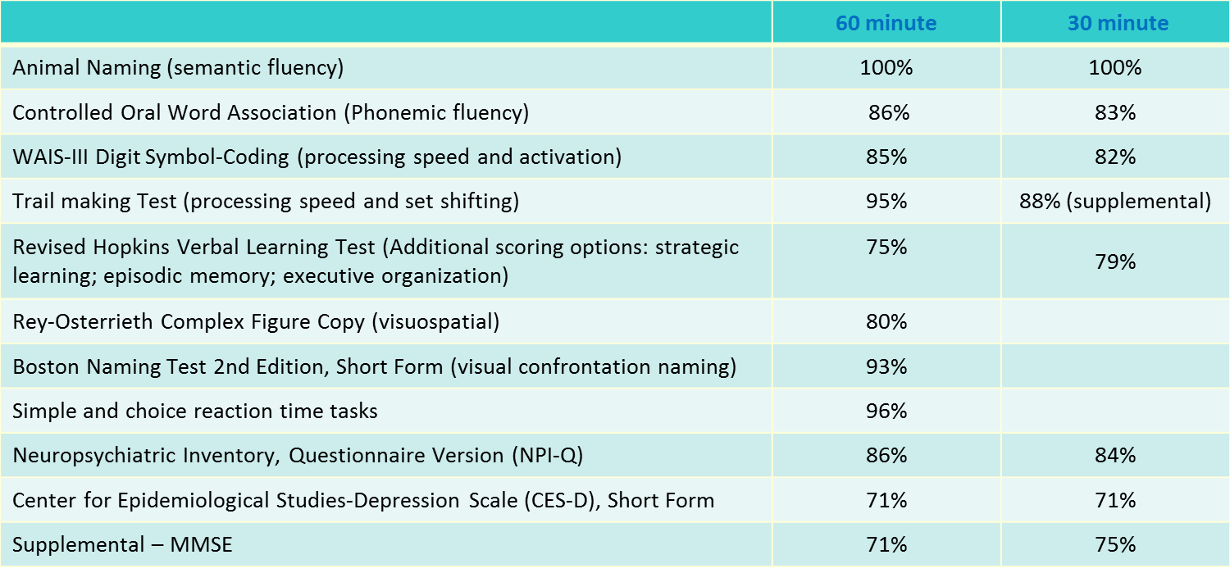
Table 1: NINDS-CSN neuropsychological assessment supported for use in VICCCS guidelines. Supported tests from the proposed NINDS-CSN [13] 30 or 60 minute protocols are listed with percentage support, where applicable. Similar word list learning tests to the revised Hopkins verbal learning test would be necessary for non-English speakers.

Feature | Core MRI Measures | Additional MRI Measures | CT measures
Brain atrophy | - Estimates of atrophy & ventricular size using the CHS Scale[50]  - Estimates of medial temporal lobe atrophy using Scheltens Scale[51] | - Quantitative measurement of brain volume normalised for head size | - Ventricular size  - Hippocampus: medial temporal atrophy[54]
White Matter Hyperintensities (WMH) | - Preferred: ARWMC scale[52]  - Acceptable: CHS WMH Scale[50] | - Quantitative measurement of WMH volume normalised for head size  - Anatomical mapping also encouraged[50] | - Diffuse white matter: ARWMC[52]
Infarction | - No. and size at specified locations:  - Size (largest diameter):  large >1.0 cm, small 3 mm- 10 mm  - Location (encourage use of Talairach atlas[53] for precision)  - Anatomical locations:  - Supratentorial  - Hemisphere  - Cortical (may include subcortical)  - Exclusively subcortical white matter  - Exclusively subcortical grey matter  - Infratentorial | - All infarcts localised using a standard approach to generate quantitative measures of volume and location. Ideally, identified infarcts would also be mapped to a common stereotactic space[50]  - All infarcts should be differentiated from perivascular spaces (Virchow-Robin spaces) by CHS criteria (see table 3), independently | - Discrete hypodensities  - Cerebrospinal fluid density consistent with infarction or old haemorrhage:  - Small > 3 mm – 1.0  - Large > 1.0  - Acute haemorrhage  - No., volume, location – as core MRI
Haemorrhage | - No. and size in each location  - Size (largest diameter)  - Large > 1 cm in diameter  - Microhaemorrhage < 1 cm susceptibility on gradient echo  - Must report lower size limit cut-off, field strength  - Location – as infarcts | - All lesions localised using a standard approach to generate quantitative measures of volume and location. Ideally, identified lesions would also be mapped to a common stereotactic space[50]
Other |  | - Mass lesions, AVMs, extra-axial fluid collections, malformations, dysplasia or any other lesion that might complicate assessment of cerebrovascular disease

Table 2: MRI and CT Imaging recommendations adapted from NINDS-CSN recommendations

 | T1 | FLAIR/Proton Density | T2
Perivascular Space | Decreased | Isointense | Increased
Ischaemic Change | Isointense  (N/A in grey matter) | Increased  (N/A in grey matter) | Increased  (N/A in grey matter)
Infarct | Decreased  (decreased or Isointense  in grey matter) | Increased | Increased

Table 3. Signal characteristics that differentiate perivascular space and infarcts. Adapted from NINDS-CSN [13], differences seen in grey matter from white matter are noted.

