ORIGINAL COMMUNICATION

Optic Chiasm Morphometric Changes in Multiple Sclerosis: Feasibility of a Simplified Brain MRI
Measure of White Matter Atrophy

Fulvio Zaccagna¹, Tomasz Matys¹, Tarik F. Massoud²*

¹Section of Neuroradiology, Department of Radiology, University of Cambridge School of Clinical Medicine, Cambridge, UK.

²Division of Neuroimaging and Neurointervention, Department of Radiology, Stanford University School of Medicine, Stanford, California, USA.

*Correspondence to:
Professor Tarik F. Massoud, MD, PhD; Department of Radiology; Stanford University Medical Center; 300 Pasteur Drive, Grant S-031, Stanford, CA 94305-5105, USA. *Tel: 650-7247026; *Fax: 650-4985374; *Email: tmassoud@stanford.edu

Abbreviated title:
Optic Chiasm Morphometrics in Multiple Sclerosis

This paper has not been published and it is not under consideration for publication elsewhere

Optic Chiasm Morphometric Changes in Multiple Sclerosis: Feasibility of a Simplified Brain MRI Measure of White Matter Atrophy

ABSTRACT
Sophisticated volume measurements of brain structures on MRI may improve specificity in determining long-term progression of multiple sclerosis (MS), but these techniques are laborious. The optic chiasm (OC) is a white matter (WM) structure clearly visible on routine MRI and is related to the optic nerves (ONs), which are known to atrophy in MS. We hypothesized that OC morphometric measurements would show OC atrophy in MS compared to normal patients. If so, this could help establish a novel simplified brain MRI measure of WM atrophy in MS patients. We retrospectively evaluated standard brain MRIs of 97 patients with known MS, and 98 normal individuals. We electronically measured eight OC morphometrics on axial T2WIs and midsagittal T1WIs: OC width and antero-posterior (AP) diameter, diameters of each ON and optic tract (OT), and angles between the ONs and OTs. Mean OC width, AP diameter and height in MS patients were 11.83±1.25 mm (95%CI 11.58–12.09), 2.99±0.65 mm (95%CI 2.85–3.12), and 2.09±0.37 mm (95%CI 2–2.19), respectively. In normal individuals they were 12.1±1.4 mm (95%CI 11.78–12.34), 3.43±0.63 mm (95%CI 3.3–3.58), and 2.15±0.37 mm (95%CI 2.07–2.23), respectively. There were statistically significant differences between MS patients and controls for AP diameter (p=0.000), but not for width (p=0.204) or height (p=0.183). The ONs were significantly smaller in MS (p<0.0017), but not the OTs. Thus, the OC is significantly atrophied in an unstratified cohort of MS patients. Future studies may establish an MRI OC morphometric index to evaluate demyelinating disease in the brain.

Keywords: Brain volume, Demyelination, Optic nerves, Optic tracts

INTRODUCTION
Multiple sclerosis (MS) is an autoimmune disease that involves the central nervous system (CNS) and causes progressive disability (Lublin, 2005). Therefore, prediction of long-term progression in MS is essential to guide therapeutic approaches. Several studies have focused to date on identifying clinical features that could be useful to predict MS progression, however only modest correlations have been found between these characteristics and long-term disability (Runmarker and Andersen, 1993; Myhr et al., 2001; Confavreux et al., 2003). Brain magnetic resonance imaging (MRI) parameters are useful to characterize subclinical disease progression in MS, but not the ensuing clinical disability (Gass, et al., 1994; Filippi et al., 1995; Gasperini et al., 1996; Miller et al., 1998; Nijeholt et al., 1998). Some advanced MRI techniques, including measurements of volumes of brain structures, may offer improved specificity in determining long-term progression of MS (Kidd et al., 1993; Losseff, et al., 1996; Filippi et al., 1996). However, these sophisticated MRI techniques are often laborious, or require special software, and they may be inaccessible or difficult to implement during routine clinical imaging of patients.
The simple corpus callosum index (CCI) derived from routine MR images has been suggested as a marker for brain atrophy in MS patients, but it is limited by inter-subject variations in shape and size of the corpus callosum, including sex differences and handedness (Figueira et al., 2007; Yaldizli et al., 2010). As an alternative, the anterior visual pathway may offer a compelling model for the evaluation of inflammatory or demyelinating disease elsewhere within the CNS. Previous studies had shown that the extent of optic nerve (ON) atrophy may be useful in determining the stage of optic neuritis and for following axonal loss over time (Youl et al., 1996; Frohman et al., 2008; Galetta et al., 2011). However implementation of specific imaging of the ONs in combination with standard brain imaging is impractical on a routine basis owing to the complexity of this anatomical region and its surroundings structures (Fadzli et al., 2013; Storoni et al., 2013), and the necessary additional imaging sequences that would be required for a dedicated examination of the ONs.
In this feasibility study we focus instead on the optic chiasm (OC, chiasma opticum), an anatomical structure in contiguity with the ONs and that is readily accessible for analysis on images obtained using routine brain MRI protocols without additional sequences. We initially establish detailed morphometric features of the OC in normal and MS patients. We then test the hypothesis that statistical comparison of these measurements would yield smaller OCs in MS patients owing to white matter (WM) tract atrophy, which is known to occur in CNS demyelinating disease. This information would be useful on three counts: to define the normative morphometric ranges for the OC and adjacent intracranial segments of the ONs, and optic tracts (OTs) when using standard brain MRI protocols; to help establish the feasibility of a simple and potentially clinically useful OC measure of WM atrophy applicable in general to most unselected MS patients; and to form the basis for future more rigorous analysis in selected MS patients, leading potentially to creation of an ‘optic chiasm index’ tailored to specific subgroups of MS patients.

MATERIALS AND METHODS
We obtained ethical approval for this research study and waiver of individual patient consent from our local institutional review board administrative panel on human subjects in medical research. We performed a retrospective study using MR images from 100 patients with a definitive diagnosis of MS, plus 100 healthy subjects as a control group. To compile this dataset, we first identified 100 MS patients from a consecutive larger sample of patients referred over a period of 24 months to our department to undergo a brain MRI for assessment of MS disease progression. Concurrently, we selected 100 different patients referred to us for imaging of headaches and who were found to have structurally normal brains on MRI; we enrolled this cohort of normal subjects as controls. We obtained these 200 patients after consideration of various inclusion and exclusion criteria.
Inclusion criteria for MS patients were: an MS diagnosis regardless of its duration (and with exclusion of particular subtypes of MS as described in the exclusion criteria) previously confirmed by a neurologist using the McDonald criteria (Polman et al., 2011); availability of a standard brain MRI that included axial T2-weighted (T2WI) and sagittal T1-weighted (T1WI) sequences obtained through the OC and its surroundings; and a clear view of the OC on these images, with no other superimposed anatomical structures. Exclusion criteria were: the presence of brain pathology other than MS, pure spinal manifestations of demyelination, neuromyelitis optica, primary progressive MS (PPMS), and when the available T2WIs were only those acquired in high resolution, e.g. by fast imaging employing steady state acquisition sequences, and not by a standard fast spin echo technique.
MRI scans were performed on a 1.5T (Discovery MR450, Optima MR 450 and Signa HDx, GE Medical Systems, Milwaukee, Wisconsin, USA) or a 3T whole-body MR unit (Discovery MR750, GE Medical Systems, Milwaukee, Wisconsin, USA) using a standard head coil with eight elements (8 HR Brain; GE Healthcare). Images were acquired using the same standardized brain protocol and included an axial T2WI sequence (repetition time/echo time [TR/TE] 4000-6000/90-110 ms; slice thickness 6 mm; slice gap 7 mm; acquisition matrix 320-512 × 224-384), and a sagittal T1WI sequence (TR/TE 460-520/12-15 ms; slice thickness 5 mm; slice gap 6 mm; acquisition matrix 256-320 × 224).
An experienced neuroradiologist, blinded to clinical data, retrospectively analyzed all anonymized axial T2WIs and sagittal T1WIs on a GE Healthcare Centricity PACS-IW review workstation. All subsequent morphometric measurements on images using electronic calipers were quantitative, objective and unambiguous, thus not requiring the measurement of intra-observer agreement (Viera and Garrett, 2005, Wikipedia contributors, 2019). Moreover, since there were no subjective, qualitative, or semi-qualitative recordings made in this study, i.e., the measurements did not contain any ambiguity in the characteristics of interest in the rating target, it was also not necessary for more than one person to perform the measurements (Wikipedia contributors, 2019).
To factor for the presence of any underlying prominent brain atrophy not owing to MS, and that could secondarily also affect the OC (and thus confound interpretation of any OC atrophy in MS), we first performed image measurements to obtain the Evans’ index (EI), an indirect measure of whole brain volume. We derived the EI as a ratio obtained by dividing the maximal frontal horn width by the maximal internal diameter (between inner tables) of the skull on the same imaging plane (Evans, 1942; Toma et al., 2011). To select the maximal width of frontal horns, we repeated measurements on three consecutive axial slices and chose the slice with the largest diameter (Fig. 1). In the absence of ventriculo-sulcal disproportion pointing to the presence of hydrocephalus, a value for EI above 0.3 was defined as ventricular dilation and regarded as an indirect marker of brain atrophy (Relkin et al., 2005).
Next, we performed precise morphometric measurements of the OCs, intracranial segments of the ONs, and the proximal OTs. We measured the width (transverse extent) and the anteroposterior (AP) diameter of the OC on magnified axial T2WIs Fig. 2, and the height (cranio-caudal extent) on magnified sagittal T1WIs Fig. 3. We also obtained the maximum diameters of bilateral ONs and OTs close to the OC, from magnified axial T2WIs; as well as the separate angles subtended by the ONs and OTs to the OC Fig. 2.
We performed statistical analyses using dedicated software (Stata 12 SE for Macintosh, StataCorp, TX, USA). Continuous values were shown as mean ± standard deviation (minimum to maximum; 95% confidence interval [CI]), and categorical values were expressed as n (%). For comparison of clinical data, we used an un-paired sample t-test. We evaluated differences between the two study groups in their OCs, ONs, OTs, and the measured angles using a Mann–Whitney test for independent samples. The significance level for all statistical tests was set at a p-value <0.05.

RESULTS
After dismissing those patients fulfilling the exclusion criteria, a total of 705 patients were initially considered based on inclusion criteria. However, a further 505 patients were secondarily excluded because the OC was only partially visualized (363 patients) or was missed on the imaged axial slices (142 patients). Of the total 200 patients available for analysis, 118 (59%) were imaged using a 1.5T MRI scanner, and the remaining 82 (41%) were imaged using a 3T MRI scanner.
The EI of three patients (aged 28, 37, and 40 years) amongst the initial 100 MS patients was considerably over 0.3 in the presence of a minimal burden of demyelinating plaques. This was judged to be likely owing to established advanced brain volume loss related to existing or prior disease(s) or the effects of prior therapies, other than the demyelinating process itself. Therefore, to avoid the potential for confounding factors, these three patients were secondarily excluded from further morphometric analysis. Similarly, two patients (aged 47 and 78 years) of the initial 100 control patients had an EI greater than 0.3 owing to advanced brain atrophy, and these cases were also excluded. Therefore, a total of 195 patients were included in subsequent morphometric analysis of the OC. The MS group (97 patients) comprised 31 (32%) males, and 66 (68%) females, with a mean age of 38.9 ± 10.12 years (18-68 years; 95% CI of 36.89-40.92); the control group (98 patients) comprised 31 (31.2%) males, and 67 (68.4%) females, with a mean age of 44.8 ± 15.8 years (16-82 years; 95% CI of 41.7-47.9). There was no statistically significant difference between the two groups in gender composition (p = 0.67), although the age distributions were significantly different (p = 0.002), with the mean ages differing by 5.9 years.
There was no statistically significant difference in EI between the two groups (MS patients, 0.25 ± 0.02 versus controls, 0.25 ± 0.02; p=0.913), and no difference between maximum frontal horn ventricular width (MS patients, 31.8 ± 2.6 mm vs. controls, 32.5 ± 3 mm; p=0.08).
The average width, AP diameter, and height of the OC in patients with MS were 11.83 ± 1.25 mm (8.6-15 mm; 95% CI of 11.58-12.09), 2.99 ± 0.65 mm (1.7-4.8 mm; 95% CI of 2.85-3.12), and 2.09 ± 0.37 mm (1.3-3.1 mm; 95% CI of 2.0-2.19), respectively. In controls, similar values for the OC were 12.1 ± 1.4 mm (8.0-14.8 mm; 95% CI of 11.78-12.34), 3.43 ± 0.63 mm (2.0-5.2 mm; 95% CI of 3.3-3.58), and 2.15 ± 0.37 mm (1.3-3.0 mm; 95% CI of 2.07-2.23), respectively. Mann-Whitney testing revealed a statistically significant difference between the two groups for OC AP diameter (p=0.000) but not for width (p=0.204) or height (p=0.183) (Fig. 4).
The intracranial segment ON diameters were significantly smaller in patients with MS than in controls for both sides (right, p=0.001; left, p=0.017). The right ON diameter was 3.74 ± 0.48 mm (2.5-4.8 mm; 95% CI of 3.64-3.84) in MS patients, and 4.0 ± 0.47 mm (2.8-5.6 mm; 95% CI of 3.91-4.1) in controls. The left ON diameter was 3.75 ± 0.52 mm (1.9-4.9 mm; 95% CI of 3.65-3.86) in MS patients, and 3.94 ± 0.45 mm (2.9-5.5 mm; 95% CI of 3.85-4.03) in controls (Fig. 5).
The OT diameters were also smaller in patients with MS but Mann-Whitney testing showed no statistically significant difference between the two groups for the right side (p=0.242) or the left side (p=0.230). We obtained the following values: the right OT diameter in MS patients was 3.46 ± 0.46 mm (2.4-4.4 mm; 95% CI of 3.35-3.57), and the left OT diameter was 3.54 ± 0.41 mm (2.6-4.5 mm; 95% CI of 3.45-3.64). The right OT diameter in controls was 3.56 ± 0.52 mm (2.4-4.7 mm; 95% CI of 3.45-3.67), and the left OT diameter was 3.63 ± 0.53 mm (2.5-4.7 mm; 95% CI of 3.52-3.75) (Fig. 5).
We found no statistically significant difference for the angle between the ONs (p=0.165) in the two groups: 73.54° ± 9.45° (51°-93.4°; 95% CI of 71.63-75.46) in MS patients, versus 71.23° ± 9.55° (45°-94.1°; 95% CI of 63.3-73.15) in controls. The angle between the OTs was significantly greater (p=0.021) in MS patients than in controls: 76.09° ± 11.22° (48°-100.4°; 95% CI of 73.37-78.8) versus 72.12° ± 11.98° (45°-101.7°; 95% CI 69.45-74.78) (Fig. 6).

DISCUSSION
Measures of Brain Atrophy in Multiple Sclerosis
MS is a progressive neurodegenerative disease currently assessed using a combination of clinical criteria and findings on MRI (Lublin et al., 2005; Geraldes et al., 2018). MRI evaluation in particular relies on visualization of dissemination in time and space of demyelinating lesions, the presence of which is considered a de facto marker of disease presence rather than a predictor biomarker of disease course (Cahalane et al., 2017). MS plaques on MRI can be considered only as the ‘tip of the iceberg’ with regard to disease extent (Hartel et al., 2016). The need for a more reliable, reproducible and quantitative method to assist in MS diagnosis as well as to assess the course of disease has been a motivating factor in the search for novel neuroimaging biomarkers that can positively impact clinical management of MS patients (Hartel et al., 2016).
The volume of brain parenchyma diminishes over time at a faster rate in MS patients compared to normal individuals. Brain atrophy has therefore been used as a potential early biomarker of MS progression (Liu et al., 1999; Gauthier et al., 2009). However, imaging assessment of global or regional brain volume is time consuming when performed as an addition to standard diagnostic interpretation of clinical imaging studies. Therefore, reproducible markers of total or regional brain atrophy that are easier to integrate in the clinical arena have long been sought after in the assessment and management of MS patients.
One of the widely used biomarkers for atrophy assessment has been the corpus callosum index (CCI) (Figueira et al., 2007). Despite its proven correlation with brain atrophy and MS progression, its wide adoption has been limited by several factors, including individual variations in shape and size of the corpus callosum, sex differences, and handedness, that can all significantly jeopardize its reliability as a biomarker (Figueira et al., 2007; Yaldizli et al., 2010). Other biomarkers proposed over the past 20 years have included volumes of the ventricles (Simon et al., 1999), the brain parenchymal fraction Rudick et al., 1999), ﻿structural image evaluation indices, e.g. Structural Image Evaluation using Normalization of Atrophy (SIENA) (Ruberte et al., 2019), or the Structural Image Evaluation using Normalisation of Atrophy—Cross-sectional (SIENAX) (Smith et al. 2002), voxel-based morphometry (VBM) of targeted regions of the brain (Ashburner and Friston, 2000; Good et al., 2001), and measurements of cortical thickness (Fischl and Dale, 2000). Generally, measurements obtained solely in two-dimensions can be easily obtained from single plane images of conventional MRI scans; however, they lack reliability and reproducibility (Radue et al., 2013). Measurements derived from multi-planar images would be more accurate. However, more advanced indices based on three-dimensional segmentation require more advanced imaging sequences (i.e. volumetric imaging) and dedicated software, which may not be available routinely (Radue et al., 2013).
The OC is a WM structure that is often clearly visible on routine MRI and is anatomically related to the ONs, which are known to atrophy in MS. In this study we evaluated the morphometry of the OC in normal and MS patients to determine the feasibility of establishing a morphometric measure of atrophy that would be easier to derive than separate ON evaluation for atrophy, and that could potentially be obtained on routine clinical diagnostic MRI scans. To that aim, we tested the hypothesis that OC morphometric measurements would show OC atrophy in MS compared to normal patients. Such a finding could be used in its own right to create a simple and potentially clinically useful OC measure of white matter atrophy applicable in a general way to most unselected MS patients. This knowledge could also form the basis for more rigorous future prospective studies aimed at establishing potentially more elaborate (if this would help achieve greater accuracy) OC MRI measures or indices (see below) of WM atrophy, either alone or in conjunction with other indices, in MS patients stratified by their subtype and clinical history.

Functional Anatomy and Morphometry of the Optic Chiasm
The OC is a somewhat quadrilateral white matter brain structure, lying on the tuberculum sellae and the anterior part of the diaphragma sellae. It is related above to the lamina terminalis and chiasmatic recess of the third ventricle, posteriorly to the infundibulum of the pituitary stalk and median eminence, and on either side, to the anterior perforated substance. It is encircled by the circle of Willis.
The history of the OC from antiquity to current times has been reviewed by Costea et al. recently (2107). Galen (129-216) identified the OC, a term originating from the Greek khiasma, meaning two structures arranged crosswise, which itself is derived from the letter chi or χ (Paluzzi et al., 2012, Davis et al., 2014). Galen was of the opinion that there was no crossing of ON fibers at the OC (Davis et al., 2014). However the ONs do undergo a partial decussation. One of the many important contributions by Avicenna (980-1037) was his first description of the importance of the OC to binocular vision. The crossing of nerve fibers, and the impact on vision that this had, was probably first identified by the Persian physician Zayn al-Din al-Jurjani (1042-1137) (Davis et al., 2014). As reviewed by Jeffery (2001), optic decussation was also postulated by Albert the Great (1193-1280), who in the 13th century noted the loss of contralateral visual fields after unilateral damage to the back of the head. The partial pattern of decussation at the OC was subsequently proposed by Isaac Newton (1642-1727), but was formulated more explicitly by John Taylor (1703–1772).
Within the OC, there are nerve fibers that do and do not connect with the ONs, and those that do and do not cross over. The fibers forming the medial part of each OT and posterior part of the OC have no connection with the ONs. They simply cross in the OC by connecting bilateral medial geniculate bodies, thus forming the commissure of Gudden (Chang and Ruch, 1949). The remaining and principal part of the OC consists of two sets of fibers, crossed and uncrossed.
We now know that axons of retinal ganglion cells form crossed and uncrossed projections at the OC to allow information from the temporal hemifield of each eye to be transmitted to the contralateral cerebral hemisphere (Schmitz et al., 2003). This optic hemi-decussation is a principal element in binocular vision in humans (Hubel and Wiesel, 1968). The crossed fibers, which are the more numerous, occupy the central part of the OC and pass from the ON of one side to the OT of the other, decussating in the OC with similar fibers of the opposite ON. In rodents and carnivores, crossed and uncrossed fibers are mixed throughout the whole OC. However, the uncrossed fibers occupy the lateral part of the OC, and pass from the ON of one side into the OT of the same side in humans and nonhuman primates (Schmitz et al., 2003).
The various dimensions we obtained for the OC are similar to those recorded by others. For normally pigmented subjects, Schmitz et al. (2003) measured a mean OC width of 12.9 ± 0.8 mm, which significantly decreased to 10.3 ± 0.8 mm in patients with albinism owing to congenital delay in ganglion cell production leading to misrouting of optic fibers and abnormal projection patterns through the OC. Their normative width of the OC was in the range (10.3-18.3 mm) of two prior published studies (Wagner et al., 1997; Parravano et al., 1993), but the mean was smaller (14.0 mm, and 14.96 mm) owing to differences in measuring techniques (Schmitz et al., 2003). Schmitz et al. (2003) also established the following morphometries: 5.2 ± 0.5 mm (right ON diameter), 4.9 ± 0.4 mm (left ON diameter), 3.7 ± 0.5 mm (right OT diameter), 3.7 ± 0.4 mm (left OT diameter), 2.5 ± 0.3 mm (OC height), 69° ± 5° (angle between ONs), and 79° ± 8° (angle between OTs), all similar to our results. However they did not determine the AP diameter of the OC.

Optic Chiasm Atrophy in Multiple Sclerosis
We found that various morphometric measures related to the OC, namely, its AP diameter, the diameters of the intracranial ON segments, and the angle between the OTs, are statistically associated with the diagnosis of MS. Of those, the OC AP diameter is the easiest and fastest to measure on MR images, and is the parameter with the greatest statistically significant difference between MS and normal individuals. Either standard sagittal T1WIs or axial T2WIs may be used to derive this measurement. However, we found that 505 out of 705 patients had to be initially excluded from our consideration because the full extent of the OC was not visible on axial T2WIs of routinely obtained brain MRIs. Given this high percentage, we recommend that the OC AP be determined primarily on magnified midsagittal T1WIs, where the right-to-left course of the OC is always seen en face. This AP measurement would be no different than that obtained on axial T2WIs. Turning to the always available TW1Is for this particular measure avoids the need for unnecessary additional technical maneuvers in an attempt to also consistently see the OC on axial T2WIs, e.g. by adopting further sequences having smaller slice thickness and/or slice gap (Vinogradov et al., 2005), or by angling the brain axial images more along the true plane of the OC (which would have to be known or established a priori, or could be performed a posteriori by rotational manipulation of a volumetric image dataset, if available) rather than obtaining these MR images with reference to the routinely used modified Talairach anterior commissure to posterior commissure (AC-PC) line (Weiss et al., 2003).
Hence, we suggest that the T2WIs can be reserved for measuring the angle between the OTs, and for the diameters of the intracranial ON segments. We aim in the future to compare the diagnostic accuracy (in MS evaluation) of using the diameters of the ON intracranial segments obtained on routine brain MRI sequences (as presented herein), versus more extensive measurements in orthogonal planes for the three ON segments (intracranial, foraminal, and intra-orbital) obtained on dedicated but more time-consuming orbital MRI sequences.
The magnet strength of the MRI scanner, whether 1.5T or 3T, appears not to influence the statistically significant findings of the three OC measures associated with the diagnosis of MS. To ascertain the independence of this AP diameter measure from the image acquisition technique, we intentionally selected a random cohort of patients that underwent MRI using scanners of either magnet strength routinely used in current clinical practice. The statistically significant smaller OC AP diameter measurements in MS patients despite the variations in field strength and scanner characteristics indicates the lack of dependence of this potentially useful morphometric measure on the technique used. Importantly, we did not perform a head-to-head comparison of OC measurements on images originating from 1.5T and 3T scanners. This is because the in-plane spatial resolution on images routinely obtained from both magnet strength scanners (including the standard fast spin-echo T1WIs and T2WIs used in this study) is approximately 0.50 × 0.50 mm² (van Wijk et al., 2015). In our analysis, we did not use higher-resolution images that would be possible to acquire with dedicated sequences when using 3T magnets. Such images can reach 0.25 × 0.25 mm² in-plane resolution, but while this allows observation of greater detail, the signal-to-noise is typically lower and the imaging time is longer (van Wijk et al., 2015). Adoption of a dedicated high-resolution sequence (e.g. Fast Imaging Employing Steady-state Acquisition, FIESTA) at 3T through the OC (Watanabe et al., 2012) may be useful in future studies where there might be a need to assess subtle longitudinal morphometric changes that parallel an indolent course of MS.
Establishing the morphometry of the OC on standard brain MRIs using electronic calipers requires minimal time and effort. We envisage that the OC measurements (especially the AP diameter) proposed herein could be routinely implemented in the evaluation of all brain MRI studies of MS patients. We did not test whether a combination of our measurements (to provide an ‘index’) would yield an even greater statistical correlation between OC atrophy and MS. Indeed, for diagnostic purposes, an ‘index’ is a number (such as a ratio) derived from a series of observations and used as an indicator or measure. Hence, our finding of a likely general association between OC atrophy and MS based on our simple measures could be used alone, or it may represent the first step toward future creation of a new ‘OC index’ for diagnosis and follow-up assessment of MS patients. We speculate that such an ‘OC index’ might be equally used, for example, as an initial biomarker for routine assessment on every patient scan, or used in conjunction with more sophisticated biomarkers, such as VBM or cortical thickness, that could be deployed at specific time points in the clinical course or when the clinical need arises. A future ‘OC index’ would also aid in patient stratification, acting as a surrogate biomarker for the extent of disease. Moreover, since the OC is mostly surrounded by CSF, we envisage that segmentation algorithms to automatically highlight and volumetrically assess the OC could be easily implemented, allowing for a potential future quantitative biomarker to be derived in little time.
Despite our promising results, further prospective validation studies using larger cohorts of patients and, importantly, in different subtypes of MS are necessary. We designed this study to test a simple hypothesis and to determine a proof-of-concept using retrospective data derived from an unselected and unstratified cohort of MS patients. We solely aimed to establish the feasibility of our approach rather than define thresholds for this new biomarker in different subgroups of MS patients. This will be the subject of future more rigorous prospective studies that also include sample stratification for separate subtypes of MS, as well as establishing the value of simple OC measures (or more elaborate OC indices) either alone or in conjunction with other already established imaging indices or clinical criteria that reflect disease severity.

CONCLUSIONS
We tested the hypothesis that the OCs in MS patients are smaller owing to WM tract atrophy occurring in conjunction with CNS demyelination. For this, we first defined the normative morphometric ranges for the OC and adjacent segments of the ONs and OTs, and found statistically significant differences between these dimensions in MS patients and normal controls; specifically for the OC AP diameter, but not for its width or height. Thus, the OC is significantly atrophied in an unstratified cohort of MS patients. It is easy and quick to measure the OC AP diameter on routine sagittal T1WI brain MR images. We propose this as a simple and potentially clinically useful indicator of OC WM atrophy applicable in general to unselected MS patients. Future more rigorous prospective analysis in selected MS patients, also leading potentially to creation of an ‘OC index’ tailored to specific subtypes of MS, may prove useful in establishing a new quantitative clinical biomarker for diagnosis and follow-up assessment of MS patients.

REFERENCES
Ashburner J, Friston KJ. 2000. Voxel-based morphometry--the methods. Neuroimage 11(6 Pt 1):805–821.
Cahalane AM, Kearney H, Purcell YM, McGuigan C, Killeen RP. 2017. MRI and multiple sclerosis––the evolving role of MRI in the diagnosis and management of MS: the radiologist’s perspective. Ir J Med Sci 1–7.
Chang HT, Ruch TC. 1949. Spinal origin of the ventral supraoptic decussation (Gudden's commissure) in the spider monkey. J Anat 83:1-9.
Confavreux C, Vukusic S, Adeleine P. 2003. Early clinical predictors and progression of irreversible disability in multiple sclerosis: an amnesic process. Brain 126(Pt 4):770–782.
Costea CF, Turliuc Ş, Buzdugă C, Cucu AI, Dumitrescu GF, Sava A, Turliuc MD. 2017. The history of optic chiasm from antiquity to the twentieth century. Childs Nerv Syst 33:1889-1898.
Davis MC, Griessenauer CJ, Bosmia AN, Tubbs RS, Shoja MM. 2014. The naming of the cranial nerves: a historical review. Clin Anat 27:14-9.
Evans WA Jr. 1942. An encephalographic ratio for estimating ventricular enlargement and cerebral atrophy. Arch Neurol Psychiatry 47:931-937.
Fadzli F, Ramli N, Ramli NM. 2013. MRI of optic tract lesions: review and correlation with visual field defects. Clin Radiol 68:e538-551.
Figueira FFA, dos Santos VS, Figueira GMA, da Silva ACM. 2007. Corpus callosum index: A practical method for long-term follow-up in multiple sclerosis. Arq Neuropsiquiatr 65(4–A):931–935.
Filippi M, Paty DW, Kappos L, Barkhof F, Compston DA, Thompson AJ, Zhao GJ, Wiles CM, McDonald WI, Miller DH. 1995. Correlations between changes in disability and T2-weighted brain MRI activity in multiple sclerosis: a follow-up study. Neurology 45(2):255–260.
Filippi M, Campi A, Colombo B, Pereira C, Martinelli V, Baratti C, Comi G. 1996. A spinal cord MRI study of benign and secondary progressive multiple sclerosis. J Neurol 243:502–505.
Fischl B, Dale AM. 2000. Measuring the thickness of the human cerebral cortex from magnetic resonance images. Proc Natl Acad Sci USA 97:11050–11055.
Frohman EM, Costello F, Stuve O, Calabresi P, Miller DH, Hickman SJ, Sergott R, Conger A, Salter A, Krumwiede KH, Frohman TC, Balcer L, Zivadinov R. 2008. Modeling axonal degeneration within the anterior visual system: implications for demonstrating neuroprotection in multiple sclerosis. Arch Neurol 65:26–35.
Galetta KM, Calabresi PA, Frohman EM, Balcer LJ. 2011. Optical coherence tomography (OCT): imaging the visual pathway as a model for neurodegeneration. Neurotherapeutics 8:117–132.
Gass A, Barker GJ, Kidd D, Thorpe JW, MacManus D, Brennan A, Tofts PS, Thompson AJ, McDonald WI, Miller DH. 1994. Correlation of magnetization transfer ratio with clinical disability in multiple sclerosis. Ann Neurol 36:62–7.
Gasperini C, Horsfield MA, Thorpe JW, Kidd D, Barker GJ, Tofts PS, MacManus DG, Thompson AJ, Miller DH, McDonald WI. 1996. Macroscopic and microscopic assessments of disease burden by MRI in multiple sclerosis: relationship to clinical parameters. J Magn Reson Imaging 6(4):580–584.
Gauthier SA, Berger AM, Liptak Z, Duan Y, Egorova S, Buckle GJ, Glanz BI, Khoury SJ, Bakshi R, Weiner HL, Guttmann CR. 2009. Rate of brain atrophy in benign vs early multiple sclerosis. Arch Neurol 66:234–237.
Geraldes R, Ciccarelli O, Barkhof F, De Stefano N, Enzinger C, Filippi M, Hofer M, Paul F, Preziosa P, Rovira A, DeLuca GC, Kappos L, Yousry T, Fazekas F, Frederiksen J, Gasperini C, Sastre-Garriga J, Evangelou N, Palace J, on behalf of the MAGNIMS study group. 2018. The current role of MRI in differentiating multiple sclerosis from its imaging mimics. Nat Rev Neurol 14:199–213.
Good CD, Johnsrude IS, Ashburner J, Henson RNA, Friston KJ, Frackowiak RSJ. 2001. A Voxel-based morphometric study of ageing in 465 normal adult human brains. Neuroimage 14(1 Pt 1):21-36.
Hartel M, Kluczewska E, Pierzchała K, Adamczyk-Sowa M, Karpe J. 2016. What you cannot get from routine MRI of MS patient and why – The growing need for atrophy assessment and seeing beyond the plaque. Neurol Neurochir Pol 50:123–130.
Hubel DH, Wiesel TN. 1968. Receptive fields and functional architecture of monkey striate cortex. J Physiol (Lond) 195:215–243.
Jeffery G. 2001. Architecture of the optic chiasm and the mechanisms that sculpt its development. Physiol Rev 81:1393-1414.
Kidd D, Thorpe JW, Thompson AJ, Kendall BE, Moseley IF, MacManus DG, McDonald WI, Miller DH. 1993. Spinal cord MRI using multi-array coils and fast spin echo. II. Findings in multiple sclerosis. Neurology 43:2632–2637.
Liu C, Edwards S, Gong Q, Roberts N, Blumhardt LD. 1999. Three dimensional MRI estimates of brain and spinal cord atrophy in multiple sclerosis. J Neurol Neurosurg Psychiatry 66:323–330.
Losseff NA, Wang L, Lai HM, Yoo DS, Gawne-Cain ML, McDonald WI, Miller DH, Thompson AJ. 1996. Progressive cerebral atrophy in multiple sclerosis. A serial MRI study. Brain 119 (Pt 6):2009–2019.
Lublin FD. 2005. Clinical features and diagnosis of multiple sclerosis. Neurol Clin 23:1–15.
Miller DH, Grossman RI, Reingold SC, McFarland HF. 1998. The role of magnetic resonance techniques in understanding and managing multiple sclerosis. Brain 121 (Pt 1):3–24.
Myhr KM, Riise T, Vedeler C, Nortvedt MW, Gronning R, Midgard R, Nyland HI. 2001. Disability and prognosis in multiple sclerosis: demographic and clinical variables important for the ability to walk and awarding of disability pension. Mult Scler 7:59–65.
Nijeholt GJ, van Walderveen MA, Castelijns JA, van Waesberghe JH, Polman C, Scheltens P, Rosier PF, Jongen PJ, Barkhof F. 1998. Brain and spinal cord abnormalities in multiple sclerosis. Correlation between MRI parameters, clinical subtypes and symptoms. Brain 121 (Pt 4):687–697.
Paluzzi A, Fernandez-Miranda J, Torrenti M, Gardner P. 2012. Retracing the etymology of terms in neuroanatomy. Clin Anat 25:1005–1014.
Parravano JG, Toledo A, Kucharczyk W. 1993. Dimensions of the optic nerves, chiasm and tracts: MR quantitative comparison between patients with optic atrophy and normals. J Comput Assist Tomogr 17:688–690.
Polman CH, Reingold SC, Banwell B, Clanet M, Cohen JA, Filippi M, Fujihara K, Havrdova E, Hutchinson M, Kappos L, Lublin FD, Montalban X, O'Connor P, Sandberg-Wollheim M, Thompson AJ, Waubant E, Weinshenker B, Wolinsky JS. 2011. Diagnostic criteria for multiple sclerosis: 2010 revisions to the McDonald criteria. Ann Neurol 69:292–302.
Radue EW, Bendfeldt K, Mueller-Lenke N, Magon S, Sprenger T. 2013. Brain atrophy: An in-vivo measure of disease activity in multiple sclerosis. Swiss Med Wkly 143:1–11.
Relkin N, Marmarou A, Klinge P, Bergsneider M, Black P. 2005. Diagnosing idiopathic normal-pressure hydrocephalus. Neurosurgery 57(S4-16).
Rudick RA, Fisher E, Lee J, Simon J, Jacobs L. 1999. Use of the brain parenchymal fraction to measure whole brain atrophy in relapsing-remitting MS. Neurology 53:1698-1704.
Ruberte E, Sinnecker T, Amann M, Gaetano L, Naegelin Y, Penner IK, Kuhle J, Derfuss T, Kappos L, Granziera C, Wuerfel J, Yaldizli Ö. 2018. Central slab versus whole brain to measure brain atrophy in multiple sclerosis. Eur Neurol 80:207-214.
Runmarker B, Andersen O. 1993. Prognostic factors in a multiple sclerosis incidence cohort with twenty-five years of follow-up. Brain 116 (Pt 1):117–134.
Schmitz B, Schaefer T, Krick CM, Reith W, Backens M, Käsmann-Kellner B. 2003. Configuration of the optic chiasm in humans with albinism as revealed by magnetic resonance imaging. Invest Ophthalmol Vis Sci 44:16-21.
Simon JH, Jacobs LD, Campion MK, Rudick RA, Cookfair DL, Herndon RM, Richert JR, Salazar AM, Fischer JS, Goodkin DE, Simonian N, Lajaunie M, Miller DE, Wende K, Martens-Davidson A, Kinkel RP, Munschauer FE 3rd, Brownscheidle CM. 1999. A longitudinal study of brain atrophy in relapsing multiple sclerosis. Neurology 53:139–148.
Smith SM, Zhang Y, Jenkinson M, Chen J, Matthews PM, Federico A, De Stefano N. 2002. Accurate, robust, and automated longitudinal and cross-sectional brain change analysis. Neuroimage 17:479-489.
Storoni M, Davagnanam I, Radon M, Siddiqui A, Plant GT. 2013. Distinguishing optic neuritis in neuromyelitis optica spectrum disease from multiple sclerosis: a novel magnetic resonance imaging scoring system. J Neuroophthalmol 33:123–127.
Toma AK, Holl E, Kitchen ND, Watkins LD. 2011. Evans’ index revisited: the need for an alternative in normal pressure hydrocephalus. Neurosurgery. 68:939-944.
van Wijk DF, Strang AC, Duivenvoorden R, Enklaar DF, Zwinderman AH, van der Geest RJ, Kastelein JJP, Groot E, Stroes ESG, Nederveen AJ. 2015. Increasing the spatial resolution of 3T carotid MRI has no beneficial effect for plaque component measurement reproducibility. PLoS One 10: e0130878.
Viera AJ, Garrett JM. 2005. Understanding interobserver agreement: The kappa statistic. Fam Med 37:360-363.
Vinogradov E, Degenhardt A, Smith D, Marquis R, Vartanian TK, Kinkel P, Maier SE, Hackney DB, Lenkinski RE. 2005. High-resolution anatomic, diffusion tensor, and magnetization transfer magnetic resonance imaging of the optic chiasm at 3T. J Magn Reson Imaging 22:302-306.
Wagner AL, Murtagh FR, Hazlett KS, Arrington JA. 1997. Measurement of the normal optic chiasm on coronal MR images. AJNR Am J Neuroradiol 18:723–726.
Watanabe K, Kakeda S, Yamamoto J, Watanabe R, Nishimura J, Ohnari N, Nishizawa S, Korogi Y. 2012. Delineation of optic nerves and chiasm in close proximity to large suprasellar tumors with contrast-enhanced FIESTA MR imaging. Radiology 264:852-858.
Weiss KL, Pan H, Storrs J, Strub W, Weiss JL, Jia L, Eldevik OP. 2003. Clinical brain MR imaging prescriptions in Talairach space: Technologist- and computer-driven methods. AJNR Am J Neurorad 24:922-929.
Wikipedia contributors. (2019). Inter-rater reliability. In Wikipedia, The Free Encyclopedia. Retrieved June 3, 2019, from https://en.wikipedia.org/w/index.php?title=Inter-rater_reliability&oldid=881644428
Yaldizli O, Atefy R, Gass A, Sturm D, Glassl S, Tettenborn B, Putzki N. 2010. Corpus callosum index and long-term disability in multiple sclerosis patients. J Neurol 257:1256–1264.
Youl BD, Turano G, Towell AD, Barrett G, MacManus DG, Moore SG, Miller DH, Jones SJ, du Boulay EP, Kendall BE, Moseley IF, McDonald WI. 1996. Optic neuritis: swelling and atrophy. Electroencephalogr Clin Neurophysiol Suppl 46:173–179.

FIGURE LEGENDS
Figure 1
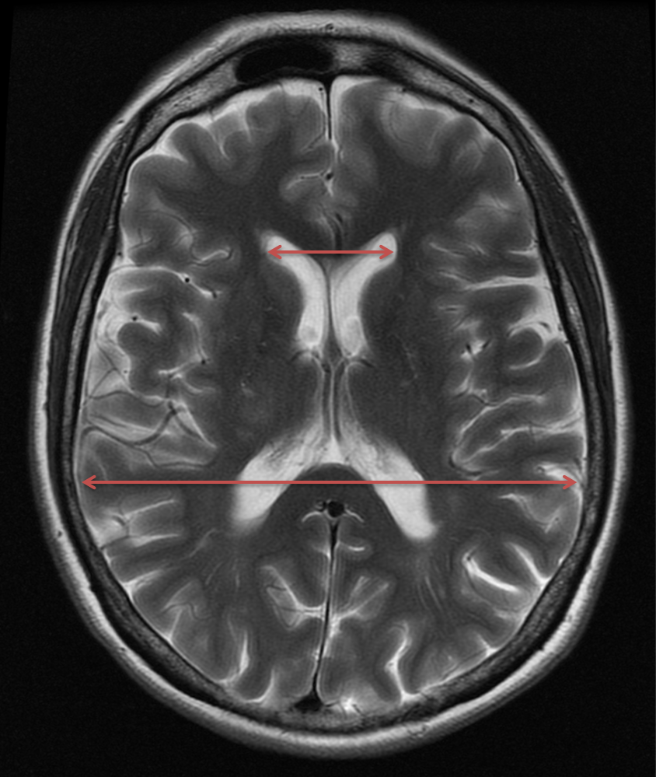
Evans’ index (EI) was measured on axial T2WIs as the ratio obtained between the maximal frontal horn width and the maximal diameter between the inner tables of the skull at the same plane.

Figure 2
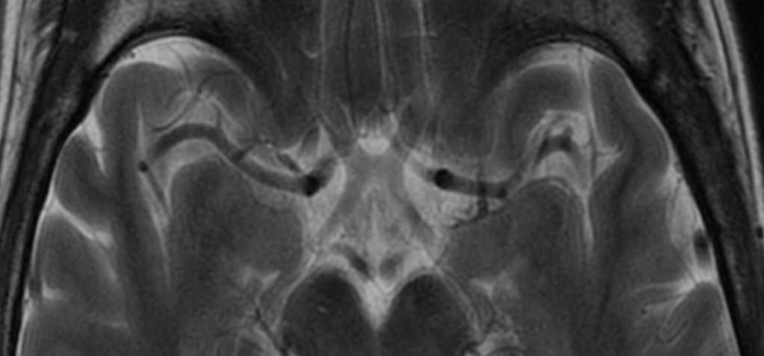

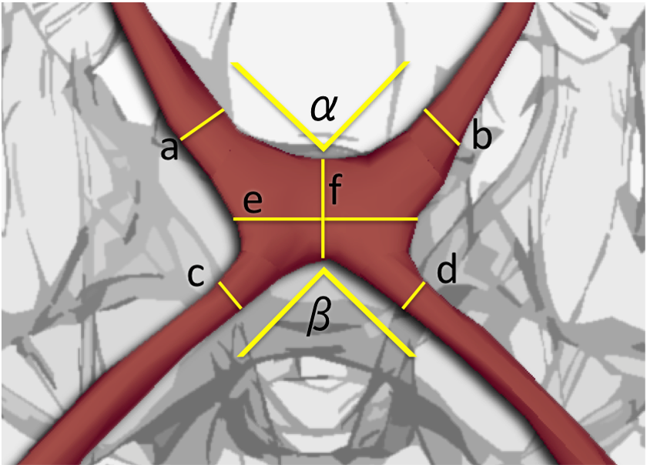
- Axial MRI (T2WI) through the OC. (B) Axial depiction of the OC, distal parts of ONs, and proximal parts of OTs on a schematic diagram showing the locations of all performed measurements. We measured the diameters of the ONs (a and b) 2 mm anterior of the ventral margin of the OC, perpendicular to the long axis of the nerve. We measured the diameters of the proximal parts of OTs (c and d) 2 mm posterior to the dorsal border of the OC, perpendicular to the long axis of the tracts. We measured the width of the OC at its narrowest part (e), and similarly for the AP diameter (f). We measured angles between both ONs and both OTs (α and β, respectively) by drawing lines through the middle of the nerves or tracts and taking the angle at the crossing point of these two lines.
Figure 3

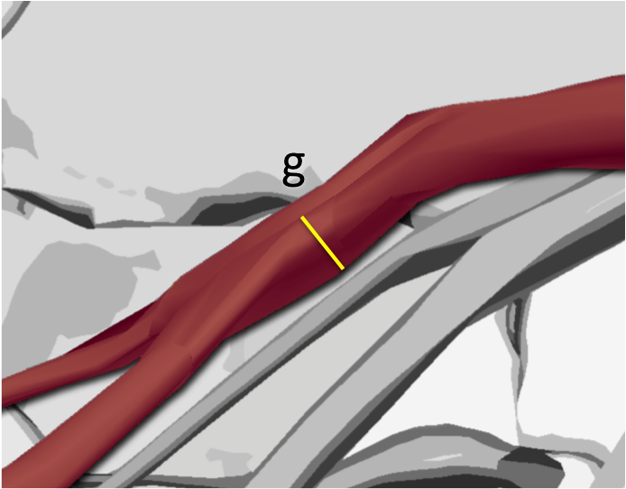
- Sagittal MRI (T1WI) through the OC. Arrow points to the OC. (B) The OC height (g) was measured perpendicular to the long axis on the sagittal plane images.

Figure 4

A box plot summarizes value of width (E), AP diameter (F) and height (G) of the OC in patients with MS (group 1), and in the controls (group 2).

Figure 5

A box plot summarizes value of ON (right and left) and OT (right ND left) diameters in patients with MS (group 1) and in controls group (group 2).

Figure 6

A box plot summarizes the values of angles between the ONs (alpha) and angles between OTs (beta) in patients with MS (group 1) and in controls (group 2).

