Mass spectrometry for fragment screening
Daniel Shiu-Hin Chan, Andrew J. Whitehouse, Anthony G. Coyne, Chris Abell*
ª Department of Chemistry, University of Cambridge, Lensfield Road, Cambridge, CB2 1EW, United Kingdom
* email: ca26@cam.ac.uk

Abstract
Fragment-based approaches in chemical biology and drug discovery have been widely adopted worldwide in both academia and industry. Fragment hits tend to interact weakly with their targets, necessitating the use of sensitive biophysical techniques to detect their binding. Common fragment screening techniques include differential scanning fluorimetry (DSF) and ligand-observed nuclear magnetic resonance (NMR). Validation and characterization of hits is usually performed using a combination of protein-observed NMR, isothermal titration calorimetry (ITC), and X-ray crystallography. In this context, mass spectrometry (MS) is a relatively underutilized technique in fragment screening for drug discovery. MS-based techniques have the advantage of high sensitivity, low sample consumption and being label-free. This review highlights recent examples of the emerging use of MS-based techniques in fragment screening.

Keywords:
fragment-based drug discovery, fragment screening, ligand-observed mass spectrometry, native mass spectrometry, hydrogen-deuterium exchange mass spectrometry

Introduction
Fragment-based drug discovery (FBDD) broadly describes the identification of small molecules (“fragments”) possessing affinity in the 0.1 to 10 mM range and their subsequent elaboration into potent ligands. The central thesis of fragment-based methods is that while smaller fragment molecules bind only weakly to the target site, they reveal high-quality interactions that can be exploited by the assembly or elaboration of individual fragments into larger molecules (1). Ever since Fesik and co-workers first demonstrated the application of FBDD against the FK506-binding protein over 20 years ago (2), the technique has been successfully applied in both academic and industrial medicinal chemistry programmes against a variety of diverse targets (3). The utility of FBDD has been further exemplified by the approval of Vemurafenib (Zelboraf) targeting the oncogenic kinase BRAF for the treatment of metastatic melanoma (4), and Venetoclax (Venclexta) targeting the anti-apoptotic protein Bcl-2 for the treatment of chronic lymphocytic leukemia (CLL) (5).
As fragment molecules (generally <250 Da) are smaller than those used for high-throughput screening (HTS) (300 to 500 Da), a significantly larger proportion of the chemical space can be sampled even with a small fragment library (typically ca. 10³ fragments) than compared with a much larger library of ca. 10⁵ molecules in a HTS campaign (6). Moreover, the minimal structural complexity of fragments allows them to effectively probe binding sites and to establish geometrically unencumbered, high-quality, and enthalpically-biased interactions, making them ideal starting points for subsequent elaboration (7). Utilizing affinity and structural data, the optimization of promising fragment hits can be carried out in an iterative manner via fragment linking, merging or growing techniques (8).
Due to the low binding affinities generally seen with fragments, the screening stage of FBDD requires the use of biophysical techniques significantly more sensitive than the methods utilized in HTS (9). Differential scanning fluorimetry (DSF), also known as the thermal shift assay (TSA), is a low-cost technique that can rapidly screen candidate fragments for validation. The principle of DSF is based upon measuring the changing fluorescence of an exogenous dye as the protein to which it is bound unfolds (10). Ligand-observed ¹H nuclear magnetic resonance (NMR) spectroscopy methods, such as saturation transfer difference (STD), water-ligand observed via gradient spectroscopy (WaterLOGSY) and Carr-Purcell-Meiboom-Gill (CPMG) techniques, are also commonly used for fragment screening (11). When performed in the presence of known ligands, ligand-observed NMR experiments can also provide preliminary binding site information as well as relative affinity data. More detailed structural information can be obtained using protein-observed 2D NMR experiments, which analyze chemical shift perturbations (CSPs) of protein amide signals induced by the ligand (12). Another method that is commonly utilized for the screening of fragment libraries is surface plasmon resonance (SPR) (13). The change of SPR signal when a solution of ligand is passed over proteins immobilized on the biosensor surface allows the determination of both kinetic and thermodynamic parameters of binding.
After validation, fragment hits are usually characterized using a combination of isothermal titration calorimetry (ITC) and X-ray crystallography. ITC can be used to determine the enthalpy (ΔH), entropy (ΔS), and Gibb’s free energy (ΔG) changes associated with binding, as well as the equilibrium dissociation constant (K_{D}) and the binding stoichiometry (n) (14). Meanwhile, X-ray crystallography provides detailed structural information on the fragment-target interaction, which is integral for facilitating the structure-based optimization of fragments in the subsequent stage (15). Although ITC and X-ray crystallography are traditionally considered to be relatively low-throughput methods, recent technological advances have enabled their exploration as preliminary screening techniques (14, 15).
Mass spectrometry (MS) is a relatively underutilized technique in drug discovery (16), particularly for fragment screening in FBDD. MS-based methods have the advantage of high sensitivity, low sample consumption and being label-free. This review aims to highlight recent examples of the emerging use of MS-based techniques for fragment screening. The studies cover three main classes of MS-based methods: (1) ligand-observed mass spectrometry, (2) native mass spectrometry and (3) hydrogen-deuterium exchange mass spectrometry, which will be discussed individually in the sections below.
Ligand-observed mass spectrometry
The general workflow of a ligand-observed MS experiment for fragment screening is shown in Figure 1 (17). In the first step, the protein target of interest is incubated with a cocktail of fragments, while in a separate control experiment, the same fragment cocktail is incubated in the absence of protein. Next, the target and control samples are subjected to ultrafiltration using a centrifugal concentrator. This retains the protein-ligand complexes in the supernatant, while the unbound ligands are driven into the filtrate. The protein-ligand complexes are subsequently dissociated by the addition of 90% aqueous methanol, and the released fragments are analyzed by liquid chromatography-mass spectrometry (LC-MS). Fragments that are enriched in the target sample compared to the control sample are deemed to be binders, as these compounds were retained in the supernatant presumably through binding to the target protein. Measurement of the bound fragment concentration moreover enables the calculation of binding dissociation constants (K_{D}) for the target-ligand interaction. It is also possible to perform LC-MS analysis on the unbound ligand fraction, which is obtained as the filtrate after the ultrafiltration step. In this case, fragments that are reduced in intensity in the unbound fraction are deemed to be binders. 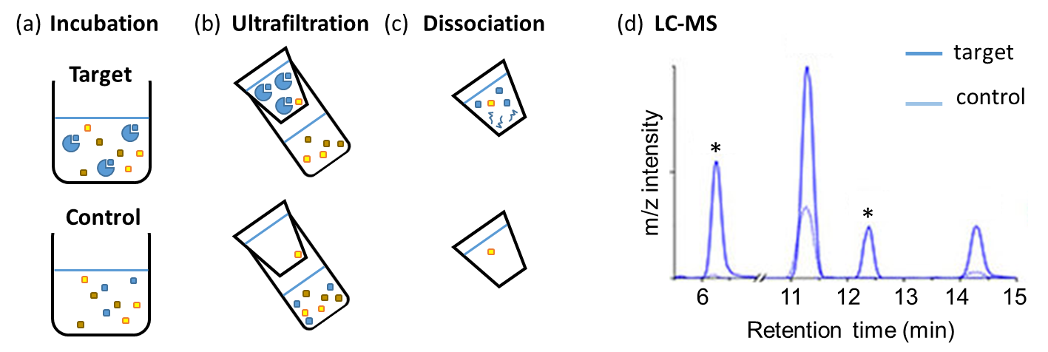
Figure 1. General workflow of a ligand-observed MS experiment for fragment screening. (a) The target protein is incubated with a mixture of fragments. The negative control experiment is performed without protein. (b) Ultrafiltration separates the free ligand from the protein-ligand complexes, which are retained in the supernatant. (c) The protein-ligand complexes are dissociated using 90% aqueous methanol. (d) The released ligands are quantified by LC-MS. Fragments that are significantly enriched in the target sample compared to the control sample (denoted with *) are deemed to be binders. Adapted from Chen et al. (17).
Recently, Shui and co-workers explored the use of ligand-observed MS for fragment screening (18). This methodology was first validated using the model enzyme human carbonic anhydrase I (hCAI) and reported inhibitors of the enzyme, which showed a close correlation between K_{D} values determined from ligand-observed MS with those determined by ITC. The researchers then screened 50 randomly selected fragments against hepatitis C virus RNA polymerase NS5B, an enzyme that is essential for viral replication (19). Nine fragment hits emerged from the ligand-observed MS screening campaign, with K_{D} values determined to be in the range of 0.7 to 9.6 mM. Seven of those hits were also shown to bind to NS5B using SPR. In a follow-up study, the researchers integrated ligand-observed MS into a fragment-based lead discovery pipeline (17). A library of 384 fragments was screened against NS5B either all at once, generating 20 fragment hits, or in cocktails of about 50 fragments, which yielded 12 fragment hits. Screening of the mixture of the latter 12 compounds using a further round of ligand-observed MS validated 10 of those hits, which bound to NS5B with K_{D} values of between 1 to 20 mM. Although binding affinities were too weak to be determined by SPR, the rank order of SPR response showed reasonable correlation with the order determined by ligand-observed MS.
Instead of ultrafiltration, fragment binders can be separated from non-binders by the use of weak affinity chromatography (WAC). In this approach, fragments are passed through a column upon which the protein of interest is immobilized. Compounds that bind to the protein are retarded within the column and elute at a longer retention time compared to inactive compounds (Figure 2a). In 2011, Ohlson and co-workers first applied WAC to fragment screening (20). They initially validated their methodology using a small collection of 20 known binders of trypsin and thrombin as model target proteases. Screening was then performed by passing fragments through the column using HPLC, either as singletons or as a mixture. The results showed that fragment binding could be detected over a K_{D} range of 10 to 1000 μM, with good correlation between apparent K_{D} of compounds calculated by WAC with IC₅₀ values determined by an enzymatic assay. Additionally, the issue of non-specific binding could be addressed by pre-treating the column with protease inhibitors. As these inhibitors saturate the active site, any retardation observed in the presence of the protease inhibitor would represent non-specific binding of the compounds to other parts of the protein molecule. The net retention time (t_{R}′), which is the difference in retention time for a particular compound in the presence and absence of the protease inhibitor, therefore gives an indication of the specific component of binding (Figure 2b). The Ohlson group later applied WAC to high-throughput screening of a commercial fragment library (21). 590 fragments randomly chosen from the TimTec fragment collection were passed through a thrombin column in cocktails of 35 to 65 fragments, resulting in 30 initial hits. However, screening of the compounds using an inhibitor-blocked thrombin column revealed that only 1 of the 30 compounds bound specifically to the active site. Fragment screening campaigns using WAC have also been conducted by the group against cyclin G-associated kinase (22) and HSP90 (23). In the case of HSP90, good overlap was observed between hits revealed by WAC and those identified by NMR and SPR spectroscopy.
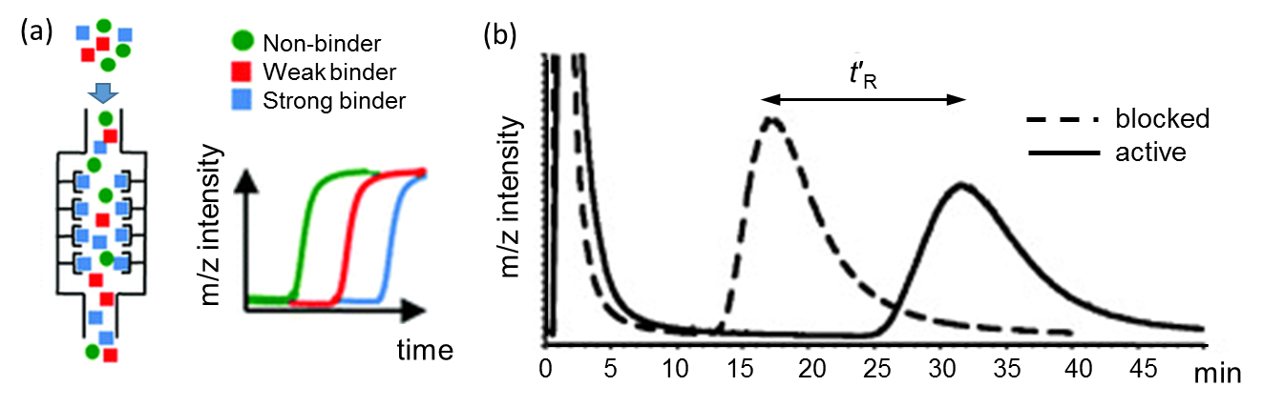 Figure 2. (a) Schematic of WAC. Compounds elute in order of their affinity to the column, with non-binders eluting first and strong binders eluting last. Adapted with permission from Potterat et al. (24). (b) The net retention time (t_{R}′) is calculated by subtracting the retention time of the fragment on the inhibitor-blocked column (dashed line) from the corresponding retention time on the active column (solid line). Adapted with permission from Duong-Thi et al. (20).
Native mass spectrometry
In native MS, also known as non-denaturating MS, biological molecules are sprayed into the mass spectrometer using electrospray ionization MS (ESI-MS) from a non-denaturing volatile buffer, commonly ammonium acetate (25). As ESI-MS is a relatively soft ionization technique, the native conformation of biomolecules as well as any biomolecular interactions can be maintained even as analytes are transferred into the gas phase (26). This technique was further refined by the introduction of a miniaturized version of the ESI process by Wilm and Mann in the 1990’s (27). Termed nanoflow-ESI (nESI), the use of much narrower spray apertures enhances the dispersion of the liquid into nanodroplets more efficiently even under very mild conditions, while also greatly reducing the consumption of protein. A schematic overview of the nanoESI process is depicted in Figure 3.
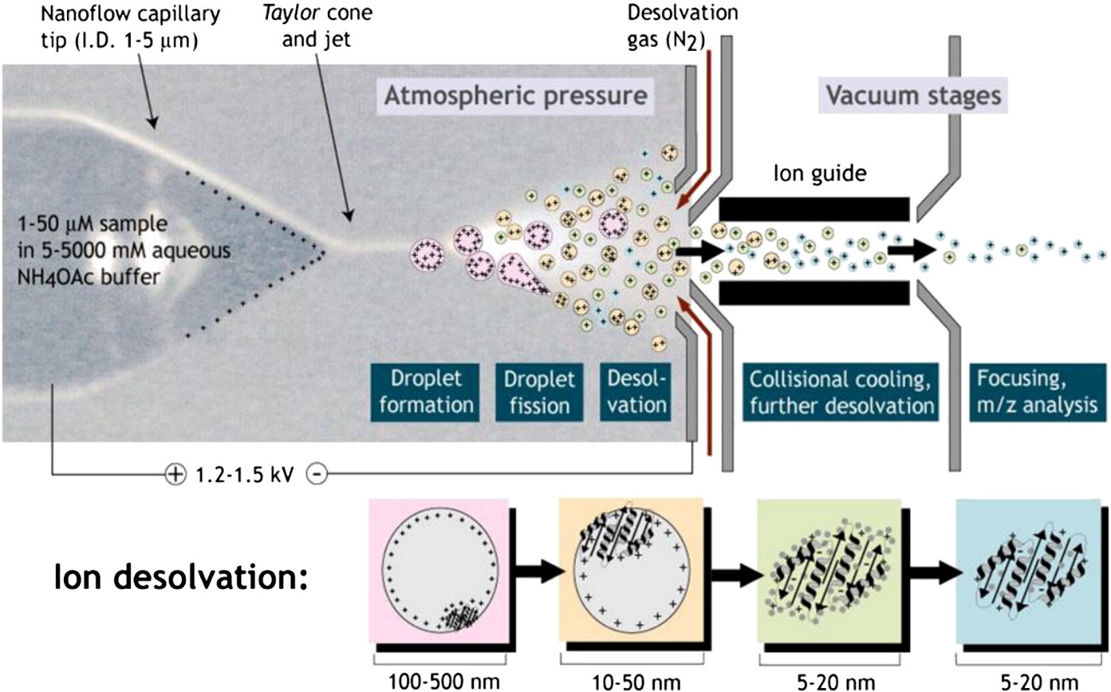
Figure 3. A schematic representation of the nESI process. A protein sample in ammonium acetate (NH₄OAc) buffer is sprayed from a charged nanoflow capillary, forming a Taylor cone and jet. Dispersed droplets undergo multiple rounds of droplet formation, droplet fission and desolvation. Further collision cooling and desolvation takes place within the vacuum stages of the mass spectrometer to release minimally solvated analyte ions before m/z analysis. Reproduced with permission from Konijnenberg et al. (26).
nESI-MS has been widely applied to study the stoichiometry and interactions of macromolecular assemblies (28, 29). A natural extension of the concept is to use native MS to screen for protein-ligand interactions (30-32). Hits are readily detected with native MS because the presence of a bound fragment will cause the m/z signal of the protein-ligand complex to be higher compared to the free protein. As an example, Figure 4a shows the native mass spectrum of carbonic anhydrase recorded in negative ion mode (31). The narrow charge state envelope together with the low absolute charge of the ions (from 8– to 10–) indicates that the protein remained compacted in the gas phase. In the presence of a cocktail of fragments, shifts to higher m/z values are observed due to the formation of protein-ligand complexes (Figure 4b). These signals are readily deconvoluted because multiplying the m/z shift (Δm/z) and the charge state directly gives the molecular weight of the bound ligand. Additionally, evaluating the proportion of bound and unbound protein species allows determination of K_{D} values (33). It is important to note that in native MS, the voltages at various stages within the mass spectrometer should be minimized as far as possible in order to preserve non-covalent interactions, while still being high enough to maintain sufficient desolvation and ion transmission.
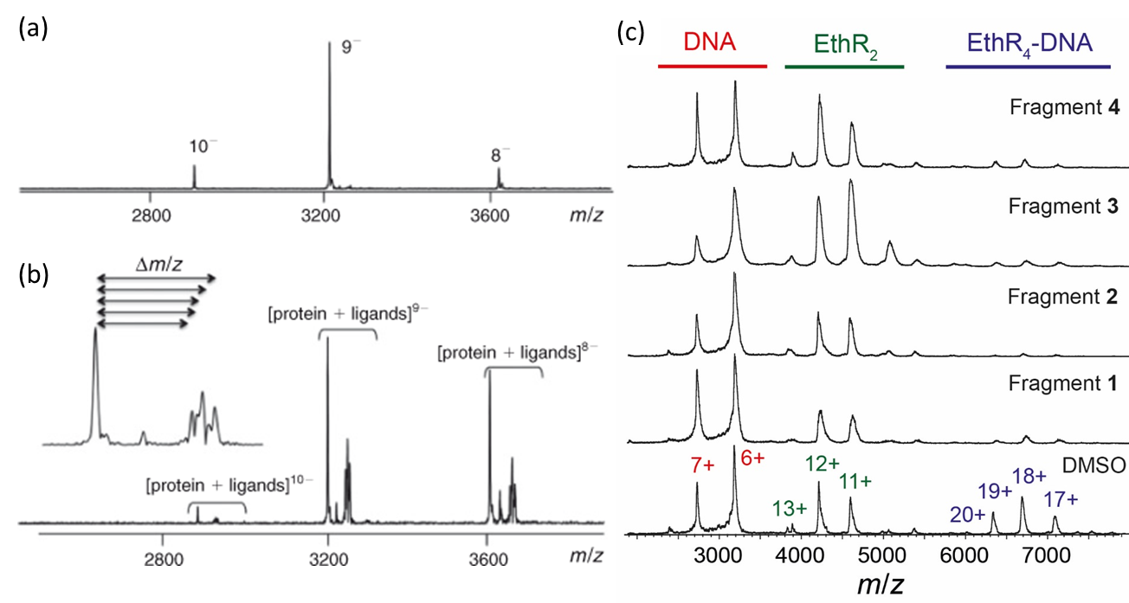
Figure 4. Native mass spectra of carbonic anhydrase in the (a) absence and (b) presence of a fragment cocktail. The formation of protein-ligand complexes causes a shift (Δm/z) in the protein signals. Reproduced from Poulsen (31), with permission from CSIRO Publishing. (c) Fragment screening against a protein-DNA interaction. The EthR₄-DNA complex was disrupted by fragments into free EthR₂ and DNA. Adapted from Chan et al. (34).
A number of studies applying native MS to fragment screening have been described in recent years. In 2012, Maple et al. provided one of the first demonstrations of automated fragment screening using native MS (35). To increase throughput, experiments were performed with the Triversa NanoMate (Advion) (36, 37), a microfluidic chip-based sample injection and liquid handling robot. The experimental setup was first validated using lysozyme as a model enzyme, which revealed good agreement between K_{D} values for acetylglucosamine oligomers determined by native MS and those determined by ITC. Subsequently, the automated native MS screening platform was applied to screen a focused phenylpyrazole fragment library against Bcl-x_{L}, an anti-apoptotic protein that has been implicated in tumorigenesis (38). Of the fragments screened, 84 out of 157 were revealed as hits (K_{D} < 300 μM), and a subset of these were further subjected to validation using other biophysical techniques, including STD NMR, 2D NMR and ITC.
Woods et al. recently described a fragment screening campaign against human carbonic anhydrase using native MS in conjunction with SPR and X-ray crystallography (39). In the first stage of this study, a library of 720 fragments were screened against carbonic anhydrase by SPR, and the 7 hits that emerged were validated by native MS and X-ray crystallography. Subsequently, a focused library of 70 compounds selected based on structural similarity to the fragment hits from the first stage, were independently screened using both native MS and SPR. The second stage revealed 37 hit compounds, 24 of which were detected as positive by both native MS and SPR, and there was agreement between the two techniques for 58 out of the 70 compounds in the library.
Fragments can also be screened as cocktails in native MS. Vu et al. (40) screened 331 natural product-like fragments against Plasmodium falciparum deoxyuridine 5′-triphosphate nucleotidohydrolase (PfdUTPase), a potential antimalarial target (41). Fragments were assessed in cocktails of eight compounds each, revealing securinine and 4-α-hydroxy-allosecurinine as hits. The two hits together with five other securinine compounds were subsequently evaluated for their ability to inhibit PfdUTPase activity as well as block P. falciparum replication. There was good correlation between binding affinities determined by native MS and inhibition of P. falciparum growth, although surprisingly, the molecules promoted rather than suppressed PfdUTPase activity. In a later study (42), the same group of researchers applied native MS to screen 659 natural product-like fragments against P. falciparum Rab11a, a Rab GTPase that regulates parasite replication (43). Using a similar cocktail method as before, 11 fragments emerged as hits against PfRab11a.
Besides screening against individual protein targets, native MS can also be used screen compounds against biomolecular complexes (44). Chan et al. have recently provided the first demonstration of the use of native MS for fragment screening against a protein-DNA interaction (34). EthR is a transcriptional repressor from Mycobacterium tuberculosis that reduces the efficacy of the anti-tubercular drug, ethionamide (45). Inhibitors of the EthR-DNA interaction can act as ethionamide boosters. To increase the sensitivity of the assay for detecting weak fragments, screening was performed against a partial, lower-affinity EthR₄-DNA complex instead of the native EthR₆-DNA complex (46). Of the 73 fragments screened, 8 compounds disrupted the EthR₄-DNA interaction by more than 50% and were deemed as hits (Figure 4c shows native mass spectra for four of the fragment hits). In parallel, the fragments were tested using DSF, which revealed 7 hits, with 4 hits overlapping between the two techniques. Hit validation using SPR showed that in general, the fragment hits discovered by native MS showed better in vitro inhibition of the EthR-DNA interaction compared to the hits revealed by DSF. X-ray crystallography of the two top hits revealed that both fragments bound to the hydrophobic channel of EthR, providing a structural basis for their inhibition of the EthR-DNA interaction.
Hydrogen-deuterium exchange mass spectrometry
The amide hydrogen atoms of a protein are labile and exchange with solvent hydrogen or deuterium through acid-, base- or water-catalyzed reactions. The rate of hydrogen-deuterium exchange (HDX) is highly dependent on the structural environment of the amide, with amides locating within the interior of a folded protein exchanging up to 10⁸ slower as compared to an amide hydrogen freely exposed to solvent (47). A schematic overview of the HDX-mass spectrometry (HDX-MS) process as applied to ligand screening is depicted in Figure 5 (48). In the first stage, “on-exchange” of hydrogen for deuterium takes place when the protein is incubated in D₂O in either the presence or absence of the ligand. Aliquots of this solution are quenched at pre-specified time intervals by the addition of a cold and acidic solution, which preserves the level of deuterium incorporation by slowing exchange reactions. The partially-deuterated protein is then digested, typically by passing through a pepsin column, to generate a collection of small peptides that are chromatographically separated and analyzed by MS. The percentage incorporation of deuterium for each peptide at each time point can then be determined. Further analysis of overlapping proteolytic fragments can generate more localized HDX data, potentially down to single-residue resolution (49). Differences in the rate of deuterium uptake between the apo and ligand-bound forms of a protein can be mapped onto the X-ray crystal structure or model of the protein, thereby giving information on the effects of ligand binding on the structure of the protein.
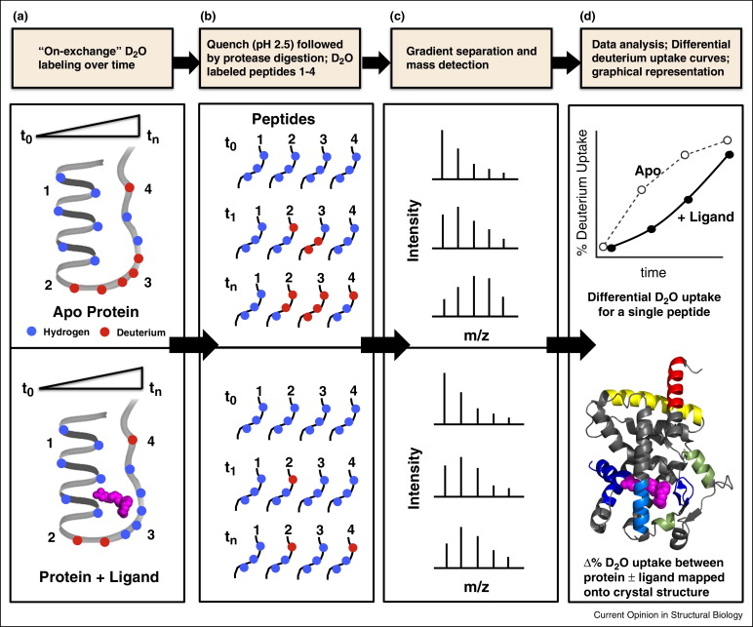
Figure 5. A schematic representation of the HDX-MS process as applied to ligand screening. (a) Proteins are labelled with D₂O either in the absence (upper panel) or presence (lower panel) of ligand. (b) Reaction aliquots are quenched at pre-specified time intervals, followed by protease digestion. (c) Peptides are separated chromatographically and analyzed by MS. (d) The rate of deuterium uptake for the apo and ligand-bound forms are compared for each peptide and differences are mapped onto the crystal structure. Reproduced with permission from Marciano et al. (48).
At the simplest level, the binding of a ligand to a protein should shield the amide protons of the ligand-binding site from D₂O, thereby reducing the deuterium uptake of the surrounding residues. However, differences in HDX patterns upon ligand binding can also result from changes to the protein structure or dynamics in regions that are distant from the binding site. The HDX-MS data can then be used to generate an “HDX fingerprint” for each ligand, and analysis of these fingerprints can allow for the clustering of ligands into groups that share a similar binding mode (50). While HDX-MS has been widely employed for studying the structure and dynamics of therapeutic antibodies (51), its use for small-molecule ligand screening has received comparatively less attention (48). The primary drawback of HDX-MS is that it is a relatively low-throughput technique, and the screening of even as few as one hundred compounds would incur significant expense in both time and money. The first and to date only study of HDX-MS for fragments was reported by Carson et al. in 2014, who used this technique as a secondary screen to discriminate fragment hits that bound to the vitamin D receptor with a similar HDX fingerprint as the natural hormone VD3 (52).
Conclusions
FBDD has emerged as a powerful alternative to traditional HTS for the discovery of new chemical leads. Due to the weak binding affinity of fragments, sensitive biophysical methods are required for their detection. MS-based methods, including ligand-observed MS, native MS and HDX-MS, have various advantages that allow them to complement existing biophysical techniques for fragment screening (Table 1). With more development, MS has the potential to become a core approach in the biophysical toolkit in the near future.
Table 1. A comparison of commonly used fragment screening techniques.
Technique | Principle | Advantages | Limitations
DSF | Fragment increases stability of protein against unfolding | High-throughput, low-cost, easy to perform, low protein consumption | Low information content, susceptibility to false positives and false negatives
Ligand-observed NMR | Change in T₂ relaxation rate (CPMG) or NOE (STD, waterLOGSY) upon ligand binding | Medium-throughput, protein can be unlabelled, allows verification of protein and ligand purity | Prone to false positives from aggregation, limited to fragments that transiently bind in the fast exchange regime, high protein consumption
Protein-observed NMR | Ligands induce CSPs of amide signals of protein | Determination of ligand binding site and K_{D} | Low-throughput, requires large amounts of labelled protein, limitations on protein size
SPR | Change in refractive index at interface of an optical biosensor induced by ligand binding | Medium-throughput, provides both kinetic and affinity data, low protein consumption | Requires that protein be stable to immobilization on surface
ITC | Detection of heat change upon ligand titration | Provides thermodynamic parameters of binding, binding affinity and stoichiometry | Low-throughput, high protein consumption
X-ray crystallography | Diffraction of X-rays by protein-ligand complexes | High-resolution structural detail of ligand binding mode | Protein must form well-diffracting crystals, high ligand concentration required, reliant on significant technical instrumentation and expertise
Ligand-observed MS (ultrafiltration) | Bound and unbound ligands separated by ultrafiltration before MS detection | High-throughput, easy to perform | Indirect detection technique, non-equilibrium method
Ligand-observed MS (WAC) | Bound and unbound ligands separated by weak affinity chromatography before MS detection | Medium-throughput, relatively easy to perform | Indirect detection technique, non-equilibrium method, requires that protein be stable to immobilization on column
Native MS | Detection of gas-phase protein-ligand complexes generated by ESI | Low sample consumption, medium-throughput, provides binding affinity and stoichiometry, allows verification of protein and ligand purity | Gas-phase species may not reflect distribution in solution
HDX-MS | Ligand changes deuteration rate of protein amide residues | Can reveal ligand binding site and allostery | Low-throughput

Summary
- The weak binding affinity of fragments necessitates the use of sensitive biophysical methods for their detection.
- Mass spectrometry is a relatively underutilized technique in fragment-based drug discovery.
- In recent years, ligand-observed mass spectrometry, native mass spectrometry and hydrogen-deuterium exchange mass spectrometry have been applied to fragment screening.
- Mass spectrometry has the potential to become a core approach in the biophysical toolkit in the future, complementing existing fragment screening approaches.

Acknowledgements
D.S.-H. Chan acknowledges the support of the Croucher Foundation and the Cambridge Commonwealth, European and International Trust for receipt of a Croucher Cambridge International Scholarship. A.J.W acknowledges the support of the EPSRC for funding.

References
1. Jencks W.P. (1981) On the attribution and additivity of binding energies. Proc. Natl. Acad. Sci., 78, 4046.
2. Shuker S.B., Hajduk P.J., Meadows R.P. and Fesik S.W. (1996) Discovering High-Affinity Ligands for Proteins: SAR by NMR. Science, 274, 1531.
3. Erlanson D.A., Fesik S.W., Hubbard R.E., Jahnke W. and Jhoti H. (2016) Twenty years on: the impact of fragments on drug discovery. Nat. Rev. Drug Discov., 15, 605.
4. Bollag G., Tsai J., Zhang J., Zhang C., Ibrahim P., Nolop K. and Hirth P. (2012) Vemurafenib: the first drug approved for BRAF-mutant cancer. Nat. Rev. Drug Discov., 11, 873.
5. Mullard A. (2016) Pioneering apoptosis-targeted cancer drug poised for FDA approval. Nat. Rev. Drug Discov., 15, 147.
6. Keserű G.M., Erlanson D.A., Ferenczy G.G., Hann M.M., Murray C.W. and Pickett S.D. (2016) Design Principles for Fragment Libraries: Maximizing the Value of Learnings from Pharma Fragment-Based Drug Discovery (FBDD) Programs for Use in Academia. J. Med. Chem., 59, 8189.
7. Williams G., Ferenczy, Ulander and Keseru. (2017) Binding thermodynamics discriminates fragments from druglike compounds: a thermodynamic description of fragment-based drug discovery. 22, 681.
8. Scott D.E., Coyne A.G., Hudson S.A. and Abell C. (2012) Fragment-based approaches in drug discovery and chemical biology. Biochemistry, 51, 4990.
9. Mashalidis E.H., Śledź P., Lang S. and Abell C. (2013) A three-stage biophysical screening cascade for fragment-based drug discovery. Nat. Protocols, 8, 2309.
10. Niesen F.H., Berglund H. and Vedadi M. (2007) The use of differential scanning fluorimetry to detect ligand interactions that promote protein stability. Nat. Protocols, 2, 2212.
11. Seetoh W.-G. and Abell C. (2016) Disrupting the Constitutive, Homodimeric Protein–Protein Interface in CK2β Using a Biophysical Fragment-Based Approach. J. Am. Chem. Soc., 138, 14303.
12. Harner M.J., Frank A.O. and Fesik S.W. (2013) Fragment-Based Drug Discovery Using NMR Spectroscopy. J. Biomol. NMR, 56, 65.
13. Shepherd C.A., Hopkins A.L. and Navratilova I. (2014) Fragment screening by SPR and advanced application to GPCRs. Prog. Biophys. Mol. Biol., 116, 113.
14. Recht M.I., Nienaber V. and Torres F.E. (2016) Fragment-Based Screening for Enzyme Inhibitors Using Calorimetry. Methods Enzymol., 567, 47.
15. Patel D., Bauman J.D. and Arnold E. (2014) Advantages of crystallographic fragment screening: Functional and mechanistic insights from a powerful platform for efficient drug discovery. Prog. Biophys. Mol. Biol., 116, 92.
16. Pacholarz K.J., Garlish R.A., Taylor R.J. and Barran P.E. (2012) Mass spectrometry based tools to investigate protein-ligand interactions for drug discovery. Chem. Soc. Rev., 41, 4335.
17. Chen X., Qin S., Chen S., Li J., Li L., Wang Z., Wang Q., Lin J., Yang C. and Shui W. (2015) A Ligand-observed Mass Spectrometry Approach Integrated into the Fragment Based Lead Discovery Pipeline. Sci. Rep., 5, 8361.
18. Qin S., Ren Y., Fu X., Shen J., Chen X., Wang Q., Bi X., Liu W., Li L., Liang G., Yang C. and Shui W. (2015) Multiple ligand detection and affinity measurement by ultrafiltration and mass spectrometry analysis applied to fragment mixture screening. Anal. Chim. Acta, 886, 98.
19. Powdrill M.H., Bernatchez J.A. and Götte M. (2010) Inhibitors of the Hepatitis C Virus RNA-Dependent RNA Polymerase NS5B. Viruses, 2, 2169.
20. Duong-Thi M.-D., Meiby E., Bergström M., Fex T., Isaksson R. and Ohlson S. (2011) Weak affinity chromatography as a new approach for fragment screening in drug discovery. Anal. Biochem., 414, 138.
21. Duong-Thi M.-D., Bergström M., Fex T., Isaksson R. and Ohlson S. (2013) High-Throughput Fragment Screening by Affinity LC-MS. J. Biomol. Screen., 18, 160.
22. Meiby E., Knapp S., Elkins J.M. and Ohlson S. (2012) Fragment screening of cyclin G-associated kinase by weak affinity chromatography. Anal. Bioanal. Chem., 404, 2417.
23. Meiby E., Simmonite H., le Strat L., Davis B., Matassova N., Moore J.D., Mrosek M., Murray J., Hubbard R.E. and Ohlson S. (2013) Fragment Screening by Weak Affinity Chromatography: Comparison with Established Techniques for Screening against HSP90. Anal. Chem., 85, 6756.
24. Potterat O. and Hamburger M. (2013) Concepts and technologies for tracking bioactive compounds in natural product extracts: generation of libraries, and hyphenation of analytical processes with bioassays. Nat. Prod. Rep., 30, 546.
25. Leney A.C. and Heck A.J.R. (2017) Native Mass Spectrometry: What is in the Name? J. Am. Soc. Mass Spectrom., 28, 5.
26. Konijnenberg A., Butterer A. and Sobott F. (2013) Native ion mobility-mass spectrometry and related methods in structural biology. Biochim. Biophys. Acta, 1834, 1239.
27. Wilm M. and Mann M. (1996) Analytical Properties of the Nanoelectrospray Ion Source. Anal. Chem., 68, 1.
28. Mehmood S., Allison T.M. and Robinson C.V. (2015) Mass Spectrometry of Protein Complexes: From Origins to Applications. Annu. Rev. Phys. Chem., 66, 453.
29. Benesch J.L.P. and Ruotolo B.T. (2011) Mass spectrometry: come of age for structural and dynamical biology. Curr. Opin. Struct. Biol., 21, 641.
30. Pedro L. and Quinn J.R. (2016) Native Mass Spectrometry in Fragment-Based Drug Discovery. Molecules, 21, 984.
31. Poulsen S.-A. (2013) Fragment Screening by Native State Mass Spectrometry. Aust. J. Chem., 66, 1495.
32. Vivat Hannah V., Atmanene C., Zeyer D., Van Dorsselaer A. and Sanglier-Cianférani S. (2010) Native MS: an ’ESI‚ way to support structure- and fragment-based drug discovery. Future Med. Chem., 2, 35.
33. Kitova E.N., El-Hawiet A., Schnier P.D. and Klassen J.S. (2012) Reliable Determinations of Protein–Ligand Interactions by Direct ESI-MS Measurements. Are We There Yet? J. Am. Soc. Mass Spectrom., 23, 431.
34. Chan D.S.-H., Mendes V., Thomas S.E., McConnell B.N., Matak-Vinković D., Coyne A.G., Blundell T.L. and Abell C. Fragment Screening against the EthR–DNA Interaction by Native Mass Spectrometry. Angew. Chem. Int. Ed., n/a.
35. Maple H.J., Garlish R.A., Rigau-Roca L., Porter J., Whitcombe I., Prosser C.E., Kennedy J., Henry A.J., Taylor R.J., Crump M.P. and Crosby J. (2012) Automated protein-ligand interaction screening by mass spectrometry. J. Med. Chem., 55, 837.
36. Keetch C.A., Hernández H., Sterling A., Baumert M., Allen M.H. and Robinson C.V. (2003) Use of a Microchip Device Coupled with Mass Spectrometry for Ligand Screening of a Multi-Protein Target. Anal. Chem., 75, 4937.
37. Zhang S., Van Pelt C.K. and Wilson D.B. (2003) Quantitative determination of noncovalent binding interactions using automated nanoelectrospray mass spectrometry. Anal. Chem., 75, 3010.
38. Kelly P.N. and Strasser A. (2011) The role of Bcl-2 and its pro-survival relatives in tumourigenesis and cancer therapy. Cell Death Differ., 18, 1414.
39. Woods L.A., Dolezal O., Ren B., Ryan J.H., Peat T.S. and Poulsen S.-A. (2016) Native State Mass Spectrometry, Surface Plasmon Resonance, and X-ray Crystallography Correlate Strongly as a Fragment Screening Combination. J. Med. Chem., 59, 2192.
40. Vu H., Roullier C., Campitelli M., Trenholme K.R., Gardiner D.L., Andrews K.T., Skinner-Adams T., Crowther G.J., Van Voorhis W.C. and Quinn R.J. (2013) Plasmodium Gametocyte Inhibition Identified from a Natural-Product-Based Fragment Library. ACS Chem. Biol., 8, 2654.
41. Whittingham J.L., Leal I., Nguyen C., Kasinathan G., Bell E., Jones A.F., Berry C., Benito A., Turkenburg J.P., Dodson E.J., Perez L.M.R., Wilkinson A.J., Johansson N.G., Brun R., Gilbert I.H., Pacanowska D.G. and Wilson K.S. (2005) dUTPase as a Platform for Antimalarial Drug Design: Structural Basis for the Selectivity of a Class of Nucleoside Inhibitors. Structure, 13, 329.
42. Yang B., Feng Y.J., Vu H., McCormick B., Rowley J., Pedro L., Crowther G.J., Van Voorhis W.C., Forster P.I. and Quinn R.J. (2016) Bioaffinity Mass Spectrometry Screening. J. Biomol. Screen., 21, 194.
43. Agop-Nersesian C., Naissant B., Ben Rached F., Rauch M., Kretzschmar A., Thiberge S., Menard R., Ferguson D.J.P., Meissner M. and Langsley G. (2009) Rab11A-Controlled Assembly of the Inner Membrane Complex Is Required for Completion of Apicomplexan Cytokinesis. PLoS Pathog., 5, e1000270.
44. Cubrilovic D., Barylyuk K., Hofmann D., Walczak M.J., Graber M., Berg T., Wider G. and Zenobi R. (2014) Direct monitoring of protein-protein inhibition using nano electrospray ionization mass spectrometry. Chemical Science, 5, 2794.
45. Engohang-Ndong J., Baillat D., Aumercier M., Bellefontaine F., Besra G.S., Locht C. and Baulard A.R. (2004) EthR, a repressor of the TetR/CamR family implicated in ethionamide resistance in mycobacteria, octamerizes cooperatively on its operator. Mol. Microbiol., 51, 175.
46. Chan D.S.-H., Seetoh W.-G., McConnell B.N., Matak-Vinkovic D., Thomas S.E., Mendes V., Blaszczyk M., Coyne A.G., Blundell T.L. and Abell C. (2017) Structural insights into the EthR-DNA interaction using native mass spectrometry. Chem. Commun., 53, 3527.
47. Chalmers M.J., Busby S.A., Pascal B.D., West G.M. and Griffin P.R. (2011) Differential hydrogen/deuterium exchange mass spectrometry analysis of protein-ligand interactions. Expert review of proteomics, 8, 43.
48. Marciano D.P., Dharmarajan V. and Griffin P.R. (2014) HDX-MS guided drug discovery: small molecules and biopharmaceuticals. Curr. Opin. Struct. Biol., 28, 105.
49. Kan Z.-Y., Walters B.T., Mayne L. and Englander S.W. (2013) Protein hydrogen exchange at residue resolution by proteolytic fragmentation mass spectrometry analysis. Proc. Natl. Acad. Sci. U. S. A., 110, 16438.
50. Dai S.Y., Chalmers M.J., Bruning J., Bramlett K.S., Osborne H.E., Montrose-Rafizadeh C., Barr R.J., Wang Y., Wang M., Burris T.P., Dodge J.A. and Griffin P.R. (2008) Prediction of the tissue-specificity of selective estrogen receptor modulators by using a single biochemical method. Proc. Natl. Acad. Sci., 105, 7171.
51. Berkowitz S.A., Engen J.R., Mazzeo J.R. and Jones G.B. (2012) Analytical tools for characterizing biopharmaceuticals and the implications for biosimilars. Nat. Rev. Drug Discov., 11, 527.
52. Carson M.W., Zhang J., Chalmers M.J., Bocchinfuso W.P., Holifield K.D., Masquelin T., Stites R.E., Stayrook K.R., Griffin P.R. and Dodge J.A. (2014) HDX reveals unique fragment ligands for the vitamin D receptor. Bioorg. Med. Chem. Lett., 24, 3459.

