Compartmentalisation of immune responses in critical illness: does it matter?

Andrew Conway Morris^{1,2,3}, Jennifer Rynne⁴, Manu Shankar-Hari⁴
¹ Division of Anaesthesia, Department of Medicine, University of Cambridge, Addenbrooke’s Hospital, Hills Road, Cambridge, CB2 0QQ
² Division of Immunology, Department of Pathology, University of Cambridge, Tennis Court Road, Cambridge, Cb2 1QP
³ JVF Intensive Care Unit, Addenbrooke’s Hospital, Cambridge, Hills Road, Cambridge, CB2 0QQ
⁴The Queen's Medical Research Institute, Edinburgh BioQuarter, Centre for Inflammation Research, 47 Little France Crescent, Edinburgh, EH16 4TJ

Address for correspondence
Andrew Conway Morris
Division of Anaesthesia
Department of Medicine
University of Cambridge
Level 4 Addenbrooke’s Hospital
Hills Road
Cambridge
United Kingdom

ac926@cam.ac.uk

Word count: 1164

ORCID
ACM: 0000-0002-3211-3216
JM 0000-0002-8945-8434
MSH 0000-0002-5338-2538

Conflict of interest statement:
ACM has received payment for speaking on behalf of Boston Scientific and sits on the Scientific Advisory Board of Cambridge Infection Diagnostics, a start-up seeking to develop novel diagnostics for infectious diseases. The other authors declare no conflicts of interest.

Keywords: Sepsis, acute respiratory distress syndrome, immunology, immunomodulation, tissue specific responses

Author contributions: ACM, JM and MSH conceived the article and generated the outline. ACM wrote the first draft, ACM, JM and MSH critically revised the manuscript for important intellectual content, and agreed the final submitted version of the manuscript.

Acknowledgements: ACM is supported by a Medical Research Council Clinician Scientist Fellowship (MR/V006118/1).

Funding: none
Ethics: not applicable
Availability of data and material: Not applicable

Introduction
Critical illness is pragmatically defined as an acute illness resulting in organ dysfunction, necessitating organ support in specialised settings (intensive care units), to survive¹. Despite current best care, ~30% of patients die within 30-days from onset of critical illness. Over the last 50-years, >500 randomised clinical trials (RCTs) involving common critical illnesses such as sepsis syndromes², and acute respiratory distress syndrome (ARDS)³ have failed to show tangible benefit with pharmacological interventions, despite most of the interventions tested being grounded in detailed understanding of the biological mechanisms involved¹. This lack of success is thought to arise from differences in biological features and in outcome risk between critically ill patients (i.e., loosely framed as heterogeneity). Hypotheses that are being pursued to improve the success of future RCTs include grouping patients based on observable clinical and or biological features (termed enrichment, vs sub-phenotyping)⁴, incorporate attributable risk of critical illness during trial design, innovative trial designs (adaptive RCTs), and redefine critical illness (such as treatable traits)⁵. In this editorial we explore another hypothesis: Compartmentalisation of immune responses during critical illness syndromes such as sepsis could explain the lack of benefit with immunomodulatory treatments? Compartmentalisation refers to the process whereby immune responses are confined to, or differ between, anatomical compartments within the body. Examples of compartments include the lungs, peritoneum, urinary tract and peripheral blood. Although we mostly focus on infectious insults, the canonical nature of immune responses implies that compartmentalised responses will occur in sterile insults such as trauma⁶ and need to be considered in all critical illness-associated immune profiling.
Broadly, the core argument with compartmentalisation of immune responses could be summarised by considering two extreme immune states (‘excess inflammation’ vs ‘immunosuppression’) and two opposing immunomodulation strategies (‘anti-inflammatory’ vs ‘immunostimulants’). As our window to determining immune states is most often blood, we seldom consider whether the tissue immune state at the time of blood sampling is similar or different to blood? In the two discordant scenarios, immunomodulation based only on systemic immune state could harm patients. Furthermore, mechanisms which predominate in one tissue space, may not dominate or even be relevant in other tissue spaces⁷. (Figure 1A)

Mechanisms of compartmentalised responses
The pathophysiological mechanisms which underpin this compartmentalisation of immune responses are legion⁸. Even within the blood vessels, sampling the circulating cells gives an incomplete picture of current immune status. Circulating immune cells, most notably neutrophils, may marginate, loosely attaching to the endothelial wall. This subpopulation is largely unmeasured in blood samples. Immune responses within the tissues themselves are effected by a combination of resident and recruited immune cells. The resident cells, by definition, are not found in the circulation and yet play a vital role in shaping local immune responses. In streptococcal pneumonia models’ inflammation is driven primarily by tissue resident macrophages, at least early on in the disease process, and remains highly compartmentalised within the lung until bacteraemia supervenes⁹. Tissue resident memory can be demonstrated in isolated lung lobes when they are selectively exposed to antigen¹⁰. Infiltrating immune cells undergo changes in their phenotype, underpinned by changes in transcriptional signatures, as they infiltrate an inflamed area. Even moving between the interstitium and site of inflammation produces demonstrable changes¹¹, with upregulation of pathways associated with antimicrobial functions¹¹. Immune signalling molecules such as cytokines and growth factors may have divergent and tissue-specific functions. Granulocyte-colony stimulating factor (GM-CSF) appears to have a significant role in driving autoimmune disease such as rheumatoid arthritis, and yet it is also critical to the health of alveolar macrophages and subsequent pulmonary antimicrobial responses¹². Indeed, the potential for compartmentalised responses has led to the rationale for testing of both systemic GM-CSF blockade and inhaled recombinant GM-CSF in COVID-19¹². However, despite evidence of compartmentalised responses in COVID-19^{12,13}, studies have neither targeted compartmentalised endotypes nor ascertained differences in responses to immunotherapies in patients with COVID-19.

Evidence for compartmentalisation in critically ill patients
The evidence for compartmentalisation of inflammatory responses is increasingly well described amongst critically ill patients. In ventilated patients with lung infiltrates, alveolar cytokine patterns can differentiate bacterial infection from non-infectious causes whilst circulating cytokine levels are unrevealing¹⁴ . Such effects are not unique to the lungs, and other tissue sites of infection such as leptomeninges, peritoneum and urinary tract demonstrate tissue-restricted inflammation⁸, further details of these compartments are provided in supplemental table 1. Differential phenotypes are noted in neutrophils from the blood and lungs of patients with ARDS, with the alveolar neutrophils showing greater priming, resistance to apoptosis and with hypersegmented nuclei relative to those isolated from autologous peripheral blood¹⁵. In patients with COVID-19, obesity has been found to alter immune pathway activation with suppression of type I and II interferons and TNFalpha signalling in pulmonary cells, but an increase in TNFalpha pathway signalling in peripheral blood cells¹³. Even when phenotypes are similar, they may be driven by different mediators. For example, whilst peripheral blood neutrophil phagocytic dysfunction is driven by C5a, different mediators drive phagocytic dysfunction in the alveolar space⁷. In these contexts, simply sampling the peripheral blood could give a misleading impression as to the pathophysiological state of the patient, and potentially be used to rationalise a therapy which may not target pathways active in tissue spaces. Figure 1B and C illustrate how immune responses may be provoked by direct or indirect injury, and some of the mechanisms which lead to compartmentalised responses.

Compartmentalised immune responses in practice.
Understanding how we may exploit the insights arising from the growing understanding of compartmentalised, tissue specific responses is crucial to developing clinically applicable tools and therapies. Although many tissue spaces can be challenging to access, the lungs provide an important window due to both their comparative accessibility and critical importance as sites of infection and inflammation. The paired sampling of blood and lung fluid (by lavage or aspiration) allows for the detection of processes which may be distinct between these two spaces¹⁴. A growing range of in-vivo photonic and radioactive probes can extend this to ‘in-situ’ phenotyping¹⁶. A further advantage of the lungs is its accessibility for topical or locally active therapies.
To consider a practical, albeit hypothetical, scenario arising from the insight that molecules such as GM-CSF may have divergent roles in different tissue spaces and different illness phases¹² Profiling the immune status in both the peripheral blood and lungs could allow for site-specific modulation. Using either neutralising antibodies, to inhibit signalling, or recombinant proteins to augment it at the appropriate time and in the appropriate space. Such apparently opposing interventions could be used sequentially, or even potentially simultaneously, but would require the ability to reliably assess immune status in each compartment. Although other tissue spaces are more challenging to access, in certain situations indwelling microdialyser catheters may allow for localised instillation of therapeutic agents.

In conclusion, we highlight a hypothesis, supported by data. Prevalence of concordant vs discordant immune state between blood and tissues (at the very least lung), and the feasible surrogates of such a classification would be a useful step forward to achieve successful immunomodulation in critically ill adults.

References

1. Shankar-Hari M, Wunsch H, Rowan K, Singer M, Rubenfeld GD, Angus DC. Reflections on Critical Care’s Past, Present, and Future. Crit Care Med. 2021;49(11):1855-1865.
2. Marshall JC. Why have clinical trials in sepsis failed? Trends Mol Med. 2014;20(4):195-203.
3. Saha R, Assouline B, Mason G, Douiri A, Summers C, Shankar-Hari M. Impact of differences in acute respiratory distress syndrome randomised controlled trial inclusion and exclusion criteria: systematic review and meta-analysis. Brit J Anaesth. 2021;127(1):85-101.
4. Shankar-Hari M, Rubenfeld GD. Population enrichment for critical care trials: phenotypes and differential outcomes. Curr Opin Crit Care. 2019;25(5):489-497.
5. Pinder EM, Rostron AJ, Hellyer TP, et al. Randomised controlled trial of GM-CSF in critically ill patients with impaired neutrophil phagocytosis. Thorax. 2018;73(10):918-925.
6. Xiao W, Mindrinos MN, Seok J, et al. A genomic storm in critically injured humans. J Ex Med. 2011;208(13):2581-2590.
7. Morris AC, Kefala K, Wilkinson TS, et al. C5a mediates peripheral blood neutrophil dysfunction in critically ill patients. Am J Resp Crit Care. 2009;180(1):19-28.
8. Cavaillon JM, Annane D. Compartmentalization of the inflammatory response in sepsis and SIRS. J Endotox Res. 2006;12(3):151-170.
9. Bergeron Y, Ouellet N, Deslauriers AM, Simard M, Olivier M, Bergeron MG. Cytokine Kinetics and Other Host Factors in Response to Pneumococcal Pulmonary Infection in Mice. Infect Immun. 1998;66(3):912-922.
10. Bice DE, Muggenburg BA. Pulmonary immune memory: localized production of antibody in the lung after antigen challenge. Immunology. 1996;88(2):191-197.
11. Khoyratty TE, Ai Z, Ballesteros I, et al. Distinct transcription factor networks control neutrophil-driven inflammation. Nat Immunol. 2021;22(9):1093-1106.
12. Lang FM, Lee KMC, Teijaro JR, Becher B, Hamilton JA. GM-CSF-based treatments in COVID-19: reconciling opposing therapeutic approaches. Nat Rev Immunol. 2020;20(8):507-514.
13. Guo SA, Bowyer GS, Ferdinand JR, et al. Obesity associated with attenuated tissue immune cell responses in COVID-19. Biorxiv. Published online 2022:2022.01.14.475727. doi:10.1101/2022.01.14.475727
14. Morris AC, Kefala K, Wilkinson TS, et al. Diagnostic importance of pulmonary interleukin-1β and interleukin-8 in ventilator-associated pneumonia. Thorax. 2010;65(3):201-207.
15. Juss JK, House D, Amour A, et al. Acute Respiratory Distress Syndrome Neutrophils Have a Distinct Phenotype and Are Resistant to Phosphoinositide 3-Kinase Inhibition. Am J Resp Crit Care. 2016;194(8):961-973.
16. Akram AR, Chankeshwara SV, Scholefield E, et al. In situ identification of Gram-negative bacteria in human lungs using a topical fluorescent peptide targeting lipid A. Sci Trans Med. 2018;10(464).

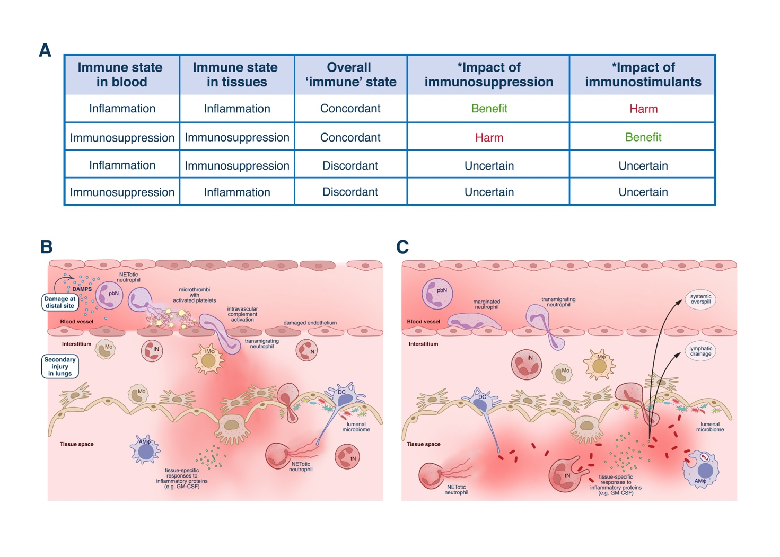
Figure 1: Diagrammatic representation of some of the mechanisms which lead to compartmentalised inflammatory responses in critical illness. Panel A indicates the summary of the hypothesis that discordant immune responses in blood and tissue compartments may lead to inappropriate therapies. *Refers to the immune state assessment based on either blood or tissue-based biomarker
Panel B illustrates how distant insults and systemic spill-over of damage-associated molecular patterns (DAMPS) can lead to inflammatory and thrombotic changes in the blood, which damage the endothelium and lead to secondary damage at distal sites such as the lungs. Panel C illustrates how direct tissue injury, in this example from pneumonia, produces systemic overspill of inflammatory mediators into both the lymphatic and blood compartments. In both situations, cross-talk between tissue resident and infiltrating immune cells, stromal and epithelial cells influence tissue responses and make them qualitatively distinct from responses in circulating cells. Within luminal organs with communication with the external environment the added complexity of the microbial inhabitants (microbiome) further influences mucosal immunity. Conversely, soluble plasma proteins such as complement, coagulation cascade components and colloidal proteins may be largely restricted to, or in far higher abundance, in the blood compartment. Notably, in both compartments the presence of inflammatory mediators does not automatically indicate cellular hyperfunction, and indeed such mediators may drive impaired antimicrobial functions^{7,15} . pbN- peripheral blood neutrophil, iN -interstitial neutrophil, tN -tissue neutrophil, iMϕ -interstitial macrophage, AMϕ Alveolar macrophage, Mo-infiltrating monocyte, DC, dendritic cell. Figure made with BioRender.com

Supplemental table
Disease state | Body Site | Comments
VAP | lungs | Pulmonary immunity may serve to confine infection to one area -VAT. If immunity is impaired this allows infection to establish in more distal parts of the lung leading to VAP/become systemic¹ (i.e. compartmentalisation may occur within as well as between organs).  Even when VAP is present, the pulmonary compartment is more inflamed ^{2,3} with more impaired immune cell function than is seen in peripheral blood.
ARDS | Lungs | Compartmentalisation of inflammatory responses is also seen in ARDS, especially with regards to CXCL-8⁴. Loss of compartmentalisation was associated with shock and adverse outcomes. Immune cell markers, such as monocyte HLA-DR^{4,5} and T-cell PD1 demonstrated blood:lung differences
COVID-19 | Lungs | Similar to previous reports from bacterial pneumonia and ARDS, COVID-19 also demonstrated compartmentalised pulmonary inflammation which may be more confined than bacterial ARDS ⁶ . Pulmonary and peripheral blood profiling revealed defects specific to the lung in obese covid patients⁷
COVID-19 | Nasal epithelium | Distinct profiles of cytokines identified in the blood and nasopharynx of patients with COVID-19, with interaction between mucosal microbiome and immune responses⁸
Autoimmune disease (lupus nephritis) and urinary tract infections | Urinary tract | Presence of tissue-specific immune cell populations (effector memory T-cells, macrophages)⁹. Anatomical arrangement of cells is also critical to their function, and remain an under-investigated aspect of compartmentalised tissue immunity¹⁰
Bacterial peritonitis | Peritoneal cavity | Ascitic fluid contains higher levels of IL-6 and CXCL8 than blood, but in spontaneous bacterial peritonitis the gradients decrease and systemic levels rise¹¹. The liver may act to filter both bacteria and cytokines from the peritoneal blood supply and shield the systemic circulation from inflammatory insults¹²
Pregnancy | Placenta | Placental immunity maintains a careful balance between preventing maternal immune cell rejection of the placenta and foetus whilst protecting the foetus from infectious insults¹³
Meningitis/Encephalitis | Central nervous system | Compartmentalisation of cytokine responses to the CSF, but not vasoactive compounds, found in meningitis¹⁴. Examination of cryptococcal encephalitis revealed expansion of CSF populations of NK cells, with differential responses to anti-fungal therapy¹⁵
Supplemental table 1: summary of some features of tissue compartmentalised immune responses of relevance to critical illness syndromes. VAT -ventilator-associated tracheitis, VAP-ventilator-associated pneumonia, ARDS -acute respiratory distress syndrome, Coronavrius disease19 – COVID-19, CXCL8- CXC motif chemokine ligand 8, also known as interleukin (IL-) 8. IL-6 interleukin 6, CSF -cerebrospinal fluid, NK-natural killer cells

Supplemental references
1. Keane S, Martin-Loeches I. Host-pathogen interaction during mechanical ventilation: systemic or compartmentalized response? Crit Care. 2019;23(Suppl 1):134.
2. Morris AC, Kefala K, Wilkinson TS, et al. Diagnostic importance of pulmonary interleukin-1β and interleukin-8 in ventilator-associated pneumonia. Thorax. 2010;65(3):201-207.
3. Morris AC, Kefala K, Wilkinson TS, et al. C5a mediates peripheral blood neutrophil dysfunction in critically ill patients. Am J Resp Crit Care Med. 2009;180(1):19-28.
4. Bendib I, Beldi-Ferchiou A, Schlemmer F, et al. Alveolar compartmentalization of inflammatory and immune cell biomarkers in pneumonia-related ARDS. Crit Care. 2021;25(1):23.
5. Skirecki T, Mikaszewska-Sokolewicz M, Hoser G, Zielińska-Borkowska U. The Early Expression of HLA-DR and CD64 Myeloid Markers Is Specifically Compartmentalized in the Blood and Lungs of Patients with Septic Shock. Mediat Inflamm. 2016;2016:3074902.
6. Jouan Y, Baranek T, Si-Tahar M, Paget C, Guillon A. Lung compartmentalization of inflammatory biomarkers in COVID-19-related ARDS. Crit Care. 2021;25(1):120.
7. Guo SA, Bowyer GS, Ferdinand JR, et al. Obesity associated with attenuated tissue immune cell responses in COVID-19. Biorxiv. Published online 2022:2022.01.14.475727. doi:10.1101/2022.01.14.475727
8. Smith N, Goncalves P, Charbit B, et al. Distinct systemic and mucosal immune responses during acute SARS-CoV-2 infection. Nat Immunol. 2021;22(11):1428-1439.
9. Bertolo M, Baumgart S, Durek P, et al. Deep Phenotyping of Urinary Leukocytes by Mass Cytometry Reveals a Leukocyte Signature for Early and Non-Invasive Prediction of Response to Treatment in Active Lupus Nephritis. Front Immunol. 2020;11:256.
10. Berry MR, Mathews RJ, Ferdinand JR, et al. Renal Sodium Gradient Orchestrates a Dynamic Antibacterial Defense Zone. Cell. 2017;170(5):860-874.e19.
11. Alvarez-Silva C, Schierwagen R, Pohlmann A, et al. Compartmentalization of Immune Response and Microbial Translocation in Decompensated Cirrhosis. Front Immunol. 2019;10:69.
12. Balmer ML, Slack E, Gottardi A de, et al. The Liver May Act as a Firewall Mediating Mutualism Between the Host and Its Gut Commensal Microbiota. Sci Transl Med. 2014;6(237):237ra66.
13. Narang K, Cheek EH, Enninga EAL, Theiler RN. Placental Immune Responses to Viruses: Molecular and Histo-Pathologic Perspectives. Int J Mol Sci. 2021;22(6):2921.
14. Fassbender K, Ries S, Schminke U, Schneider S, Hennerici M. Inflammatory cytokines in CSF in bacterial meningitis: association with altered blood flow velocities in basal cerebral arteries. J Neurology Neurosurg Psychiatry. 1996;61(1):57.
15. Naranbhai V, Chang CC, Durgiah R, et al. Compartmentalization of innate immune responses in the central nervous system during cryptococcal meningitis & HIV coinfection. Aids. 2014;28(5):657-666.

