Title: Patients Presenting with a Hot, Swollen Joint: a Single-Centre Retrospective Analysis
Emanuele Chisari ^{*1,2}, Khaled M. Yaghmour ¹, Fidel Peat ¹, Wasim Khan ¹
¹ Division of Trauma & Orthopaedics, Addenbrooke’s Hospital, University of Cambridge, Cambridge, CB2 0QQ, UK. chisari.emanuele@gmail.com (E.C); khalid.yagh@gmail.com (K.M.Y); wk280@cam.ac.uk (W.K.),

² Department of General Surgery and Medical Surgical Specialties, Section of Orthopaedics and Traumatology, University Hospital Policlinico, University of Catania, Catania, 95123, Italy. chisari.emanuele@gmail.com

ORCID numbers: Emanuele Chisari (0000-0003-0933-6806); Khaled Yaghmour (0000-0003-4157-1793)

Correspondence should be addressed to:
* Emanuele Chisari, Department of General Surgery and Medical Surgical Specialties, Section of Orthopaedics and Traumatology, University Hospital Policlinico-Vittorio Emanuele, University of Catania, Via Santa Sofia, 78, 95123, Catania, Italy. Mail: chisari.emanuele@gmail.com

Investigation was performed at the Addenbrooke’s Hospital, Cambridge University Hospital, Trauma & Orthopaedics Division, Cambridge, UK

Abstract
A hot, swollen joint is a common clinical condition encountered in the ED and elective orthopaedic and rheumatology clinics. These patients can be difficult to manage and properly treat. The aim of this study was to report a single centre retrospective analysis of patients presenting to our institution for a hot, swollen joint over a three-month period. The study included patients presenting with a hot, swollen joint to ED or electively to clinics. The synovial fluid was aspirated and sent for microbiological and cytological investigation. P value was set to < 0.001. 36 patients (22 M, 14 F) with a mean age of 72.8 ± 17.4 years met our criteria. 20 cases (55.6 %) involved the knee joint, the wrist in 10 cases (27.8%), the elbow in 3 cases (8.3%) and the shoulder in 3 cases (8.3%). Of the 36 synovial fluid samples collected, only 7 (19.4%) reported evidence of infection. On cytological examination of the synovial fluid, 21 (58.3%) reported presence of calcium pyrophosphates crystals (Pseudogout), 4 (11.1 %) reported presence of uric acid crystals (Gout) and 11 (30.5%) reported absence of crystals. We found a significant correlation between age and the diagnosis of pseudogout and between previous antibiotic treatment and ED presentation. Our study sheds light on the high incidence of crystal-related pathologies. In order to improve our management of this common condition and enhance our understanding of the clinical diagnosis in certain patient population, further high-profile clinical studies are needed.
Keywords: Hot joint; swollen joint; crystal arthropathies; pseudogout; gout; monoarthritis;

1. INTRODUCTION

Acute monoarthritis is a common clinical presentation seen in the emergency departments (ED), general practitioner (GP), and elective clinic [1][2]. Patients that present with a hot swollen joint can be difficult to manage due to the fact that there are numerous differential diagnoses to consider. This presentation should be dealt with a high level of vigilance and suspicion since the delay or mismanagement can lead to very serious health consequences.
Patients presenting with a hot swollen joint can be classified into three different categories; these include crystal induced joint damage, infectious causes, and non-infectious causes[3]. Conditions that cause joint damage secondary to crystals include gout and pseudogout. Pseudogout flares present either as monoarticular or oligoarticular [4]; but it usually presents in a polyarticular manner, however it can initially manifest as a monoarticular disease [5]. Previous published literature reported that monoarticular form of pseudogout is relatively rare [6], however in a cross-sectional study investigating 103 patients presenting with crystal induced arthritis it was noted that 59% of the pseudogout cases were monoarticular [7]. Other causes include infections such as bacteria, viruses, fungus, and Lyme disease[3]. One of the most common and serious infectious causes of a hot swollen joint includes septic arthritis[1]–[3], [8]. Its incidence is 2–10 cases per 100,000, and if undiagnosed it could result in bacteraemia, sepsis, joint degeneration eventually leading to total joint arthroplasty or even death[2]. Non-infectious causes include the spectrum of diseases leading to internal joint degeneration; these include osteoarthritis, rheumatoid arthritis, and trauma[3]. Despite this long list of potential causes of acute hot swollen joints, the most commonly encountered diagnoses are crystal arthritis, septic arthritis and reactive arthritis[8].
Proper management of a hot swollen joint is crucial given the clinical consequences of a misdiagnosis. The initial approach should involve the completion of both a detailed history and a physical examination[1][3]. The history should include a review of systems, current medications and comorbidities. However, in this setting it is necessary for the history to include an extensive review of certain risk factors such as previous joint disease or surgery, recent trauma, family history of crystal related diseases or joint diseases[1][3]. In addition, sexual, diet, and travel history are very important in this presentation [1][3]. Additionally, tick bites, alcohol use, intravenous drug use, and an occupational assessment can aid in guiding the diagnosis and management of the patient[1][3].
Multiple diagnostic modalities have been used to assist in investigating a hot swollen joint. The tests include a complete blood count, erythrocyte sedimentation rate (ESR), C-reactive protein (CRP), and uric acid level[1][3]. Also, radiographs of the involved joint, and synovial fluid analysis of the cell count and differential, white blood cell count, gram stain, cultures, and crystal evaluation should be performed[1][3]. The gram-stain results aid in the primary antibiotic choice, and the analysis of synovial fluid may be helpful in quickly discriminating inflammatory causes from non-inflammatory causes [3].
The aim of this study was to retrospectively analyse the patients presented to both ED and clinics with a hot, swollen joint.
2. MATERIALS AND METHOD
2.1. Study characteristic
After obtaining institutional trust approval, we retrospectively evaluated all of the patients that presented to the emergency department or clinics at one single centre (Addenbrooke’s Hospital, Cambridge University Hospital, Cambridge UK) between May 2018 and July 2018. N=48 patients were recruited through a retrospective medical registry analysis. Ultimately, N=36 patients (22 males, 14 females) met inclusion criteria. All the patients were clinically and radiologically assessed and then underwent aseptic joint aspiration for microbiological and cytological investigations. Data included in the study were collected from the NHS Addenbrooke’s registry database. When the information was inaccurate, the records of the senior investigator were evaluated.

2.2. Selection criteria
Inclusion criteria: patients presenting with a hot, swollen joint to the ED or electively to the clinic. Exclusion criteria: patients with joint prostheses or other metal implants (plates, wires, screws etc) in the joint. The diagnosis of the included patients was confirmed by an experienced orthopaedic surgeon or by a rheumatologist. Plain radiographs were used to exclude alternative causes of joint pain such as fractures, soft tissues trauma and osteoarthritis.

2.3. Joint Aspiration and management
All of the patients underwent aseptic joint aspiration. The appropriate needle was used depending on the joint involved (range 18 to 24 gauge). Synovial fluid collected was sent for microbiological and cytological investigation. When the analysis of the fluid was associated with an infection, empiric antibiotic therapy was initiated according to the hospital guidelines.

2.4. Statistical Methods and analysis
All statistical analyses were performed with SPSS software (version 17.0; IBM, Armonk, NY). Quantitative variables were presented as mean, standard deviation or median and interquartile range. We analysed the association between the quantitative variables involving the demographic characteristics of the patients and the final clinical diagnosis. In order to assess the correlation of the quantitative data with the final diagnosis, a Pearson correlation test was done. Due to the limited sample differences only results with a P < 0.001 were considered statistically significant.

4. RESULTS
We included 36 (22 M, 14 F) patients that presented with a hot, swollen joint to the ED and elective clinics over three months (May 2018 – July 2018). Mean age was 72.8 ± 17.4, 18 patients presented to the clinics and 18 to ED. Patients presenting to the ED typically complained of acute progressive joint pain. Patients presenting to the clinic usually reported episodic joint pain for the past 12 months. Each patient was initially clinically assessed then underwent imaging, blood test, and synovial fluid investigations. On physical examination, a painful passive and active range of movement (ROM) was found. The joint involved was erythematous, swollen and tender. ﻿ No significant differences were found across the study group. Of the 36 patients, 20 cases involved the knee joint (55.6 %), the wrist was involved in 10 cases (27.8), the elbow in 3 cases (8.3%) and the shoulder in 3 cases (8.3%). Patients characteristics and frequency of the joint involved were reported (Table 1.).

Table 1. Patients Characteristics and frequency of the joint involved

All the joints were aspirated under sterile conditions. The synovial fluid sample was sent for microbiological and cytological analysis. Of the 36 synovial fluid samples collected, only 7 (19.4%) reported evidence of infection, 21 (58.3%) reported presence of calcium pyrophosphates crystals (Pseudogout), 4 (11.1 %) reported presence of uric acid crystals (Gout) and 11 (30.5%) reported absence of crystals. Results of cytological analysis split by joint sampled were reported (Table 2.)

Table2. Cytological exam results

We did not find any significant association (p > 0.001) between age, sex, referral (ED or clinics), ROM and the final diagnosis after lab analysis. However, we found a significant correlation between age and the diagnosis of Pseudogout compared to the diagnosis of Gout and no reported crystal presence (Person’s R= -0.533 p<0.001). Another significant correlation is previous antibiotic treatment and ED access (Person’s R= 0.041 p<0.001). In addition, a possible but not significant (p=0.014) correlation between age and ED admission was reported.

5. DISCUSSION
Gout is well correlated with monosodium urate (MSU) crystals, while pseudogout is linked to calcium pyrophosphate dihydrate (CPPD) crystals [7]. Distinguishing between the two forms of crystal disease clinically is difficult, therefore synovial fluid analysis and microscopic visualization of the crystals is very beneficial in diagnosing either disease [7]. Under polarized light microscopy MSU crystals are seen as strongly negatively birefringent, needle-shaped crystals; while, CPPD crystals appear as weakly positive birefringent, rod-shaped or rhomboid-shaped crystals [9]. Gout has been reported to be prevalent in at an older age in women when compared to men, 70 and 58 years of age, respectively [10], while it has been reported that pseudogout implicates both genders equally over the age of 50 [11].

In our study we investigated a common clinical presentation of a hot, swollen joint. As previously reported [3], several differential diagnoses should be considered when this condition is encountered. However, in our study we found interesting results related to the outcome of the cytological studies. In our cohort of patients, the frequency of Pseudogout was higher (21/36) and significantly (p< 0.001) correlated with elderly patients. All these findings were in agreement to a recent published article [12], [13].
Gout disease was found to be prevalent in the wrist joint in our cohort of patients (Figure 1.). This could be explained by the tendency of the disease to involve distal joints [14]. Pseudogout, was more frequently found in the knee (13/21), and less frequently in the wrist (4/21), elbow (2/21) and shoulder (2/21) (Figure 2.).

Figure 1 and figure 2.

Although the incidence and the prevalence of these crystal arthropathies is undetermined till this day [13], the socio-economic burden of these pathology is consistent. For instance, a large epidemiological study held in France reported 10,691 hospital admissions for pseudogout arthritis between 2009 and 2011 which resulted in 37.1 million Euros of expenses. [12]
If we further consider any kind of hospitalization for crystal arthropathies as primary or secondary diagnosis, 132,275 hospitalizations involving 109,734 patients were reported (61% related to gout, 34% to chondrocalcinosis, and 5% to other microcrystal arthropathies) [12]. The overall hospital costs for microcrystal arthropathies encoded as primary diagnosis were 82.3 million Euros, 45% related to gout, 45% to pseudogout/chondrocalcinosis and 11% to other microcrystals. [12]
Figure 3. Descriptive plot of crystal results and age.
The older age of the patients presenting with pseudogout (Figure 3) can be partially explained as part of the common risk factors associated with this disease, this includes higher BMI, use of thiazide and loop diuretics, and osteoarthritis. [15] However, these risk factors seems common to other crystal arthropathies such as Gout [14], which in our study was less diagnosed (4/36). This can be explained by the improved management of the disease which reduces the number of acute presentations [14]. The lack of definitive management for Pseudogout leads to more frequent acute presentations. [13]
In our study we did not find significant difference between patients presenting to the ED and patients presenting to elective clinics. Even though, subgroup analysis split by crystal microscopy diagnosis was done, no significant evidence was found. This may be explained by the variability of the severity of symptoms of the disease, which can present in different grade of severity even in acute events. [13]
The high incidence of Pseudogout and gout in our study group sheds light on the importance of the crystal arthropathies in patients presenting with a hot swollen joint. When managing this common condition, both in the ED and in the clinics, it should be taken into account the possibility of a monoarthritic due to crystal deposition. In a similar condition, we recommend aspirating the joint and sending the sample for further analysis.
CONCLUSION
A hot, swollen joint is a common presentation to both ED and elective clinics. Literature lacks definitive evidence on the incidence of the different pathologies involved in this clinical presentation. Our single-centre retrospective study sheds light on the high incidence of crystal related pathologies. In particular, elderly patients presenting to both ED and clinics with a hot swollen joint are more commonly affected by Pseudogout. In order to improve our management of this common condition and enhance our understanding of the clinical diagnosis in certain patient population, further high-profile clinical studies are needed.

LIST OF ABBREVIATIONS
ED: Emergency Department
GP: General practitioner
ESR: erythrocyte sedimentation rate
CRP: C-reactive protein
CONFLICT OF INTEREST
All the authors of the present paper declare no conflict of interest and nothing to disclose.

References

[1] L. Ma, A. Cranney, and J. M. Holroyd-Leduc, “Acute monoarthritis: What is the cause of my patient’s painful swollen joint?,” Canadian Medical Association Journal, vol. 180, no. 1. pp. 59–65, 06-Jan-2009.
[2] M. J. Reed and A. Carachi, “Management of the nontraumatic hot swollen joint,” Eur. J. Emerg. Med., vol. 19, no. 2, pp. 103–107, Apr. 2012.
[3] J. A. Becker, J. P. Daily, and K. M. Pohlgeers, “Acute Monoarthritis: Diagnosis in Adults.,” Am. Fam. Physician, vol. 94, no. 10, pp. 810–816, Nov. 2016.
[4] W. Louthrenoo and W. Sukitawut, “Calcium pyrophosphate dihydrate crystal deposition: a clinical and laboratory analysis of 91 Thai patients.,” J. Med. Assoc. Thai., vol. 82, no. 6, pp. 569–76, Jun. 1999.
[5] L. C. Hamilton, L. C. Biant, L. N. Temple, and R. E. Field, “Isolated pseudogout diagnosed on hip arthroscopy.,” J. Bone Joint Surg. Br., vol. 91, no. 4, pp. 533–5, Apr. 2009.
[6] F. Kocyigit, E. Kuyucu, and A. Kocyigit, “Monoarticular hip involvement in pseudogout.,” Case Rep. Rheumatol., vol. 2015, p. 302389, 2015.
[7] C. Muangchan and T. Bhurihirun, “An investigation of the independent risk factors that differentiate gout from pseudogout in patients with crystal-induced acute arthritis: a cross-sectional study.,” Rheumatol. Int., vol. 38, no. 1, pp. 89–95, Jan. 2018.
[8] Z. Farah, V. Reddy, W. Matthews, and I. Giles, “Poor adherence to guidelines on early management of acute hot swollen joint(s): an evaluation of clinical practice and implications for training.,” vol. 69, no. 5, May 2015.
[9] H. R. Schumacher, “Crystal-induced arthritis: an overview.,” Am. J. Med., vol. 100, no. 2A, p. 46S–52S, Feb. 1996.
[10] L. R. Harrold et al., “Sex differences in gout epidemiology: evaluation and treatment.,” Ann. Rheum. Dis., vol. 65, no. 10, pp. 1368–72, Oct. 2006.
[11] P. Richette, T. Bardin, and M. Doherty, “An update on the epidemiology of calcium pyrophosphate dihydrate crystal deposition disease,” Rheumatology, vol. 48, no. 7, pp. 711–715, Jul. 2009.
[12] M. Maravic and H.-K. K. Ea, “Hospital burden of gout, pseudogout and other crystal arthropathies in France,” Jt. Bone Spine, vol. 82, no. 5, pp. 326–329, Oct. 2015.
[13] A. Abhishek, “Calcium pyrophosphate deposition disease,” Curr. Opin. Rheumatol., vol. 28, no. 2, pp. 133–139, Mar. 2016.
[14] N. Dalbeth, T. R. Merriman, and L. K. Stamp, Gout, vol. 388, no. 10055. Elsevier, 2016, pp. 2039–2052.
[15] Y. H. Rho, Y. Zhu, Y. Zhang, A. M. Reginato, and H. K. Choi, “Risk factors for pseudogout in the general population,” vol. 51, no. 11, pp. 2070–2074, Nov. 2012.

Figure 1. Gout frequency
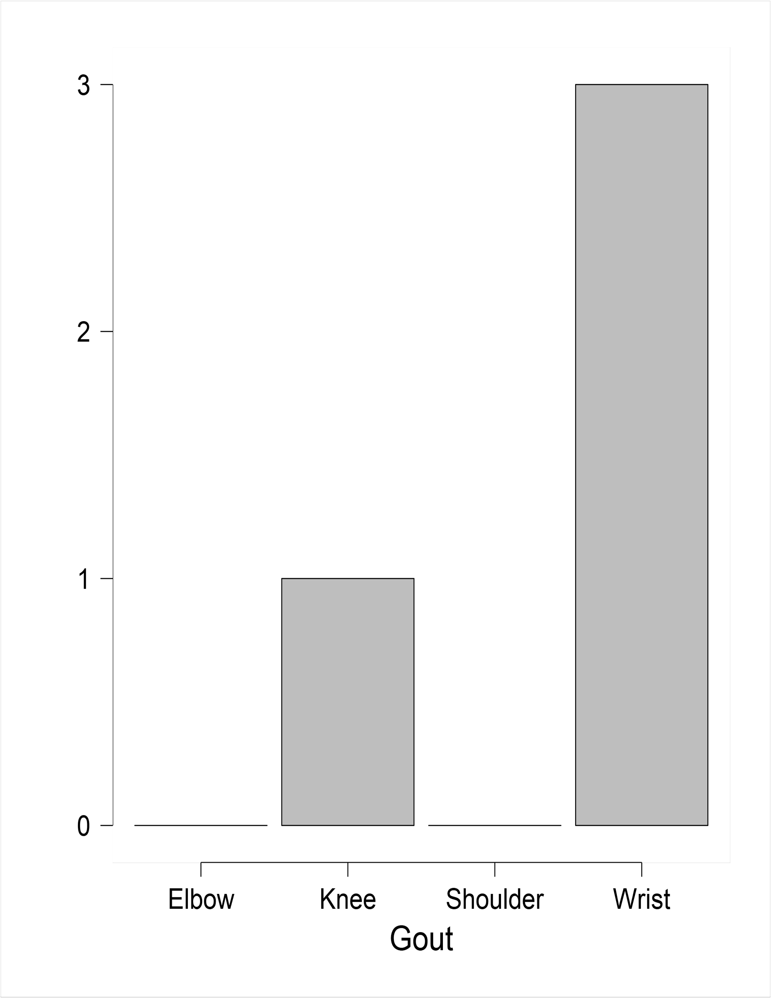
Figure 2. Pseudogout frequency
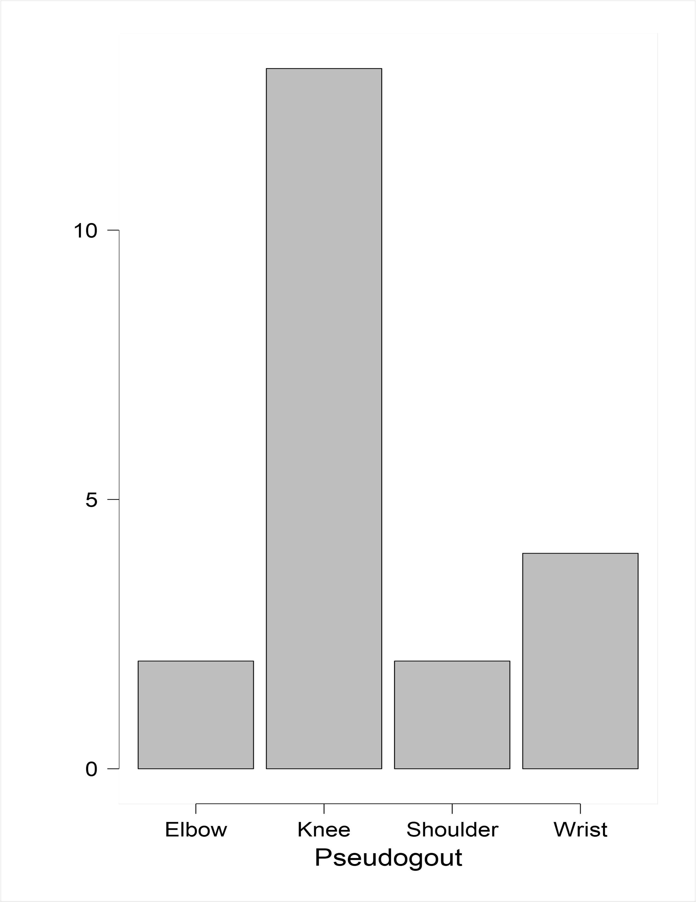

Figure 3. Descriptive plot of crystal results and age.

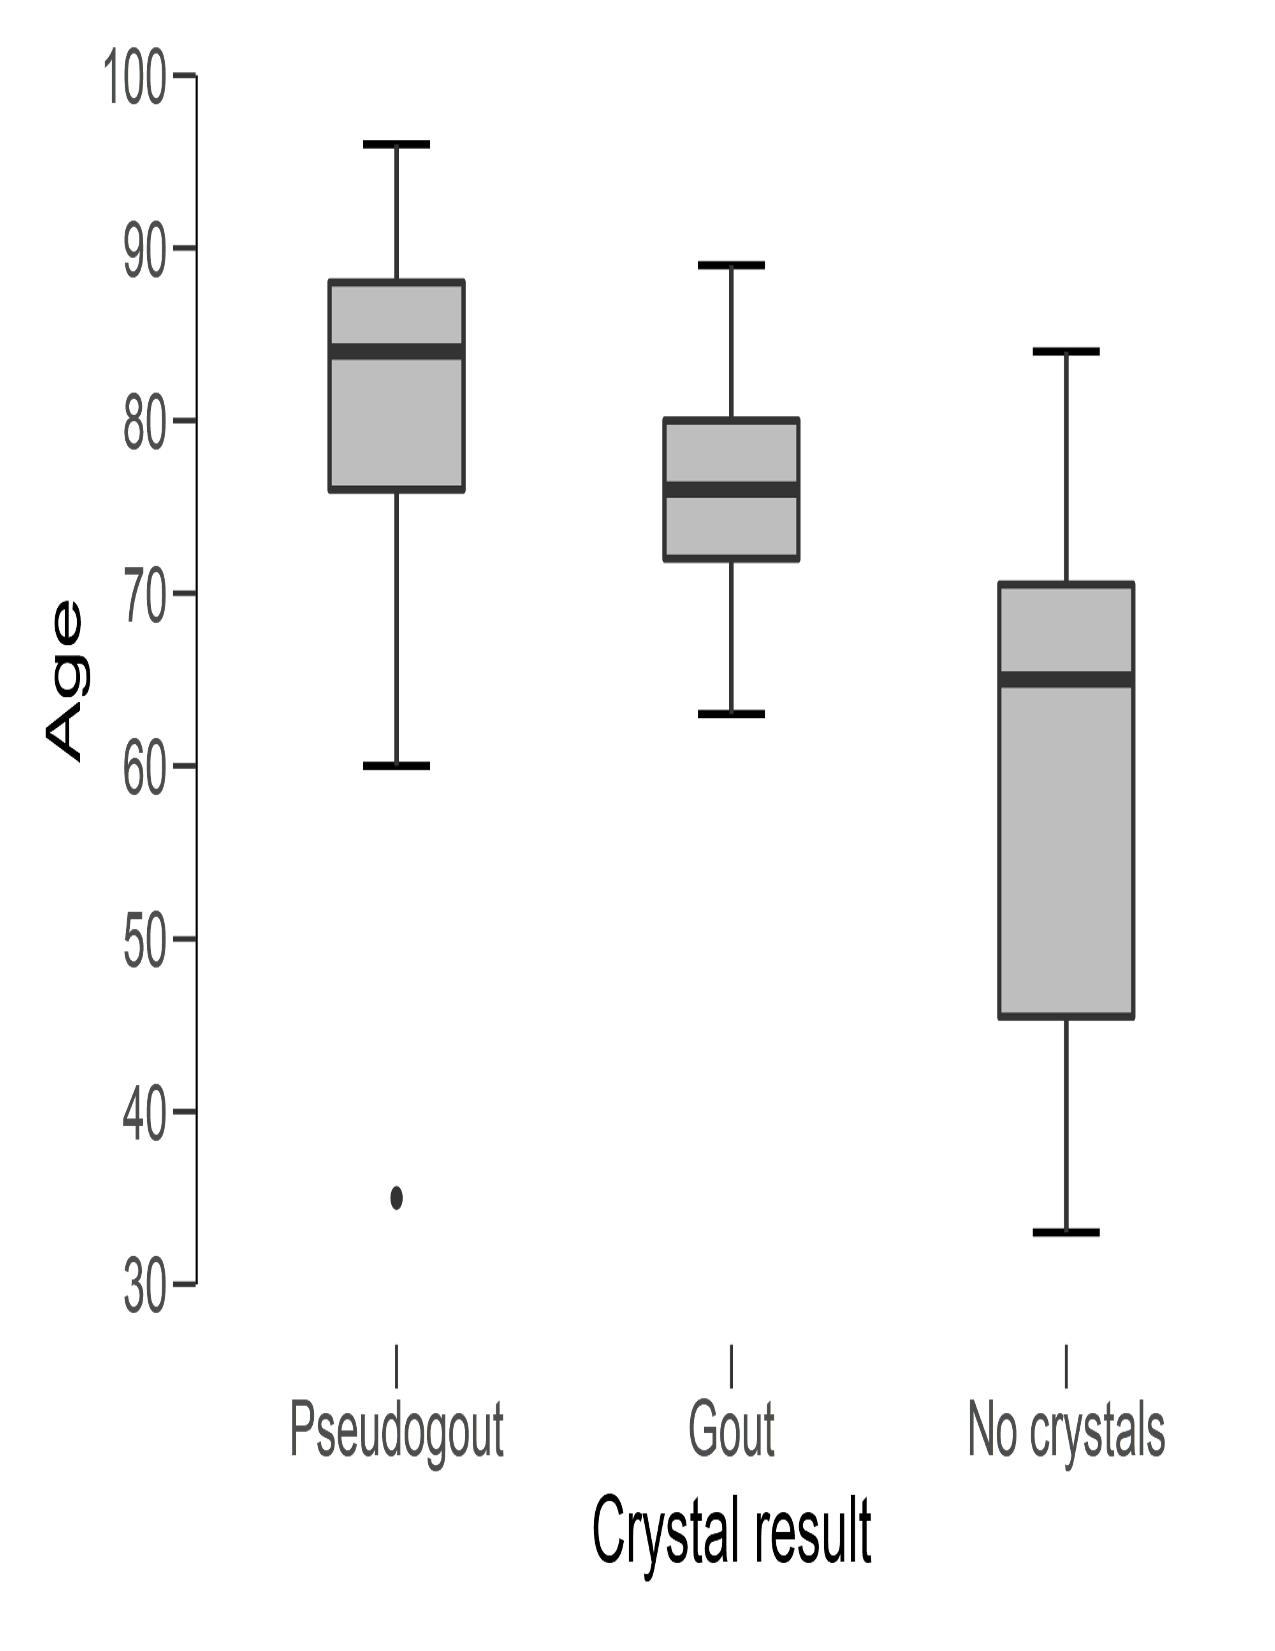

Table 1. Patients Characteristics and frequency of the joint involved
Sex |  | Joint | Frequency |  |  | % |  | Mean age
M |  |  |  |  |  |  |  | 70.36 ± 18.03
 |  | Knee |  | 15 |  | 68.2
 |  | Wrist |  | 4 |  | 18.2
 |  | Elbow |  | 2 |  | 9.1
 |  | Shoulder |  | 1 |  | 4.5
 |  | Total |  | 22 |  | 100.0
F |  |  |  |  |  |  |  | 76.71 ±16.45
 |  | Knee |  | 5 |  | 35.7
 |  | Wrist |  | 6 |  | 42.9
 |  | Elbow |  | 1 |  | 7.1
 |  | Shoulder |  | 2 |  | 14.3
 |  | Total |  | 14 |  | 100.0

Table2. Cytological exam results
Crystal result | Joint | Frequency | %
Pseudogout (Calcium Pyrophosphate) | Knee | 13 | 61.9
 | Wrist | 4 | 19.0
 | Elbow | 2 | 9.5
 | Shoulder | 2 | 9.5
 | Total | 21 | 100.0
Gout (Uric Acid) | Knee | 1 | 25.0
 | Wrist | 3 | 75.0
 | Elbow | 0 | 0.0
 | Shoulder | 0 | 0.0
 | Total | 4 | 100.0
No crystals | Knee | 6 | 54.5
 | Wrist | 3 | 27.3
 | Elbow | 1 | 9.1
 | Shoulder | 1 | 9.1
 | Total | 11 | 100.0

