SUPPORTING INFORMATION

Electrically controlled nano and micro actuation in memristive switching device with on-chip gas encapsulation
Dean Kos‡,¹ Hippolyte P.A.G. Astier‡,¹ Giuliana Di Martino,¹ Jan Mertens,¹ Hamid Ohadi,¹ Domenico De Fazio,² Duhee Yoon,² Zhuang Zhao,² Alex Kuhn,³ Andrea C. Ferrari,² Christopher J.B. Ford,¹ Jeremy J. Baumberg^{1,}*
¹ Cavendish Laboratory, J J Thomson Avenue, University of Cambridge, CB3 0HE, UK

² Cambridge Graphene Centre, 9 J J Thomson Avenue, CB3 0FA, Cambridge, UK
³ Univ. Bordeaux, CNRS 5255, Bordeaux INP, Site ENSCBP, 33607, Pessac, France
‡ These authors contributed equally to this work.
* Corresponding author

S1. Reservoir cooling
To demonstrate the presence of gas in the bubbles we monitor their temperature dependence. The inflated bubble is modelled as a spherical cap with base radius $a$ and height $h$ (Figure S1a). The AFM measured height and diameter records the values of $a$ and $h$ at room temperature (Figure S1b). The devices are cooled from 292K to 6K in an optical cryostat (Oxford Instruments Microstat He) with the sample held on a cold finger in vacuum. The bubble evolution is observed in situ through the cryostat window with a 50x microscope objective (0.4 N.A.) using a monochromatic LED light source (λ = 665nm). We record a set of images at different temperatures (Figure S1a,b) and extract the intensity pattern along the bubble diameter. Fringes observed result from the interference between the light reflected off the top surface of the bubble and off the bottom gold substrate (Figure S1a). The phase difference between the two is $Δϕ=2πnh/λ$, where $h$ is the height of the point along the cross section, $λ=665$nm, and refractive index $n=1$. Finally, we vary the geometric parameters in our model of the bubble to find the height that matches the interference pattern (Figure S1e). This two-dimensional model thus allows the bubble height to be reliably inferred from the observed temperature dependent interference patterns.
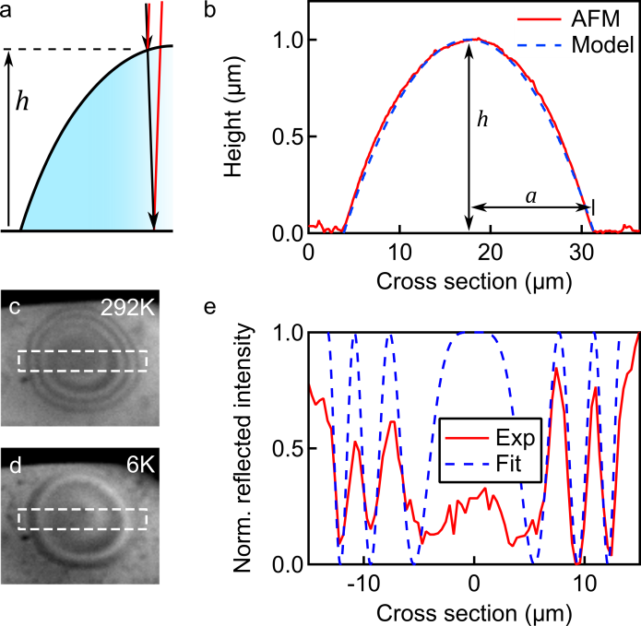
Figure S1 | Bubble reservoir cooling. a, Interference between light reflected from the top and bottom of the bubble reservoir. b, Cross-section of O₂ reservoir fitted shape compared to measured AFM profile at room temperature. c,d, Interference images of bubble reservoir inside the cryostat at 292K and 6K. Dashed lines show region used for the fit. e, Exemplar fit of interference pattern along the reservoir diameter at temperature of 70K.

S2. Pressure inside a reservoir
The internal pressure $P$ of the O₂ bubble reservoir, which has the shape of a spherical cap, is related to its geometrical properties by^{[1]}
 | $$P=\frac{E}{1-ν}\frac{8th^{3}}{3a^{4}}$$ | (1)

where $E$ is the Young’s modulus of the wall material, $ν$ its Poisson’s ratio, $t$ the wall thickness, $h$ the height of the cap and $a$ the base radius. The pressure therefore scales as $P∝(h^{3}/a^{4})$, rapidly decreasing with decreasing reservoir aspect ratio. By considering the wall composed of both Al₂O₃^{[2,3]} ($t=12.5$nm, $E=170$GPa, $ν=0.24$) and graphene^{[4,5]} ($t=0.34$nm, $E=1$TPa, $ν=0.13$), we thus obtain pressures in the range of 20±10atm (Figure S2) for the majority of bubbles. Because many reservoirs start forming simultaneously across the whole area of a device when voltage is applied, we find eq. (1) valid up to a reservoir diameter of approximately 5µm. Beyond this limit the boundaries of adjacent reservoirs start touching, leading to geometry rearrangements and mergers that do not preserve uniform wall thickness and increase the base areas.
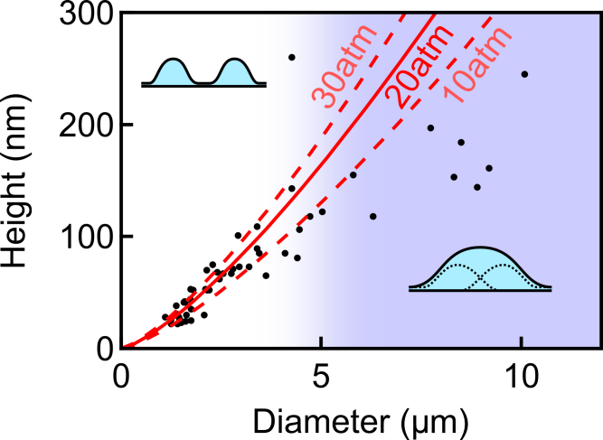
Figure S2 | Internal reservoir pressure. Distribution of bubble height vs diameter measured with AFM. In the small bubble regime (diameter <5µm), where reservoirs are separated from each other, most bubbles have an internal pressure of 20±10atm. In the large bubble regime (diameter >5µm), the reservoirs merge and the pressure scaling breaks down.

Once the reservoir size and pressure are known, we calculate the number of moles $n_{O_{2}}$ of O₂ inside the bubble from the ideal gas law:
 | $$n_{O_{2}}=\frac{PV}{RT}$$ | (2)
where $V$ is the bubble volume, $T$ is the temperature and $R=8.3$ JˑK⁻¹ˑmol⁻¹. Assuming the oxygen is extracted from the Al₂O₃ layer, using the density^{[6]} $d=2.8$g/cm³ and molar mass $MM{}_{Al_{2}O_{3}}=101.96$g/mol of Al₂O₃ we derive the fraction $f$ of the layer that has been converted at room temperature:
 | $$f=\frac{n_{O_{2}}}{n_{Al_{2}O_{3}}}=n_{O_{2}}\frac{MM_{Al_{2}O_{3}}}{πa^{2}td}$$ | (3)
Applying these calculations to the largest bubble shown in Figure S3, on which we performed the reflectivity measurements reported in the main text, we obtain a conversion fraction $f=60\%$. Completing analogous calculations on Al ($d=2.7$g/cm3, $MM_{Al}=26.98$g/mol)^{[7]}, we infer a metallic Al layer thickness on the reservoir around 6nm, which is compatible with what is obtained experimentally considering our approximations and the use of nominal parameter values in the calculation.
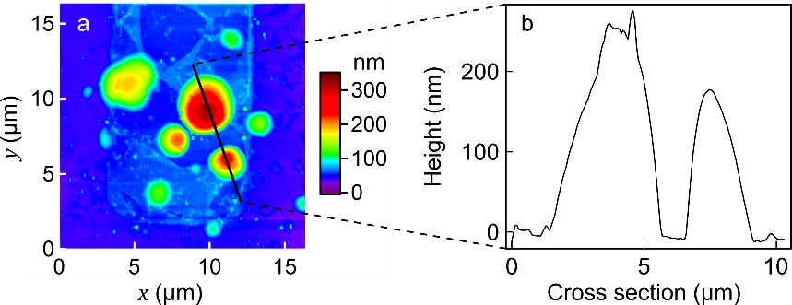
Figure S3 | High aspect ratio bubble AFM. Topography (a) and cross section (b) of a bubble with particularly high aspect ratio measured with AFM. With a height of 260nm and a base diameter of 4.26µm the calculated internal O₂ pressure is 73atm, corresponding to an O₂ conversion fraction of 70% and Al film thickness of 6nm.

From the bubble pressure we can also extract the scaling of the bubble height with temperature. The volume $V$ of a spherical cap with height $h$ and base radius $a$, with $a≫h$, is:
 | $$V=\frac{π}{6}h\left(3a^{2}+h^{2}\right)≈\frac{π}{2}ha^{2}$$ | (4)
Combining eq. (4) with eq. (1) and the ideal gas law we obtain:
 | $$T=\frac{PV}{nR}=\frac{E}{1-ν}\frac{4πt}{3nRa^{2}}h^{4}∝h^{4}$$ | (5)
and thus the height of the bubble scales with temperature as $h∝T^{1/4}$, as described in the main text.

S3. Multilayer model for reflectivity calculations
We apply a transfer matrix method model^{[8]} for one-dimensional multilayers to calculate the reflectivity of a bubble. The model captures the vertical layer structure of the bubble. Starting from the bottom we have a semi-infinite Si substrate, a 285nm insulating SiO₂ layer, a 100nm Au contact, layers of air, Al₂O₃ and metallic Al with thickness $t_{air}$, $t_{Al_{2}O_{3}}$ and $t_{Al}$ respectively, a 0.34nm layer of graphene ($n=2.6$, $k=1.3$)^{[9,10]}, and a semi-infinite air superstrate (Figure S4).

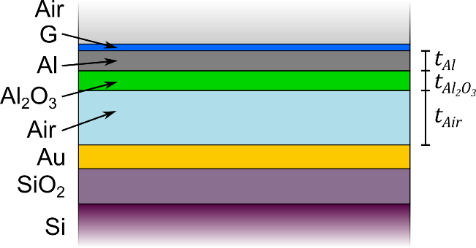

Figure S4 | Bubble multilayer model. Vertical layer profile used in bubble reflectivity calculations.

To highlight the contribution to the reflectivity given by the bubble alone, we normalise the reflectivity $R_{f}$ calculated using the structure in Figure S4 to the reflectivity $R_{i}$ of a region without any bubble, for which $t_{Air}=t_{Al}=0$ and $t_{Al_{2}O_{3}}$ has the nominal thickness of the Al₂O₃ layer. In our calculations, we vary the values $t_{air}$, $t_{Al_{2}O_{3}}$ and $t_{Al}$ in the bubble model to match the spectrum of $R_{f}/R_{i}$ obtained from reflectivity measurements. We observe that the major contribution to the reflectivity is provided by the metallic Al layer, whereas variations in the values of $t_{air}$ and $t_{Al_{2}O_{3}}$ have a marginal effect.

S4. Optical detection of switching cycles
Bubbles with diameter <2µm are problematic to detect in darkfield microscopy, and their small size does not allow reflectivity measurements. The height of such bubbles is 10-20nm, and the AuNP plasmonic coupling with the Au electrode thus provides a unique tool to detect their formation and growth in real time. Figure S5 shows the spectrum of a AuNP sitting on top of a bubble displaying multiple switching cycles. Positive voltages inflate the bubble, lifting the NP and causing a 10nm blueshift in the coupled mode peak from 645 to 635nm, whereas negative voltages fully deflate the bubble, inducing a redshift and restoring the initial NP spectrum. Applying the switching voltage for a longer time or increasing its magnitude inflates larger bubbles and causes greater NP spectrum shifts (50nm shift in Figure 3d). This demonstrates the plasmonic ruler to measure the actuation, the repeatability of subsequent cycles, and the ability to control height of actuation through the voltage applied.
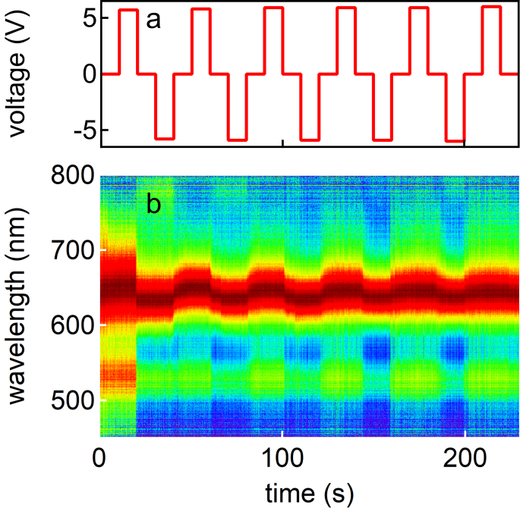
Figure S5 | Optical detection of bubble inflation/deflation. (a) Positive/negative voltage cycles of 5V amplitude. (b) Bubble inflation/deflation is tracked in real time through the spectrum of an AuNP sitting on top of the bubble.

S5. Stability of conductance in switching cycles
The I-V characteristic of a junction in subsequent switching cycles is measured at room temperature with voltage pulses distributed over 48h to assess retention of the on/off states. Figure S6 shows that the conductance (I/V) values remain stable within this time scale in the respective states. Voltage pulses with amplitude ≤0.1V leave the conductance state unchanged and can thus be used reliably for readout.
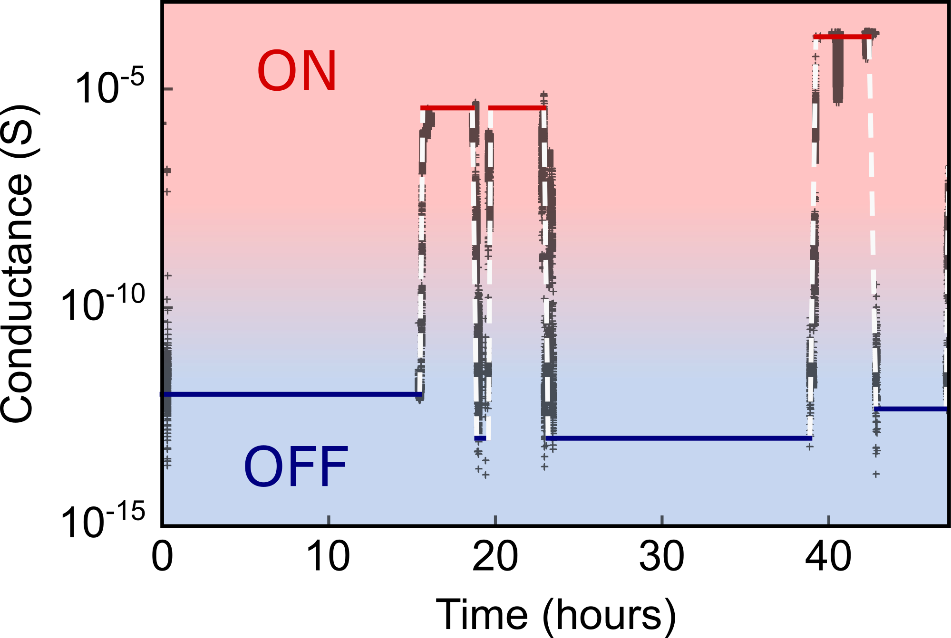
Figure S6 | Stability of switching cycles. Conductance as a function of time over 48h. On (red) and off (blue) states retain their conductance values, and the device state can be read using voltage pulses with amplitude ≤0.1V.

S6. Graphene growth
SLG is prepared via chemical vapour deposition (CVD) on 35µm-thick Cu, following ^{[11]}. Initially, Cu is annealed in H₂ atmosphere (∼200mTorr), by raising the temperature up to 100°C and keeping it constant for 30 minutes. Then, 5 sccm of CH₄ are added to the 20 sccm flow to initiate the growth, which lasts 30 minutes. The sample is then cooled in vacuum (∼1 mTorr) to room temperature and unloaded from the chamber.

S7. Graphene transfer
SLG is then transferred by wet transfer^{[12,13]} on top of the Al₂O₃/Au/SiO₂/Si substrate as follows: a PMMA layer is spin-coated at the surface of SLG/Cu and then placed in a solution of ammonium persulfate (APS) and DI water for Cu etching^{[14]}. The PMMA membrane with attached SLG is then transferred to a beaker filled with DI water for cleaning APS residuals and finally lifted with the target substrate.
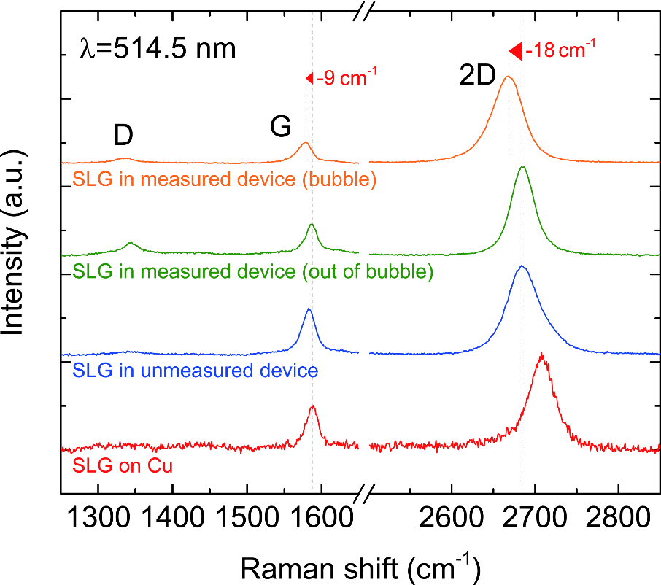
Figure S7 | Raman spectroscopy of SLG on different substrates. Red: SLG on Cu substrate (before deposition), blue: SLG on junction before applying voltage bias, green: SLG on inflated junction outside of a bubble, orange: SLG on inflated bubble. Shifts in the SLG on bubbles are attributed to doping and strain.

S8. Raman spectroscopy and strain measurement
Graphene is characterized by Raman spectroscopy after growth, after deposition on devices before measurement, and after activation of devices, through a Renishaw InVia spectrometer equipped with a 100× objective. The Raman spectra in Figure S7 are measured at 514.5nm.

The Raman spectrum of SLG on Cu (red line), before deposition onto the device, with the Cu photoluminescence subtracted^{[15]}, shows negligible D peak, indicating negligible defects^{[16,17]}. The 2D peak at ∼2707cm⁻¹ is a single Lorentzian fingerprint of SLG^{[18]}. The G peak at ∼1588cm⁻¹ has full width at half maximum (FWHM) 17cm⁻¹, while FWHM(2D)∼35cm⁻¹. The 2D to G intensity and area ratios are I(2D)/I(G) ∼2.2 and A(2D)/A(G)∼4.6, respectively.

SLG tranferred on Al₂O₃/Au/SiO₂/Si is again characterized by Raman spectroscopy (blue curve). The Au photoluminescence has been subtracted to analyze the features of the SLG. The positions of the G and 2D peak are Pos(G)∼1583cm⁻¹ and Pos(2D)∼2686cm⁻¹. FWHM(G) and FWHM(2D) are ∼21cm⁻¹ and ∼45cm⁻¹. I(2D)/I(G)∼1.9 and A(2D)/A(G)∼4.4, corresponding to a p doping ∼300 meV^{[19]}. A D peak is present with I(D)/I(G)∼0.06, indicating that defects are induced by the transfer process. After electrical measurements I(D)/I(G)~0.4 away from the bubble (green curve) and~0.25 on top of the bubble (orange curve), indicating significant defect formation. Furthermore, away from the bubble we have Pos(G)~1586cm⁻¹, Pos(2D)~2685cm⁻¹, FWHM(G)~19cm⁻¹, and FWHM(2D)~32cm⁻¹, with I(2D)/I(G)~2.8 and A(2D)/A(G)~5.4, corresponding to~250 meV p-doping^{[19,20]}. On the bubble: Pos(G)~1577cm⁻¹, Pos(2D)~2667cm⁻¹, FWHM(G)~23cm⁻¹, and FWHM(2D)~41cm⁻¹, with I(2D)/I(G)~4.2 and A(2D)/A(G)~7.5, corresponding to~150 meV doping.
We observe a red-shift of Pos(G) and Pos(2D) on the bubble: ~-9 and -18cm⁻¹, respectively. Doping^{[19,20]} and strain^{[5,21]}, can cause shifts of the Raman peaks. A 100 meV smaller p-doping causes red shifts of G and 2D peaks ~-2.5 and ~-1 cm⁻¹, while the rest of the shift is caused by strain. The peak shift rates with respect to biaxial tensile strain are -70cm⁻¹/% and -160cm⁻¹/% for the G and 2D peaks, respectively^{[16,17]}. Thus, we estimate a ~0.1% biaxial strain^{[22]}.

References
[1] M. K. Small, W. D. Nix, Journal of Materials Research 1992, 7, 1553.
[2] G. Simmons, H. Wang, Single Crystal Elastic Constants and Calculated Aggregate Properties: A Handbook, M.I.T. Press, Cambridge, Mass, 1971.
[3] M. K. Tripp, C. Stampfer, D. C. Miller, T. Helbling, C. F. Herrmann, C. Hierold, K. Gall, S. M. George, V. M. Bright, Sensors and Actuators A: Physical 2006, 130, 419.
[4] C. Lee, X. Wei, J. W. Kysar, J. Hone, Science 2008, 321, 385.
[5] T. M. G. Mohiuddin, A. Lombardo, R. R. Nair, A. Bonetti, G. Savini, R. Jalil, N. Bonini, D. M. Basko, C. Galiotis, N. Marzari, K. S. Novoselov, A. K. Geim, A. C. Ferrari, Phys. Rev. B 2009, 79, 205433.
[6] M. D. Groner, F. H. Fabreguette, J. W. Elam, S. M. George, Chem. Mater. 2004, 16, 639.
[7] P. Enghag, Encyclopedia of the Elements: Technical Data - History - Processing - Applications, John Wiley & Sons, 2008.
[8] A. Kavokin, Ed. , Microcavities, Oxford University Press, Oxford ; New York, 2011.
[9] M. Bruna, S. Borini, Appl. Phys. Lett. 2009, 94, 031901.
[10] P. Blake, E. W. Hill, A. H. Castro Neto, K. S. Novoselov, D. Jiang, R. Yang, T. J. Booth, A. K. Geim, Appl. Phys. Lett. 2007, 91, 063124.
[11] X. Li, W. Cai, J. An, S. Kim, J. Nah, D. Yang, R. Piner, A. Velamakanni, I. Jung, E. Tutuc, S. K. Banerjee, L. Colombo, R. S. Ruoff, Science 2009, 324, 1312.
[12] F. Bonaccorso, A. Lombardo, T. Hasan, Z. Sun, L. Colombo, A. C. Ferrari, Materials Today 2012, 15, 564.
[13] F. Bonaccorso, Z. Sun, T. Hasan, A. C. Ferrari, Nature Photonics 2010, 4, 611.
[14] S. Bae, H. Kim, Y. Lee, X. Xu, J.-S. Park, Y. Zheng, J. Balakrishnan, T. Lei, H. Ri Kim, Y. I. Song, Y.-J. Kim, K. S. Kim, B. Özyilmaz, J.-H. Ahn, B. H. Hong, S. Iijima, Nature Nanotechnology 2010, 5, 574.
[15] A. A. Lagatsky, Z. Sun, T. S. Kulmala, R. S. Sundaram, S. Milana, F. Torrisi, O. L. Antipov, Y. Lee, J. H. Ahn, C. T. A. Brown, W. Sibbett, A. C. Ferrari, Appl. Phys. Lett. 2013, 102, 013113.
[16] A. C. Ferrari, D. M. Basko, Nature Nanotechnology 2013, 8, 235.
[17] L. G. Cançado, A. Jorio, E. H. M. Ferreira, F. Stavale, C. A. Achete, R. B. Capaz, M. V. O. Moutinho, A. Lombardo, T. S. Kulmala, A. C. Ferrari, Nano Lett. 2011, 11, 3190.
[18] A. C. Ferrari, J. C. Meyer, V. Scardaci, C. Casiraghi, M. Lazzeri, F. Mauri, S. Piscanec, D. Jiang, K. S. Novoselov, S. Roth, A. K. Geim, Phys. Rev. Lett. 2006, 97, 187401.
[19] D. M. Basko, S. Piscanec, A. C. Ferrari, Phys. Rev. B 2009, 80, 165413.
[20] A. Das, S. Pisana, B. Chakraborty, S. Piscanec, S. K. Saha, U. V. Waghmare, K. S. Novoselov, H. R. Krishnamurthy, A. K. Geim, A. C. Ferrari, A. K. Sood, Nature Nanotechnology 2008, 3, 210.
[21] D. Yoon, Y.-W. Son, H. Cheong, Phys. Rev. Lett. 2011, 106, 155502.
[22] J. Zabel, R. R. Nair, A. Ott, T. Georgiou, A. K. Geim, K. S. Novoselov, C. Casiraghi, Nano Lett. 2012, 12, 617.

