Author MS, accepted for publication in CNS Spectrums on 19.4.2019

Cold Pressor Pain and Gambling Disorder:
Implications for the Opioid System
Jon E. Grant, MDª
Samuel R. Chamberlain MD, PhD^{b}

ªDepartment of Psychiatry & Behavioral Neuroscience
University of Chicago, Chicago, IL, USA
^{b}Department of Psychiatry, University of Cambridge; & Cambridge and Peterborough NHS Foundation Trust (CPFT), UK

Address correspondence to:
Jon E. Grant, JD, MD, MPH
Professor, Department of Psychiatry & Behavioral Neuroscience
University of Chicago, Pritzker School of Medicine, 5841 S. Maryland Avenue, MC 3077
Chicago, IL 60637
Phone: 773-834-1325; Fax: 773-834-6761; Email: jongrant@uchicago.edu

Abstract

Objective: Gambling disorder (GD) is a common, disabling condition that often is exacerbated by stressful life events. Under stress, the sympathetic nervous system and the HPA axis are activated. The question therefore arises as to whether an abnormal sympathetic response can be found in individuals with GD.
Method: Adult individuals with GD and no current co-occurring mental disorders were enrolled. Participants completed impulsivity and gambling related questionnaires and underwent cold pressor evaluation. GD participants were compared to controls on measures of heart rate, blood pressure and pain.
Results: 15 people with GD and 18 controls completed the study. Kaplan-Meier analysis indicated that the GD group withdrew their hand from the painful stimulus more rapidly than controls (Wilcoxon chi-square = 3.87, p=0.049) suggestive of lesser pain tolerance. Subjective pain ratings and cardiovascular measurements did not significantly differ between groups.
Conclusions: Individuals with GD manifested a relative intolerance on pain on the Cold Pressor paradigm, even though they physiologically did not seem to experience greater pain. Given the role of the opioid system in pain processing, it would be valuable in future work to examine whether Cold Pressor measures can predict response to treatments in GD, including with opioid antagonists.
Keywords: gambling disorder, cold pressor test, pain, autonomic

Introduction
Gambling disorder (GD) is a significant public health problem affecting 0.4% to 1% of the US population, also being prevalent in many other countries.¹⁻² Psychosocial impairment, financial and family problems, as well as elevated rates of suicide are common among individuals with GD.³ Gambling disorder can be conceptualized from a neurobiological perspective in terms of excessive drive from subcortical regions involved in reward processing coupled with diminished top-down control from prefrontal cortical regions.⁴ Meta-analyses have confirmed that GD is associated with impulsivity (indicative of loss of top-down control) across a number of domains, as compared to controls.⁵⁻⁷ In a recent Delphi consensus study, impulsivity was highlighted as an important construct in understanding addictive problems more broadly.⁸ Top-down control for many individuals with GD is more difficult under stress.⁹ Furthermore, people with disordered gambling commonly report stress both as a trigger to more severe gambling episodes as well as a to relapse when attempting abstinence.¹⁰ Stress, and aberrant responses to stress, are implicated in etiological models of Gambling Disorder.¹¹⁻¹⁵ When one is subjected to a stressor, activation of the sympathetic system and the hypothalamic-pituitary-adrenal (HPA) axis occurs.¹⁶⁻¹⁷ It has been hypothesized that alterations in HPA axis function may play a role in various stages of addiction, including initiation, maintenance, and relapse.¹⁸⁻¹⁹
While losing everything on gambling would likely be psychologically painful for healthy individuals, those with GD report gambling episodes lasting several hours, resulting in significant personal and financial ruin,²⁰ which may suggest changes in pain perception – such as loss of pain sensitivity. Conversely, research suggests that in some individuals with GD, the inability to cope with painful or uncomfortable physical sensations may drive the gambling behavior, suggestive of a general inability to cope with discomfort.²¹⁻²⁵ To date, little research has examined whether individuals with GD experience pain differently from healthy controls. Therefore, the question remains as to whether adults with GD have different pain thresholds, pain tolerances, or autonomic responses to painful stimuli, as contrasted to people without this disorder.
One means of understanding pain perception is via the cold pressor test. The cold pressor test requires a person to immerse their hands in ice-cooled water until the task becomes too uncomfortable. Although the role of aberrant pain transmission in GD has not been previously examined, a general understanding of pain suggests that noxious cold cutaneous sensations are recognized primarily by the cold-sensitive ion channel TRPM8 before sensory signal transduction.²⁶ Functional neuroimaging data reveals that noxious cold stimulation applied to the upper limbs of healthy subjects activates the amygdala and anterior cingulate cortex, regions classically implicated in aversive emotional processing.²⁷ Intriguingly, limited imaging data implicate the anterior cingulate cortex and amygdala in the pathophysiology of GD.²⁸ Using the cold pressor test, and based on the clinical data regarding GD, we hypothesized that adults with GD would exhibit a dampened autonomic response to pain compared to healthy controls. In addition, we hypothesized that adults with GD would subjectively report less discomfort when undergoing the cold pressor task and that pain sensitivity would significantly and negatively correlate with worse gambling symptom severity.

Materials and Methods
Participants
Adult men and women with a current primary diagnosis of GD, based on DSM-5 criteria (see later for diagnostic methods), were recruited by media advertisements, referrals, and in person at the University of Chicago. Age and gender-matched healthy controls were recruited by word of mouth and through poster and newspaper advertisements. All control group participants were free of any current psychiatric disorder, as measured using the Mini International Neuropsychiatric Inventory (MINI),²⁹ and Minnesota Impulse Disorder Inventory (MIDI).³⁰⁻³¹
Exclusion criteria across all participants included: 1) current psychiatric disorder (other than GD in the GD group); 2) use of any psychotropic medication; 3) history of therapy for GD; 4) current nicotine dependence; 5) history of Raynaud’s phenomenon; 6) history of cardiovascular disorder; 7) open cuts or sores on the hands; 8) history of fainting or seizures; 9) fracture of the limb to be submersed; 10) history of frostbite; and (11) an inability to understand or undertake the procedures or an inability to provide written informed consent.
The Institutional Review Board (IRB) of the University of Chicago approved the study and consent procedures, which followed the Declaration of Helsinki’s ethical principles for medical research involving human participants. After a complete description of study procedures, participants were given the opportunity to ask questions and provided voluntary informed consent using the IRB-approved consent form. Subjects were compensated with $10 cash at the end of the visit.
Procedures
Demographics and clinical features of GD were assessed with an unpublished semi-structured interview, in both cases and controls (available on request from the authors). The diagnosis of GD was confirmed using the Structured Clinical Interview for Gambling Disorder³² modified for DSM-5. Psychiatric comorbidity was assessed using the Mini International Neuropsychiatric Inventory (MINI)²⁹, and Minnesota Impulse Disorder Inventory.³⁰⁻³¹ Gambling severity measures were the Yale Brown Obsessive Compulsive Scale modified for Pathological Gambling (PG-YBOCS) (a 10-item clinician-administered scale that assesses gambling symptoms during the last seven days)³³; and the Gambling Symptom Assessment Scale (G-SAS) (a 12-item self-report scale of gambling symptoms over the past seven days).³⁴ We also assessed impulsive personality traits in the gambling group using the Barratt Questionnaire.³⁵
We examined pain perception using the Cold Pressor Test (CPT), a reliable and valid pain induction method³⁶ that requires participants to submerge their non-dominant hand in a 85-fluid ounce container filled with ice water at a temperature between 0-4° C. Participants were instructed to keep their hand open (rather than in a closed fist position) while it was in the water. Before immersion, participants were told to keep the hand in the water until the pain became intolerable or until the cutoff time of 3 minutes was reached. During the task, subjects rated their pain at 15-second intervals using an adapted version of the Wong-Baker Faces Pain Rating Scale (0 [not painful at all] to 100 [extremely painful] with intermediate ratings marked on the Likert scale 25 [somewhat painful], 50 [moderately painful], and 75 [very painful]).³⁷⁻³⁸ Pain ratings were displayed on a large poster in a line from 0-100. Latency to pain tolerance (when the hand was voluntarily withdrawn) was measured with a stopwatch in seconds. Heart rate and blood pressure were recorded using an automated digital device: heart rate every 15 seconds, and blood pressure at baseline and at point of hand withdrawal. Because the CPT may cause physical discomfort or psychological stress, participants were free to discontinue the task at any point.

Data Analysis
Demographic measures were compared between the GD and the control groups using one way analysis of variance or equivalent non-parametric tests as indicated in the text. Kaplan-Meier curve analysis was used to explore whether the two groups differed in pain tolerance, i.e. length of time before withdrawing their hand from cold water (Wilcoxon chi-square test). Kaplan-Meier analysis is ideal for use in situations whereby a period of time is monitored and times-to-event (in this case, withdrawal of the hand) differ between subjects, and cannot always be determined (i.e. here, when subjects reached the study time cap, and had still not withdrawn their hand).³⁹ Subjective pain ratings and cardiovascular parameters were analyzed using full factorial mixed modelling (method: restricted maximum likelihood, REML; effects of time, group, time x group) with subject (nested by group) included as a random effect. Where any evidence of effects of group was found, potential relationships with participant age (all subjects), and with symptom severity in the GD group, were explored using Pearson’s r. Statistical significance was defined as p<0.05 uncorrected. Statistical analyses were conducted using JMP Pro software.

Results
The mean (SD) age in the GD and control groups respectively were 47.5 (13.6) and 31.4 (8.8) years, the GD group being significantly older (F=16.92, p<0.001). Groups did not differ significantly in terms of gender (GD 7F, 7M; controls 14F, 4M; Likelihood Ratio Chi-square = 3.465, p=0.063). The mean PG-YBOCS and G-SAS scores for the GD participants were 20.6 (5.9) and 26.9 (10.7), respectively, which equates to on average moderate severity of symptoms. The mean age at onset for those with GD was 20.9 (6.4) years.

Cold Pressor Test
The key findings are summarized for convenience in Table 1, and are outlined in further detail below.

Table 1. Summary of key findings from CPT challenge in Gambling disorder versus controls.
CPT Related Measure | Description | Key Finding
Pain tolerance | Kaplan-Meier analysis of time to hand withdrawal | Significantly earlier hand withdrawal in GD versus controls
Subjective pain ratings | Serial visual analogue assessment of subjective pain, analysed using mixed model | No significant group differences (or group by time interactions)
Pulse rate | Serial pulse rate recordings, analysed using mixed model | No significant group differences (or group by time interactions)
Blood pressure | Serial systolic and diastolic blood pressure recordings, analysed using mixed model | No significant group differences (or group by time interactions)

Pain tolerance
Kaplan-Meier analysis (Figure 1) indicated that the GD group withdrew their hand from the painful stimulus more readily than controls (Wilcoxon chi-square = 3.87, p=0.049). Survival time did not relate significantly to age across subjects (p=0.2663), nor to symptom severity (PG-YBOCS total scores) in the GD group (p=0.371), nor to Barratt impulsivity scores in the GD group (p=0.13).

Figure 1. Kaplan-Meier curve showing proportion of subjects (Y-Axis) keeping hand in cold water over time (X-Axis). Top line (red in color version): controls; bottom line (blue in color version): Gambling Disorder

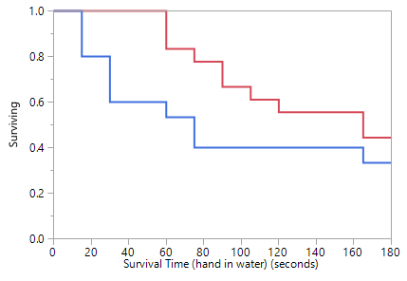

Subjective pain ratings
Mixed modelling indicated that there was a significant effect of time on subjective pain ratings (F=42.78, p<0.001; see Figure 2). There was no significant effect of group (F<0.01, p>0.99), nor was there a significant group x time interaction (F=0.878, p=0.570). The effect of time was mainly due to subjective pain ratings increasing between baseline and +15 seconds (t=9.87, p<0.001), then again between +15 and +30 seconds (t=2.74, p=0.007), whereas changes between other sequential timepoints were non-significant (all p>0.10) except for a significant increase between +45 seconds and +60 seconds (t=2.22, p=0.03).

Figure 2. Mean (SEM) subjective pain rating (range 0-100) over time in controls (top) and Gambling Disorder (Bottom).
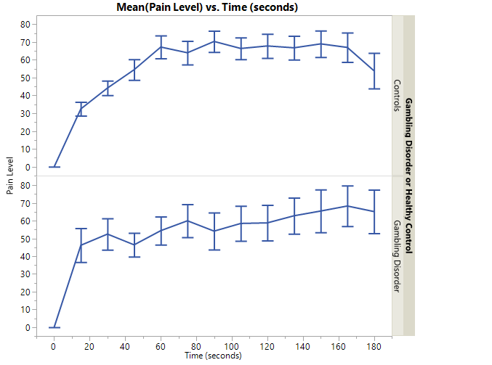

Cardiovascular parameters
For pulse rate (Figure 3), mixed modelling indicated a significant effect of time (F=5.781, p<0.001). There was no significant effect of group (F=1.184, p=0.283), nor was there a significant group x time interaction (F=1.117, p=0.347). The main effect of time was mainly due to pulse increasing significantly from baseline to +15 seconds in the pooled sample (t=6.08, p<0.001), whereas other step-by-step changes over time were generally insignificant (all p>0.10). Mixed modelling indicated that there was a significant effect of time on systolic blood pressure (F=10.03, p<0.001; see Figure 4, top panel). There was no main effect of group (F=0.285, p=0.600), nor was there a significant group x time interaction (F=1.03, p=0.385). Overall, systolic blood pressure increased significantly between baseline and 30 seconds of pain challenge (t=2.70, p=0.009), then was similar to +30 seconds at hand withdrawal (t=0.48, p=0.636), and then significantly reduced again after pain had resolved (t=-0.472, p<0.001). For diastolic blood pressure, there was a significant main effect of time (F=21.36, p<0.001; see Figure 4, bottom panel). There was no significant main effect of group (F=0.712, p=0.402), nor was there a significant group x time interaction (F=1.451, p=0.234). Overall, diastolic blood pressure increased significantly between baseline and 30 seconds of pain challenge (t=5.96, p<0.001), then remained similar from 30 seconds through to hand withdrawal (t=-1.28, p=0.203), then decreased significantly again after pain had resolved (t=-5.38, p<0.001).

Figure 3. Mean (SEM) pulse rate (in beats per minute, bpm) at each recorded point in controls (top graph), and Gambling Disorder (bottom graph).

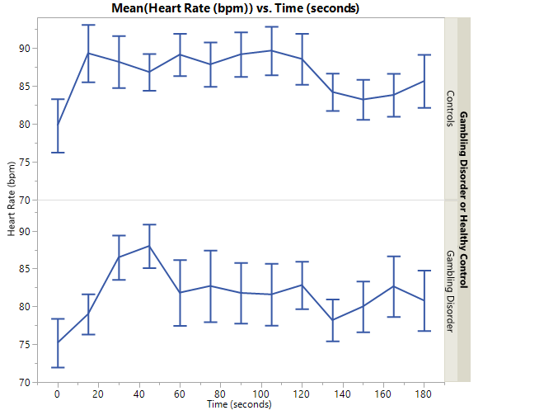

Figure 4. Top Panel: Mean (SEM) systolic blood pressure at each recorded point in controls (top graph) and Gambling Disorder (bottom graph). Bottom Panel: Mean (SEM) diastolic blood pressure at each recorded point in controls (top graph) and Gambling Disorder (bottom graph)
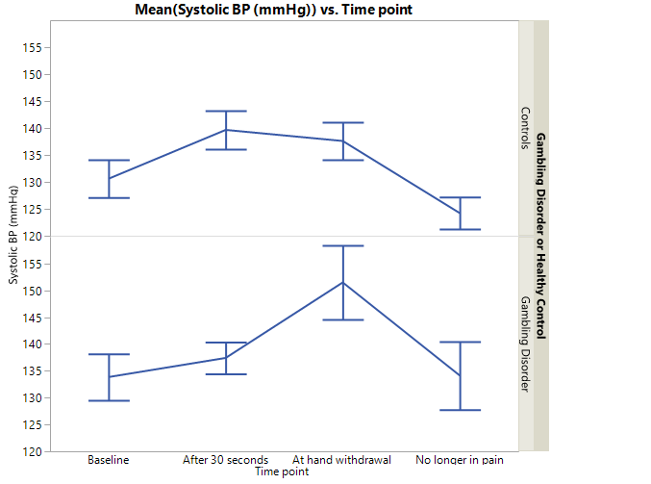
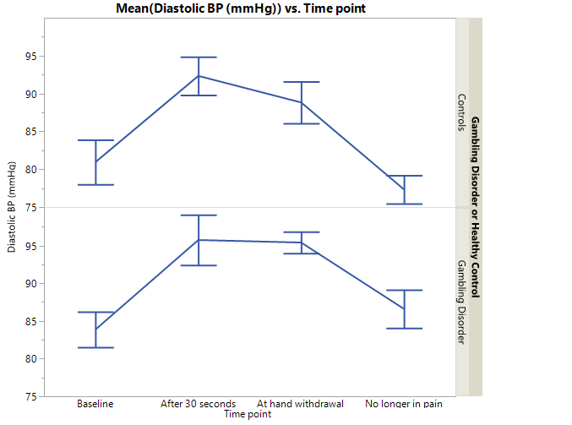
Discussion
In this study, and contrary to our hypothesis, adults with GD failed to exhibit a different autonomic response to pain during the CPT when compared to control participants. GD participants however pulled their hands out of the water quicker and thereby exhibited an inability to tolerate the discomfort of the CPT, as indicated by Kaplan-Meier analysis. Taken together, these findings suggest that GD may be associated with greater difficulty or tolerance of discomfort. This biological finding is in keeping with clinical observations that have reported stress as a trigger to gambling behavior in individuals with GD.²¹⁻²⁵ Gambling itself may serve a function of allowing the person to escape unpleasant or stressful events, ironically though resulting in possibly more stress due to the financial and personal problems associated with gambling. These findings may suggest a need to include stress coping skills modules in the psychotherapy used to treat GD.
These finding are also potentially interesting when seen in light of pharmacological treatment for GD. Opioid antagonists have generally produced positive results in GD and may even be considering first-line pharmacotherapy for the disorder,³⁹⁻⁴³ but many individuals fail to respond to opioid antagonists. Opioid receptors influence the sensation of pleasure and pain. Given their ability to block opioid receptors, opioid antagonists have been used to dampen painful stimuli. Studies examining the stress response in GD may thereby lay the groundwork for future studies to see if stress response could be a useful biomarker for subsequent treatment response to an opioid antagonist.
This study has several limitations. First, because a small sample was used, it is unclear how generalizable our results are to the larger population of individuals with GD. Second, groups differed on age; however, we found no evidence that age was correlated with the cardinal measure of pain tolerance on the CPT, hence we feel it unlikely that this contributed to the key finding. Third, we used a well-respected model of pain perception (the cold pressor test), but other methods of assessing response to painful stimuli could theoretically yield different results, such as if the model utilized a different pain modality. Despite these limitations, the study inclusion/exclusion was fairly broad and the study used both objective measures of heart rate and blood pressure. Lastly, statistical power might have been limited to detect more subtle differences between groups, or correlations between cold pressor measures and symptom severity in patients.

Conclusion
In conclusion, these results suggest that adults with GD may have decreased ability to cope with painful stimuli, as indexed by an objective pain challenge task (Cold Pressor). Future research should be directed at understanding the mechanisms of pain regulation in GD, and whether these mechanisms can be targeted with novel interventions with a view to helping patients reduce the frequency of gambling behavior. In light of these findings, it would also be interesting to examine whether baseline Cold Pressor measures are predictive of who does or does not experience symptomatic improvement following treatments, such as with opioid antagonists.

Acknowledgment of Funding: Internal funds

Declaration of interest: Dr. Grant has received research grants from the TLC Foundation for Body Focused Repetitive Behaviors and, Takeda Pharmaceuticals. He receives yearly compensation from Springer Publishing for acting as Editor-in-Chief of the Journal of Gambling Studies and has received royalties from Oxford University Press, APPI, Norton Press, and McGraw Hill. Dr. Chamberlain’s involvement in this research was funded by a grant from the Wellcome Trust Intermediate Clinical Fellowship (110049/Z/15/Z). Dr. Chamberlain consults for Cambridge Cognition, Promentis, Ieso, and Shire. Dr. Chamberlain receives a stipend for his role as associate editor at Comprehensive Psychiatry; and at Neuroscience and Biobehavioral Reviews.

References
- Ferguson CJ, Coulson M, Barnett J. A meta-analysis of pathological gaming prevalence and comorbidity with mental health, academic and social problems. J Psychiatr Res 2011; 45(12):1573-8.
- Nowak DE. A Meta-analytical Synthesis and Examination of Pathological and Problem Gambling Rates and Associated Moderators Among College Students, 1987-2016. J Gambl Stud 2018 Jun;34(2):465-498.
- Grant JE, Schreiber L, Odlaug BL, et al. Pathologic gambling and bankruptcy. Compr Psychiatry 2010; 51(2): 115-20.
- Grant JE, Chamberlain SR. Impulsive action and impulsive choice across substance and behavioral addictions: cause or consequence? Addict Behav 2014; 39(11):1632-9.
- Marazziti D, Picchetti M, Baroni S, Consoli G, Ceresoli D, Massimetti G, Catena Dell'Osso M. Pathological gambling and impulsivity: an Italian study. Riv Psichiatr. 2014 Mar-Apr;49(2):95-9.
- Chowdhury NS, Livesey EJ, Blaszczynski A, Harris JA. Pathological Gambling and Motor Impulsivity: A Systematic Review with Meta-Analysis. J Gambl Stud. 2017 Dec;33(4):1213-1239.
- Ioannidis K, Hook R, Wickham K, Grant JE, Chamberlain SR. Impulsivity in Gambling Disorder and problem gambling: a meta-analysis. Neuropsychopharmacology. 2019 Apr 16. [Epub ahead of print]
- Yücel M, Oldenhof E, Ahmed SH, et al. A transdiagnostic dimensional approach towards a neuropsychological assessment for addiction: an international Delphi consensus study. Addiction. 2018 Aug 22. [Epub ahead of print]
- Goudriaan AE, Yucel M, Van Holst RJ. Getting a grip on problem gambling: what can neuroscience tell us? Front Behav Neurosci 2014; 8:141.
- Oakes J, Pols R, Battersby M, et al. A focus group study of predictors of relapse in electronic gaming machine problem gambling, part 1: factors that 'push' towards relapse. J Gambl Stud 2012; 28(3): 451-64.
- Blaszczynski A, Nower L. A pathways model of problem and pathological gambling. Addiction 2002; 97(5):487-99.
- Nower L, Martins SS, Lin KH, et al. Subtypes of disordered gamblers: results from the National Epidemiologic Survey on Alcohol and Related Conditions. Addiction 2013; 108 (4):789-98.
- Sharpe L. A reformulated cognitive-behavioral model of problem gambling. A biopsychosocial perspective. Clin Psychol Rev 2002; 22(1): 1-25.
- Sharpe L, Tarrier N. Towards a cognitive-behavioural theory of problem gambling. Br J Psychiatry 1993;162: 407-12.
- Valleur M, Codina I, Venisse JL, et al. Towards a Validation of the Three Pathways Model of Pathological Gambling. J Gambl Stud 2016; 32(2):757-71.
- Tassorelli C, Micieli G, Osipova V, et al., Pupillary and cardiovascular responses to the cold-pressor test. J Auton Nerv Syst 1995;55(1-2):45-9.
- Velasco M, Gomez J, Blanco M et al. The cold pressor test: pharmacological and therapeutic aspects. Am J Ther 1997;4(1):34-8.
- Kreek MJ. Cocaine, dopamine and the endogenous opioid system. J Addict Dis 1996;15(4): 73-96.
- Kreek MJ. Opioid receptors: some perspectives from early studies of their role in normal physiology, stress responsivity, and in specific addictive diseases. Neurochem Res 1996; 21(11):1469-88.
- Grant JE, Kim SW. Demographic and clinical features of 131 adult pathological gamblers. J Clin Psychiatry 2001;62(12):957-62.
- Barry DT, Pilver C, Potenza MN, et al. Prevalence and psychiatric correlates of pain interference among men and women in the general population. J Psychiatr Res 2012;46 (1):118-27.
- Barry DT, Pilver CE, Hoff RA, et al. Pain interference and incident mood, anxiety, and substance-use disorders: findings from a representative sample of men and women in the general population. J Psychiatr Res 2013;47(11):1658-64.
- Barry DT, Pilver CE, Hoff RA, et al. Pain Interference, Gambling Problem Severity, and Psychiatric Disorders among a Nationally Representative Sample of Adults. J Behav Addict 2013; 2(3):138-144.
- Ekholm O, Davidsen M, Larsen CVL, et al. A nationwide study of health-related quality of life, stress, pain or discomfort and the use of medicine among problem gamblers. Scand J Public Health 2018;46(5):514-521.
- Parke A, Griffiths M, Pattinson J, et al. Age-related physical and psychological vulnerability as pathways to problem gambling in older adults. J Behav Addict 2018; 7(1): 137-145.
- Winchester WJ, Gore K, Glatt S, et al. Inhibition of TRPM8 channels reduces pain in the cold pressor test in humans. J Pharmacol Exp Ther 2014; 351(2): 259-69.
- Duerden EG, Albanese MC. Localization of pain-related brain activation: a meta-analysis of neuroimaging data. Hum Brain Mapp 2013; 34(1):109-49.
- Zois E, Kiefer F, Lemenager T, et al., Frontal cortex gray matter volume alterations in pathological gambling occur independently from substance use disorder. Addict Biol 2017;22(3):864-872.
- Sheehan DV, Lecrubier Y, Sheehan KH, et al. The Mini-International Neuropsychiatric Interview (M.I.N.I.): the development and validation of a structured diagnostic psychiatric interview for DSM-IV and ICD-10. J Clin Psychiatry 1998;59Suppl20, 22-33.
- Chamberlain SR, Grant JE. Minnesota Impulse Disorders Interview (MIDI): Validation of a structured diagnostic clinical interview for impulse control disorders in an enriched community sample. Psychiatry Res 2018;265:279-283.
- Grant JE. Impulse Control Disorders: A Clinician's Guide to Understanding and Treating Behavioral Addictions., New York., WW Norton and Company, 2008.
- Grant JE, Steinberg MA, Kim SW, et al. Preliminary validity and reliability testing of a structured clinical interview for pathological gambling. Psychiatry Res 2004;128(1):79-88.
- Pallanti S, Decaria CM, Grant JE, et al. Reliability and validity of the pathological gambling adaptation of the Yale-Brown Obsessive-Compulsive Scale (PG-YBOCS). J Gambl Stud 2005; 21(4):431-43.
- Kim SW, Grant JE, Potenza MN, et al. The Gambling Symptom Assessment Scale (G-SAS): a reliability and validity study. Psychiatry Res 2009;166(1):76-84.
- Patton JH, Stanford MS, Barratt ES. Factor structure of the Barratt impulsiveness scale. J. Clin. Psychol 1995;51(6):768-74.
- Edens L, Gil KM. Experimental induction of pain: Utility in the study of clinical pain. Behavior Therapy 1995;26:197-216.
- Al'Absi M, Wittmers LE, Ellestad D, et al. Sex differences in pain and hypothalamic-pituitary-adrenocortical responses to opioid blockade. Psychosom Med 2004;66(2):198-206.
- Wong DL, Baker CM. Smiling faces as anchor for pain intensity scales. Pain 2001; 89(2-3):295-300.
- Rich JT, Neely JG, Paniello RC, Voelker CC, Nussenbaum B, Wang EW. A practical guide to understanding Kaplan-Meier curves. Otolaryngol Head Neck Surg. 2010 Sep;143(3):331-6.
- Grant JE, Kim SW, Hartman BK. A double-blind, placebo-controlled study of the opiate antagonist naltrexone in the treatment of pathological gambling urges. J Clin Psychiatry 2008; 69(5):783-9.
- Van den Brink W. Evidence-based pharmacological treatment of substance use disorders and pathological gambling. Curr Drug Abuse Rev 2012; 5(1):3-31.
- Yip SW, Potenza MN. Treatment of Gambling Disorders. Curr Treat Options Psychiatry 2014; 1(2):189-203.
- Kim SW, Grant JE. The psychopharmacology of pathological gambling. Semin Clin Neuropsychiatry 2001;6(3):184-94.

