Nanoscale Adhesion Profiling and Membrane Characterisation in Sickle Cell Disease using Hybrid Atomic Force Microscopy-IR Spectroscopy

A. P. Fellows¹, M. T. L. Casford¹, P. B. Davies^{1*}, J. S. Gibson^{2*}, J. N. Brewin³ and D. C. Rees³

¹Department of Chemistry, University of Cambridge, Lensfield Road, Cambridge, CB2 1EW, UK; ²Department of Veterinary Medicine, Madingley Road, Cambridge, CB3 0ES, UK; and ³Department of Paediatric Haematology, King’s College Hospital, London, SE5 9RS, UK

Manuscript Statistics
Total Words: 6585 (exc. References)
Tables: 0
Figures: 5

*Corresponding Authors:
pbd2@cam.ac.uk; +44 (0)1223 336460
jsg1001@cam.ac.uk; +44 (0)1223 337638

Keywords: sickle cell disease, red blood cell, AFM-IR, deoxygenation, oxidative stress, phosphatidylserine exposure, cell adhesion, vaso-occlusive crises

Abstract

Sickle cell disease (SCD) presents a significant global health problem. At present there is no effective treatment, with most being supportive for its associated complications such as the vaso-occlusive crises that result from increased cell adhesion. Hypoxic sickle cells have previously shown greater phosphatidylserine (PS) exposure and oxidative damage, as well as being notably “stickier” suggesting that increased cell cohesion and adhesion to the blood vessel endothelium is a possible mechanism for vaso-occlusion. The present work uses the hybrid technique of atomic force microscopy nano-infrared spectroscopy (AFM-IR) to probe changes to the coefficient of friction and C-O IR intensity in SCD on a nanoscale for dried red blood cells (RBCs) fixed under conditions of hypoxia and correlates these observations with adhesive interactions at the membrane. Using functionalised AFM tips, it has been possible to probe adhesive interactions between hydrophilic and hydrophobic moieties exposed at the surface of the dried RBCs fixed under different oxygenation states and for different cell genotypes. The results are consistent with greater PS-exposure and oxidative damage in hypoxic sickle cells, as previously proposed, and also show strong correlation between localised oxidative damage and increased adhesion. A mechanistic explanation involving significant lipid tail disruption as a result of oxidative action, in combination with differing concentrations of externalised PS lipids, is proposed to explain the observed adhesion behaviour of each type of cell.

- Introduction

Red blood cells (RBCs), or erythrocytes, play a crucial role in oxygen delivery throughout the circulatory system. They commonly have the morphology of round biconcave disks, containing high concentrations of haemoglobin (Hb) within a cytoskeleton that is intermittently bound to an enveloping cell membrane, consisting of a lipid bilayer.¹ Their flexible structure allows them to fit through gaps significantly smaller than their natural diameter, facilitating efficient transport of blood gases throughout the microvasculature. Furthermore, lack of a nucleus, mitochondria or many other intracellular organelles, facilitates the cells’ respiratory function but prevents replication or repair.² During their lifetime, RBCs may be exposed to many environmental stresses contributing to cellular damage, including oxidation, resulting in chemical changes to the cell membrane and cytoskeleton, which may impair their deformability and, hence, their ability to deliver oxygen.^{3,4}

Sickle cell disease (SCD) is an inherited disease that affects millions of humans worldwide, primarily those from sub-Saharan Africa where it causes considerable morbidity and mortality, but with substantial patient cohorts in North America, Europe and the UK.^{5,6} It is so-called due to the morphological change to RBCs upon deoxygenation. The shape change is caused by an abnormality in the Hb protein, present as the mutated HbS form rather than the normal adult Hb (HbA), which polymerises upon deoxygenation, giving rise to rigid protein structures within the cell and resulting in the observed ‘sickling’. On re-oxygenation, the HbS depolymerises and the cell morphology returns to the classic biconcave disk.⁷ When deoxygenated, sickle cells are notably more “sticky” than oxygenated ones, and it is under conditions of hypoxia that sickle cells are presumed to have their greatest contribution to vaso-occlusion, tissue ischaemia and the multiple complications of SCD.⁸

The inner leaflet of the RBC membrane bilayer predominantly contains the charged aminophosholipids (APs), phosphatidylserine (PS) and phosphatidylethanolamine (PE), while the major components in the outer leaflet are phosphatidylcholine (PC) and sphingomyelin (SM).⁹ This asymmetry is important because exposure of APs, and particularly of PS, is indicative of apoptotic events and, in RBCs, is prothrombotic.¹⁰ It is believed that the increase in PS exposure during ageing of RBCs is due to damage to the RBC cytoskeleton and membrane proteins and lipids, partially as a result of oxidative stress, together with the limited capacity for RBC repair.¹¹ Exposure of PS is controlled by two main transport proteins: activation of a ’scramblase’ (which moves lipids rapidly in both directions) and inhibition of a ’flippase’ (which solely moves lipids from the outer to inner leaflet). Both of these processes have been shown to result from increased concentrations of intracellular Ca²⁺ ([Ca²⁺]_{i}).^{12,13} Whereas ’flippase’ inhibition was previously considered more sensitive to [Ca²⁺]_{i}, more recent studies have shown that both processes occur at similar [Ca²⁺]_{i} in the low micromolar range.^{14,15} PS exposure is also associated with sickle cell deoxygenation, when it appears to result from an increase in cation permeability, mediating Ca²⁺ entry, and the ensuing solute loss and dehydration.¹⁶

Oxidative damage is notably more prevalent in SCD, largely due to increased auto-oxidation of Fe²⁺ in the mutated Hb, HbS, generating reactive oxygen species (ROS).⁴ It is thought that this damage is characterised by protein and lipid oxidation and PS exposure on the outer leaflet, arising both directly and indirectly via mechanisms such as thiol oxidation, which has been shown to both inhibit the flippase and activate the scramblase.⁹ In addition to increased exposure to oxidants, sickle cells probably have a lower antioxidant capacity and hence are considerably more prone to oxidative damage.¹⁷ Furthermore, the oxidation of RBCs has been shown to inhibit the plasma membrane Ca²⁺ pump, thereby leading to increased concentrations of intracellular Ca²⁺.^{18,19} Externalised PS has been suggested as playing an important role in vaso-occlusion. Tait and Gibson, along with others, have shown sickle cells to have high PS exposure that is further increased by deoxygenation and the resulting HbS polymerisation and morphological distortion.^{14,20,21}

In order to elucidate further the mechanism of cell adhesion and any changes on deoxygenation in sickle cells, as well as its link to molecular changes in the membrane itself, we have used atomic force microscopy nano-infrared spectroscopy (AFM-IR) to measure the frictional, adhesive and IR characteristics of the surface of RBCs fixed in both oxygenation states. Furthermore, as sickle cells are known to show far greater adhesion than cells from normal individuals, membrane adhesion profiles were compared for cells from both normal individuals (HbAA genotype) and SCD patients (homozygous HbSS). AFM-IR uses the force microscope tip to detect infrared absorption on a surface through the photothermal effect, circumventing the Abbe diffraction limit and yielding nano-scale point spectra and spectral maps of the surface. When the frequency of the incident IR radiation coincides with a vibrational transition within the substrate, the light is absorbed. This results in local heating and thus a subsequent rapid thermal expansion which, if in the vicinity of the surface, displaces the AFM tip and results in oscillations of the cantilever. The amplitude of these oscillations is proportional to the IR absorption coefficient and hence can be measured to give an IR intensity for the surface region directly beneath the tip. This is schematically represented in Figure 1. Greater detail of the photothermal AFM-IR method can be found elsewhere.²² Furthermore, the AFM tip can be used to measure frictional properties by means of the lateral torsion on the tip and its cantilever, leading to measurable deflection, as well as the detachment force at specific locations on the surface. The aim of this work is to probe the effect of deoxygenation of RBCs as well as any differences between RBCs from normal individuals and those from SCD patients exhibiting the HbS mutation. Differences between the membranes of each type of cell have been studied for oxidative damage as well as PS lipid exposure to determine the characteristic alterations that result in significantly increased adhesion that is observed for hypoxic sickle cells.

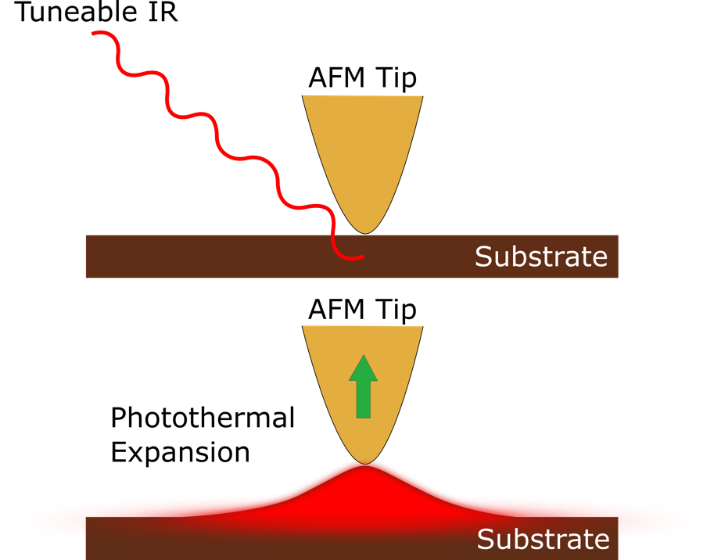
Figure 1: Schematic representation of the photothermal AFM-IR technique for achieving nanoscale IR mapping and spectra.

- Methods

2.1 Sample collection and handling
Patients homozygous for sickle cell disease, HbSS genotype, attended the sickle cell clinic at King’s College Hospital, London. Consented blood samples were taken into the anticoagulant EDTA. The study was approved by the National Research Ethics Committee (reference 16/LO/1309). All research was conducted with ethical approval and in accordance with the Helsinki Declaration of 1975, as revised in 2008.

2.2 Solutions and red cell preparation
The standard saline was buffered with 4-(2-hydroxyethyl)piperazine-1-ethanesulfonic acid (HEPES), and comprised (in mM): NaCl 145, KCl 5, CaCl₂ 1.1, MgCl₂ 0.15, inosine 10 and HEPES 10, with pH 7.4 at 37 °C, and an osmolality of 290 ± 5 mOsm.kg⁻¹. After washing three times (600 g, 3 min) to remove plasma and buffy coat, RBCs were resuspended at an haematocrit of 1 %. They were then placed in gently rotating Eschweiler tonometers (37 ºC) flushed with gas at an oxygen tension of either 100 (oxygenated) or 0 (deoxygenated) mmHg (with air replaced with N₂).²³ After incubation for 20 min they were fixed by addition of glutaraldehyde (final concentration 0.25 %) before being processed for AFM-IR measurements. The resulting measurements were made on RBCs in air (AFM-IR of such thick samples under aqueous conditions is not currently possible) and thus do not replicate physiological conditions. However, the stability of RBCs in air is significantly greater than pure lipid bilayers and consequently the effects of air exposure on the membranes of RBCs are considered to be much less. For this reason, the RBCs of different types were treated identically so that any observed differences can be fundamentally attributed to alterations resulting from the specific genotype and / or oxidation state of the cell.

2.3 AFM-IR measurements
AFM-IR spectroscopic and physical measurements were carried out in contact mode using an Anasys NanoIR2 instrument equipped with a MIRcat Laser system (Daylight Solutions) containing four quantum cascade lasers (QCLs). The presented IR spectra were averaged over multiple cells, spanning the whole top-surface membrane, and were smoothed using a 7pt FFT filter at 1 cm⁻¹ spectral resolution to reduce high-frequency noise contributions.²⁴ The AFM-IR maps shown are both characteristic and representative of the surface for the given cell type although some variation was observed, as expected. Spectra were averaged over at least 10 membrane locations spanning the top surface from at least 5 different cells with good qualitative reproducibility between each. Adhesion force measurements were recorded with a 0.4 V deflection offset at a frequency of 1Hz using a standard Au-coated AFM tip, either uncoated or chemically functionalised, with the manufacturer quoted range for the spring constant 0.07-0.4 Nm⁻¹ and resonant frequency 13 ± 4 kHz (Anasys Instruments). The absolute and specific value of the cantilever spring constant is a crucial parameter when comparing adhesion measurements and hence the same tip was used for all functionalised-tip adhesion measurements. The resulting distributions with functionalised tips consist of 1200 measurements, each at a different membrane location, made across 12 cells of each type, spanning the whole top surface of the membrane, where distribution profiles from individual cells were compared and found to give good reproducibility. The tip was chemically functionalised with octadecanethiol (ODT) or 11-mercaptoundecanoic acid (MUA) by submersing the tip in a methanolic solution of each for 24 hours. The ODT solution was generated by dissolving a needlepoint amount of ODT in 1ml methanol, ultrasound sonicating for 10 mins and warming the methanol solution prior to submersion of the tip. The MUA solution was generated by dissolving 1 mg MUA in 1 ml methanol at room temperature prior to submersion – no sonication or heating was necessary due to the good solubility of MUA in methanol. The resulting functionalised AFM cantilevers were mounted on hemicylindrical discs for use on the nanoIR2 instrument using 2-component epoxy resin and leaving to dry for 24 h at room temperature.

- Results

3.1 Hypoxic Morphology Change in SCD

Figure 2 shows AFM topographical maps of representative RBCs from SCD patients fixed in both the oxygenated (top row, a-d) and deoxygenated (bottom two rows, e-l) state, and is representative of the most prevalent forms. Oxygenated RBCs from SCD patients showed the classic biconcave disc structure that is present in control RBCs containing the HbA protein from normal individuals (Figure 2a-d). When fixed in the deoxygenated state, however, these sickle RBCs showed various morphologies including, but not limited to, the typical sickled shape associated with the disease. Under hypoxia, biconcave discs became much less common, and a variety of abnormal morphologies were observed: from classic sickle (2e&f), through “holly leaves” (2g), burrs (2h,i&k), stomatocytes (2j&k) and spherocytes (2l).²⁵ Occasional abnormal morphologies can also be present in oxygenated RBCs, and are probably representative of irreversibly sickled cells which fail to regain their normal morphology on re-oxygenation, whilst conversely some normal shapes are also observed under deoxygenated conditions.²⁵ This variability was partly stochastic, and also probably related to the different ages of RBCs or variability in the amount of fetal haemoglobin (HbF) present. In general, younger cells, and those with less fetal Hb, HbF, are more likely to adopt the sickled morphologies.⁷

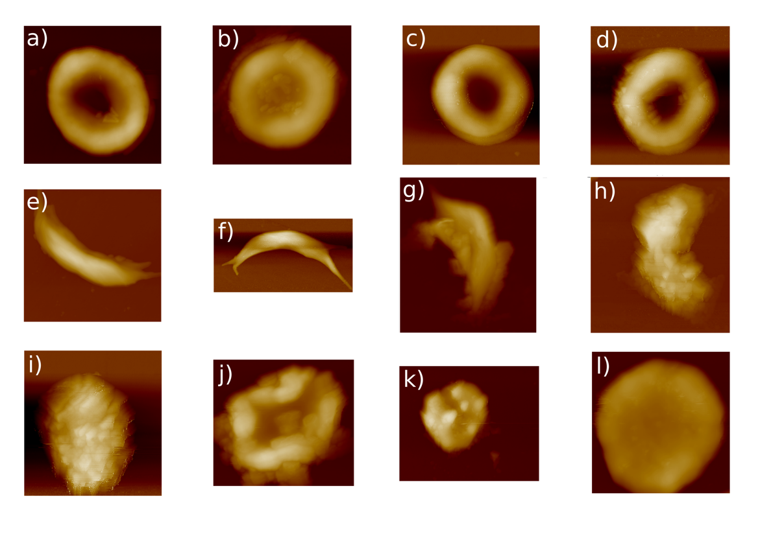
Figure 2: AFM height images showing representative examples of fixed RBCs from SCD patients recorded in air: (a)-(d) oxygenated RBCs showing the classic biconcave disk profiles; (e)-(l) deoxygenated RBCs with various abnormal morphologies.

3.2 AFM-IR Analysis of HbS RBCs

Figure 3 shows the properties of both oxygenated and deoxygenated RBCs from SCD patients measured using AFM-IR with a gold-coated, chemically un-functionalised tip. For oxygenated and deoxygenated cells in Figure 3a, the z-scale for the deoxygenated sample is twice that of the oxygenated one, indicative of significantly greater roughness for the deoxygenated cells. Whilst the particular orientation and morphology of the cells may have an effect on the z-scale, the imaged region in both examples comprised a comparatively flat section of the membrane (with z-scales significantly less than that of the cell thickness, ~2 μm), suggesting that the observed height variations, and thus differing degrees of roughness, were not an experimental artefact.

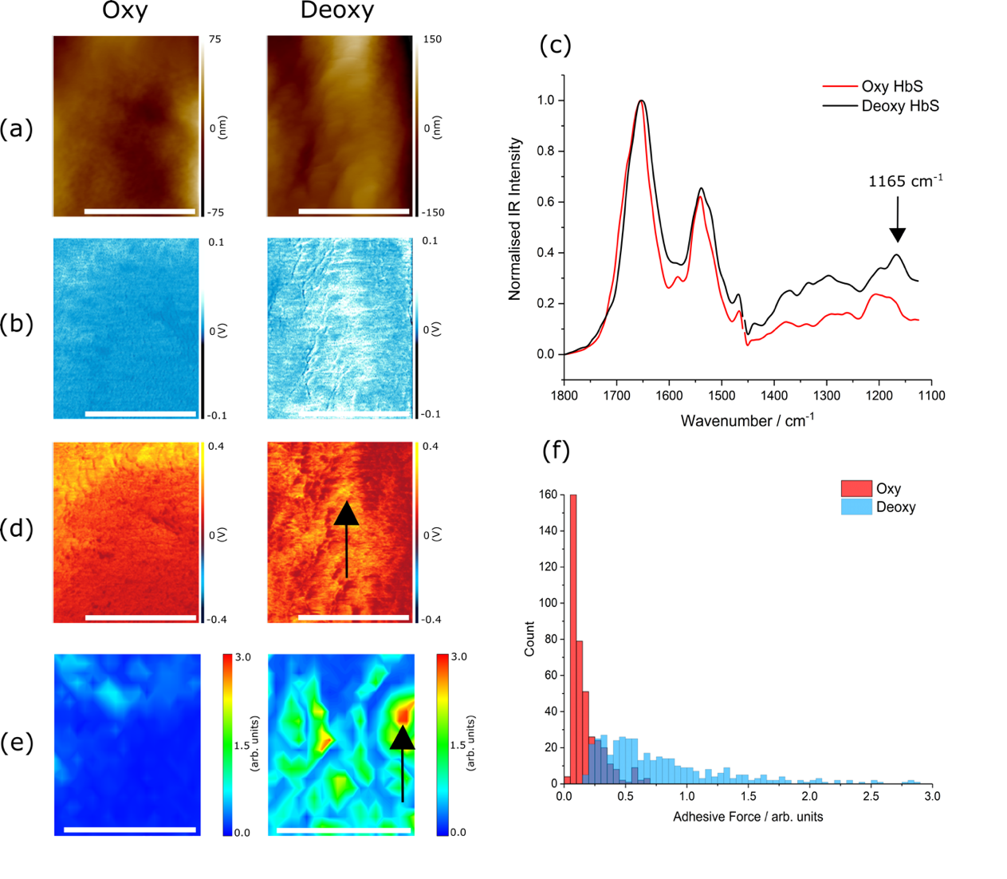
Figure 3: AFM-IR data for oxygenated and deoxygenated RBCs from SCD patients using an Au-coated tip: (a) height maps, (b) friction maps, (c) normalised AFM-IR spectra in the 1125-1800 cm⁻¹ region, (d) IR intensity maps at 1165 cm⁻¹, (e) 20x20 px adhesion force maps, (f) histogram profiles of the adhesion force for the two cell states. The white scale bars in (a), (b), (d) and (e) represent 1 μm and the black arrows in (d) and (e) indicate the lateral drift in the image due to the long acquisition times required to produce the adhesion force maps. The adhesion maps were recorded across a surface region contained within the maps shown in (a), (b) and (d), and correspond to a slightly smaller region of the membrane.

Figure 3b shows changes in the lateral deflection of the tip at the surface. Attractive forces between the tip and surface would result in the same deflection profile in opposite scanning directions and hence can be eliminated by calculating a difference image of the trace and retrace directions, leaving non-cancelling features that give opposite deflection profiles in either scanning direction i.e. those caused by friction between the membrane and the tip. The images in Figure 3b, both with the same z-scale, show that the average friction coefficient between the tip and the cell membrane for the deoxygenated cells was significantly greater than for the oxygenated one.

AFM-IR spectra at the cell surface were recorded randomly across multiple cells and over the whole surface, with average spectra being shown in Figure 3c. Although relatively weak in oxygenated samples, the common feature at 1165 cm⁻¹ (Figure 3c) is of significance as it arises from C-O moieties commonly associated with addition of ROS, e.g. peroxides, to aliphatic moieties, and therefore is taken as a prima facie marker for oxidative action at the surface, and hence presumably of the lipid component of the cell membrane.^{3,26} To extend the spectroscopic observations, IR intensity maps at 1165 cm⁻¹, shown in Figure 3d, were measured, corresponding to the same region of surface as the maps in Figures 3a and 3b. Regions that showed an increase of the 1165 cm⁻¹ band intensity (3d) also showed an increase in the coefficient of friction (3b) but bore no correlation with the topography (3a). IR intensity maps showed similar distributions of intensities for both states of oxygenation. However, oxygenated cells appeared to exhibit more localised high IR intensity regions, i.e. appearing as ‘domain-like’ regions of high C-O concentrations, whereas for deoxygenated cells the intensity was more uniform across the cells, showing more ‘sporadic’ intensities across the surface and thus suggesting they have more homogeneously stressed membranes. An example map of a region of a cell membrane for each cell type is shown in Figure 3d demonstrating the ‘domain-like’ intensities for the oxygenated cells and less structured intensities across the deoxygenated cells. The same observation was evident in the friction measurements (3b) but with the caveat that the average coefficient of friction was significantly greater under deoxygenated conditions. The increase in intensity of the 1165 cm⁻¹ band for the deoxygenated cells, compared to oxygenated ones, was considerably smaller in proportion to the increase in friction, implying that additional factors contributed to the increased coefficient of friction for the deoxygenated cells that did not contribute to the IR intensity. The full AFM-IR spectra (3c) show that the intensity of the 1165 cm⁻¹ band for the deoxygenated cells was greater across the membrane. Thus, for individual cells, the regions of increased IR intensity were more localised and significantly less common in the oxygenated samples. In contrast, the deoxygenated cells showed much greater homogeneity of the increased IR intensity and led to a greater average across the cells.

Figures 3e and 3f are measurements of the vertical detachment force between the tip and the surface. For these measurements, the AFM tip was pushed vertically onto the RBC surface and then retracted. Under such conditions, inter-digitation of residual tip molecules (known to contaminate “clean” gold under ambient conditions) is more likely to occur than for the lateral deflection measurements in which the tip is continuously rastered laterally across the cell surface.²⁷ This results in the detachment force better mimicking the extent of cell adhesion rather than using any adhesive forces that arise in lateral deflection profiles (that were previously eliminated for the frictional measurements). The maps shown in Figure 3e, therefore, represent the adhesion between the cell and the tip for the same regions of the surface shown in 3a, 3b and 3d. Unfortunately, due to the long acquisition time required to acquire adhesion maps, there was some unavoidable lateral drift in the adhesion measurement (indicated by the black arrows for the deoxygenated cell in Figure 3d and e). (In contrast, the drift for the oxygenated cell was much less and features on the maps can be accurately correlated.) Comparison of the adhesion maps for cells shows clear evidence of increased average adhesion under deoxygenated conditions. This increased adhesion is emphasised in the histogram profiles (3f) that were generated from the individual pixel values used for the adhesion maps (3e). Increased adhesion correlated with the corresponding friction and 1165 cm⁻¹ intensity measurements but, as with the friction, demonstrated greater increases relative to the increase in IR intensity for deoxygenated cells.

3.3 SCD Adhesion Profiling

The likelihood that several factors might underlie the observed differences in adhesion of the tip to the membrane for the different oxygenation states (e.g. the extent of PS lipid exposure or the surface response to different levels of oxidation) prompted further investigations of HbSS cell membrane adhesion using specifically functionalised gold AFM tips: namely tips with octadecanethiol (ODT) and 11-mercaptoundecanoic acid (MUA) coatings. These tips make it possible to distinguish between hydrophobic adhesive interactions and those dominated by hydrophilic H-bonding. It should be noted that these interactions are occurring in air rather than under aqueous conditions and hence represent interactions between the tip functionality and exposed surface groups on the cell. Thus, hydrophobic adhesion is referring to the attractive Van der Waals’ interactions that occur which will be dominated by interactions between two hydrophobic (likely long chain hydrocarbons). On the other hand, hydrophilic interactions will source from electrostatic interactions and H-bonding to the exposed MUA acid moieties on the tip.
Furthermore, as RBCs from patients with SCD are known to be significantly “stickier” (i.e. show greater cohesion) than those from normal individuals, the effects of deoxygenation were probed alongside comparisons between cells of both genotypes (HbAA and HbSS). For statistically reliable comparisons of individual cells, force detachment measurements were made spanning the entire top surface of several cells, as mentioned in the Methods section. They showed consistently similar profiles within the same cell genotype / oxygenation state. These results are presented in Figure 4 and discussed below. Enlarged, and appropriately scaled distribution comparisons, as well as the calculated quantitative adhesion data are given in Supporting Information, S2 and S3 respectively.

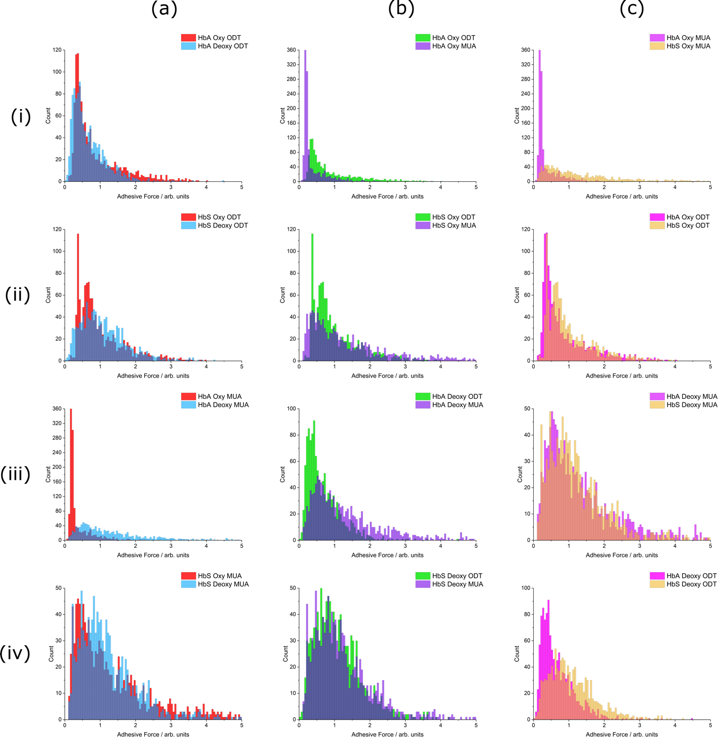

Figure 4: Comparisons of the generated attachment force histogram profiles generated from 1200 force detachment scans across several cells, covering the whole RBC surface. Profiles are shown under all possible permutations, comparing RBCs from normal individuals (HbAA genotype, labelled HbA) or from SCD patients (HbSS genotype labelled HbS), under oxygenated or de-oxygenated states, using either MUA or ODT functionalised tips. (a) compares the oxygenated and deoxygenated states with other variables fixed, (b) compares the ODT and MUA functionalised tip profiles, and (c) compares RBCs from normal individuals (labelled HbA) and SCD patients (labelled HbS) in the same oxygenation state using the same tip functionality. All adhesion profiles are shown with the adhesion force on quantitatively comparable scales (but in arbitrary units) and are plotted on different ordinate scales for clarity and easier comparison.

Comparing the two different oxygenation states (Figure 4, column (a)), with the ODT-functionalised (hydrophobic) tip, RBCs from both normal individuals and SCD patients (labelled HbA and HbS, respectively) showed broader adhesion distributions when deoxygenated (4a(i) and 4a(ii)), suggesting a more heterogeneous distribution of hydrophobicity at the membrane surface. With the hydrophobic tip, despite no change to the modal adhesion, deoxygenated RBCs from normal individuals (cf. oxygenated) showed a noticeable reduction in the abundance of regions of greatest adhesion i.e. reduction in P=0.1 adhesion (4a(i)), which was not observed for deoxygenated RBCs from SCD patients (4a(ii)). This, along with an increased distribution width, suggests an increase in hydrophilic moieties (reducing the P=0.1 adhesion) as well as increased regions of strong hydrophobic character (together rendering no change to the modal adhesion) for the HbAA cells on deoxygenation. Similarly, the HbSS cells show an increased modal adhesion with ODT on deoxygenation, along with the increased distribution width, suggesting greater heterogeneity and much-increased hydrophobicity at the surface.

For the hydrophilic tip, the modal adhesion was distinctly higher for both genotypes upon deoxygenation (4a(iii) and 4a(iv)), being particularly noticeable for those from normal individuals. In the case of normal cells, the regions of greater adhesion increased as well as the average adhesion (4a(iii)). For RBCs from SCD patients, however, although the modal cell adhesion with the MUA tip increased, regions with strongest adhesion (e.g. P=0.1 adhesion) became less abundant (4a(iv)), i.e. a situation which mirrored that for RBCs from normal individuals examined using the ODT tip (4a(i)). This suggests a significant increase in hydrophobic moieties for both genotypes but with much greater relative exposure of hydrophobic species in the case of cells from SCD patients. Overall, modal adhesion was greatest for deoxygenated RBCs from SCD patients, particularly when probed with the MUA tip. To summarise, the results in column (a) suggest an increase in both hydrophobic and hydrophilic species at the surface of deoxygenated RBCs, independent of the presence of normal (HbA) or mutated (HbS) Hb, but with greater emphasis from hydrophobic moieties in the latter case.

Results in column (b) directly compare adhesion profiles obtained with the two different tip functionalities. For oxygenated RBCs from normal individuals (labelled HbA in Figure 4), greater adhesion was observed for the ODT tip (4b(i)), indicating a preferential adhesion for hydrophobic species. By contrast, for oxygenated RBCs from SCD patients (labelled HbS in Figure 4), the hydrophilic MUA tip (4b(ii)) showed a greater abundance of high-adhesion regions despite a slight reduction in modal adhesion (overall leading to greater mean adhesion, cf. ODT tip). These observations, together, suggest an increase in surface hydrophilic species in SCD patients’ RBCs under oxygenated conditions (cf. those from normal individuals). For deoxygenated RBCs from normal individuals, the MUA tip showed stronger adhesion than the ODT tip, indicating greater hydrophilic adhesion in this state (contrary to what was observed for oxygenated normal RBCs), providing evidence for an increase in surface H-bonding species of RBCs in the deoxygenated state. For deoxygenated RBCs from SCD patients, the adhesion profiles for either tip (shown in Figure 4b(iv)) became essentially indistinguishable by eye showing increased modal adhesion for both functionalities compared to the oxygenated state and greater relative adhesion from hydrophilic moieties. This leads to the conclusion that the surface of deoxygenated sickle cells had no significant overall preference between hydrophilic or hydrophobic probes notwithstanding the observation that they were “stickier” than when oxygenated (4a(ii) and 4a(iv)). The results from using two differently coated tips implies that both strongly hydrophilic and strongly hydrophobic species are more prevalent on the surface of RBCs from SCD patients than on the surfaces of RBCs from normal individuals and that, furthermore, such differences are exaggerated on deoxygenation.

Finally, column (c) compares RBCs from normal individuals and SCD patients under both the same state of oxygenation and the same tip functionality. When oxygenated, both types of tip exhibited stronger adhesion for the surface of RBCs from SCD patients than for those from normal individuals (4c(i) and 4c(ii)), clearly showing increased concentrations of strongly hydrophilic and strongly hydrophobic moieties at the surface of the former. The same was true for the modal adhesion for deoxygenated RBCs (4c(iii) and 4c(iv)), however the distinction was not as pronounced. Using the MUA tip, deoxygenated RBCs from SCD patients showed an increase in the modal adhesion (0.9 compared to 0.7 units) but lower abundance of high-adhesion regions compared to those from normal individuals (4c(iii)), giving a lower overall mean adhesion of 1.27 for HbSS compared to 1.37 for HbAA. This suggests increases in both hydrophilic and hydrophobic moieties, but to a lesser extent than for cells in the oxygenated state. With the ODT tip, however, there was a distinct increase in the mean adhesion (1.09 compared to 0.68), modal adhesion (0.8 compared to 0.4), and abundance of high-adhesion regions for patients’ RBCs (P=0.1 adhesion of 1.962 compared to 1.322, 4c(iv)). This infers that there is a substantial increase in hydrophobic moieties at the surface in the deoxygenated state (cf. the increase in hydrophilic species). In summary, comparing the adhesion profiles of both cell genotypes shows that there are significant differences with cells from SCD patients being considerably “stickier”. It is also apparent that deoxygenated sickle cells show a far greater exposure of strongly hydrophobic moieties than hydrophilic ones. Furthermore, the differences are more substantial in the oxygenated state, suggesting that deoxygenation also results in significant membrane alterations which dampen the observed distinction between cell genotypes when in this oxygenation state.

- Discussion

Spectroscopic and frictional changes as well as adhesive interactions of the HbS RBC surface in the oxygenated and deoxygenated states were initially examined with an uncoated gold tip, which is intrinsically hydrophobic. More detailed characterisation was achieved using tips coated with ODT and MUA, comparing the HbSS cells to HbAA cells in each oxygenation state. ODT functionality on the AFM tip exposes long-chain (hydrophobic) hydrocarbon tails which will adhere preferentially to similar hydrophobic species that can form significant Van der Waals’ interactions e.g. through interdigitation of hydrocarbon chains (i.e. lipid tail groups). MUA, however, exposes acid functionality that will adhere predominantly through H-bonding and thus is a surface probe for hydrophilic moieties (e.g. increased surface concentrations of oxygen-containing groups from membrane oxidation, or larger concentrations of negatively charged PS lipid head groups). Although measurements were made in air (i.e. not in a physiological environment), in which lipid bilayers are less stable (cf. under aqueous media), RBCs from both normal individuals and from SCD patients were treated similarly, implying that any differences in behaviour resulted from fundamental effects due to the presence of normal HbA or mutated HbS, as well as the oxygenation state of the cell.²⁸ Furthermore, it should be noted that, unlike pure lipid bilayers, RBC membranes do not rapidly ‘collapse’ or degenerate on exposure to air and maintain their structure and integrity for long periods. Therefore, it is reasonable to conclude that the effects on the membrane due to exposure in air are significantly less than those observed in pure lipid bilayers.

  - Morphology

As expected, deoxygenation of RBCs from SCD patients caused distortion in morphology from the normal biconcave disc to sickles and a variety of other bizarre shapes, subsequent to polymerisation of the mutated HbS.²⁵ Topographical measurements on the sickle cells (Figure 3a) showed an increase in membrane roughness for these sickled cells compared to those in the oxygenated state, consistent with polymer formation and Hb aggregation.^{29–32}

  - Infrared and Friction Imaging

RBCs from SCD patients, under both oxygenated and deoxygenated conditions, showed close correlation, when taken concurrently, between regions of increased friction and of greater IR intensity at 1165 cm⁻¹ (Figure 3b and 3d). These regions were also subsequently correlated with increased adhesion through detachment force measurements. Spectra averaged over multiple regions and across several cells confirmed this increase in the 1165 cm⁻¹ band intensity for deoxygenated cells (Figure 3c). The 1165 cm⁻¹ band is attributed to C-O moieties, i.e. it is a marker for addition of oxygen to the membrane and thus for oxidative stress.^{3,26} These findings are consistent with a rise in friction and adhesion occurring concomitantly with greater oxidative stress. The relative increase in friction (as well as adhesion) for a specific increase in concentration of C-O moieties was significantly greater, however, for deoxygenated cells (comparing Figure 3d with 3b and 3e), meaning significantly greater membrane disruption under hypoxic conditions, but also that the increase in friction, in part, arises from sources other than C-O moieties at the surface. When deoxygenated, RBC metabolism is switched such that glucose passes preferentially along the normal glycolytic (Embden-Meyerhof) pathway and away from the pentose-phosphate pathway (or hexose monophosphate shunt) with concomitant reduction in synthesis of NADPH, a major antioxidant defence of red cells.³³ A fall in NADPH levels would provide a logical mechanism to explain these observations of greater oxidative action for cells in the deoxygenated state.

  - Adhesion

The use of ODT and MUA tips to measure adhesion in RBCs from both normal individuals and from SCD patients, in the oxygenated and deoxygenated states, allowed identification of surface alterations from species that predominately interact through hydrophobic (Van der Waals’) or hydrophilic (electrostatic and/or H-bonding) attractions in air, respectively. The adhesion profiles in Figure 4 indicate that there were significant changes to the modal adhesion as well as to the width of the distribution occurring for both deoxygenated cells (cf. oxygenated) and in HbSS cells (cf. HbAA).

Deoxygenated RBCs, irrespective of Hb type or tip functionality, showed an increased width distribution compared to their oxygenated counterparts, i.e. indicating increases in both hydrophobicity and hydrophilicity, and consistent with lateral inhomogeneity in the membrane components. A similar comparison between adhesion profiles from HbSS and HbAA cells, independent of oxygenation state or tip functionality, indicates that the adhesion distributions of RBCs from SCD patients were broader than those from normal individuals.

Changes in hydrophobic and hydrophilic adhesion may occur to one modality alone or, conversely, both may be altered. There is the potential to distinguish between these two possibilities. Thus, an increase in hydrophobic adhesion (ODT tip) on its own would increase its “high extreme” adhesion regions (e.g. increase in P=0.1 adhesion) alongside the distribution width. The adhesion profiles comparing oxygenation state with the ODT tip (4a(i) and 4a(ii)), however, mostly showed a decrease in high adhesion regions relative to the modal peak (e.g. P(A>3xMode)). This was visually much clearer for RBCs from normal individuals since the modal adhesion was indistinguishable for either oxygenation state. For RBCs from SCD patients, however, under deoxygenated conditions there was increased modal adhesion and a similar contribution from high adhesion regions, indicating a relative reduction of “high extremes” (clearly demonstrated in P(A>3xMode) values).

These results show that increases in hydrophobic adhesion, resulting in greater modal adhesion with ODT and a greater distribution width (surface heterogeneity), do not occur alone on deoxygenation, and that there are additional increases in concentrations of highly hydrophilic surface moieties. Furthermore, no increase in modal adhesion for HbAA cells suggests competing increases in both functionalities whereas the increase in the modal ODT adhesion for HbSS cells shows that the hydrophobic moieties dominate (but still presenting increased hydrophilic species, hence the reduced P value).

A similar comparison to that between oxygenated and deoxygenated RBCs from SCD patients, as previously described, can be made between oxygenated RBCs from the two different genotypes (Figure 4c(ii)). This shows that HbSS cells with ODT result in a reduction of high adhesion regions relative to the modal peak (P(A>3xMode)) despite an increased modal adhesion and increased distribution width. This, as previously, suggests increases in both hydrophilic and hydrophobic moieties at the surface, but with greater emphasis on hydrophobic species. In deoxygenated RBCs from SCD patients such a comparison is more difficult to make due to the considerable increase in adhesion. Nevertheless, quantitative analysis demonstrates the same observation where a slight decrease in P(A>3xMode) is observed for the SCD cells compared to those from normal individuals. However, this decrease is comparatively small so for this purpose it is more useful to consider results obtained with the hydrophilic MUA tip (4c(iii)). These showed that, despite an increased modal adhesion, the ‘high extremes’ were also visually found to be numerically fewer for SCD patient RBCs, concomitant with a greater decrease in the P value. Using this tip to probe hydrophilic interactions, a reduction of high-adhesion regions, despite increased width distribution and modal peak, suggested far greater oxidative stress to the surface, to the extent that the homogeneity was actually increased (as was observed in the C-O IR intensity maps in Figure 3d). In this case, membrane disruption resulting in the exposure of hydrophobic moieties must have been sufficiently extensive to reduce the adhesion of those regions that would otherwise have led to the measurement of “extreme’ values.

  - Mechanistic considerations

To explain the changes in adhesion profiles, we postulate that the main targets of strongly hydrophobic adhesion are the aliphatic lipid tails which can undergo Van der Waals’ attractions through interdigitation with the ODT tip functionality. Targets of hydrophilic adhesion, however, may be two-fold: first, oxidative damage to membrane proteins that result in the inhibition of flippase and activation of scramblase leading to exposed aminophospholipid PS (as previously mentioned) which has charged, ionic head groups; and, second, the presence of C-O moieties following oxidative damage.^{34,35} For PS exposure, surface changes are more likely to be comparatively homogeneous whilst oxidative damage leading to accumulation of C-O moieties may be more irregular, due to inhomogeneity either in the capacity for oxidative defence or in the amount of oxidative challenge (Supporting Information, S1). As demonstrated by the friction and adhesion maps (Figure 3b and 3e) and adhesion profiles (Figure 4), oxidative damage may disturb the lateral homogeneity of lipid across the surface. We propose that addition of a hydrophilic ROS to an otherwise hydrophobic environment would be followed by migration of this group to the surface, with consequent disruption to the aliphatic lipid tail. Thus, oxidative stress would result not only in localised exposure of oxygen-containing groups, but also in significant disruption of the membrane, leading to exposure of the hydrophobic groups of aliphatic lipid tails propagating from the site of oxidation (as is consistent with the experimental AFM-IR and adhesion measurements). These membrane alterations would be expected to occur concurrently with PS lipid exposure and so the observed adhesion would result from convolution of the two effects. A schematic version of the mechanism showing just the oxidative stress is presented in Figure 5. (The contribution of PS exposure has been omitted as its mechanism is well-known and straight forward.) Consequently, we hypothesise that a small amount of localised oxidative stress can lead to significant membrane disruption and the exposure of both hydrophobic as well as H-bonding groups that can alter the adhesion properties of the membrane to both hydrophilic and hydrophobic tip functionalities. This would result in a broadening of the adhesion profile in these regions with either of the functionalised tips, in comparison to the narrower and quite uniform adhesion noted for PS exposure alone.

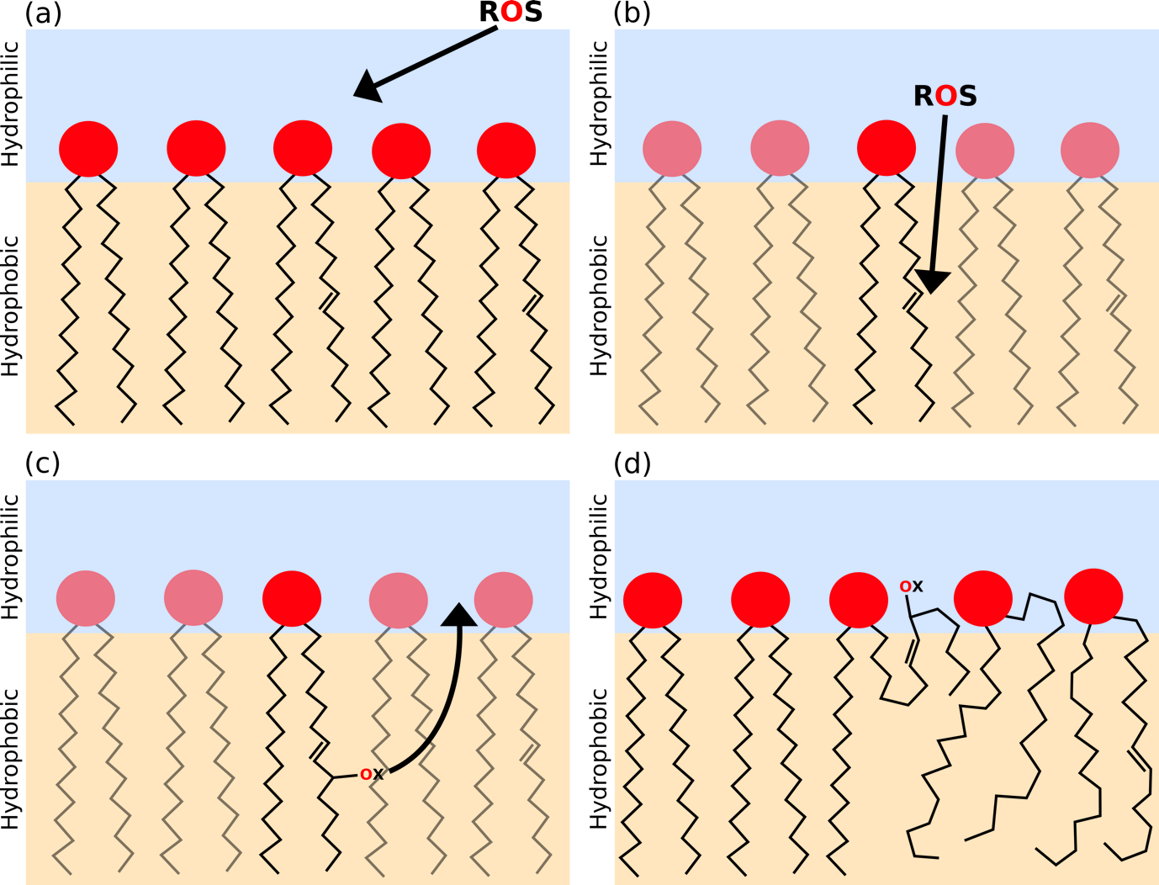

Figure 5: Schematic representation of the mechanism proposed for oxidative stress and reaction to a lipid bilayer membrane. This represents only part of the overall change in the membrane and should be considered in combination with PS lipid exposure that has been omitted here for clarity. Specifically, the mechanism involves the following processes: (a) ROS appear at the surface of a well-ordered lipid bilayer; (b) ROS attack at the α positions to unsaturation forming the most stable intermediate; (c) this introduces new hydrophilic moieties into an otherwise hydrophobic environment, forcing their migration to the membrane surface (thermodynamic considerations for this spontaneous process are given in Supplementary Information, S4); and (d) the movement causes direct disordering and kinks in the lipid tail which can also expose hydrophobic functionality at the surface. (Adapted from previous mechanistic representations, e.g. Itri el al.³⁶)

- Conclusion

In this study, we have examined the adhesive interactions and spectroscopic changes to the membranes of dried RBCs from normal individuals and those from patients with SCD using the hybrid technique of AFM-IR with gold tips and with specifically functionalised tips to provide hydrophobic (ODT) or hydrophilic (MUA) probes. Significant differences and changes in adhesion behaviour of normal and sickle cells were observed. RBCs were exposed to and fixed under different oxygenation environments prior to drying and AFM-IR analysis. On deoxygenation (cf. oxygenation), red cells from both genotypes showed changes consistent with an increase in oxidative damage and of PS exposure. Overall, however, red cells from SCD patients were more compromised than those from normal individuals, especially regarding oxidative damage to the membrane and hydrophobic lipid tail exposure. With these measurements being on RBCs in air, however, there are likely to be some differences compared to the physiological environment. Nevertheless, comparisons between similarly treated cells are compatible with previous suggestions about the nature of membrane changes on deoxygenation as well as within SCD itself. By probing the significance of such oxidative stress and PS exposure on cell adhesion, the current work has provided support for a mechanism for oxidative stress on RBC membranes whereby oxidative action to the membrane lipids result in migration of hydrophilic oxygen-containing groups to the surface followed by propagating lipid tail disruption and exposure of hydrophobic tail groups. The large observed variations between different cell genotypes and oxygenation states demonstrates that a large proportion of the oxidative damage occurs in situ rather than due to air exposure, thus correlating the observations to physiological differences between the cells. Such exposure was found to result in significant increases to both membrane friction and adhesion, and hence are significant in the context of vaso-occlusion crises and potential SCD treatments.

Acknowledgements

We are grateful for Unilever R&D and the EPSRC for providing the iCASE studentship for A. P. F. on Grant EP/R511870/1.

Author Contributions

A.P.F. conducted the experiments, processed and interpreted the results and drafted the manuscript; M.T.L.C. commissioned the instrument, designed the experiments and supervised the acquisition of the data; P.B.D. conceived the project, oversaw the structure of the manuscript and refined the interpretation of the data; J.S.G. prepared the samples, oversaw the data interpretation and refined the manuscript; J.N.B. and D.C.R. undertook sample collection, oversaw the project and revised the structure of and interpretation within the manuscript.

References

1. Lux, S. E. Anatomy of the red cell membrane skeleton: Unanswered questions. Blood 127, 187–199 (2016).
2. D’Alessandro, A., Hansen, K. C., Eisenmesser, E. Z. & Zimring, J. C. Protect, repair, destroy or sacrifice: A role of oxidative stress biology in inter-donor variability of blood storage? Blood Transfus. 17, 281–288 (2019).
3. Petibois, C. & Déléris, G. Oxidative stress effects on erythrocytes determined by FT-IR spectrometry. Analyst 129, 912–916 (2004).
4. Mohanty, J. G., Nagababu, E. & Rifkind, J. M. Red blood cell oxidative stress impairs oxygen delivery and induces red blood cell aging. Front. Physiol. 5, (2014).
5. Rees, D. C., Williams, T. N. & Gladwin, M. T. Sickle-cell disease. Lancet 376, 2018–2031 (2010).
6. Piel, F. B. Distribution géographique de la drépanocytose en 2010. Medecine/Sciences 29, 965–967 (2013).
7. Bunn, H. F. & Forget, B. G. Hemoglobin: Molecular, Genetic and Clinical Aspects. (Saunders, 1986).
8. Christoph, G. W., Hofrichter, J. & Eaton, W. A. Understanding the shape of sickled red cells. Biophys. J. 88, 1371–1376 (2005).
9. Haest, C. W. M. Distribution and Movement of Membrane Lipids. in Red Cell Membrane Transport in Health and Disease (2003). doi:10.1007/978-3-662-05181-8_1
10. Wesseling, M. C. et al. Phosphatidylserine exposure in human red blood cells depending on cell age. Cell. Physiol. Biochem. 38, 1376–1390 (2016).
11. Hannemann, A. et al. Oxidative stress and phosphatidylserine exposure in red cells from patients with sickle cell anaemia. Br. J. Haematol. 182, 567–578 (2018).
12. Bassé, F., Stout, J. G., Sims, P. J. & Wiedmer, T. Isolation of an erythrocyte membrane protein that mediates Ca2+- dependent transbilayer movement of phospholipid. J. Biol. Chem. (1996). doi:10.1074/jbc.271.29.17205
13. Bevers, E. M. & Williamson, P. L. Phospholipid scramblase: An update. FEBS Letters 584, 2724–2730 (2010).
14. Weiss, E., Cytlak, U. M., Rees, D. C., Osei, A. & Gibson, J. S. Deoxygenation-induced and Ca2+ dependent phosphatidylserine externalisation in red blood cells from normal individuals and sickle cell patients. Cell Calcium (2012). doi:10.1016/j.ceca.2011.10.005
15. Cytlak, U. M., Hannemann, A., Rees, D. C. & Gibson, J. S. Identification of the Ca 2+ entry pathway involved in deoxygenation-induced phosphatidylserine exposure in red blood cells from patients with sickle cell disease. Pflugers Arch. Eur. J. Physiol. 465, 1651–1660 (2013).
16. Lew, V. L. & Bookchin, R. M. Ion transport pathology in the mechanism of sickle cell dehydration. Physiol. Rev. 85, 179–200 (2005).
17. Hebbel, R. P. Beyond hemoglobin polymerization: the red blood cell membrane and sickle disease pathophysiology. Blood 77, 214–37 (1991).
18. Shalev, O, Leida, MN, Hebbel, RP, Jacob, HS, Eaton, J. Abnormal erythrocyte calcium homeostasis in oxidant-induced hemolytic disease. Blood 58, 1232–5. (1981).
19. Zaidi, A. et al. Oxidative Inactivation of Purified Plasma Membrane Ca 2+ -ATPase by Hydrogen Peroxide and Protection by Calmodulin. Biochemistry 42, 12001–12010 (2003).
20. Tait, J. F. & Gibson, D. Measurement of membrane phospholipid asymmetry in normal and sickle-cell erythrocytes by means of annexin V binding. J. Lab. Clin. Med. (1994).
21. Kuypers, F. A. et al. Detection of altered membrane phospholipid asymmetry in subpopulations of human red blood cells using fluorescently labeled annexin V. Blood 87, 1179–87 (1996).
22. Dazzi, A. et al. AFM-IR: Combining atomic force microscopy and infrared spectroscopy for nanoscale chemical characterization. Appl. Spectrosc. 66, 1365–1384 (2012).
23. Speake, P. F., Roberts, C. A. & Gibson, J. S. Effect of changes in respiratory blood parameters on equine red blood cell K-C1 cotransporter. Am. J. Physiol. - Cell Physiol. 273, 1811–8 (1997).
24. Fellows, A. P., Casford, M. T. L. & Davies, P. B. Spectral Analysis and Deconvolution of the Amide I Band of Proteins Presenting with High-Frequency Noise and Baseline Shifts. Appl. Spectrosc. (2020). doi:10.1177/0003702819898536
25. Mohandas, N., Rossi, M. E. & Clark, M. R. Association between morphologic distortion of sickle cells and deoxygenation-induced cation permeability increase. Blood 68, 450–454 (1986).
26. Bujok, J. et al. Applicability of FTIR-ATR method to measure carbonyls in blood plasma after physical and mental stress. Biomed Res. Int. 2019, (2019).
27. Smith, T. The hydrophilic nature of a clean gold surface. J. Colloid Interface Sci. 75, 51–55 (1980).
28. Blodgett, K. B. Monomolecular films of fatty acids on glass. J. Am. Chem. Soc. 56, 495 (1934).
29. Kozlova, E. et al. Morphology, membrane nanostructure and stiffness for quality assessment of packed red blood cells. Sci. Rep. 7, (2017).
30. Feeling-Taylor, A. R. et al. Crystallization mechanisms of hemoglobin C in the R state. Biophys. J. 87, 2621–2629 (2004).
31. Girasole, M. et al. Roughness of the plasma membrane as an independent morphological parameter to study RBCs: A quantitative atomic force microscopy investigation. Biochim. Biophys. Acta - Biomembr. 1768, 1268–1276 (2007).
32. Tomaiuolo, G. Biomechanical properties of red blood cells in health and disease towards microfluidics. Biomicrofluidics 8, (2014).
33. Harrison, M. L., Rathinavelu, P., Arese, P., Geahlen, R. L. & Low, P. S. Role of band 3 tyrosine phosphorylation in the regulation of erythrocyte glycolysis. J. Biol. Chem. 266, 4106–4111 (1991).
34. Blumenfeld, N., Zachowski, A., Galacteros, F., Beuzard, Y. & Devaux, P. F. Transmembrane mobility of phospholipids in sickle erythrocytes: Effect of deoxygenation on diffusion and asymmetry. Blood 77, 849–854 (1991).
35. Kuypers, F. A. Phospholipid asymmetry in health and disease. Current Opinion in Hematology 5, 122–131 (1998).
36. Itri, R., Junqueira, H. C., Mertins, O. & Baptista, M. S. Membrane changes under oxidative stress: The impact of oxidized lipids. Biophysical Reviews 6, 47–61 (2014).

