The role of radiology in anatomy teaching in UK medical schools: a national survey

Dr Timothy J Sadler¹
Dr Ting-Ting Zhang¹
Dr Helen L Taylor^{1,2}
Dr Cecilia Brassett²
¹Department of Radiology, Addenbrooke’s Hospital, Cambridge University Hospitals NHS Foundation Trust, Cambridge, CB2 0QQ, UK
²Department of PDN, Downing Site, Downing Street, University of Cambridge, Cambridge, CB2 3DY, UK

Corresponding author: Timothy J Sadler
Email: tjs59@cam.ac.uk

Abstract

Aims
Anatomy is the cornerstone of medical education and underpins all areas of clinical practice. Over the past few decades, there have been considerable changes in the way anatomy teaching is delivered in medical schools. In particular, radiology has played an increasingly important role. This study aims to investigate the current use of radiology in anatomy teaching across the UK, and to determine the level of interest expressed in expanding its role in medical education.

Materials and Methods
A 22-question electronic survey was distributed to the organisers of anatomy teaching at 35 UK medical schools. The questionnaire explored the use of radiology in their anatomy course, the different kinds of available resources, and attitudes towards integrating radiology into anatomy teaching.

Results
Responses were received from 29/35 (83%) of medical schools. Among the respondents, radiological anatomy features in all but one of their curricula. Of those schools using radiology to aid anatomy teaching, 20/28 expressed a wish for more radiology in the curriculum. Timetabling constraints constituted one of the main difficulties in further implementation. In addition, 22/28 medical schools had already fostered collaborative links with local radiology departments, with 18 of these expressing a wish for further cooperation. Of the remaining 6 schools without current collaboration, 4 would like to establish connections.

Conclusion
Compared with previous studies, this national survey shows a definite increase in radiological anatomy in medical school curricula with a stronger presence of radiologists in anatomy teaching. Despite this, most anatomy departments still express a desire to increase the radiological component in their courses.

Keywords
Anatomy, radiology, teaching, education.

Introduction
Anatomy is a cornerstone of medical education and underpins all areas of clinical practice. There have been substantial changes in the way anatomy teaching is delivered in recent years, with greater emphasis on clinical relevance. In addition, following the recent expansion of medical school places and the need to deliver a more comprehensive curriculum¹, medical schools are facing increasing pressures to maximise their efficiency in providing effective anatomy teaching.
The importance of incorporating radiology in anatomy teaching is not a new concept, with references in the literature as early as 1927². With the tremendous technological advances in radiological imaging in the past couple of decades and its ever more central role within clinical practice, there has been renewed interest in its role in anatomy teaching. As clinician of all specialties must apply their anatomical knowledge when interpreting radiological images in their daily practice, these images are ideal for teaching students the clinical relevance of anatomy learned in lectures or the dissection room. Imaging software programmes allow reconstruction and manipulation of images to aid interactive learning enabling students to gain a greater understanding of topographical anatomy. In addition, dynamic imaging methods can relate structure to function in the living body.
It has been over a well over decade since the last national UK survey which investigated the role of radiology in anatomy teaching³. In 2002, Mitchell and Williams discovered considerable variation across medical schools both in the content and delivery of radiological anatomy teaching. Few medical schools were in possession of a substantial number of radiographs and for many schools, images were stored and only available on student request. Only 19% of medical schools had a radiologist on the teaching faculty and only 50% of schools reported established links with a radiology department. In a more recent national survey conducted in North America, radiology formed part of the anatomy curriculum in 91% of responding institutions, with a radiologist featuring as the director or co-director in 43% of courses⁴. These figures are echoed in a similar survey in Australia and New Zealand in which all respondents used some form of medical imaging in anatomy instruction⁵. In contrast, therefore, radiology seems to occupy a less central place in anatomy teaching in the UK. However, no recent studies have been conducted.
This study aims to redress this by investigating the current use of radiology in anatomy teaching across the UK, as well as determining the level of interest expressed by anatomists in expanding its role in medical education and the role played by the radiologist in delivering of anatomy teaching.

Materials and Methods

Survey distribution and data collection
An electronic survey was distributed to the anatomy teaching leads of all 35 UK medical schools. A list of UK medical schools was identified from the Medical Schools Council website⁶. The contact details of teaching leads for the anatomy course of each medical school were identified on departmental websites. Recipients were sent an email inviting them to participate in the survey in two possible formats. Participants could either use a link to an online survey tool (Typeform, Barcelona) or complete an attached structured electronic word document and return this via email. Reminder emails were sent every fortnight. Survey administration and analysis were performed using Typeform online survey software and Microsoft Excel (Redmond, Washington State).

Survey questions
The survey consisted of 22 questions – including multiple option questions, Likert style questions and open white space questions.
The questions in the survey explored the following five themes:
- Use of radiology in anatomy teaching
- Course structure and examination
- Availability of resources
- Collaborative links with radiology departments
- Challenges in integrating radiology into anatomy teaching

Results
Responses were received from 83% (29/35) of medical schools.

Use of radiology in anatomy teaching
Among the respondents, radiological anatomy featured in all but one of the medical schools’ curricula. Of those schools already using radiology to aid anatomy teaching, 20 of the 28 expressed a wish for more radiological content in the curriculum, in contrast to three schools which did not. The one medical school which did not currently include radiology in its curriculum expressed a keen desire for its use.

Course structure and examination
The majority of medical schools teach radiological anatomy using small group teaching and didactic lectures, with problem based learning or computer assisted modules being used by at least 50% (Figure 1). The full range of radiological modalities are used to varying degrees (Figure 2).
20/28 (71%) of medical respondents teach with direct correlation between cadaveric material (hands-on dissection or previously prepared anatomical prosections) and radiological imaging.
All schools that use radiology in their anatomy teaching also use radiological images in their examinations. Most schools used multiple choice questions and steeplechase to assess radiological anatomy, with seven also using written short answer questions or essays (Figure 3). In most schools, radiological images contribute less than 10% of anatomy examination content (Figure 4).

Availability of resources
Whilst lightboxes for the display of printed films are still used by 23/28 (82%), all medical schools surveyed now also use digital imaging, most choosing to display images on computers with one school using iPads instead. One school is planning on using tablet computers and another uses the additional printed material. Several schools have invested in more interactive technology for anatomy teaching, for example seven medical schools use virtual dissection facilities such as Anatomage tables. In addition, 17/28 (61%) provided hands on ultrasound as an aid in anatomy teaching.

Collaborative links with radiology departments
Radiologists teach radiological anatomy at 24/28 (86%) of the surveyed schools and provide additional non-radiological gross anatomy teaching at eight schools (29%). Radiological anatomy is taught by both registrars and consultant radiologists at eight schools, registrars only at one school and consultants only in the remaining schools. At 15 medical schools, radiologists are involved in curriculum design, in which their roles include formulating learning objectives and deciding on appropriate materials for teaching and assessment.
In addition, 22/28 medical schools had already fostered collaborative links with local radiology departments, with 18 of these expressing a wish for further cooperation. Of the remaining six schools without current collaboration, four would like to establish connections.

Challenges in integrating radiology into anatomy teaching
Timetabling constraints constituted one of the main difficulties in further implementation. Other challenges identified were the lack of radiologists’ time and the lack of confidence expressed by anatomists and surgeons in teaching more specialist imaging techniques such as ultrasound and MRI (Table 1). In addition, several schools reported a lack of suitable facilities.
Participants were also invited to express any further thoughts or comments (Table 2).

Discussion
Compared with data from previous studies on the use of radiology in anatomy teaching in the UK³, this national survey shows a definite increase in radiological anatomy in medical school curricula and a stronger presence of radiologists in anatomy teaching.
This mirrors the recommendation from Pathiraja et al. for greater radiologist involvement in anatomy teaching⁷. Recognition of the importance of radiology in undergraduate education is reflected in the Royal College of Radiology (RCR) undergraduate curriculum in which the identification of normal structures as they appear on imaging forms a major component. In addition, in the recently updated 2nd edition (2017) the RCR encourages an expanded role for the use of ultrasound in undergraduate teaching programmes as a tool to teach normal anatomy⁸. However, they do recognise that this is limited by provision of adequate resources and local priorities.
Despite this, most anatomy departments still express a desire to increase the radiological component in their courses. As one respondent commented: “Radiologists are now the modern clinical anatomists and their involvement in anatomy teaching is essential”. This perhaps reflects the growing importance and reliance on imaging in the wider sphere of clinical medicine.

Our collaborative experience of radiology in anatomy education
Topographical anatomy is taught to approximately 280 students over the first two years of our preclinical course. The hands-on cadaveric dissection-based course is supplemented by five ‘Applied Anatomy’ sessions which comprise case-based learning, patient presentations, radiological and living surface anatomy. The radiological component includes the use of radiographs, ultrasound and cross sectional imaging to aid in the teaching of anatomy. We have a practising full time consultant radiologist with an additional part time Clinical Anatomist role, whose responsibilities include organising and teaching at these applied anatomy sessions. We also have a mutually beneficial arrangement with the local radiology department. The first-year radiology trainees help to teach in small groups at these sessions and in return, receive cadaveric anatomical teaching to support their FRCR part I examinations. This is an excellent opportunity for these junior trainees to further develop both their anatomy and teaching skills.
As a result of undertaking this national survey we have expanded the use of hands on ultrasound in our anatomy course. Students are now able to study dynamic and functional anatomy on one another, under the guidance of a radiologist. This has received positive feedback from students.
Radiological anatomy can never completely replace the benefits of traditional cadaveric teaching but can act as a complementary tool. We hope that this survey will encourage the fostering of mutually beneficial partnerships between radiologists and their local anatomy departments.

Figures

Figure 1 Teaching modalities used

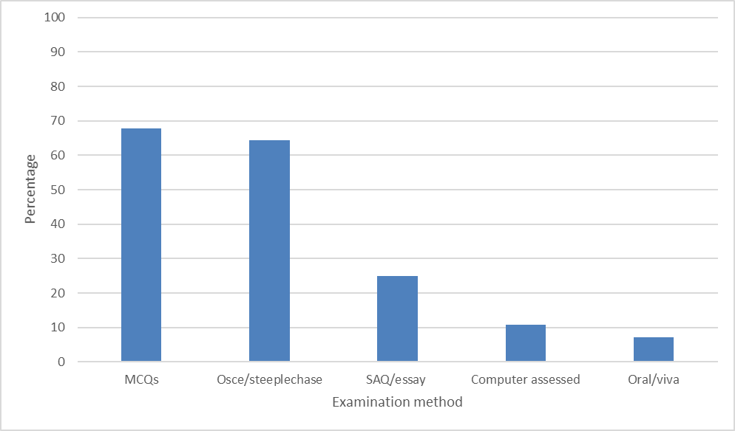
Figure 2 Examination methods
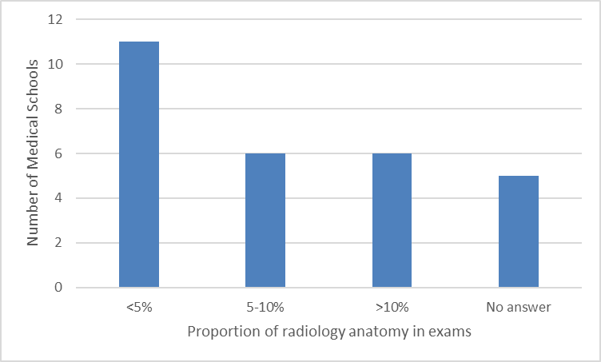
Figure 3 Proportion of radiological anatomy in examinations
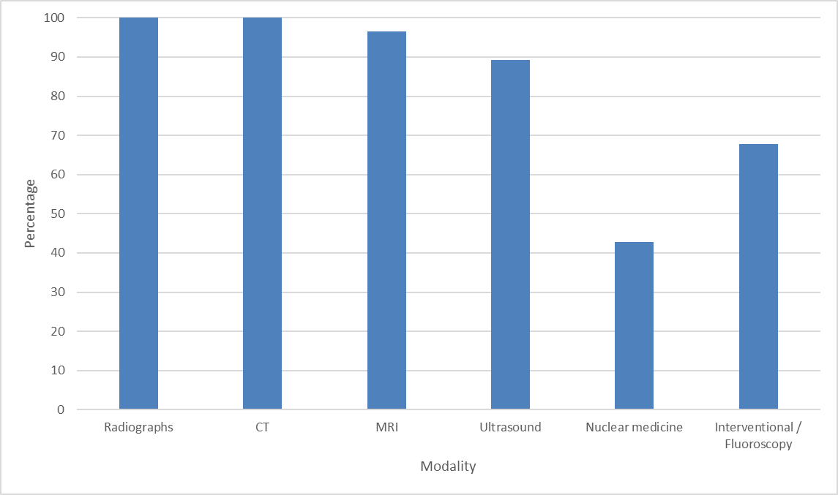
Figure 4 Radiological modalities used

“Freeing up radiologists’ time”
“Lack of availability of staff”
“Juggling clinical commitments with timetable”
“Freeing up radiologists’ time”
“Lack of collaboration between basic science teachers and radiologists”
“Obtaining images from Trusts due to their restrictive policies”
“Insufficient computers with large screens, lack of CT 3D reconstruction images, lack of MRI series, lack of portable ultrasound machine to demonstrate anatomy”
“Rapid change in radiological or imaging technology. As anatomists, we struggle to interpret ultrasound, MRI and CT. Time must be found to teach the students how to interpret images, but essentially that time is limited and we are primarily aiming to teach anatomy but illustrating it radiologically”
“Facilities for students to interact with cross sectional/3D imaging individually in a larger group setting.”
“The demonstrators tend to have a surgical background and we and the anatomy department feel the teaching would be best delivered by radiologists, but it has proved difficult to find the bodies in the radiology department to actually deliver this teaching.”
“Images need to be fully anonymised which can be difficult for ultrasound images which have personal information written on them.”
“Time limitations in the curriculum.”
“I found it difficult to establish a radiological image bank which could be used in my teaching and examination.”
“Some of the anatomy staff are not very comfortable in teaching it, as they have no training”
Table 1 Challenges in integrating radiology into anatomy teaching

“Radiological anatomy lectures, delivered by radiologists, should form part of any anatomy course”
“I have worked hard to bring radiological anatomy into the first two years and I think we have been quite successful, students see it as part of the normal structure of our teaching and I think are positive also about the prospect of radiology as a career - especially interventional radiology - but they are at a very early stage in their careers. Many of our demonstrators go into radiological careers and again act as role models for the students.”
“Radiologists are now the modern clinical anatomists and their involvement in anatomy teaching is essential”
“We are doing this throughout anatomy as we agree that radiological anatomy is fundamental for a future doctor's knowledge and practice”
Table 2 Further Thoughts

References
1 General Medical Council. Tomorrow’s Doctors: Outcomes and standards for undergraduate medical education. (GMC, 2009).
2 Bardeen, C. R. The Use of Radiology in Teaching Anatomy. Radiology 8, 384-386, doi:10.1148/8.5.384 (1927).
3 Mitchell, B. S. & Williams, J. E. Trends in radiological anatomy teaching in the U.K. and Ireland. Clinical Radiology 57, 1070-1072 (2002).
4 Rubin, Z. & Blackham, K. The state of radiologic teaching practice in preclinical medical education: survey of American medical, osteopathic, and podiatric schools. Journal of the American College of Radiology: JACR 12, 403-408, doi:10.1016/j.jacr.2014.11.010 (2015).
5 Craig, S., Tait, N., Boers, D. & McAndrew, D. Review of anatomy education in Australian and New Zealand medical schools. ANZ journal of surgery 80, 212-216, doi:10.1111/j.1445-2197.2010.05241.x (2010).
6 Medical Schools Council: UK medical schools A-Z, <http://www.medschools.ac.uk/Students/UKMedicalSchools/Pages/UK-Medical-Schools-A-Z.aspx> Accessed 13 March 2017.
7 Pathiraja, F., Little, D. & Denison, A. R. Are radiologists the contemporary anatomists? Clinical Radiology 69, 458-461, doi:10.1016/j.crad.2014.01.014 (2014).
8 The Royal College of Radiologists. Undergraduate radiology curriculum, second edition. (2017).

Acknowledgements
We would like to thank all the medical schools that took part in the survey, including: Brighton and Sussex Medical School; Bristol University; Cardiff University; Durham University; Edinburgh University; Hull York Medical School; Imperial College London; Keele University; King's College London; Lancaster University; Plymouth University, Peninsula Schools of Medicine & Dentistry; School of Medicine, Dentistry and Biomedical Sciences, Queen's University Belfast; St George’s, University of London; Swansea University College of Medicine; University College London; University of Aberdeen; University of Birmingham; University of Buckingham; University of Cambridge; University of East Anglia; University of Exeter; University of Leeds; University of Liverpool; University of Manchester; University of Nottingham; University of Oxford; University of Southampton; University of St Andrews; University of Warwick.

