Succulent plants

Howard Griffiths & Jamie Males*
Physiological Ecology, Department of Plant Sciences, University of Cambridge, Cambridge, UK
Lead contact: jom23@cam.ac.uk

Introduction
The peculiar morphologies of succulent plants have been variously considered as grotesque monstrosities and exotic curiosities, but succulents have always been perceived as unique. The succulent syndrome is considered to be one of the most remarkable examples of convergent evolution across the plant kingdom. Common to all succulents is the presence of large cells for water storage. However, cellular succulence can occur in any vegetative plant organ, with the level of succulence in roots, stems, and leaves being subject to a certain degree of evolutionary coordination. Furthermore, cellular succulence scales up to morphological succulence according to various anatomical schemes which confer contrasting functional characteristics. This means that succulence is associated with a broad range of ecophysiological strategies and occurs in plants that have evolved in many different environments.
The term ‘succulence’ itself is generally agreed to refer to the storage of a significant amount of withdrawable water in living cells. Since it is dependent on variation in quantitative parameters such as cell volume, cell packing, and tissue thicknesses, succulence is better considered as a continuous rather than a binary trait. Running parallel to this spectrum of succulence is a corresponding and underappreciated spectrum of ecological strategies based on contrasting water-use characteristics. Nevertheless, categorisation is sometimes necessary, and approximately 3-5% of all flowering plants are commonly described as succulents- a small but important proportion. Although some succulent lineages have undergone much greater net species diversification than others, there is no strong bias in the phylogenetic distribution of origins of succulence, suggesting that it is a relatively ‘evolutionarily accessible’ syndrome. The phylogenetic placement of some of the major radiations of succulents in the angiosperms is shown in Fig. 1.

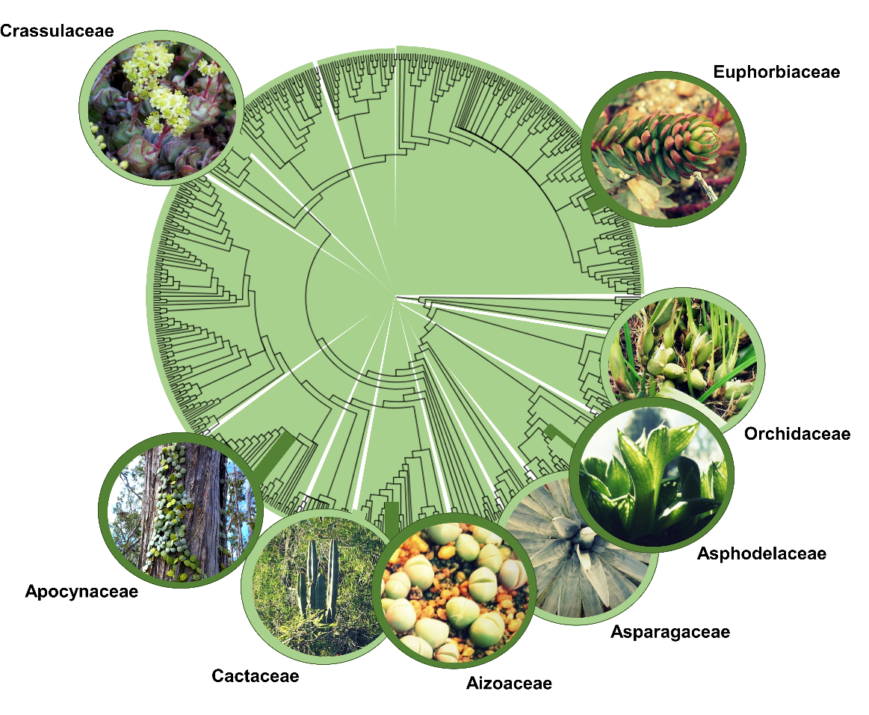
Figure 1. Phylogenetic distribution of some major succulent plant groups across the angiosperms. Phylogeny based on data from Smith et al. (2011).

We will first consider how the structural and functional properties of succulent plants influence their ecology, beginning with a survey of the core commonalities of the succulent syndrome. We will then go on to consider how these relationships have shaped the diversity of different succulent subtypes, and further define these categories in terms of habitat preferences and global distributions.

Key attributes of the succulent syndrome
The primary role of succulence is the storage of water in living cells for later remobilisation, and the water content of succulent organs may reach 90-95%. This hydraulic capacitance is fundamental to the ecophysiological strategies of succulent plants, but is underpinned by a range of structural varieties. Plants with specialised achlorophyllous water-storage tissue (hydrenchyma) are known as ‘storage succulents’, in contrast with those which simply store water in expanded chlorenchyma cells and are called ‘all-cell succulents’. Many all-cell succulents are annual plants, and utilise their leaves as single-use stores to extend the effective growing season. Transpiration can be maintained while the stored water is gradually spent, allowing maximal carbon gain before seed-set and senescence. Storage succulents are generally perennial, using stored water to buffer transpiration and chlorenchyma water potential during drought, and refilling their hydrenchyma during periods of water availability. The remobilisation of water to the chlorenchyma is facilitated by elastic cell walls in the hydrenchyma, which make this tissue highly collapsible. In both storage- and all-cell succulents, symplastic water storage may be augmented by the secretion of polysaccharides into extracellular spaces, increasing the water-retentive capacity of the apoplast and forming a gelatinous substance known as mucilage. The importance of mucilage as a water store varies widely between succulent species.
A low surface area to volume ratio (SA:V) is characteristic of most succulent plant organs, providing maximal volume for water storage and minimal surface area for transpirational water loss. In some leaf-succulents, the optimal solution for water conservation in terms of SA:V has evolved: entirely spherical leaves. In keeping with their conservative water-use strategies, succulents tend to display thick cuticles, low stomatal density, high stomatal sensitivity to environmental stimuli, and low hydraulic conductances (sometimes associated with anatomically-reduced vasculature). Recent developments in plant hydraulic research are opening up many new opportunities for characterising the pathways of water transport in plant tissues, which could be of special relevance to processes of water remobilisation and recharge in succulents (see below).
The high cell volumes found in succulent plants are also important for the operation of Crassulacean acid metabolism (CAM), the photosynthetic pathway which is an integral component of the ecophysiology of the vast majority of succulents. This is because CAM requires large vacuoles for the storage of organic acids produced during nocturnal primary CO₂ fixation. Since stomatal opening occurs principally at night in canonical CAM, gas exchange occurs under higher ambient humidity, meaning that CAM confers enhanced water-use efficiency relative to C₃ photosynthesis. Moreover, CAM is also a highly plastic photosynthetic syndrome, which in many species can be expressed at varying intensities or as a facultative response to drought or other environmental stressors.

Drought avoidance in succulents
Contrary to a common misconception, succulents are not abundant in the most arid desert environments. Instead, they tend to occur in semi-arid zones where there is regular and predictable, though not necessarily frequent, rainfall. The seasonal water deficit of these environments may be strong, but rains do return after a relatively fixed period of time. Moisture input from fog or dew may supplement direct precipitation in some cases, and occasionally accounts for a large proportion of the plant’s total water uptake. The ‘atmospheric’ bromeliads of some South American coastal deserts use absorptive leaf hairs to move condensate directly into the leaf. However, water uptake is more usually mediated by wide, shallow root systems, sometimes with a central taproot.
The array of anatomical and biochemical adaptations they display allow succulents of all kinds to maintain high water potentials during drought. There is often dramatic contrast between the dry-season water potentials developed by sympatric C₃ shrubs and succulent plants: the water status of the woody perennial shrubs will usually track soil water/matric potentials, down to -3.0 or -5.0 MPa, whilst the water potentials for succulents very rarely fall below -1.2 MPa. Quantification of the water potential at turgor loss point in succulents shows that these plants are in fact highly sensitive to cellular drought, and often have a relatively limited capacity for cellular mechanisms of drought acclimation such as osmotic adjustment.

Adaptation for hydraulic recharge in storage-succulents
There is increasing interest in the evolutionary trade-offs associated with regulating water transport within plant systems, between roots, stems and aerial photosynthetic organs, and the partitioning of limitations between vascular and extra-vascular pathways. These characteristics are only now being explored for succulent plants, where the process of hydraulic recharge in storage-succulents offers an exciting study system. The diffuse, shallow roots of storage-succulents are extremely well-adapted for rapid rehydration when water becomes available during short, intense rainfall events. These roots absorb a high proportion (up to 50%) of such rain events, while the taproot usually does not make contact with the water table but provides firm anchorage. Roots tend to be very sensitive to soil water potential, and may mechanically contract or undergo biochemically-mediated or cavitation-effected loss of hydraulic conductance during drought, which has the advantage of hydraulically isolating the shoot from the drying soil.
Evolutionary gains of ‘three-dimensional’ venation in leaves, where the vasculature is no longer restricted to a single horizontal plane, have been associated with increased levels of succulence, which highlights the importance of hydraulic connectivity. It is possible that the three-dimensional proliferation of veins in tissues with inherently low vein and mesophyll hydraulic conductances has not been driven by the need for slow and steady metering of water for transpiration between rain events, which often occurs through low stomatal conductances and nocturnal gas exchange in CAM plants. However, if three-dimensional venation allows the rapid recharge of succulent water storage tissues during rain events, this would be consistent with the high proportional use of each rain event. In the extra-xylary compartment, there is a need for functional characterisation of aquaporins in succulent tissues, which may help establish the importance of these channels for dynamic changes in radial hydraulic conductances relevant to the process of redistribution and recharge.
Variation in the spatial configuration of the chlorenchyma and hydrenchmya in storage-succulents could also be of considerable functional significance (Fig. 2). In some cases, there is a central core of hydrenchmya surrounded by a chlorenchymatous rind, or the reverse can occur, with water being stored in a specialised epidermis or hypodermis. Alternatively, the hydrenchmya can be limited to sheet-like structures above, below, or sandwiching the chlorenchyma. In some cases, the transition from chlorenchyma to hydrenchyma is very abrupt, while in other cases it is more gradual. Our understanding of the physiological consequences of this anatomical variation is still in its infancy, but it is likely to involve divergences in tissue hydraulic conductances and the kinetics of recharge and water remobilisation during drought. It may additionally be of special significance for leaf light relations, given the differing optical properties of the chlorenchyma and hydrenchyma.

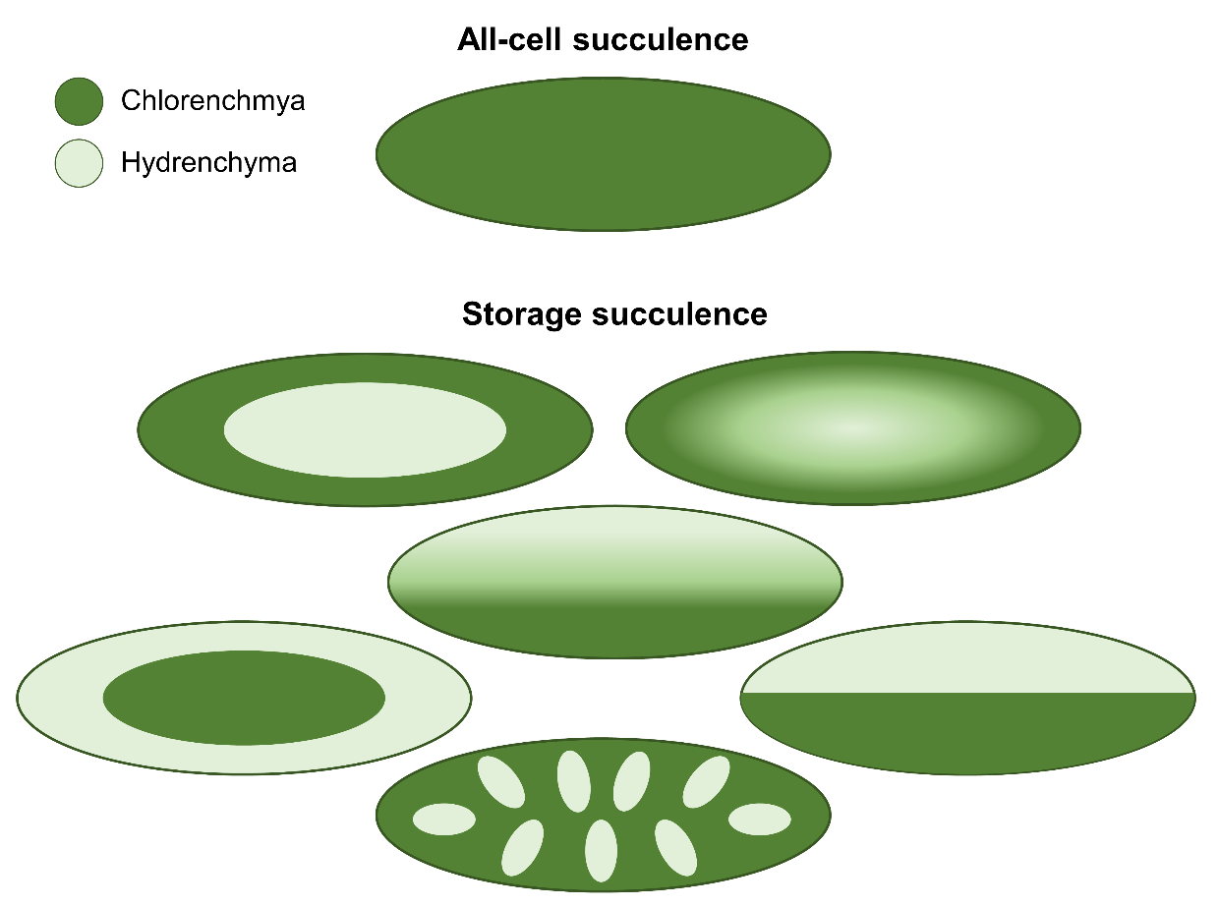
Figure 2. The anatomical diversity of succulence: examples of possible distributions of chlorenchyma and hydrenchyma in all-cell and storage leaf-succulents, including abrupt and gradual transitions between tissue types.

Interactions with other environmental factors
Apart from their role in water storage, succulent organs interact with the environment in a number of other ways. First, their size, density and water content confer high thermal capacity. Since evaporative cooling through transpiration is usually precluded by succulent morphology and physiology, succulents must be particularly tolerant of high tissue temperatures. Having a high thermal capacity can also be beneficial: slow radiative heat loss during the night can decouple plant temperature from air temperature and protect core tissues and nocturnal metabolism from low temperatures (Fig. 3). However, most succulents are susceptible to freezing damage at very low temperatures, and this is an important factor in defining range edges for some temperate zone and subalpine species.

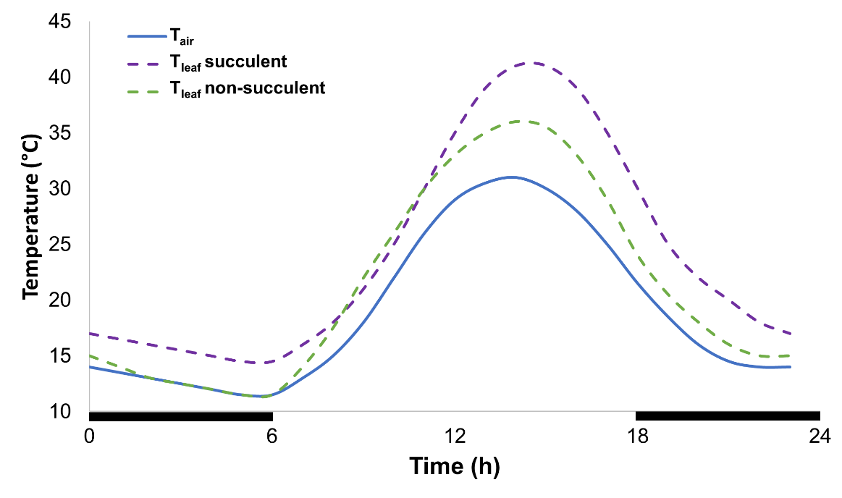
Figure 3. Effect of succulence on diurnal fluctuations in leaf temperature (T_{leaf}). In massive leaf-succulents, high thermal capacity and limited evaporative cooling cause T_{leaf} to reach high levels relative to ambient air temperature (T_{air}) during the day, but T_{leaf} remains relatively high at night. In non-succulent species, T_{leaf} tracks T_{air} more closely, reaching a nocturnal equilibrium.

Secondly, the light relations of succulent tissues differ substantially from those of equivalent non-succulent tissues. Proportionally less light arrives at the centre of a more succulent leaf, although this is to some extent compensated for by the high light levels characteristic of many environments inhabited by succulents. Meanwhile exposure of superficial tissues to excess light can be damaging, and many succulents from high light intensity desert and semi-desert environments have evolved adaptations to reduce epidermal light transmission, including glaucous epicuticular waxes, powders, spines and leaf hairs. Furthermore, the orientation of Opuntia cladodes can be seen to minimise light interceptions at low latitudes, and optimise light absorption on a single planar surface at higher latitudes.
Thirdly, the tight cell-packing in photosynthetic succulent organs reduces the mesophyll conductance to CO₂ (g_{m}), with air spaces often only comprising 5-10% of tissue volume as compared to 30-40% in typical mesophytic leaves. This can strongly restrict the maximal rate of photosynthesis, and constrain overall leaf thickness and hydraulic capacitance in all-cell succulents. In storage succulents, where there is a division of labour between photosynthetic and water storage capacity, chlorenchyma cells are not necessarily as densely packed as in all-cell succulents. Thus g_{m} may remain relatively high in storage succulents. Furthermore, density-related constraints on g_{m} can be offset somewhat by the presence of stomata on both sides of the leaf. In species with CAM, denser tissues will have lower g_{m} during nocturnal CO₂ fixation but greater capacity for organic acid storage and reduced leakiness to CO₂ during the daytime portion of the CAM cycle.
Finally, succulence also has important implications for plant mechanical properties. Heavily succulent aerial organs are often mechanically supported either by woodiness in dicots or by high levels of fibre in monocots lacking secondary growth. This trade-off with investment in mechanical support could have important consequences for the level of succulence that can be achieved in challenging, resource-limited environments. In areas where strong winds are frequent, robust architecture is of special importance to prevent damage from shear. However, fragments of succulents detached by wind or other means can often take root and grow, particularly in species with modular architecture.

Succulent growth forms and their environments
Succulent growth forms are highly diverse, ranging from small herbaceous rosettes and cushion-plants to woody shrubs and trees. Some example of different succulent growth forms are illustrated in Fig. 4. Some of the major groupings, including columnar and opuntioid stem-succulents and massive leaf-succulents, are distributed in similar climatic zones characterised by low water availability and high evaporative potential. Evolutionary analyses have shown that many lineages representative of these functional groups underwent contemporaneous diversification in response to palaeoclimatic and palaeoatmospheric change. However, other succulent growth forms show rather different ecological specialisation, in association with strongly contrasting structural and functional properties. We briefly outline some of the key succulent growth forms to emphasise how the environments in which they have evolved have shaped their structural and functional characteristics.
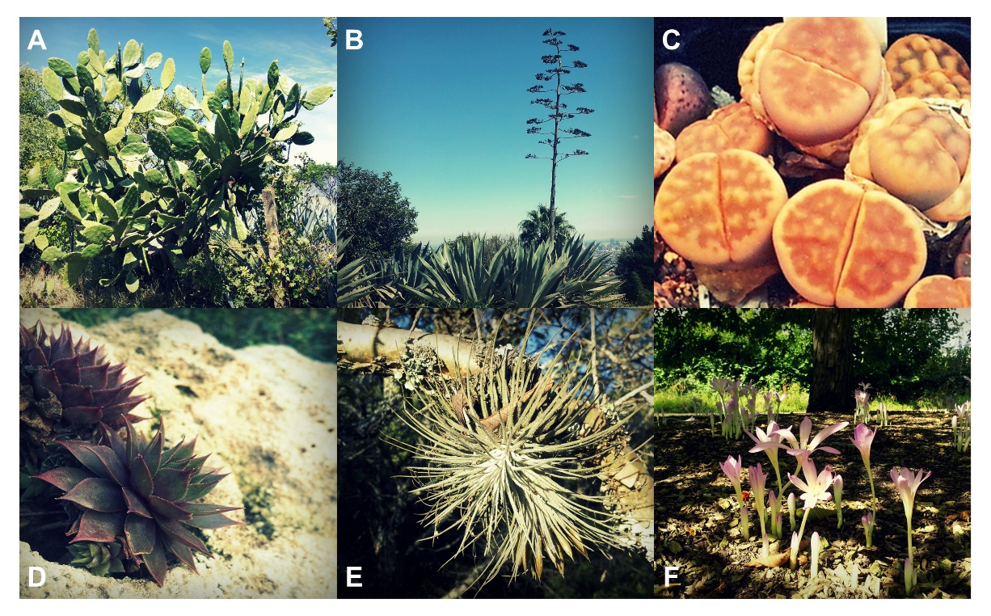
Figure 4. Examples of some of the major succulent growth forms: A) Opuntia ficus-indica (Cactaceae), an opuntioid stem-succulent; B) Agave americana (Asparagaceae), a massive leaf-succulent; C) Lithops aucampiae (Aizoaceae), a miniature desert succulent; D) Sempervivum tectorum (Crassulaceae), an arctic-alpine succulent; E) Tillandsia magnusiana (Bromeliaceae), a succulent epiphyte; and F) Colchicum laetum (Colchicaceae), a succulent geophyte.

Columnar and opuntioid stem-succulents
Columnar stem-succulents are the stereotypical semi-desert succulents of the popular imagination, best exemplified by the Old World euphorbias and New World cacti. Cylindrical stems comprise a photosynthetic rind and central core of hydrenchyma, which provides the high hydraulic capacitance these plants need to survive extended seasonal periods of intense drought. Stems are also often ribbed, allowing accordion-like swelling and shrinking depending on water content, and improving mechanical support. Another common feature of this group is the reduction of leaves to spines, providing a defence against thirsty herbivores and demonstrably reducing the heat and light load on the stem. In the cacti of the Opuntieae tribe, stems are laterally compressed in disc-shaped segments known as cladodes.

Massive leaf-succulents
Epitomised by the aloes and agaves (the latter also displaying stem-succulence), massive leaf-succulence involves a very high degree of succulence in a rosette of large leaves. Hydraulic capacitance is therefore high, but the semi-desert environments in which these plants usually occur have shaped their morphology in other ways too. Adaptive differences in phyllotactic fraction and leaf inclination angle regulate the degree of self-shading to optimise light interception. Plant size and compactness are also important traits that have been subject to environmental filtering in this group, with high-altitude species that are tolerant of cooler conditions, such as Agave montana, tending to be of smaller and more compact stature. This reduced night-time heat loss and improves insulation of meristematic tissue.

Miniature desert and semi-desert succulents
In deserts such as the Namib in southern Africa, many herbaceous perennial succulents are miniaturised. These small plants are often dependent on fog and dew formation for their water balance. In the case of storage-succulent Lithops spp. (Aizoaceae), which grow half-buried in the stony substrate, translucent ‘windows’ of hydrenchyma on the surface of the leaf allow light to penetrate to the chlorenchyma in the subterranean part of the plant. The growth habit of Lithops spp. allows them to remain coupled to more stable soil temperature rather than air temperature, which may be of particular importance in preventing low temperature stress during cool desert nights.
Of similar size but ecologically distinct are the annual all-cell succulents of families such as the Aizoaceae. These plants show a bewildering range of leaf morphologies, which have been able to evolve due to the duplication of a master regulator gene involved in leaf development. The ecophysiological significance of leaf morphology variation among these plants is not clear, since many co-occur in the same environments. The different morphologies may therefore be associated with as yet undetected micro-environmental adaptation and environmental niche partitioning. Clonal propagation is common in succulents inhabiting stressful environments, but it is especially strongly expressed in this group, many of which are rapidly-spreading invasives where they have been introduced outside of their native ranges.

Pachycauls
Among plants with the capacity for secondary growth, stem-succulence is sometimes associated with a highly convergent morphological syndrome known as pachycauly. Pachycauls display a strongly swollen woody stem with often highly-reduced branches. Well-known examples include the Gondwanan baobab trees (Adansonia spp.), the Sahelian desert rose (Adenium obesum), and the Socotran cucumber tree (Dendrosicyos socotranus). Water storage in wood parenchyma is by no means exclusive to pachycauls, but attains its greatest expression among these plants. Green photosynthetic tissue is frequently present on the surface of the stem, particularly among those pachycauls exhibiting strong foliar reduction, and predominantly fixes respiratory rather than atmospheric CO₂. Pachycauls are usually also drought-deciduous, dropping their leaves at the beginning of the dry season and using stored water to initiate a flush of new growth just prior to the start of the rainy season.

Arctic-alpine succulents
Some succulent plants have evolved tolerance of very cold conditions as well as very hot. Alpine succulents, including roseroots (Rhodiola spp.), stonecrops (Sedum spp.) and houseleeks (Sempervivum spp.), occur well above alpine snow-lines and into the Arctic tundra zone. The high thermal capacity associated with succulence and the compact rosette habit typically displayed by arctic-alpine succulents can make a contribution to the avoidance of damage caused by very low air temperatures and freezing, but it is also important to note that some succulents are also freezing tolerant. Some of the biochemical mechanisms involved in freezing tolerance have probably evolved from drought resistance mechanisms.

Epiphytes
Succulence is very common among epiphytes- plants that grow in the canopies of other plants. The combination of epiphytism and succulence occurs in groups such as the orchids (often in the form of strongly succulent pseudobulbs), bromeliads, gesneriads and some ferns, making a particularly important contribution to the floristic and functional diversity of forests throughout the tropics. Nearly one-third of the total leaf biomass of some wet tropical forests is contributed by succulent epiphytes. Some morphologically-reduced epiphytes (e.g. Spanish moss, a bromeliad) are strongly succulent at the anatomical level despite their non-succulent appearance. Among some groups of epiphytes there are correlations between succulence and the degree of exposure in species-specific microhabitats. Phenotypic plasticity is also observed in the degree of succulence expressed among conspecific individuals growing in canopy sites of differing levels of exposure.

Geophytes
Since the most important role of subterranean storage organs (e.g. bulbs, corms, tubers) in geophytes appears to be water storage, these plants are sometimes considered borderline succulents. Geophytism is especially common in regions with a Mediterranean climate, and has evolved in a wide range of plant families, including the Amaryllidaceae (e.g. onions, daffodils, snowdrops), Iridaceae (irises), and Zingiberaceae (gingers) in the monocots, and the Asteraceae (dahlias), Primulaceae (cyclamen), and Solanaceae (potatoes) in the dicots. The storage organs of geophytes have evolved from several different plant parts. For example, bulbs are modified leaves and corms are formed from stem tissue, while tubers may be derived from either stem or root tissue. The environmental factors that have selected for the geophytic habit are equally diverse, and include seasonal drought, extreme temperatures, fire, and herbivory. What degree of physiological diversity exists between succulents growing in different environments and using different storage organs is currently an open question.

Halophytes
Water storage in water-limited environments is not always the primary function of succulence. Halophytes (plants which thrive under saline conditions) are often markedly succulent, often in combination with C₄ photosynthesis. This pairing of traits enables halophytes to achieve high water-use efficiencies while accumulating high levels of salt to help extract water from substrates with very negative water potentials. This may come at the cost of a rapid rate of leaf turnover as endogenous salt levels quickly become toxic, although some species have either specialised epidermal bladder cells for compartmented salt storage or mechanisms for efficient foliar secretion of salt crystals. The unique environment in which halophytes have evolved has therefore selected for a special kind of succulence integrated in an ecophysiological syndrome that is rather different from that of other succulents groups.

The future of succulents: challenges and opportunities
At a fundamental level, there is still much to learn about the nuts and bolts of succulence. Ongoing physiological research, making use of improved modelling methodologies and empirical tools including transcriptomics and gene-editing techniques, will provide greater clarity on key aspects of the functional biology of succulent plants. At the same time, efforts to generate more robust phylogenies for key succulent radiations will be crucial to elucidating how succulence has influenced evolutionary dynamics and ecological trajectories.
Filling in knowledge-gaps about succulence will also be pivotal to advancing important projects in applied plant biology. There is currently intense interest in the potential of succulent plants and the succulent syndrome to provision bioenergy production on marginal land. In conjunction with CAM, succulence can confer high and climate-resilient productivity under semi-arid conditions. The possibility of engineering succulence into non-succulent agricultural and biomass crops to improve their environmental tolerances is also being explored. These efforts will have to take into account how complex structural-functional coordination mediates the efficiency of physiological processes in, and the environmental tolerances of, succulent plants.
In the development of production systems on marginal land, care must also be taken not to exacerbate pressures on populations of wild-growing succulents. Many groups of succulents, including cacti, are threatened by ongoing habitat destruction, unsustainable harvesting for the horticultural trade, and climate change. Efforts to raise international awareness of tropical conservation have hitherto tended to show disproportionate bias towards rain forests, to the exclusion of other vulnerable tropical biomes including dry forests, xeric shrublands, savannas, deserts and semi-deserts, where a great deal of succulent diversity is concentrated. Effective conservation measures are sorely needed to protect imperilled regions with diverse succulent flora. These initiatives could benefit from process-based models of species’ bioclimatic relations. The elaboration of such models will be contingent on a clear, quantitative understanding of the integration of organism-environment relations by structural-functional trait complexes, and may help safeguard the future of this fascinating and diverse group of plants.

Further reading
Arakaki, M., Christin, P.-A., Nyffeler, R., Lendel, A., Eggli, U., Ogburn, R.M., Spriggs, E., Moore, M.J., Edwards, E.J., 2011. Contemporaneous and recent radiations of the world’s major succulent plant lineages. PNAS 108: 8379-8384.
Borland, A.M., Griffiths, H., Hartwell, J., Smith, J.A.C., 2009. Exploiting the potential of plants with crassulacean acid metabolism for bioenergy production on marginal lands. Journal of Experimental Botany 60: 2879-2896.
Evans, M., Aubriot, X., Hearn, D., Lanciaux, M., Lavergne, S., Cruaud, C., Lowry, P.P., Haevermans, T., 2014. Insights on the evolution of plant succulence from a remarkable radiation in Madagascar (Euphorbia). Systematic Biology 63: 697-711.
Heyduk, K., McKain, M.R., Lalani, F., Leebens-Mack, J., 2016. Evolution of a CAM anatomy predates the origins of Crassulacean acid metabolism in the Agavoideae (Asparagaceae). Molecular Phylogenetics and Evolution 105: 102-113.
Ihlenfeldt, H.-D., 1985. Lebensformen und Übelebensstrategien bei Sukkulenten. Plant Biology 98: 409-423.
Klak, C., Reeves, G., Hedderson, T., 2004. Unmatched tempo of evolution in Southern African semi-desert ice plants. Nature 427: 63-65.
Lüttge, U., 2004. Ecophysiology of crassulacean acid metabolism (CAM) plants. Annals of Botany 93: 629-652.
Males, J., 2017. Secrets of succulence. Journal of Experimental Botany (in press).
Nyffeler, R., Eggli, U., 2010. An up-to-date familial and suprafamilial classification of succulent plants. Bradleya 125-144.
Ogburn, R.M., Edwards, E.J., 2010. The Ecological Water-Use Strategies of Succulent Plants. Advances in Botanical Research 55.
Ogburn, R.M., Edwards, E.J., 2013. Repeated origin of three-dimensional leaf venation releases constraints on the evolution of succulence in plants. Current Biology 23: 722-726.
Ripley, B.S., Abraham, T., Klak, C., Cramer, M.D., 2013. How succulent leaves of Aizoaceae avoid mesophyll conductance limitations of photosynthesis and survive drought. Journal of Experimental Biology 64: 5485-5496.
Schwinning, S., Ehleringer, J.R., 2001. Water use trade-offs and optimal adaptation to pulse-driven arid ecosystems. Journal of Ecology 89: 464-480.
Smith, S.A., Beaulieu, J.B., Stamatakis, A., Donoghue, M.J., 2011. Understanding angiosperm diversification using small and large phylogenetic trees. American Journal of Botany 98: 404-414.
Von Willert, D.J., Eller, B.M., Werger, M.J.A., Brinckmann, E., 1990. Desert succulents and their life strategies. Vegetatio 90: 133-143.

