Supporting Information

S1: Membrane Alteration Homogeneity
The lateral lipid distribution within the cell membrane is considered to be essentially uniform and hence PS exposure through migration between membrane leaflets is also expected to occur comparatively homogeneously. Oxidative stress, however, is not necessarily expected to occur uniformly as demonstrated in the 1165 cm⁻¹ IR maps in Figure 3d. Hence, differing amounts of each alteration can also affect the adhesion profile width and the abundance of ‘extreme’ adhesion values. (Such effects relate to the observed profiles that are compared in Figure 4.)

S2: Individual Adhesion Profiles
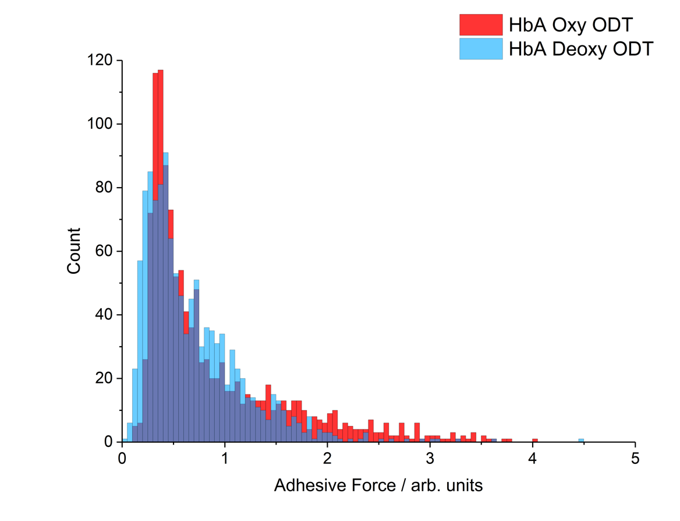
S2a(i): Enlarged adhesion profile of Figure 3a(i)
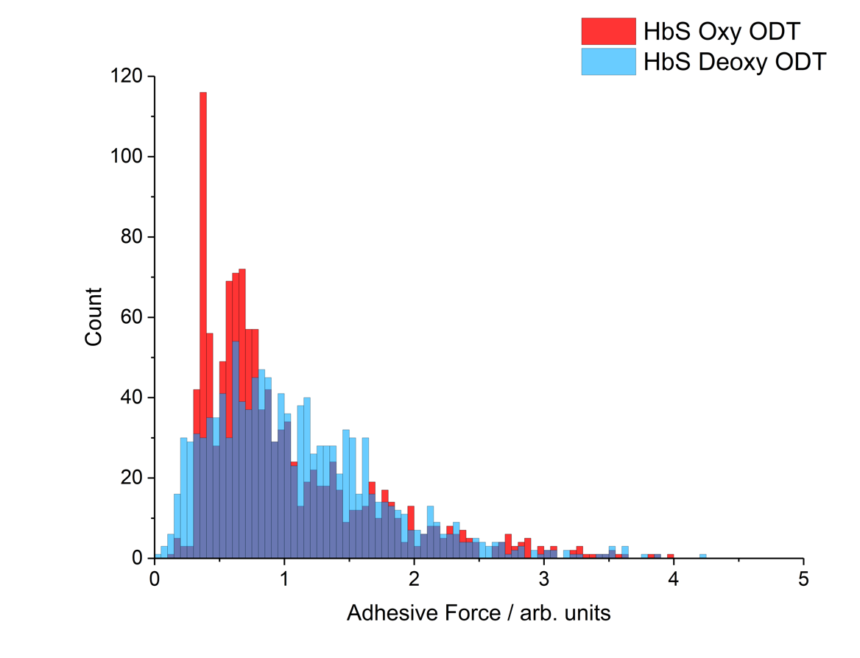
S2a(ii): Enlarged adhesion profile of Figure 4a(ii)
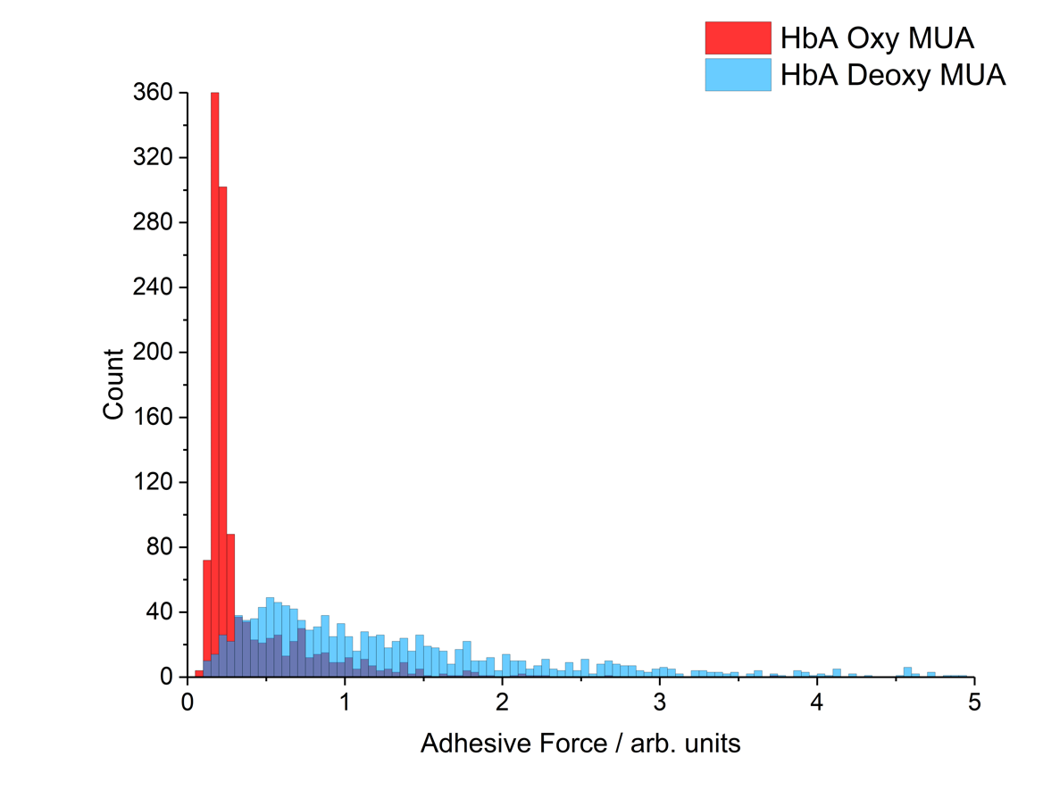
S2a(iii): Enlarged adhesion profile of Figure 4a(iii)
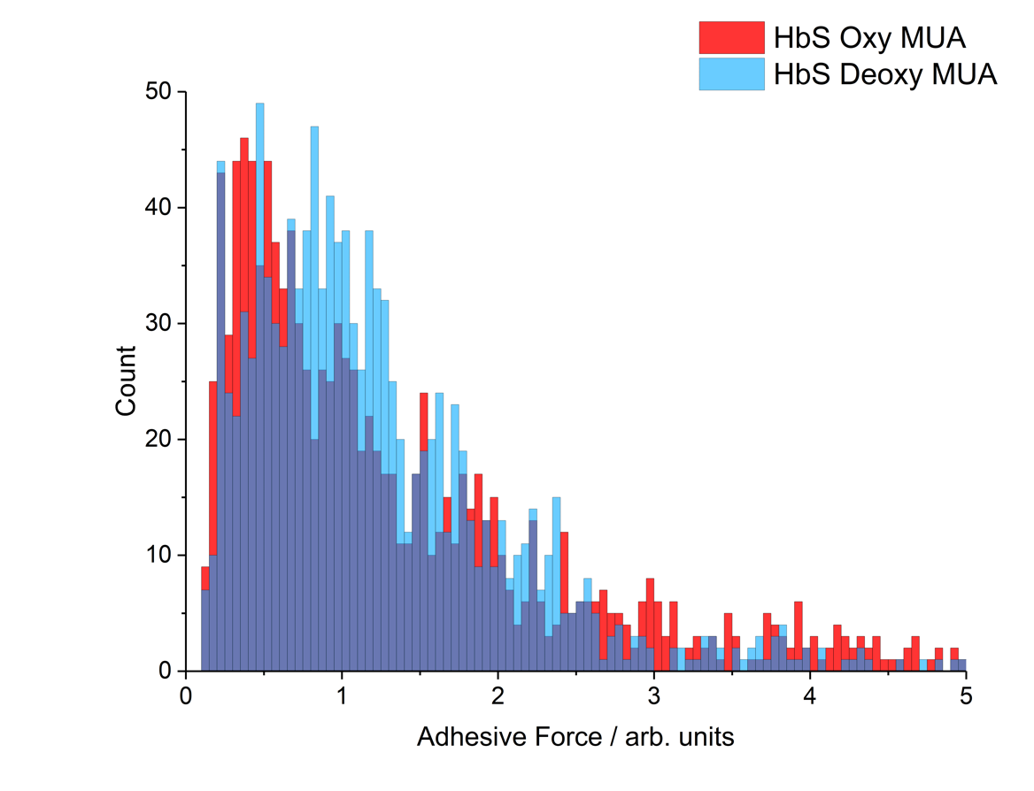
S2a(iv): Enlarged adhesion profile of Figure 4a(iv)

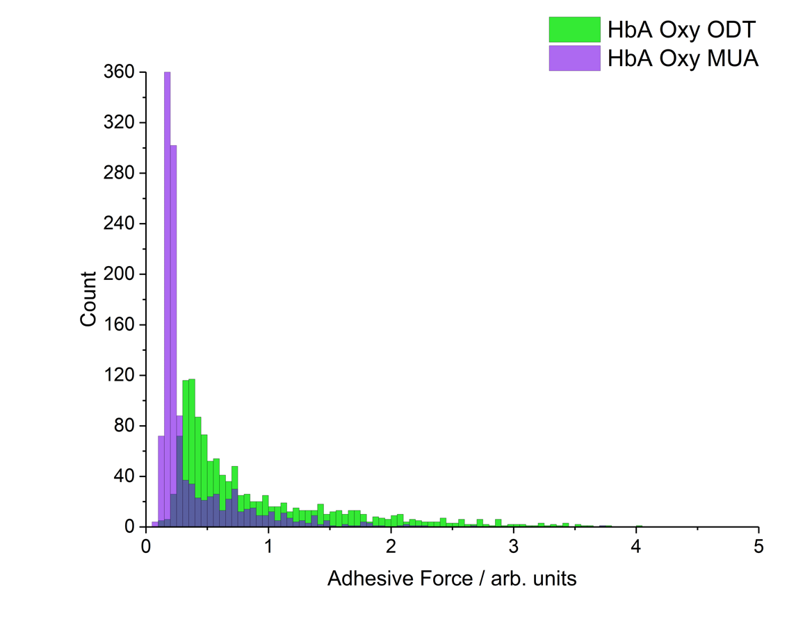
S2b(i): Enlarged adhesion profile of Figure 4b(i)
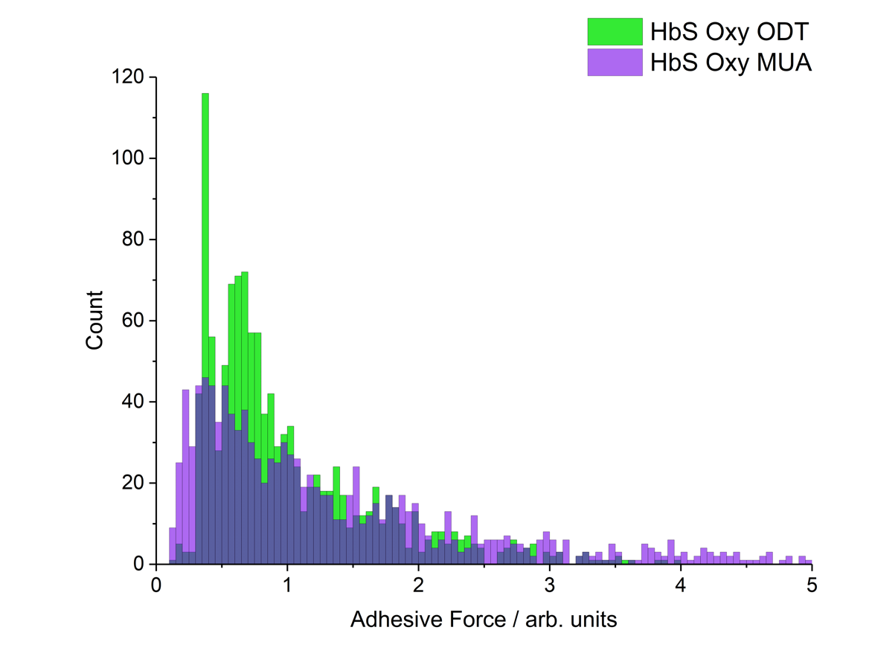
S2b(ii): Enlarged adhesion profile of Figure 4b(ii)

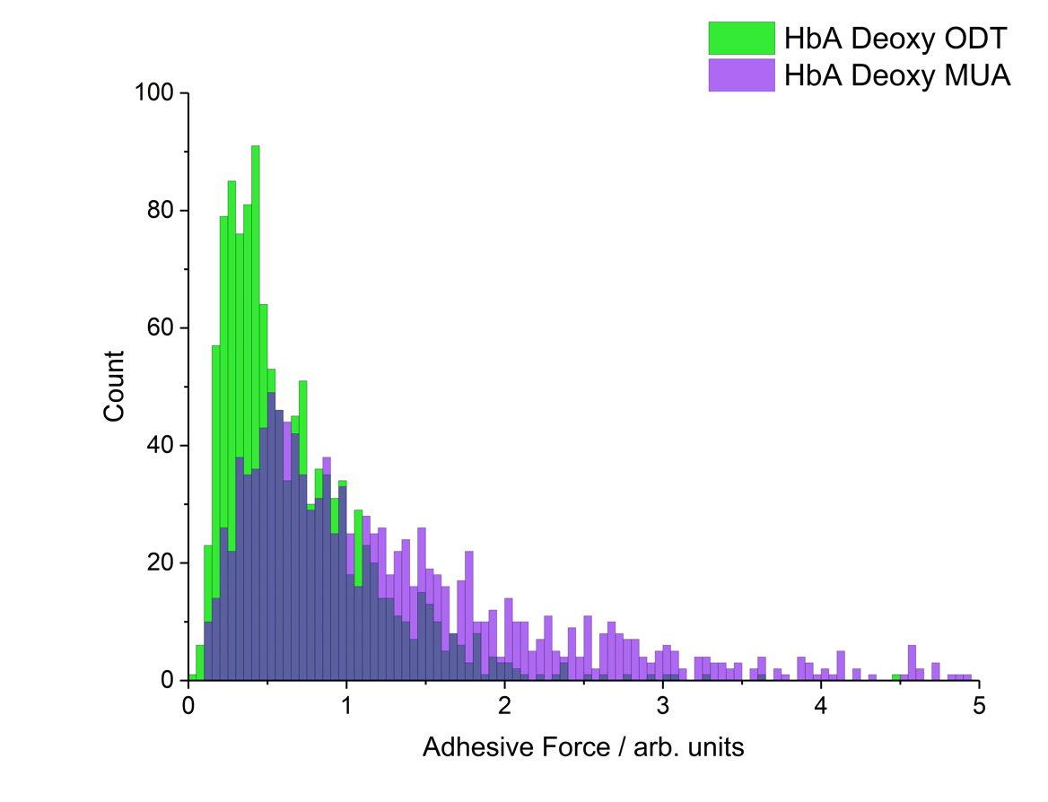
S2b(iii): Enlarged adhesion profile of Figure 4b(iii)
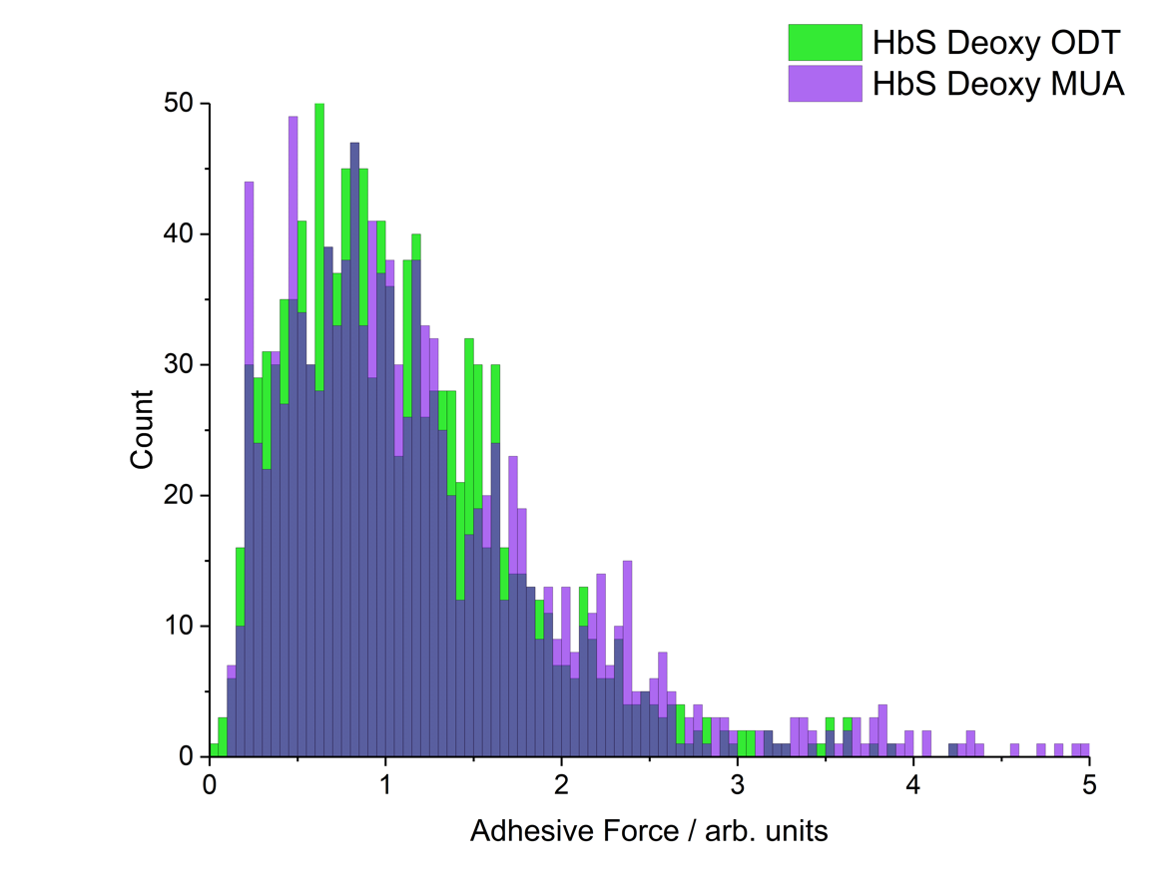
S2b(iv): Enlarged adhesion profile of Figure 4b(iv)

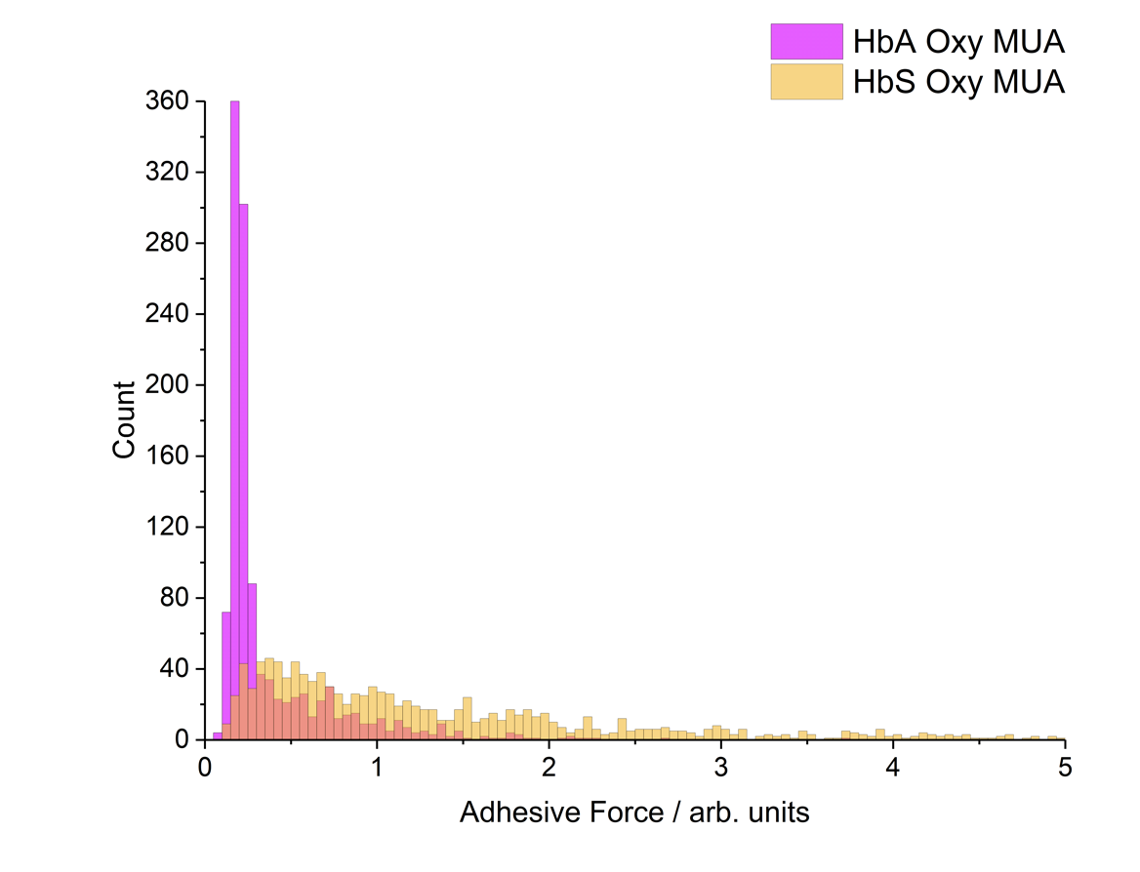
S2c(i): Enlarged adhesion profile of Figure 4c(i)
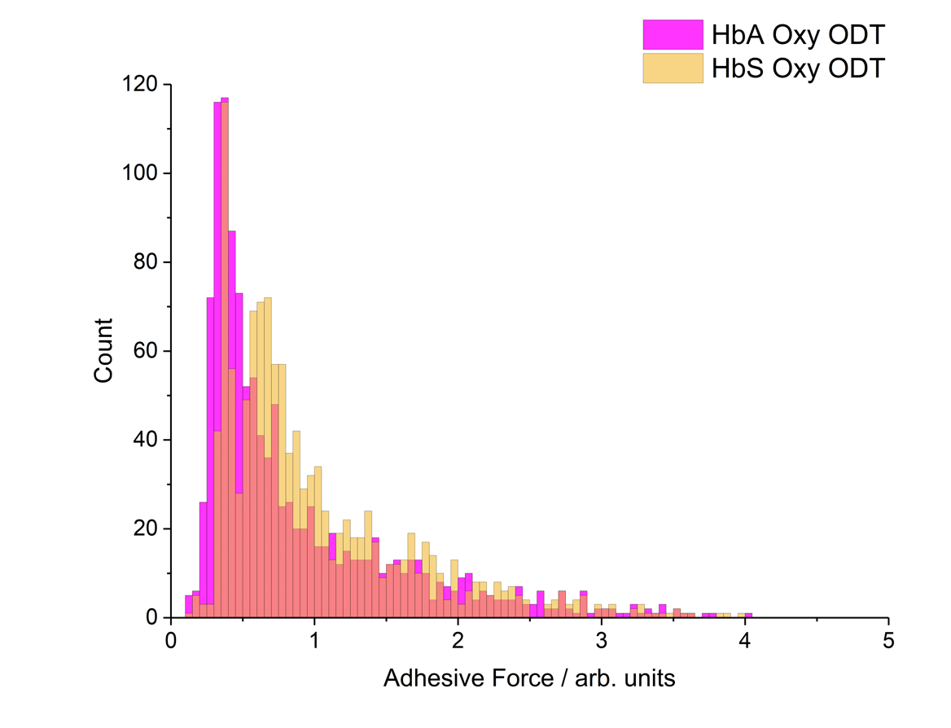
S2c(ii): Enlarged adhesion profile of Figure 4c(ii)
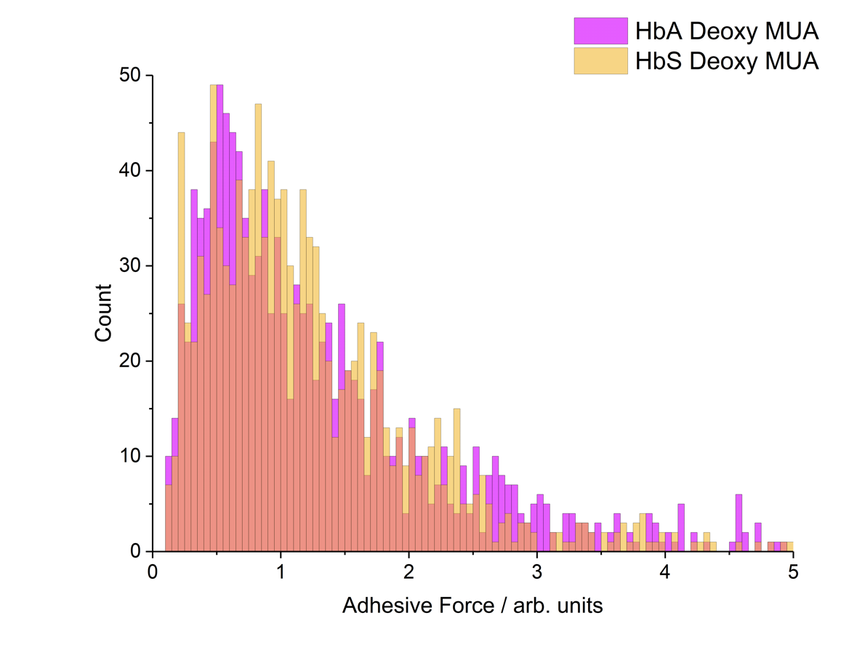
S2c(iii): Enlarged adhesion profile of Figure 4c(iii)
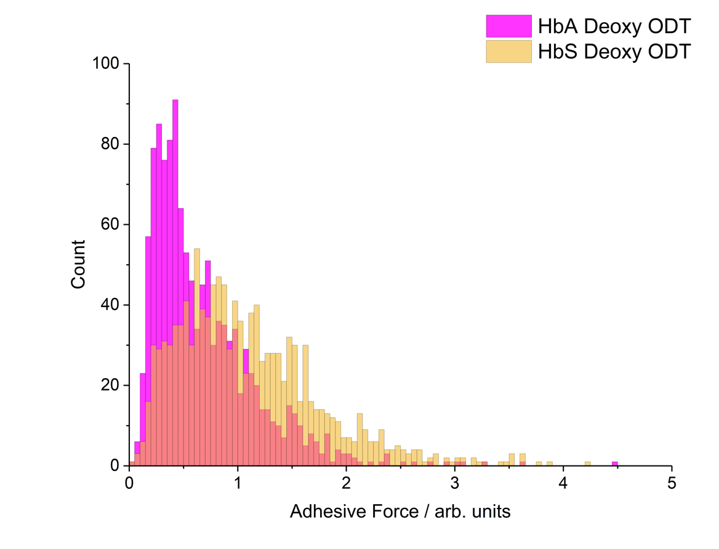
S2c(iv): Enlarged adhesion profile of Figure 4c(iv)

S3: Adhesion Profile Quantitative Information

 | Cell Type | HbAA |  |  |  | HbSS
 | Tip Functionality | ODT |  | MUA |  | ODT |  | MUA
 | Cell State | Oxy | Deoxy | Oxy | Deoxy | Oxy | Deoxy | Oxy | Deoxy
Adhesion / a.u. | Mean | 0.88 | 0.68 | 0.38 | 1.37 | 1.01 | 1.09 | 1.55 | 1.27
Adhesion / a.u. | Median | 0.58 | 0.54 | 0.22 | 1.01 | 0.77 | 0.97 | 1.03 | 1.03
Adhesion / a.u. | Mode ±0.1 | 0.4 | 0.4 | 0.2 | 0.7 | 0.6 | 0.8 | 0.4 | 0.9
Adhesion / a.u. | FWHH ±0.05 | 0.28 | 0.43 | 0.10 | 0.95 | 0.58 | 1.13 | 0.90 | 1.08
High ‘Extreme’ Adhesion | P(A>X) = 0.1  / a.u. | 1.904 | 1.322 | 0.844 | 2.76 | 1.960 | 1.962 | 3.708 | 2.352
High ‘Extreme’ Adhesion | ± / a.u. | 0.006 | 0.003 | 0.006 | 0.01 | 0.001 | 0.001 | 0.002 | 0.009
High ‘Extreme’ Adhesion | P(A>3xMode) | 0.24 | 0.13 | 0.17 | 0.18 | 0.13 | 0.04 | 0.43 | 0.06
High ‘Extreme’ Adhesion | ± | 0.04 | 0.05 | 0.06 | 0.02 | 0.04 | 0.02 | 0.06 | 0.01
Table S3: Quantitative analysis of the adhesion profiles given in Figure 4 and shown in greater detail in S2. The mean and median values given are as found directly from the adhesion data. The mode and FWHH, however, are given from an approximated distribution fit, to allow for random variation and hence are given with an appropriate uncertainty. High ‘extreme’ adhesion regions were quantified using the 90% threshold adhesion as well as the ‘P’ value for adhesion greater than three time the mode.

S4: Thermodynamic Considerations for the Oxidative Stress Mechanism

The mechanism in Figure 5 suggests a mechanism for the oxidative stress to the lipid membrane that is consistent with the observed AFM-IR and adhesion data. A crucial step to this mechanism involves the addition of reactive oxygen species (ROS) to the lipid tail which introduces an oxygen-containing moiety along the lipid tail that is surrounded by significant hydrocarbon tail functionality i.e. a hydrophilic group is introduced into a hydrophobic environment. It is proposed that, consequently, there is a significant driving force for migration of this group to the membrane surface, thus resulting in a large disordering effect to the lipid tail. This can be justified from a simple qualitative thermodynamic model of the process.

Firstly, it is important to consider the high stability of the well-packed lipid leaflet which is highly entropically unfavourable (very low conformational freedom and thus a small number of microstates contributing to S = klnw). This low entropy is accounted for by the significant inter-chain Van der Waals’ interactions that form between well-packed, all-trans lipids (i.e. highly exothermic enthalpic term). Hence, the Gibbs energy change for the formation of an all-trans leaflet can be considered to be negative i.e. spontaneous. Therefore, it would be expected that a disordering effect to the chain as proposed in the oxidative stress mechanism to be unfavourable and with a positive Gibbs energy change. However, the introduction of the oxygen-containing moiety changes this. When the oxygen-containing group is exposed at the surface of the membrane, it encounters an aqueous environment and can be significantly solvated, thus forming favourable electrostatic and H-bonding interactions driving the enthalpic term for the migration less endothermic, leading to a more favourable Gibbs energy change.

A mathematical description of this can be found below:

$$ΔG_{migration}=ΔH_{migration}-TΔS_{migration}$$
$$ΔH_{migration}\left(no ROS\right)=-VdW \\ ΔH_{migration}\left(with ROS\right)=-VdW+{ROS}_{solvation}$$
$$ΔS_{migration}={Tail}_{disorder}$$

Where VdW and ROS_{solvation} are both favourable, exothermic enthalpies (i.e. negative) and Tail_{disorder} is a positive entropic contribution.

$$ΔG_{migration}\left(no ROS\right)=-VdW-T×{Tail}_{disorder}>0$$
$$ΔG_{migration}\left(with ROS\right)=-VdW+{ROS}_{solvation}-T×{Tail}_{disorder}$$

Therefore, where ROS_{solvation} is comparably large (which is likely owing to the strength of electrostatic and H-bonding interactions), the Gibbs energy change on migration becomes negative and therefore represents a spontaneous process.

