Contents
1 Introduction 1
2 Helicoidal structures and their optical response. 2
2.1 An intuitive explanation of the optical effect 2
2.1.1 Bragg Reflection 3
2.1.2 Helicoidal Stacks 3
2.2 Mathematical description 4
2.3 Examples 9
3 Helicoidal structures in nature 9
3.1 Cellulose-based helicoidal structures for structural colour 10
3.2 Chitin-based helicoidal structures for structural colour 11
4 Liquid Crystals as helicoidal structures 12
5 Helicoidal architectures in biomimetic photonics 14
5.1 Artificial helicoidal Cellulose films 15
5.1.1 Cellulose Nanocrystal extraction by hydrolysis 15
5.1.2 Suspension parameters for chiral films 16
5.1.3 Drying parameters for chiral films 17
5.1.4 Cellulose film characterisation 18
5.2 Cellulose as a template – extending functionality 19
5.2.1 Cellulose film composites 19
5.2.2 Templating 19
5.3 Sensors 20
5.4 Hydrogels and cellulose derivatives 21
5.5 Chitin 21

Authors: Rox Middleton, Ullrich Steiner, Silvia Vignolini

Introduction
The most striking and brilliant colours in nature are obtained by structuring materials on the scale of the wavelength of light¹, especially when these are combined with absorbing pigments. Such colorations, called structural, are the results of the constructive interference of reflected light with periodically organised interfaces within nanostructured materials. This means colour can be created from any material, transforming otherwise transparent or slightly absorbing polymers and composites into evolutionary assets of shimmering colour and hue.
Natural polymers are assembled in an incredible variety of complex architectures in the plant and animal kingdom². The diversity of the mechanisms used in nature for the production of structural colour has been intensively covered in several books and reviews, which have appeared during the recent maturation of this field^{1,3,4}. Although the formation/development of these structures in nature is far from being understood⁵, they are an excellent source of inspiration for emerging technologies, even though the artificial production of structural colour is still in its infancy in comparison to the advanced structures found in nature. Most bio-mimetic photonic structures that were produced so far were obtained by using synthetic polymers, photoresist, or inorganic materials^{6–9}. The slow progress in developing processes capable of rivalling natural effects is largely due to the complexity of the natural structures, where a large variety of complex three-dimensional architectures are observed. A striking example of such complexity is the single gyroid structure found in the wing of various papilionid and lycaenid butterflies¹⁰. Natural gyroids have been replicated on different scales both with bottom-up and top-down fabrication. However, both approaches require either the use of synthetic polymers^{11,12} or inorganic materials¹³, and the fabrication of such architectures using natural building block remains still an open challenge.
In contrast, simpler architectures, such as one-dimensional photonic structures, e.g. the multilayers found in insects exocuticles¹⁴ or plants epidermis¹⁵, have been replicated using a plethora of methodologies and materials^{16–19} including also natural polymers²⁰.
In this chapter will therefore focus on this latter group of structures, in particular helicoidal stacks, where the optical properties are well understood, and whose artificial production using biopolymers has been demonstrated.
After a brief introduction of helicoidal architecture and their optical properties we will describe examples observed in nature. Then, we will discuss liquid crystals and biomimetic photonics. Finally, we will discuss the future of the field, its extension into templating, sensors and the use of cellulose derivatives.
In order to progress beyond our current limits, it seems necessary to better study natural processes and materials, to incorporate them into the production of more bio-compatible and sustainable biopolymer-based photonic structures with novel functionalities²¹.

Helicoidal structures and their optical response.

An intuitive explanation of the optical effect
Lyotropic mesophases have been observed in different biopolymers including polysaccharides, DNA, proteoglycans²⁰. Among the different phases observed, the chiral nematic (or cholesteric) phase is quite common on a wide range of length scales²².
In such architectures, also commonly referred as helicoidal, rod-like fibrils are organised in quasi-planes where the fibrils are all aligned in one direction. Such planes are then piled on top of each other so that the directionality identified by the fibrils rotates from plane to plane, by a few degrees, thereby forming a helicoidal stack. Helicoids can be described by the distance between two planes with the same orientation of the fibrils, defined as pitch. When such distance is comparable with the wavelength of light, it can be reflected as in the case of standard Bragg multilayers.
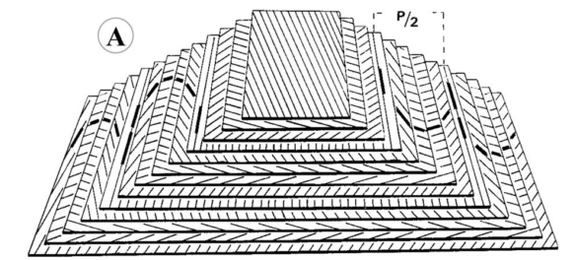
Figure 1: A diagram showing a helicoidal stack. The bold lines are Bouligand arcs resulting from an oblique section. Reproduced from Giraud-Guille et al.²³

Bragg Reflection
A standard Bragg multilayer consists of repeating layers with alternating. Through constructive interference from refractive index boundaries, a single wavelength band is reflected.²⁴
For sufficient number of layers, total reflection of light of wavelength λ occurs when
N λ’ = 2 d sinϴ
where d is the pitch. For normally incident light n = 1, ϴ = 0. λ’ is the wavelength of the light in the material. This yields the reflection condition
λ’ = 2 d.

Helicoidal Stacks
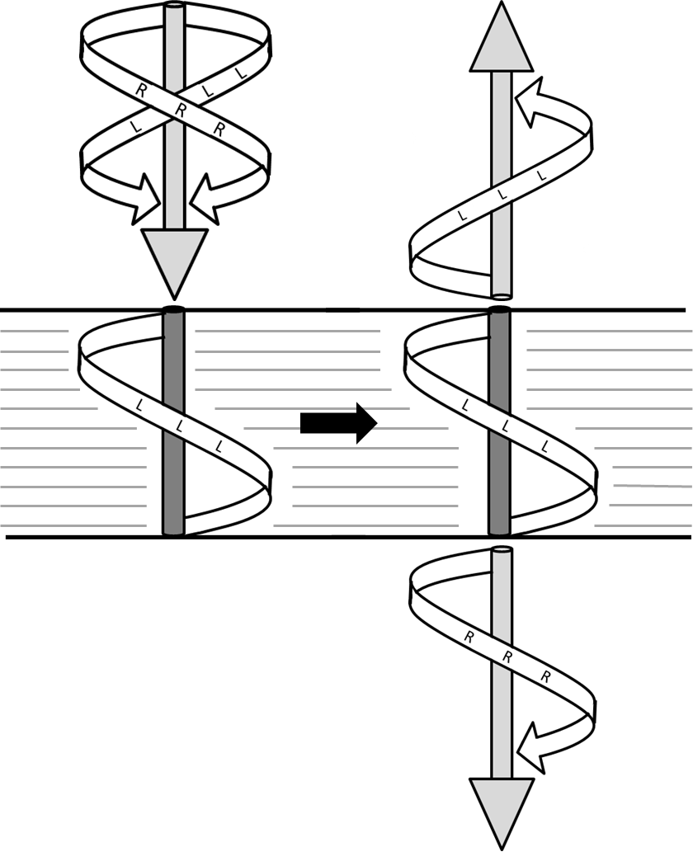
Figure 2 Schematic showing the reflection of left circularly polarised light by a left-handed chiral material. The image illustrates the interplay of structural and optical chirality.
Rod-like particles are birefringent. In a helicoidal stack, their rotating arrangement therefore gives rise to refractive index changes, resulting in a periodically varying refractive index. This implies that the Bragg condition applies.
The Bragg condition for light reflection for the wavelength that matches the material pitch, however, only applies for circularly polarised light that turns in the opposite direction to the twist of the material. Light of the same polarisation direction passes through. In contrast to standard Bragg reflectors, chiral multilayers therefore only reflect one-half of the intensity of unpolarised light
The handedness of light is defined by the receiver (i.e. light coming towards the observer), whilst the material handedness is defined by the chirality moving away from the observer. For this reason, left handed materials have opposite chirality to, and reflect, left-handed light.

Mathematical description
The intuitive description above shows that a helicoidal stack may be considered in terms of a standard Bragg reflector in the rotating frame of circularly polarised light. In more detail, its optical response may be demonstrated analytically using Maxwell’s equations, to show the existence of a photonic bandgap. The key results of the analytic treatment are summarised below.
Since chiral nematic liquid crystals phases have a very similar structural morphology (i.e. rod-like molecules with a rotating director), the method developed to describe chiral nematic liquid crystals can be applied to the case of a solid helicoidal film. This method examines the electromagnetic response of materials with screw-like rotating electrical axes²⁵. The use of transfer matrices, which can be constructed to express the effect on a wave vector as it passes through a material were developed for general materials^{26–28} and later for stratified anisotropic materials^{28,29}.
The full derivation of this approach can be found in ²⁹. In summary, we first consider the general case of a 4 × 4 transfer matrix for electromagnetic materials, followed by the specific case of a screw-like electrical axis.
Maxwell’s equations may be written in rectangular co-ordinates
1
$\left[\begin{matrix}0 & 0 & 0 & 0 & -\frac{∂}{∂z} & \frac{∂}{∂y} \\ 0 & 0 & 0 & \frac{∂}{∂z} & 0 & -\frac{∂}{∂x} \\ 0 & 0 & 0 & -\frac{∂}{∂y} & \frac{∂}{∂x} & 0 \\ 0 & \frac{∂}{∂z} & \frac{∂}{∂x} & 0 & 0 & 0 \\ -\frac{∂}{∂z} & 0 & \frac{∂}{∂y} & 0 & 0 & 0 \\ \frac{∂}{∂y} & \frac{∂}{∂x} & 0 & 0 & 0 & 0\end{matrix}\right]\left[\begin{matrix}E_{x} \\ E_{y} \\ E_{z} \\ H_{x} \\ H_{y} \\ H_{z}\end{matrix}\right]= \frac{1}{c}\frac{∂}{∂t} \left[\begin{matrix}D_{x} \\ D_{y} \\ D_{z} \\ B_{x} \\ B_{y} \\ B_{z}\end{matrix}\right],$
where $E, H, D, B$ are the electromagnetic field vectors. The 6 × 6 matrix is symmetrical with elements only in the first (upper right) and third (lower left) quadrant. The non-zero elements are the curl operators.
This can be rewritten as
2
$$RG=\frac{1}{c} \frac{∂}{∂t}C,$$
where $R$ is the 6 × 6 differential matrix. By defining the time dependence of a light wave by the exponential factor $e^{-iωt}$ (ω is the wave frequency) and in a first approximation ignoring nonlinear effects (i.e. assuming a linear relationship between $G$ and $C$), this is rewritten as
3
$$RΓ=\frac{-iω}{c}MΓ,$$
where $Γ$ is the spatial part of $G$. In this construction
4
$$M=\left(\begin{matrix}ε & ρ \\ ρ' & μ\end{matrix}\right),$$
where each of the four quadrants represent a 3 × 3 tensor (i.e. 3 spatial dimensions), ε is the dielectric tensor, μ the permeability tensor and ρ and ρ’ the optical rotation tensors.
In the case of a plane wave incident obliquely in the $x,z$ plane on a region, $M$ is a function only of $z$. By expanding Equation 3 in terms of the 6 × 6 matrix $R$, two linear algebraic equations in terms of the six components of $Γ$ are found. Two components may thus be expressed in terms of the other four, resulting in four first-order linear differential equations for the other four variables, and two linear algebraic equations. These differential equations may be written in 4 × 4 matrix form as
5
$$-\frac{ic}{ω} \frac{∂}{∂z}\left(\begin{matrix}0 & 0 & 0 & 1 \\ 0 & 0 & -1 & 0 \\ 0 & -1 & 0 & 0 \\ 1 & 0 & 0 & 0\end{matrix}\right)\left(\begin{matrix}E_{x} \\ E_{y} \\ H_{x} \\ H_{y}\end{matrix}\right)=S\left(\begin{matrix}E_{x} \\ E_{y} \\ H_{x} \\ H_{y}\end{matrix}\right),$$
which by multiplying by the inverse 4 × 4 matrix and rearranging is equivalent to
6
$$\frac{∂}{∂z}\left(\begin{matrix}E_{x} \\ H_{y} \\ { E}_{y} \\ {-H}_{x}\end{matrix}\right)=\frac{iω}{c}\left(\begin{matrix}S_{41} & S_{44} & S_{42} & {-S}_{43} \\ S_{11} & S_{14} & S_{12} & -S_{13} \\ {-S}_{31} & -S_{34} & -S_{32} & S_{33} \\ S_{21} & S_{24} & S_{22} & -S_{23}\end{matrix}\right)\left(\begin{matrix}E_{x} \\ E_{y} \\ H_{x} \\ H_{y}\end{matrix}\right).$$
In abbreviated form,
7
$$\frac{∂}{∂z}ψ=\frac{iω}{c}Δ ψ .$$
If $Δ$ is approximately independent of $z$ over a small distance $δz$, the four periodic solutions to Equation 7 are
8
$$ψ_{j}\left(δz\right)= e^{-iq_{j}δz}ψ_{j}\left(0\right).$$
The four eigenvectors and corresponding eigenvalues are found analytically by solving the characteristic equation
9
$$Det\left(\frac{ω}{c}Δ-qI\right)=0,$$
where $I$ is the 4 × 4 Identity matrix. If $Δ$ is independent of $z$ over a distance $h$, integrating Equation 7 gives
10
$$ψ\left(z+h\right)=P\left(h\right)ψ\left(z\right).$$
$P(h)$ can be found by taking the matrix of eigenvectors Ψ and using it in equation 7
11
$$ΨK\left(h\right)=P\left(h\right)Ψ.$$
Here, $K(h)$ is a diagonal matrix with elements
12
$$K_{jj}= e^{iq_{j}h}.$$
With this,
13
$$P\left(h\right)= ΨK\left(h\right)Ψ^{-1}.$$
Exact analytic solutions can be found for cases where $M$ is periodic, as in a single domain of a chiral nematic structure illuminated along its axis of helicity. This method then yields Eigenmodes which are permitted in a material.
In this material the optical activity in each plane is assumed to be negligible in comparison to the optical rotation of the structure. Oseen’s model³⁰ has unit permeability, zero optical rotation and
14
$$ε= \left(\begin{matrix}ϵ+δ cos2βz & δ sin2βz & 0 \\ δ sin2βz & ϵ-δ cos2βz & 0 \\ 0 & 0 & ϵ_{3}\end{matrix}\right).$$
This represents a helical twist in the dielectric values with an $x$ value of $ϵ+δ$ at $z=0$. The pitch of the helical spiral is
15
$$λ= {2π}/{β.}$$
Using Equation 14, the components of $S$ can be derived, so that
16
$$Δ(z)= \left(\begin{matrix}0 & 1-{ X}^{2}/ϵ_{3} & 0 & 0 \\ ϵ+ δ cos2βz & 0 & δsin2βz & 0 \\ 0 & 0 & 0 & 1 \\ δsin2βz & 0 & ϵ-X^{2}- δcos2βz & 0\end{matrix}\right)$$
17
$$X=\frac{cξ}{ω},$$
where $ξ$ is the component of the propagation vector in the $x$ direction.
The secular equation can be solved numerically, providing results that fit well the observed behaviour in chiral nematic solids³¹. This method was used to produce the model of a flat chiral nematic multilayer which is shown in Figure 1.
When $X$ is zero, the characteristic equation can be solved analytically for the eigenvectors and eigenvalues. In this case $E_{x}, H_{y}$ are the same, as are $E_{y}, -H_{z}$, except for a phase difference at $z= λ/4$. The eigenvectors are
18
$$ψ= e^{i(q+ β)z} \left(\begin{matrix}A \\ A' \\ -iA \\ -iA'\end{matrix}\right)+ e^{i(q- β)z} \left(\begin{matrix}B \\ B' \\ -iB \\ -iB'\end{matrix}\right),$$
where the $A$s and $B$s have to be determined.
Matrix multiplication when $X$ is zero gives
19
$$Δψ= e^{i(q+ β)z} \left(\begin{matrix}A \\ ϵA^{'}+ δB \\ -iA \\ -i(ϵA^{'}+ δB)\end{matrix}\right)+ e^{i(q- β)z} \left(\begin{matrix}B \\ ϵB^{'}+ δA \\ -iB \\ -i(ϵB^{'}+ δA)\end{matrix}\right)$$
and by differentiation,
20
$$-i\frac{c}{ω}\frac{∂ψ}{∂z}= e^{i\left(q+ β\right)z} \left(\begin{matrix}A \\ A^{'} \\ -iA \\ -iA^{'}\end{matrix}\right)\frac{c}{ω}\left(q+β\right)+ e^{i\left(q- β\right)z} \left(\begin{matrix}B \\ B^{'} \\ -iB \\ -iB^{'}\end{matrix}\right) \frac{c}{ω}\left(q-β\right).$$
Equation 7 implies that the left hand sides of the last two equations are equal, so by equating the terms, four equations are obtained, two of which provide nontrivial solutions for the case when q has one of four eigenvalues,
21
$$q= {±(β^{2}±2β\frac{ω}{c}\sqrt{ϵ+ \frac{\frac{δ^{2}}{ϵ}{\left(\frac{ω}{c}\right)}^{2}}{4β^{2}}}+ {\left(\frac{ω}{c}\right)}^{2}ϵ )}^{\frac{1}{2}},$$
which provides a full solution with either $A$ or $B$ specified.
The important aspect about the solution for the eigenvectors is that for small values of $ω$, the eigenvalues of $q$ are approximately circularly polarised, affected by the chiral material as if it was optically active . In addition, when
22
$$ω≈ \frac{cβ}{\sqrt{ϵ}}$$
i.e. when the wavelength in the medium is near half the pitch length, the eigenvectors are no longer approximately circularly polarised. Furthermore, one pair of eigenvalues is imaginary over a frequency band and is attenuated. In real materials, the wavelength of light exciting this mode is totally reflected for samples consisting of many perfectly ordered layers. The non-attenuated modes are transmitted through the material.
This single reflection band for light breaks up at oblique incidence. The solutions when $X$is non-zero give further weak bands near higher multiples of the fundamental band frequency³².

Examples
The plots below were created using the Berreman 4 × 4 matrix method, simulating the optical response of a multilayer. Variations in the anisotropy of the refractive index, the pitch of the layers, the number of layers and the average refractive index are shown. The changes shown by the Berreman simulation match the intuitive understanding of ordinary Bragg reflectors.

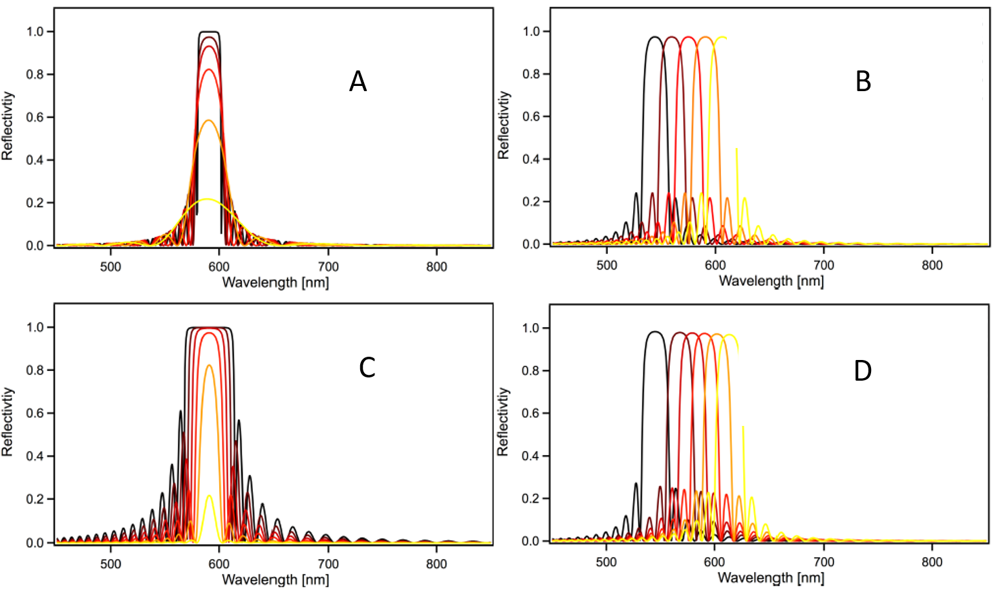
Figure 3: Variation of parameters in a chiral nematic multilayer numerically solving the Berreman. A. Variation in number of layers:5 (yellow), 10, 15, 20, 25, 50 (black). B. Variation in chiral pitch: 390nm (yellow), 380nm, 370nm, 360nm, 350nm (black). C. Variation in refractive index contrast: 0.01 (yellow), 0.02, 0.03, 0.04, 0.05, 0.06 (black) D. Varaition in average refractive index: 1.62 (yellow), 1.59, 1.56, 1.53, 1.50, 1.47 (black).

Helicoidal structures in nature

Helicoidal architectures of polysaccharides, like chitin and cellulose are found both in the animal and plant kingdoms with a great variety range³³ (see Figure 5). Since the pioneering work on these structures, mainly preformed in the 1970s by Neville^{34–38}, they have been shown to be extremely widespread, probably because of their mechanical performance^{39–42} . Cellulose and chitin are, in fact, called structural polysaccharides. They can be found in every plant cell wall and in the cuticle of different genera^{39,43}. For this reason they are the most abundant renewable organic materials produced in the biosphere ^{44,45}. The mechanical properties of cellulose and chitin are a consequence of their super-molecular architecture⁴⁶. In nature, both cellulose and chitin organize in fibrillar structures mainly via inter-molecular hydrogen bonding⁴⁷. The fact that the elementary fibrils contain interconnected amorphous and crystalline regions result in good stiffness and elastic properties. The size of these elementary fibrils, has been extensively researched and strongly depends on the polysaccharide source^{39,48}. The dimensions of the crystalline parts also vary between species^{44,49}. A schematic illustrating the organization of these polysaccharides in nature is shown in Fig. 4.
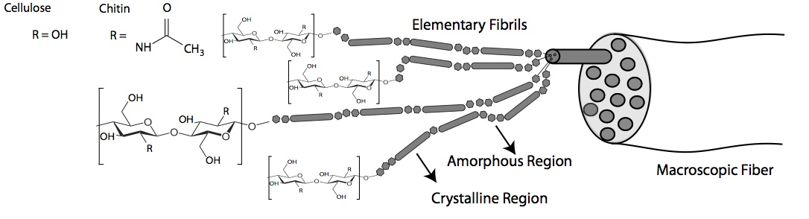
Figure 4 Hierarchical structure of cellulose and chitin from molecules to macroscopic fibers adapted from⁵⁰ .
These hierarchical fibrils are extruded from the external plasma membrane of the cell into the cell wall by groups of synthase molecules arranged in ‘rosettes’^{51,52}. The parallel synthesis of cellulose molecules results in the growth of the polymorph I instead of the otherwise energetically more favourable polymorph II. This second polymorph is the form of cellulose synthesised in vitro ⁵³.
The extruded fibrils are continuously wrapped around the cell⁵⁴ to build the growing cell wall^{51,55,56}. The arrangement of fibrils is adapted to the cell type, and may be a random, axial, transverse, crossed, helical or helicoidal arrangement⁵⁶.
To form helicoids, each individual nano-fibril is arranged parallel to another other in stacked planes. From plane to plane, the orientation of the fibrils changes by a few degrees to obtain the helicoidal structure. While in many instances the dimensions such helicoidal structures are not on the right length-scale to produce structural colour, there are many examples where such hierarchical structures provide a vivid and strong iridescent coloration.

Cellulose-based helicoidal structures for structural colour
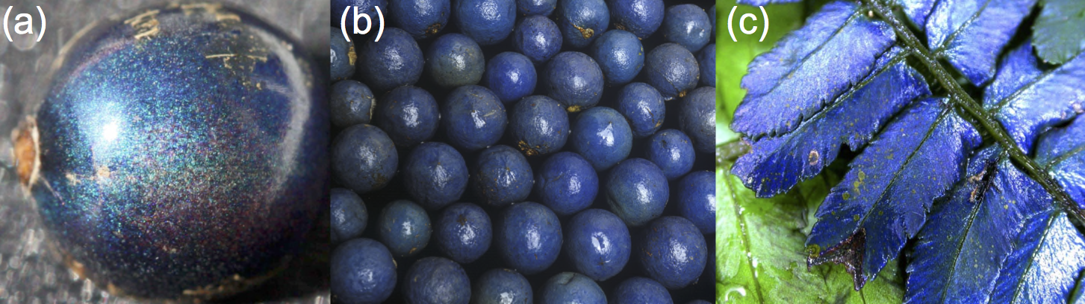
Figure 5 Structurally coloured helicoids in plants, (a) Pollia condensata and (b) Elaeocarpus fruits. (c) Danaea nodosa ferns. Reprinted from ²²
Cellulose helicoidal structures can be found in algae and land plants²². Cellulose is one of the polysaccharides composing the cell wall and it is synthesized by large membrane complexes, which extrude the fibril from the cell. Cellulose is composed by (1,4)-linked β-d-glucan chains in which every unit is corkscrewed 180° with respect to its neighbours, see Figure 4. Each cellulose chain possesses a directional chemical asymmetry with respect to the termini of its molecular axis: one end has a chemically reducing functionality (i.e., a hemiacetal unit) and the other has a pendant hydroxyl group, the nominal non-reducing end. During the biosynthesis, cellulose chains aggregate into microfibrils with cross-sectional dimensions ranging from 2 to 20 nm, depending on the source of the cellulose⁴⁴. Cellulose can be found in the primary and secondary cell wall, but helicoidal structures that display structural colour are observed mainly in the primary cell wall.
Helicoidal structures that produce selective reflection of the blue - ultra-violet wavelength band have been observed in leaves of many different rain-forest understorey plants. Examples are the leaves of Danaea nodosa and Diplazium tomentosum^{4,7,15,21,57,58}. In the case of Danaea nodosa the blue colour is observed only in young leaves, as a result of ordered layers with pitch of about 133 nm in the adaxial cell walls of the adaxial epidermis, but the helicoidal structure is maintained also in the mature tissue. Similar cellulose-based helicoids are observed also in flowering plants, like Phyllagathis rotundifolia^{4,58} and in the tropical understorey herb Mapania caudata⁵⁹. In the latter, in addition to the blue reflection of left-handed circularly polarized light from a cellulose-helicoid structure, silica granules accumulate at uniform position within the helicoids, contributing to the optical appearance of the tissue.
Helicoidal architectures have also been found in the epicarp of different fruits. The first observation of this phenomenon has been reported by D. Lee in 1991 in Elaeocarpus⁶⁰. Recently, similar structures have been observed in the fruit of Margaritaria nobilis and Pollia condensata^{15,61}. While all the other published examples of helicoidal architectures (both in cellulose and chitin) are left-handed, the fruit of Pollia condensata also have cell walls with right-handed orientation of the cellulose structures.

Chitin-based helicoidal structures for structural colour
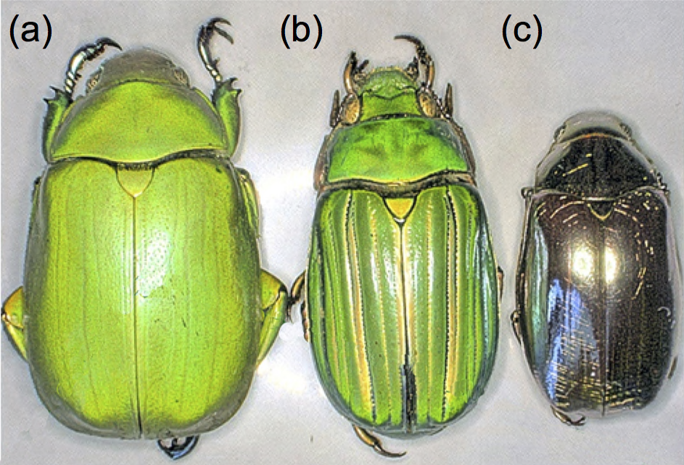
Figure 6 Three representative beetles featuring strong reflectance of circularly polarised light (a) Anomala dimidata, (b) Plusiotis (Chrysina) gloriosa and (c) Plusiotis (Chrysina) optima. Reprinted from ²²
Chitin is a fairly completely acetylated polysaccharide akin to cellulose. The monosaccharide units are joined by 1,4 links that make the molecule very straight and ribbon-like. Within the body of the cuticle, chitin is assembled into nanofibres with diameters and lengths that vary in different organisms⁴⁹. Helicoidal plywoods are particularly widespread in the exocuticle of different species of beetles^{14,39}. The exocuticle is one of the layers composing the exoskeleton of beetles (their hardened wings). In this layer, chitin microfibrils of very small diameter (2.8 nm)⁶² are arranged in a helicoidal architecture. Such chitin microfibrils are embedded in a matrix of proteins, which are stiffened by small, reactive aromatic molecules which cross-link the protein chains. The first observation of this architecture to produce structural colour dates back to 1911 when Albert Abraham Michelson discovered that the scarab beetle Plusiotis resplendens had a left-handed circularly polarized component⁶³.
Since then, many examples in the jewelled beetles (family Scarabaeidae) and its subfamilies Rutelinae, Scarabaeinae and Cetoniinae have been reported^{14,39}. About 20% of the species in both the Rutelidae and Cetoniidae families have an entirely or partially metallic-shiny exocuticle, but not all metallic body parts reflect circularly polarized light⁶⁴.
In the beetle Chrysina gloriosa left-handed green colour reflection is observed from the an exoskeleton, but without colour variation, and patterns are structurally and optically analogous to the focal conic domains formed spontaneously on the free surface of a cholesteric liquid crystal⁶⁵. While, more sophisticated helicoidal structure can be found in Plusiotis resplendens. The latter species is capable of reflecting both left and right circularly polarised light⁶⁶. In contrast to Pollia condensata the right-handed circular polarisation in this case is obtained by using a half-wave retardation plate that is sandwiched between two left handed helicoids.
While there are not conclusive studies on the biological significance of structural colouration produced by helicoids, it is commonly accepted that such a reflection mechanism might play a role in mate signalling and/or camouflage^{67,68}.
While extremely widespread in beetles, other chitin architectures are less successful in other species, and only few examples are reported in the literature, probably because helicoidal components in some Crustacea (crayfish, crabs) are not the individual chitin crystallites, but bundles with a diameter of 25-50 nm⁶². Such filaments form non-optically active helicoid with pitches on the order of the microns. However, in the case of Panulirus argus, chitin calcified architectures produce green coloration⁶⁹.

Liquid Crystals as helicoidal structures

All of the examples of helicoidal architectures given in the previous section are created in living organisms by self-replicating and active processes. This presents an engineering challenge for biomimesis to develop an artificial helicoidal architecture without self-replicating cells. The similarity of biological helicoidal stacks and chiral nematic liquid crystals, however, suggests that biomimeic approaches are possible.
The extent to which different biologically grown tissues itself makes use of this liquid crystalline self-assembly, (a passive, entropy-driven process, as described below) has been a subject of much debate for decades^{33,70,71}. Although liquid crystalline morphologies in many ways strongly resemble helicoidal biological tissue, there are significant differences in the materials and conditions present in passive liquid crystals and living cells ^{72–78}. The evidence is now in favour of a ‘directed self-assembly’ mechanism in organisms, in which the chiral nematic is formed by active directed deposition in situ with a passive, liquid-crystalline relaxation⁷⁹.
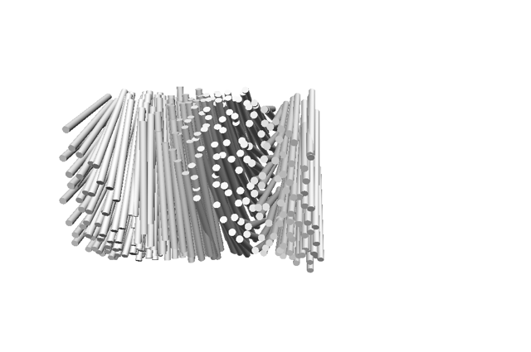
Figure 7 Schematic showing the liquid crystal chiral nematic phase. Image courtesy of Gen Kamita, University of Cambridge.
Liquid crystals were first identified in 1888⁸⁰ in a molecule extracted from carrots. The first observed phase was the cholesteric or chiral nematic phase, whose shape is the subject of this chapter. Liquid crystals are made of molecules of particular shapes which under certain conditions align to form the phase shown in Figure 7. In 1889, the first synthetic liquid crystals were manufactured ⁸⁰. Liquid crystalline phases have been observed in many biopolymers²⁰.
The constituent parts that make liquid crystals can exist over a wide range of sizes, from molecules to colloids. At each size scale different forces control the interactions of the liquid crystal constituents, but the principles of liquid crystalline formation remain the same. In order to understand the use of liquid crystals in biomimetic structural colour for helicoidal architecture, a brief introduction into the huge and varied field of liquid crystals is given here.
Liquid crystal (LC) phases can occur when particles in a liquid have orientational order through anisotropy either in effective shape or charge, which tends to favour a certain directionality when packing the particles. The simplest of these is in particles, with one dimension of anisotropy, are rod-like particles⁸¹.

For these rodlike particles, there is a critical threshold, which according to the system may be either in the concentration of the particles in the system (lyotropic), or in the temperature (thermotropic)⁷⁹. At this concentration or temperature, the interaction of the particles in the liquid is such that entropic evaluation dominates the behaviour.
The entropic description of liquid crystalline phases was first made by Onsager⁸². In Onsager’s description, bringing the particles into a closely packed system, or a liquid crystal, decreases the excluded volume between the particles and creates a two phase system. This reduction of excluded volume is sufficient to overcome the orientational entropy favouring orientational disorder in both rotation and translation.
This description also takes into account the electrostatic interaction, which tends to repel particles from each other, and to increase the excluded volume. This balance between entropic crystallisation and electrostatic repulsion is the key to a stable liquid crystal which neither disperses nor flocculates; it may be affected in real systems by the addition of ions on the particles and in solution. Onsager used the idea of an effective diameter to take into account the change in ionic strength in the system.
Onsager’s theory has since been extended to include chiral nematic phases, notably in the Stroobants-Lekkerkerker-Odijk description⁸³. By quantitatively taking into account the tendency of electrostatic repulsion to favour perpendicular orientation, and entropic consideration to favour parallel orientation, a twisting effect was predicted, caused by charges present. This allows the description of the chiral nematic phase by the use of two parameters; the effective diameter, and the twisting action. This account of chiral nematic phases has been shown to provide a good prediction of experimental results, although discrepancies have been demonstrated and explained as due to flexibility^{84,85} and inhomogeneity⁸⁶ in non-ideal systems.
In a liquid crystal phase the system remains a colloidal liquid but the arrangement of the particles becomes ordered and periodic, and exhibits many of the attributes of a traditional solid crystal, despite having an order parameter far lower than in a solid crystal. This difference can be seen in the latent heat of crystallisation, with a typical value for solid crystals of 250J/g, while liquid crystals have 5J/g⁸⁷. Understanding the control of these systems allows us to exploit chiral nematic liquid crystals to create artificial structural colour with biopolymers.

Helicoidal architectures in biomimetic photonics
By using self-assembly of a chiral nematic phase in a biopolymer liquid crystal of cellulose nanocrystals, a well-controlled technique has been developed to create a solid helicoidal architecture for structural colour, and for further functionalisation.
This section describes the self-assembly process and the control parameters of tunable helicoidal cellulose films, and the prospects for future development.
Currently, this method relies on the biological origin of cellulose nanoparticles, since cellulose synthesized in vitro forms a different polymorph, as described in Section 3.1. This is however not a limiting factor, since cellulose has been processed from its natural sources for centuries. Cellulose nanocrystals are extracted and stabilised in suspension which is then dried to form a helicoidal film as shown in Figure 8.
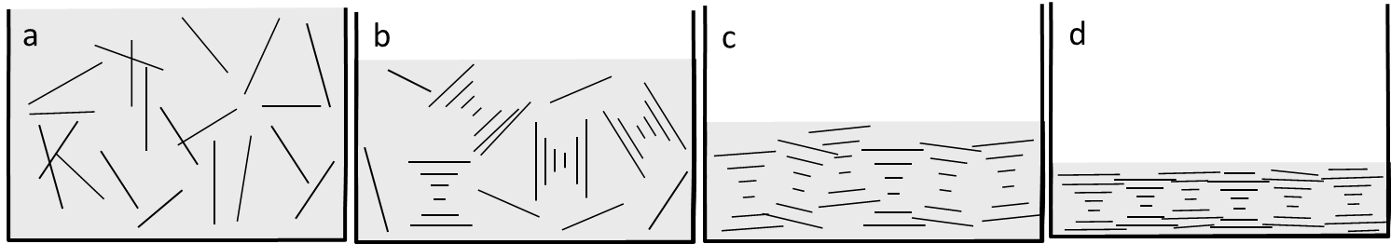
Figure 8 - Schematic of film drying. a. Isotropic suspension, b. Emergence of self-assembled tactoids at a critical concentration. c. Alignment of tactoids in a highly concentrated solution, and d. Dried chiral nematic film.
Through controlled treatment of this suspension before and during drying, the parameters of the resulting structurally coloured film can be tuned. These steps are discussed in the next sections along with the prospect for subsequent functionalisation, and transfer to other materials.
The extraction of cellulose nanocrystals or CNCs ( also called (nano-/micro-)crystallites, whiskers, nanorods and nanowires⁸⁸ ), was first demonstrated in 1952⁸⁹ using acid hydrolysis of cellulose fibres. However, interest in the technique remained low until 1992 when their chiral nematic properties were first reported^{52,90–93}. A patent on the production of structurally coloured cellulose films was filed in 1995 ⁹². Since then, interest in the characteristics of CNCs has grown⁵², especially in the context of mechanical reinforcement⁹⁴.

Artificial helicoidal cellulose films

Cellulose nanocrystal extraction by hydrolysis

The first part of the process consists of the extraction of rodlike particles of cellulose, which can form a liquid crystal phase. In microfibrils, these crystalline regions are connected by amorphous regions as shown in Section 3. The amorphous parts are less well-packed, and therefore less dense than the crystalline regions. This low density makes them more vulnerable to acid hydrolysis. When the fibrils are exposed to sulphuric acid, the amorphous parts are stripped away first, leaving only the crystalline regions⁹⁰. The suspension is sonicated to break apart the crystallites, and filtered to remove large aggregations.
The hydrolysis can be controlled by the concentration of the sulphuric acid and the length of time of acid exposure⁴⁴. After hydrolysis, the cellulose suspension is cooled and dialysed for several days until the acid is removed from the suspension.
This process produces rodlike or whiskerlike nanocrystals between 3-30nm⁹⁵ in width and 50nm to several microns in length⁹⁶. The size and aspect ratio is influenced by the hydrolysis and sonication parameters which break down the fibrils to different extents^{89,97,98}. The more intense the hydrolysis, the narrower and shorter the crystallites become⁸⁹. However, the form of the crystallites is more strongly influenced by the biological source of the cellulose fibrils⁹⁵, as can be seen in the wide variety of cellulose forms in the image in Figure 9.

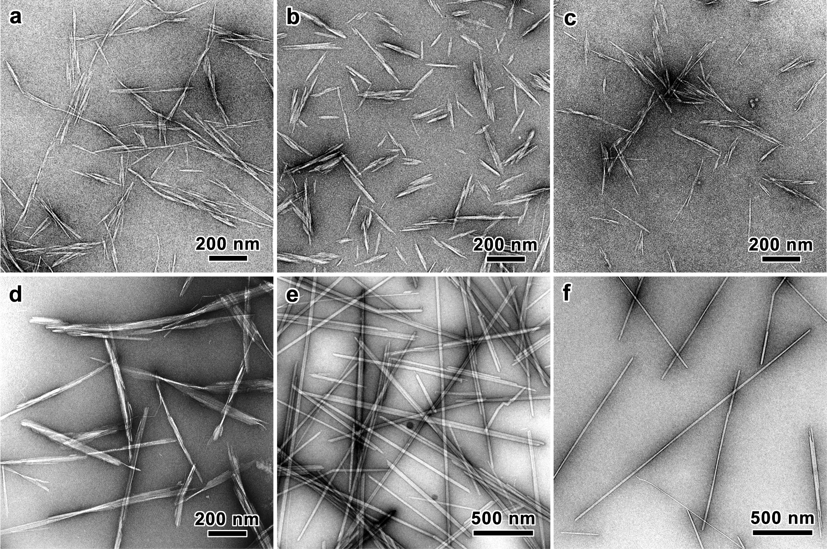
Figure 9: CNCs taken from a) wood b) cotton c) bamboo d) bacteria e) algae f) tunicates, reproduced from Kaushik et al.⁹⁹

Suspension parameters for chiral films
After extraction, further changes to the CNC suspension can be made by heating, sonication and addition or removal of salts. These changes can influence the liquid crystalline phase according to the SLO theory⁸³, as explained in the discussion of liquid crystals. Furthermore, these changes can be used to control the parameters of the final structure.
The assembly of the chiral nematic structure happens in two steps. As the solvent evaporates from the suspension, the critical concentration of the lyotropic liquid crystal phase is reached. The CNCs form discrete localised clusters of chiral nematic phase, called tactoids, as predicted by the phase separation of liquid crystals. These tactoids can be observed between cross-polarisers under a microscope. The first reported image of tactoids in cellulose suspension⁹⁰ is reproduced in Figure 10. The tactoids are visible from the birefringent stripes which represent axes of crystallite arrangement parallel to the stripes⁹⁰.
The rate of evaporation from the suspension at this stage is crucial, as the self-assembly can only occur provided the crystals are not forced to freeze in the isotropic arrangement as happens when the evaporation rate is too high. With a sufficiently slow evaporation rate, the interaction between the CNCs is mediated by the charges on the surfaces of the crystals and those in solution. The tactoids in suspension grow to form a characteristic ‘fingerprint texture’ shown in Figure 10⁹⁰.
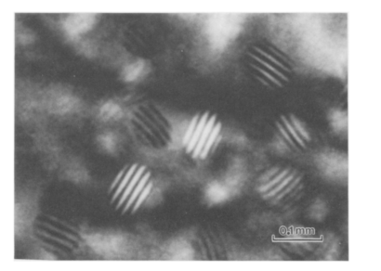
Figure 10: Reproduction of the first recorded tactoids of cellulose nanocrystals in suspension, Revol 1992. Birefringent bands are visible between crossed polars.
Several parameters in the processing of the CNCs influence the degree of chirality and tactoid pitch. A decrease in the width of the individual CNCs has been shown to cause a decrease in the final pitch in the film. Less intuitively, a decrease in the length of the individual CNCs also causes a decrease in pitch¹⁰⁰.
The effect of sonication has also been extensively investigated and has been shown to increase the pitch of the final film¹⁰¹. Sonication breaks apart aggregations of crystals, as well as breaking weak links remaining between crystallites, and releases ions into the solution. The release of ions from the crystallites is the mechanism proposed to explain the increase in pitch¹⁰¹.
The ion concentration may also be changed by direct addition of electrolytes into the suspension. By increasing the surface charges, it has been shown^{86,102} that the chirality of the suspension can be increased, i.e. the pitch decreased. It has again been suggested that the ions increase the effective diameter and the twist on the CNCs and make the chiral stacking interaction stronger. This effect can be demonstrated to be even more pronounced by the inclusion of surfactants which effectively screen the charge of the nanocrystals and allow a much closer packing, decreasing the pitch to a tenth of its previous value¹⁰³.

Drying parameters for chiral films
The final part of the formation of a helicoidal film is the transition from the hydrated chiral nematic phase suspension, to the solid dry film.
Further evaporation of the chiral nematic suspension after the chiral nematic phase has formed, compresses the tactoids and brings the alignment of their planes closer to the substrate plane^{104,105}. The pitch changes during this process according to the forces perpendicular and parallel to the plane in which the crystals lie, and the duration of the drying process¹⁰⁶. By changing the parameters of the evaporation environment, the film’s characteristics may be tuned.
These forces are mostly mediated by surface tension acting on the diminishing volume of the suspension. This evaporation increases the concentration, which tends to compress the hydrated cholesteric structure. A further effect, the so-called the coffee-ring effect, is caused by the geometry of an evaporating liquid, which has increased evaporation at the edges, where the suspension is pinned to the substrate (e.g. the contact-line of a drop). This increase evaporation causes fluid flow towards the edges, causing increased particle deposits at the edges^{107–109}.
The rate with which the evaporation and dehydration of the film takes place plays a vital role in the film pitch. Slower evaporation rates have been shown to produce blue-shifted, smaller-pitch films^{101,110}. This is caused by the increased time allowing the movement of particles into a more tightly packed and twisted arrangement.¹¹¹ An even faster evaporation rate can however prevent the formation of tactoids altogether by jamming nanocrystals in their low-interaction state to produce gelation or a glassy configuration. This generally also occurs at the edges of films due to the the coffee-ring effect¹⁰⁶. Increasing the CNC concentration in the initial suspension, a parameter that also influences the evaporation rate, increases the pitch (redshifts the film) through an increase in the proportion of anisotropic phase in the suspension¹¹². A higher temperature, in contrast, has been shown to decrease the pitch. This is explained by an increase in the flexibility of the rods which weakens the interaction between rods¹¹². The electrostatic interaction of the film with its substrate has also been demonstrated as a control variable.¹¹⁰
In addition to these parameters, extensive control has been shown using fields¹¹¹. Helicoids may be unwound, aligning the nanocrystals in an electric field¹¹³. Furthermore the director of the helicoid itself may be oriented by a magnetic field^{91,114}. A similar alignment of the helicoidal director has been reported using hydrodynamic shear forces¹¹⁵.

Cellulose film characterisation
CNC films have been produced and characterised using electron microscopy and spectrometry, and the chiral Bragg reflector effect was confirmed, with the observed reflection of light corresponding to the helicoidal structure, as predicted by the theory¹¹⁶. Evidence of digitalisation in the observed colours within one film (i.e. discrete jumps in spectral response ) has also been reported¹⁰⁵, and this correlated with different discrete numbers of layers found within a uniformly thick film . The films have been shown to strongly resemble optically responsive helical plywoods found in nature using electron microscopy⁶¹.
Figure 11: Photograph of a chiral nematic cellulose film (a) and its optical microscopy image in cross polarisation configuration (b), reproduced from Dumanli et al^{105a}.

Cellulose as a template – extending functionality
So far, the creation of structural colour by helicoidal architecture was described. This unusual architecture has however much potential in extended applications beyond its optical characteristics, and huge advantages remain to be exploited.
Pathways to these functionalities lie in the inclusion of other materials in the helicoidal structure, and the transfer of the structure into entirely new materials, by creation of porosity, and hard and soft templating of the original structure.

Cellulose film composites

The inclusion of other material within the structurally coloured CNC film is of huge importance for the production of structurally coloured films.
Of particular interest is the inclusion of plasmonic particles^{117–122} whose directed inclusion has been especially studied, as well as latex nanoparticles¹²³. There has also been significant interest in the inclusion of polymers in the films to improve their mechanical flexibility^{124,125}. The inclusion of these molecules also causes a redshift, by acting as a spacer between the cellulose nanocrystals, similar to the inclusion of a smaller molecule, D-(+)-glucose¹⁰⁶.

Templating
An overview of this emerging field is given by Giese¹²⁶ as illustrated in Figure 12.
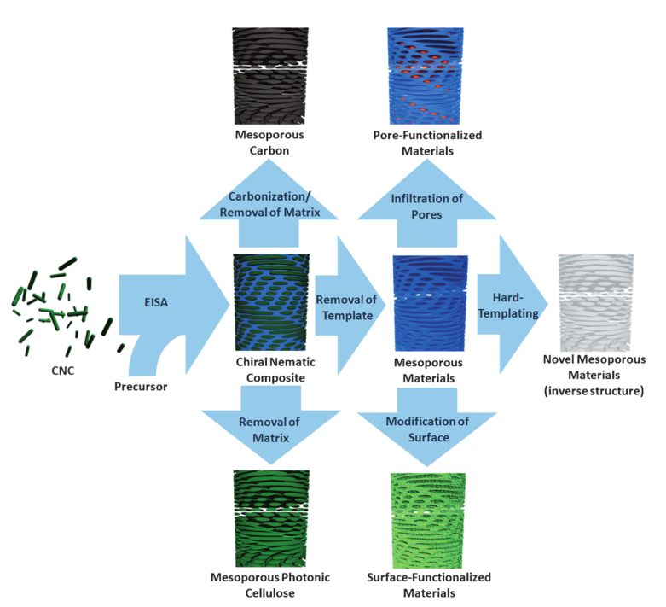
Figure 12 Reproduced from¹²⁶ Giese 2015, showing different routes using CNC films as templates¹²⁶.
A key development in the use of helicoidal films as template materials is the use of silica templates. In this method, silica is grown into the matrix of a chiral nematic crystal using a sol-gel chemistry, employing the chiral nematic structure as a soft template. Removal of the cellulose then leaves an inverse helicoidally patterned template in silica. Kresge’s¹²⁷ demonstration of this technique has since been applied in soft-templating techniques using liquid crystals derived from cellulose¹²⁸.
This template has also been used to demonstrate hard templating of helicoidal patterns into titanium dioxide and other metal oxides^{111,126,129–131}, by refilling and the silica replica, followed by etching away the silica.
This use of other materials is proposed in order to create robust and high-refractive index structural colour, and it is also is proposed as a way of constructing metamaterials.
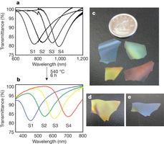
Figure 13: Silica free-standing films created by replicating the CNC chiral phase using a sol-gel chemistry. a) and b) show the transmission spectra before and after the removal of the CNCs c) shows a variety of different colours produced by the technique. d) and e) show the same flake of patterned silica seen at different angles. Reproduced from Shopsowitz et al. ¹²⁸
Soft-templating has been recently reported by the same group¹³² where CNCs are embedded into an amino resin polymer. The obtained composite films are highly flexible and their colouration can be permanently changed by simply applying a pressure.

Sensors
An attractive and demonstrably viable application for these template structures is as sensors. The strong sensitivity of structural colours to very slight changes in scale or shape, and the visible and obvious effect on the optical response make them excellent candidates for sensors. This has been demonstrated in chemical sensing¹³³, temperature¹²⁶ and pressure¹³⁴ sensing.
In each of these cases, the infiltration of another molecule, or the expansion of the existing structure causes the Bragg layer to expand, reflecting light of a longer wavelength. This simple technique can be used to create cheap and simple sensors which are non-toxic and biocompatible.

Hydrogels and cellulose derivatives
Chiral nematic phases can also be achieved in polymeric systems, employing polymers that incorporate motives that form a liquid crystalline phase. Liquid crystallinity occurs in polymers either when they are dissolved in a solvent (lyotropic liquid-crystal) or for temperature above their glass or melt transition point (thermotropic liquid-crystal polymers). Two examples of liquid crystal polymers are hydroxypropylcellulose (HPC) and ethyl cellulose. These polymers are synthetic cellulose derivatives prepared by alkaline treatment to yield alkali cellulose, followed by reaction with the alkyl chlorides^{111,126,135–137}. The first observation of colour production from HPC suspensions has been reported by Werbowyj et al. in 1976^{138,139}. Since then a plethora of works studied the possibility to tune the coloration in suspension^{140–142}, and preserve it in dry films^{143,144}.

Chitin
From the beginning the production of artificial helicoidal structural colour has also been attempted to use the same technique for the helicoidal assembly of chitin^{145–147}. The use of chitin to assemble into a chiral nematic phase in suspension was demonstrated soon after it had been demonstrated in cellulose¹⁴⁸, with no obvious differences. The parameters of the chiral nematic assembly have been demonstrated¹⁴⁹ in suspension and in a gel¹⁵⁰ In the drying stage, chitin however produced a white or colourless film in every study. Even though the helicoidal structure is maintained during the drying of the film, its pitch was larger than visible wavelengths of light. The chitin helicoidal structure has been demonstrated in co-assembly with CaCO₃ showing the prominent helicoidal layers¹⁵¹.
The reason why visibly reflecting chitin films have not yet been obtained is not clear. As discussed in Section 3, visibly reflecting helicoidal chitin structures are abundant in nature. Furthermore, cellulose films can be made from cellulose extracted from non-iridescent fibres. An intact crab cuticle has even been stripped of material to produce a visibly reflecting helicoidal material using biologically assembled materials¹⁵².
The mechanical and structural properties of chitin have been extensively explored^{43,45,153–155} and it promises to establish a complementary system to helicoidal cellulose films in the future.

1 S. Kinoshita, Structural colors in the realm of nature, World Scientific Publishing Co. Singapore, 2008.
2 C. Sanchez, H. Arribart and M. M. G. Guille, Nat. Mater., 2005, 4, 277–288.
3 P. Vukusic and J. R. Sambles, Nature, 2003, 424, 852–855.
4 D. Lee, Nature’s Palette, Chicago, 2007.
5 V. Saranathan, A. E. Seago, A. Sandy, S. Narayanan, S. G. J. Mochrie, E. R. Dufresne, H. Cao, C. O. Osuji and R. O. Prum, Nano Lett., 2015, 18, 150514090040000.
6 L. P. Lee and R. Szema, Science, 2005, 310, 1148–1150.
7 O. Karthaus, Biomimetics in photonics, CRC Press, 2012.
8 K. Yu, T. Fan, S. Lou and D. Zhang, Prog. Mater. Sci., 2013, 58, 825–873.
9 A. R. Parker and H. E. Townley, Nat. Nanotechnol., 2007, 2, 347–353.
10 G. E. Schröder-Turk, S. Wickham, H. Averdunk, F. Brink, J. D. Fitz Gerald, L. Poladian, M. C. J. Large and S. T. Hyde, J. Struct. Biol., 2011, 174, 290–295.
11 T. H. Epps, E. W. Cochran, T. S. Bailey, R. S. Waletzko, C. M. Hardy and F. S. Bates, Macromolecules, 2004, 37, 8325–8341.
12 M. D. Turner, M. Saba, Q. Zhang, B. P. Cumming, G. E. Schröder-Turk and M. Gu, Nat. Photonics, 2013, 7, 801–805.
13 C. Mille, E. C. Tyrode and R. W. Corkery, Chem. Commun. (Camb)., 2011, 47, 9873–9875.
14 A. E. Seago, P. Brady, J.-P. Vigneron and T. D. Schultz, J. R. Soc. Interface, 2009, 6 Suppl 2, S165–S184.
15 S. Vignolini, E. Moyroud, B. J. Glover and U. Steiner, J R Soc Interface, 2013, 10, 20130394.
16 M. Kolle, A. Lethbridge, M. Kreysing, J. J. Baumberg, J. Aizenberg and P. Vukusic, Adv. Mater., 2013, 25, 2239–2245.
17 M. Mitov and N. Dessaud, Liq. Cryst., 2007, 34, 183–193.
18 A. Matranga, S. Baig, J. Boland, C. Newton, T. Taphouse, G. Wells and S. Kitson, Adv. Mater., 2013, 25, 520–523.
19 L. P. Biró, K. Kertész, E. Horváth, G. I. Márk, G. Molnár, Z. Vértesy, J.-F. Tsai, a Kun, Z. Bálint and J. P. Vigneron, J. R. Soc. Interface, 2010, 7, 887–894.
20 I. W. Hamley, Soft Matter, 2010, 6, 1863–1871.
21 S. Z. M. Diah, S. B. Karman and I. C. Gebeshuber, J. Nanomater., 2014, 2014.
22 B. D. Wilts, H. M. Whitney, B. J. Glover, U. Steiner and S. Vignolini, Mater. Today Proc., 2014, 1, 177–185.
23 M. M. Giraud-Guille, E. Belamie and G. Mosser, Comptes Rendus - Palevol, 2004, 3, 503–513.
24 M. Born and E. Wolf, Principles of Optics, Cambridge University Press, 1999.
25 H. de Vries, Acta Crystallogr., 1951, 4, 219–226.
26 H. Hurwitz and R. C. Jones, J.O.S.A., 1941, 31, 493–499.
27 R. C. Jones, J.O.S.A., 1941, 31, 488–493.
28 S. Teitler and B. W. Henvis, J. Opt. Soc. Am., 1970, 60, 830–834.
29 D. W. Berreman, J. Opt. Soc. Am., 1972, 62, 502–510.
30 Oseen, Trans Faraday Soc, 1932, 29, 833.
31 H. G. Yoon and H. F. Gleeson, J. Phys. D. Appl. Phys., 2007, 40, 3579–3586.
32 D. Berreman, J. Opt. Soc. Am., 1972, 62.
33 Y. Bouligand, Tissue Cell, 1972, 4, 189–217.
34 A. C. Neville, BioEssays, 1985, 3, 4–8.
35 A. C. Neville, J. Theor. Biol., 1988, 131, 243–254.
36 a C. Neville and S. Caveney, Biol. Rev. Camb. Philos. Soc., 1969, 44, 531–562.
37 A. C. Neville and S. Levy, Planta, 1984, 162, 370–384.
38 a C. Neville and B. M. Luke, J. Cell Sci., 1971, 8, 93–109.
39 A. C. Neville, Biology of Fibrous Composites, Cambridge University Press, 1993.
40 J. C. Weaver, G. W. Milliron, a. Miserez, K. Evans-Lutterodt, S. Herrera, I. Gallana, W. J. Mershon, B. Swanson, P. Zavattieri, E. DiMasi and D. Kisailus, Science (80-. )., 2012, 336, 1275–1280.
41 T. Zhang, Y. Ma, K. Chen, M. Kunz, N. Tamura, M. Qiang, J. Xu and L. Qi, Angew. Chemie - Int. Ed., 2011, 50, 10361–10365.
42 S. Weiner and H. D. Wagner, Annu. Rev. Mater. Sci., 1998, 28, 271–298.
43 R. a a Muzzarelli, Nanochitins and Nanochitosans, Paving the Way to Eco-Friendly and Energy-Saving Exploitation of Marine Resources, Elsevier B.V., 2012, vol. 10.
44 Y. Habibi, L. a Lucia and O. J. Rojas, Chem. Rev., 2010, 110, 3479–500.
45 R. a a Muzzarelli, J. Boudrant, D. Meyer, N. Manno, M. Demarchis and M. G. Paoletti, Carbohydr. Polym., 2012, 87, 995–1012.
46 J. F. V Vincent, Mater. Today, 2002, 5, 28–41.
47 M. Jarvis, Nature, 2003, 426, 611–612.
48 H. Chanzy, K. Imada, a. Mollard, R. Vuong and F. Barnoud, Protoplasma, 1979, 100, 303–316.
49 J. F. V Vincent and U. G. K. Wegst, Arthropod Struct. Dev., 2004, 33, 187–199.
50 N. Lavoine, I. Desloges, A. Dufresne and J. Bras, Carbohydr. Polym., 2012, 90, 735–764.
51 T. H. Giddings and L. A. Staehelin, Planta, 1988, 173, 22–30.
52 R. J. Moon, A. Martini, J. Nairn, J. Simonsen and J. Youngblood, Cellulose nanomaterials review: structure, properties and nanocomposites., 2011, vol. 40.
53 A. O’sullivan, Cellulose, 1997, 4, 173–207.
54 A. M. C. Emons and H. Kieft, Protoplasma, 1994, 180, 59–69.
55 D. P. Delmer and Y. Amor, Plant Cell, 1995, 7, 987–1000.
56 a. M. C. Emons and B. M. Mulder, Trends Plant Sci., 2000, 5, 35–40.
57 B. J. Glover and H. M. Whitney, Ann. Bot., 2010, 105, 505–511.
58 R. M. Graham, D. W. Lee, K. Norstog, R. M. Graham, D. W. Lee and K. Norstog, 2015, 80, 198–203.
59 G. Strout, S. D. Russell, D. P. Pulsifer, S. Erten, A. Lakhtakia and D. W. Lee, 2013.
60 D. Lee, Nature, 1991, 349, 260–262.
61 S. Vignolini, P. J. Rudall, A. V Rowland, A. Reed, E. Moyroud, R. B. Faden, J. J. Baumberg, B. J. Glover and U. Steiner, Proc. Natl. Acad. Sci. U. S. A., 2012, 109, 15712–5.
62 M. N. . Ravi Kumar, React. Funct. Polym., 2000, 46, 1–27.
63 A. A. Michelson, Philos. Mag. Ser. 6, 1911, 21, 554–567.
64 R. Hegedüs, G. Szél and G. Horváth, Vision Res., 2006, 46, 2786–2797.
65 V. Sharma, M. Crne, J. O. Park and M. Srinivasarao, Mater. Today Proc., 2014, 1, 161–171.
66 S. Caveney, Proc. Roy. Soc. Lond. B., 1971, 178, 205–225.
67 P. Brady and M. Cummings, 2010, 175, 614–620.
68 M. Srinivasarao, Chem. Rev., 1999, 99, 1953–1961.
69 A. C. Neville and B. M. Luke, J. Insect Physiol., 1971, 17, 519–526.
70 G. W. Gray, Molecular structure and properties of liquid crystals, London: Academic Press, 1962.
71 G. D. Mazur, J. C. Regier and F. C. Kafatos, in Insect Ultrastructure, Springer-US, 1982, pp. 150–185.
72 D. Reis, B. Vian, H. Chanzy and J. C. Roland, Biol. Cell, 1991, 73, 173–178.
73 B. Vian, D. Reis, D. Darzens and J. C. Roland, Protoplasma, 1994, 180, 70–81.
74 S. Mizuta, a. Watanabe, S. Kimura and K. Yoshida, Protoplasma, 1994, 180, 82–91.
75 J. C. Roland, D. Reis, B. Vian, B. Satiat-Jeunemaitre and M. Mosiniak, Protoplasma, 1987, 140, 75–91.
76 B. Satiat-Jeunemaitre, Tissue Cell, 1992, 24, 315–334.
77 J. Chan, J. Microsc., 2012, 247, 23–32.
78 M.-M. Giraud-Guille, Curr. Opin. Solid State Mater. Sci., 1998, 3, 221–227.
79 A. D. Rey, Soft Matter, 2010, 6, 3402.
80 M. Mitov, ChemPhysChem, 2014, 15, 1245–1250.
81 D. Demus, Mol. Cryst. Liq. Cryst. Inc. Nonlinear Opt., 1988, 165, 45–84.
82 L. Onsager, Ann. New York Acad. Sci., 1949, 627–659.
83 A. Stroobants, H. N. W. Lekkerkerker and T. Odijk, Macromolecules, 1986, 19, 2232–2238.
84 S. T. Fraden, G. Maret, D. L. D. Caspar and R. B. Meyer, Phys. Rev., 1989, 63, 2068–2071.
85 T. E. Strzelecka and R. L. Rill, Macromolecules, 1991, 24, 5124–5133.
86 X. M. Dong, T. Kimura and D. G. Gray, Langmuir, 1996, 12, 2076–2082.
87 P. J. Collings and M. Hird, Introduction to Liquid Crystals, Taylor & Francis, 1997.
88 H. Charreau, M. L. Foresti and A. Vázquez, 2013, 56–80.
89 B. G. Ranby and E. A. Immergut, Engineering, 1951, 1183–1189.
90 J. F. Revol, H. Bradford, J. Giasson, R. H. Marchessault and D. G. Gray, Int. J. Biol. Macromol., 1992, 14, 170–172.
91 J. Revol, L. Godbout, X. Dong, D. G. Gray, H. Chanzy and G. Maret, Liq. Cryst., 1994, 16, 127–134.
92 D. Godbout and D. Gray, US Pat. 5,629,055, 1997, 28, 9.
93 D. G. Gray, Carbohydr. Polym., 1994, 25, 277–284.
94 M. A. S. A. Samir, A. Dufresne and F. Alloin, Biomacromolecules, 2005, 6, 612–626.
95 S. J. Eichhorn, Soft Matter, 2011, 7, 303.
96 S. Elazzouzi-Hafraoui, Y. Nishiyama, J. L. Putaux, L. Heux, F. Dubreuil and C. Rochas, Biomacromolecules, 2008, 9, 57–65.
97 S. M. Mukherjee and H. J. Woods, Biochim. Biophys. Acta, 1953, 10, 499–511.
98 X. M. Dong, J.-F. Revol and D. G. Gray, Cellulose, 1998, 5, 19–32.
99 M. Kaushik, C. Fraschini, G. Chauve, J. Putaux and A. Moores, in The Transmission Electron Microscope - Theory and Applications, 2015, pp. 129–163.
100 S. Beck-Candanedo, M. Roman and D. G. Gray, Biomacromolecules, 2005, 6, 1048–1054.
101 S. Beck, J. Bouchard and R. Berry, Biomacromolecules, 2011, 12, 167–72.
102 J. Araki and S. Kuga, Langmuir, 2001, 17, 4493–4496.
103 L. Heux, G. Chauve and C. Bonini, Langmuir, 2000, 16, 8210–8212.
104 J.-F. Revol, L. Godbout and D. G. Gray, J. Pulp Pap. Sci., 1998, 24, 146–149.
105 A. G. Dumanli, H. M. van der Kooij, G. Kamita, E. Reisner, J. J. Baumberg, U. Steiner and S. Vignolini, ACS Appl. Mater. Interfaces, 2014, 6, 12302–6.
105a A. G. Dumanli, G. Kamita, J. Landman, H. M. van der Kooij, B. J. Glover, J. J. Baumberg, U. Steiner, S. Vignolini, Advanced Optical Materials, 2014, 2, 646-650.
106 X. Mu and D. G. Gray, Langmuir, 2014, 30, 9256–9260.
107 R. D. Deegan, O. Bakajin, T. F. Dupont, G. Huber, S. R. Nagel and T. A. Witten, 2000, 62, 756–765.
108 X. Mu and D. G. Gray, Cellulose, 2015, 22, 1103–1107.
109 S. Choi, S. Stassi, A. P. Pisano and T. I. Zohdi, 2010, 26, 11690–11698.
110 T.-D. Nguyen, W. Y. Hamad and M. J. MacLachlan, Chem. Commun. (Camb)., 2013, 49, 11296–8.
111 J. P. F. Lagerwall, C. Schütz, M. Salajkova, J. Noh, J. Hyun Park, G. Scalia and L. Bergström, NPG Asia Mater., 2014, 6, e80.
112 J. Pan, W. Hamad and S. K. Straus, Macromolecules, 2010, 43, 3851–3858.
113 Y. Habibi, T. Heim and R. Douillard, 2008, 1430–1436.
114 F. Kimura, T. Kimura, M. Tamura, A. Hirai, M. Ikuno and F. Horii, 2005, 2034–2037.
115 J. H. Park, J. Noh, C. Schütz, G. Salazar-alvarez, G. Scalia, L. Bergström and J. P. F. Lagerwall, ChemPhysChem, 2014, 15, 1477–1484.
116 J. Majoinen, E. Kontturi, O. Ikkala and D. G. Gray, Cellulose, 2012, 19, 1599–1605.
117 A. Querejeta-Fernandez, B. Kopera, K. S. Prado, A. Klinkova, M. Methot, G. Chauve, J. Bouchard, A. S. Helmy and E. Kumacheva, ACSnano, 2015.
118 G. Chu, X. Wang, T. Chen, J. Gao, F. Gai, Y. Wang and Y. Xu, ACS Appl. Mater. Interfaces, 2015, 7, 11863-11870.
119 Q. Liu, M. G. Campbell, J. S. Evans and I. I. Smalyukh, Adv. Mater., 2014, 26, 7178–7184.
120 M. Schlesinger, M. Giese, L. K. Blusch and Y. Hamad, Chem. Commun., 2014, 51, 530–533.
121 H. Qi, K. E. Shopsowitz, W. Y. Hamad and M. J. Maclachlan, 2011, 3728–3731.
122 A. Lukach, H. Therien-Aubin, A. Querejeta-ferna, N. Pitch, G. Chauve, M. Methot, J. Bouchard and E. Kumacheva, Langmuir, 2015, 31, 5033–5041.
123 H. Thérien-aubin, A. Lukach, N. Pitch and E. Kumacheva, Nanoscale, 2015, 7, 6612–6618.
124 C. C. Y. Cheung, M. Giese, J. A. Kelly, W. Y. Hamad and M. J. Maclachlan, ACS Macro Lett., 2013, 2, 1016–1020.
125 R. Bardet, N. Belgacem and J. Bras, Appl. Mater. Interfaces, 2015, 7, 4010–4018.
126 M. Giese, L. K. Blusch, M. K. Khan and M. J. MacLachlan, Angew. Chemie Int. Ed., 2015, 54, 2888–2910.
127 C. T. Kresge, M. E. Leonowicz, W. J. Roth, J. C. Vartuli and J. S. Beck, Nature, 1992, 359, 710–712.
128 K. E. Shopsowitz, H. Qi, W. Y. Hamad and M. J. Maclachlan, Nature, 2010, 468, 422–425.
129 K. E. Shopsowitz, A. Stahl, W. Y. Hamad and M. J. MacLachlan, Angew. Chem. Int. Ed. Engl., 2012, 51, 6886–90.
130 K. E. Shopsowitz, J. a. Kelly, W. Y. Hamad and M. J. MacLachlan, Adv. Funct. Mater., 2014, 24, 327–338.
131 K. E. Shopsowitz, W. Y. Hamad and M. J. MacLachlan, J. Am. Chem. Soc., 2012, 134, 867–70.
132 M. Giese, M. K. Khan, W. Y. Hamad and M. J. Maclachlan, 2013.
133 Y. P. Zhang, V. P. Chodavarapu, A. G. Kirk and M. P. Andrews, Sensors Actuators B Chem., 2013, 176, 692–697.
134 H. Coles, in Handbook of Liquid Crystals, Wiley-VCH Verlag GmbH, 1998, pp. 335–409.
135 Q. Liao, Q. Shao, H. Wang, G. Qiu and X. Lu, Carbohydr. Polym., 2012, 87, 2648–2654.
136 G. S. Rekhi and S. S. Jambhekar, Drug Dev. Ind. Pharm., 1995, 21, 61–77.
137 D. G. Gray, in J. Appl. Polym. Sci; Appl Polym. Symp., 1982, p. 6980365.
138 R. S. Werbowyj and D. G. Gray, Mol. Cryst. Liq. Cryst., 1976, 34, 97–103.
139 R. S. Werbowyj and D. G. Gray, Macromolecules, 1980, 13, 69–73.
140 Y. Onogi and Y. Nishijima, Kobunshi Ronbunshu, 1986, 43, 223–229.
141 Y. Nishio, R. Chiba, Y. Miyashita and K. Oshima, Polym. J., 2002, 34, 149–157.
142 R. S. Werbowyj and D. G. Gray, Macromolecules, 1984, 17, 1512–1520.
143 G. Charlet and D. G. Gray, Macromolecules, 1987, 20, 33–38.
144 S. N. Bhadani and D. G. Gray, Mol. Cryst. Liq. Cryst., 1984, 102, 255–260.
145 R. H. Marchessault, F. F. Morehead and N. M. Walter, Nature, 1959, 184, 632–633.
146 K. Kurita, Prog. Polym. Sci., 2001, 26, 1921–1971.
147 S. Ifuku and H. Saimoto, Nanoscale, 2012, 4, 3308.
148 J. F. Revol and R. H. Marchessault, Int. J. Biol. Macromol., 1993, 15, 329–335.
149 E. Belamie, P. Davidson and M. M. Giraud-Guille, J. Phys. Chem. B, 2004, 108, 14991–15000.
150 M. V. Tzoumaki, T. Moschakis and C. G. Biliaderis, Biomacromolecules, 2010, 11, 175–181.
151 S. Matsumura, S. Kajiyama, T. Nishimura and T. Kato, Small, 2015, 201501083.
152 T. Nguyen and M. J. Maclachlan, Adv. Opt. Mater., 2014, 2, 1031–1037.
153 R. A. A. Muzzarelli, Chitin, 2011, vol. 34.
154 K. Gopalan Nair and A. Dufresne, Biomacromolecules, 2003, 4, 657–665.
155 J. D. Goodrich and W. T. Winter, Biomacromolecules, 2007, 8, 252–257.

