Electrically controlled nano and micro actuation in memristive switching device with on-chip gas encapsulation
Dean Kos^{‡,1} Hippolyte P.A.G. Astier^{‡,1} Giuliana Di Martino,¹ Jan Mertens,¹ Hamid Ohadi,¹ Domenico De Fazio,² Duhee Yoon,² Zhuang Zhao,² Alex Kuhn,³ Andrea C. Ferrari,² Christopher J.B. Ford,¹ Jeremy J. Baumberg^{1,}*
¹ Cavendish Laboratory, J J Thomson Avenue, University of Cambridge, CB3 0HE, UK
² Cambridge Graphene Centre, 9 J J Thomson Avenue, CB3 0FA, Cambridge, UK
³ Univ. Bordeaux, CNRS 5255, Bordeaux INP, Site ENSCBP, 33607, Pessac, France
‡ These authors contributed equally to this work.
* Corresponding author
Keywords: nanoactuation, plasmonic coupling, resistive switching, graphene, nanoparticles
Nanoactuators are a key component for developing nanomachinery. Here, an electrically-driven device yielding actuation stresses exceeding 1 MPa with integrated optical readout is demonstrated. Electrolyte films of 10nm-thick Al₂O₃ are sandwiched between graphene and Au electrodes that allow reversible room-temperature solid-state redox producing Al metal and O₂ gas in a memristive-type switching device. The resulting high-pressure oxygen micro-fuel reservoirs are encapsulated under the graphene, swelling to heights of up to 1µm, which can be dynamically tracked by plasmonic rulers. Unlike in standard memristors where the memristive redox reaction occurs in single or few conductive filaments, the mechanical deformation forces the constant creation of new filaments over the whole area of the inflated film. The resulting on-off resistance ratios are exceptionally high, reaching 10⁸ in some cycles. The synchronisation of nanoactuation and memristive switching in these devices is compatible with large-scale fabrication and has potential for precise and electrically monitored actuation technology.

1. Introduction
Revolutions in nanotechnology rely on miniaturising functional components, which is a particular problem for nanoactuators required to control nanostructures and manipulate matter at the nanoscale^{[1]}. Several microactuators have been demonstrated based on electrostatic^{[2]}, electro-thermal^{[2]}, magnetic^{[2]} and piezoelectric forces^{[2]} as well as bimorphs^{[3]}. However, the transition to the nanoscale raises a number of fabrication and cost/complexity challenges. Small-scale bimorphs, such as carbon-nanotube/aluminium nanoactuators^{[4]}, are hard to fabricate and position. Electroactive polymer films have been used for large scale devices with areas of the order of m², but they lack local control, and are complex to switch electrically^{[5–7]}. Organic molecules, such as DNA, can be folded into structures with chemically triggered actuating capabilities in liquid environments^{[8]}, but these are inherently slow (typically seconds). All these systems however face challenges in fabrication and operation when device size is pushed towards the sub-100nm scale^{[9]}, where high actuation stresses (>1MPa) are particularly important since van der Waals interactions, capillary forces, and ionic charges become dominant.

Here we report an electrically driven nanoactuator based on memristive switches, that is compatible with large scale fabrication and incorporates optical readout capabilities. Memristive devices have been proposed in [10] and demonstrated in [11], and can be obtained with thin layers of oxides, as well as protein-based materials^{[12,13]}, by electrically inducing a reversible local change in conductivity via ion migration at the nanoscale. This ion migration triggers a redox reaction that is often accompanied by gas release from the oxide, which is usually fatal for the memristive switch^{[14–16]}. In our work, we instead trap this gas in micrometre-sized tanks to create an electrically-driven reversible actuator based on memristive switching.

2. Results and discussion
The functional component of the actuator is a thin Al₂O₃ film, sandwiched between a graphene electrode and a flat Au substrate. The top single layer of graphene (SLG) is grown by chemical vapour deposition (CVD)^{[17]} (see Supporting Information), while the thin Al₂O₃ film ($t\sim 12$nm or $t\sim 8$nm) is deposited via atomic layer deposition (ALD) on the 100nm thick bottom gold contact (Figure 1a, see Experimental Section). By incorporating gold nanoparticles (AuNP) under the SLG in a nanoparticle-on-mirror (NPoM) geometry^{[18,19]}, we optically track the state of the thin Al₂O₃ film under bias. Incident light is trapped in the plasmonic hotspot tightly localised within the nanoscale gap between AuNP and Au substrate, providing optical access to changes in the thin film morphology and its dielectric properties^{[20]}. Because Au NPs can be easily deposited over areas of several cm² and their optical response is highly reproducible, we optically probe large regions of the thin film in real time. The NPs are drop-cast over the surface with a number density controlled by the deposition time, and optimised to ensure light collection for spectroscopy from individual NPs within the collection spot.
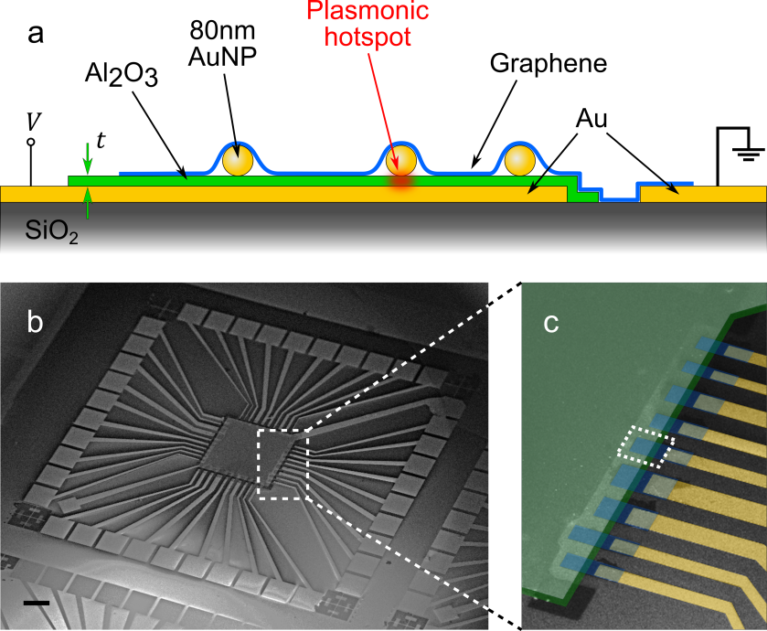
Figure 1. Device design. a, The Al₂O₃ layer (thickness t ~ 8 or 12 nm) is sandwiched between separately contacted top SLG and bottom Au substrate to which a potential $V$ is applied relative to the SLG. Low density 80 nm Au NPs under the SLG allow optical tracking. b,c, SEM images of device with Au fingers (false colour yellow) contacting SLG pads (blue) sitting on Al₂O₃ (green). Scale bar 200µm.

The SLG and Au contacts are arranged as independent junctions (Figure 1b,c) electrically isolated from each other so that a voltage $V$ can be applied across independent SLG-Al₂O₃-Au structures. SLG is used as the top electrode for its conductivity^{[21]}, transparency (making the encapsulated NPs optically accessible)^{[21]}, flexibility (conforming to mechanical deformations in the underlying structure)^{[21]}, and impermeability to gases^{[21]}. Raman spectroscopy can be used to monitor the presence of defects^{[22]}, doping^{[23,24]}, and strain^{[25,26]} in the graphene^{[27,28]} (see Supporting Information). Using large (~1-100cm²) CVD SLG sheets and optical lithography allows parallel fabrication of an arbitrary number of junctions.

Electrical measurements are used to characterise the junctions at room temperature. The initial state of the junctions is insulating with conductance in the 0.1 to 10pS range for junctions of area $\sim$500µm² and Al₂O₃ t~8nm. Based on the overlap region between the SLG and Al₂O₃ with junction area of typically ~500µm², this corresponds to a conductance per unit area ranging from 0.1 to 10nS/mm². Each junction can be made conductive (switched on) by applying a critical voltage across it. In the case of devices with 8nm Al₂O₃ layers, this voltage is ~5V (for 12.5nm thick layers devices switch on ~7V). The turn-on transition appears as a sudden jump in current, in which the conductance rises to values in the 1µS to 100µS range, which for a typical junction area of 500µm² corresponds to a conductance per unit area between 1µS/mm² and 0.1mS/mm². In a given cycle, on-off resistance ratios as high as 10⁸ have been observed (Figure 2a,b), which compares favourably to some of the highest ratios observed in memristors^{[29–32]}. Reversing the voltage polarity across the junction drives the opposite reaction and decreases the conductance back towards the initial state, seen either in a sudden drop in current or a more gradual transition (Figure 2a). Approximately 5 cycles can be switched in this way (Figure 2b), before the memristive behaviour and bubble inflation/deflation are compromised. In either state, the junction remains stable when varying the voltage within a small range, between -1V and 1V. The junctions at 0V for times in the range of tens of hours are stable, however a slight decrease in conductivity in the conductive state can sometimes be observed. After typically 5-10 cycles the conduction state and bubble configuration can no longer be changed with voltage. This failure occurs if the bubbles collapse enough after inflation to allow O₂ escape from reservoirs at the edge of the Al₂O₃, but may thus be further improved by specific device design.

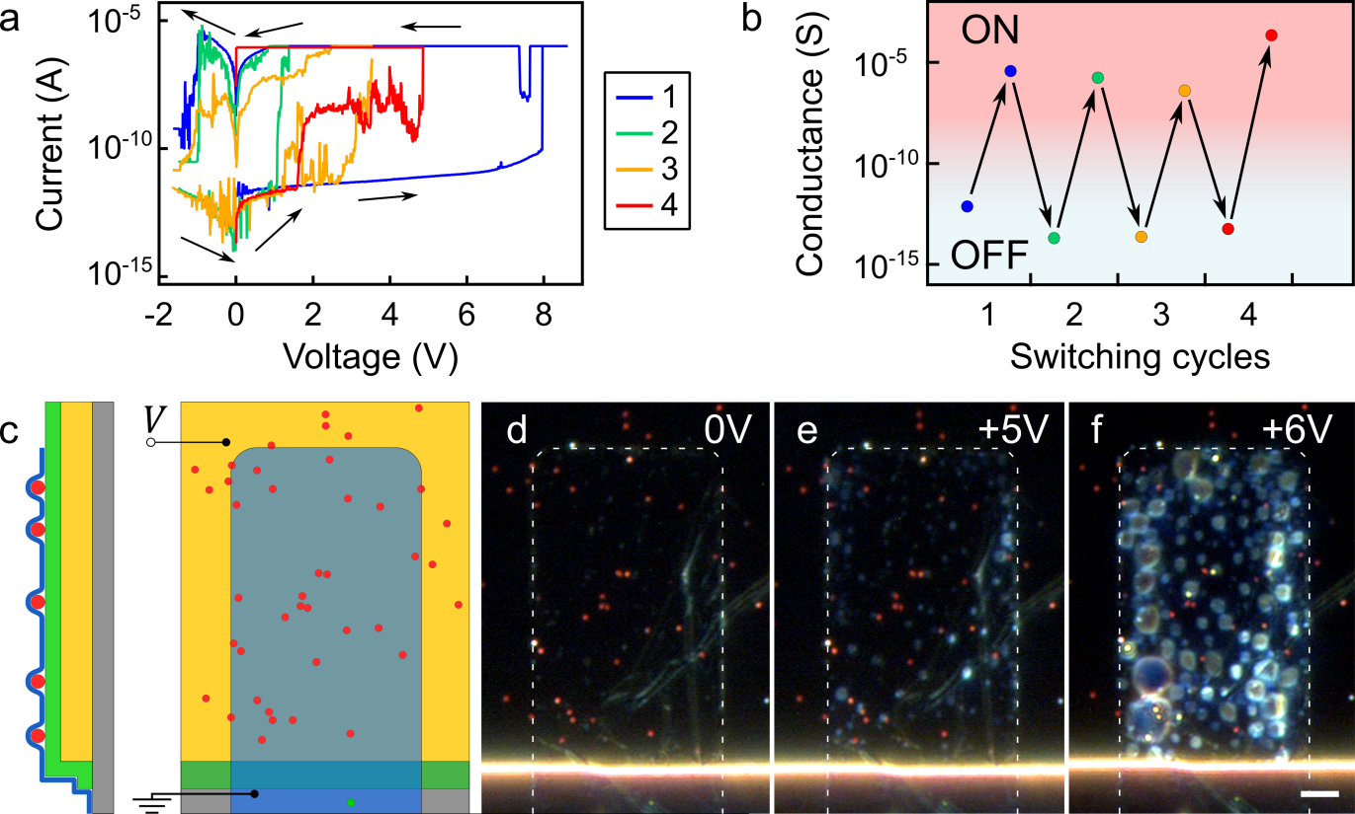
Figure 2. Device dynamics under applied potential. a, I-V plot of transitions between on and off states driven by varying junction voltage to positive or negative polarities. Magnitude of current |I| shown on logarithmic scale, legend colour indicates order in which measurements are taken, while a current compliance limits the maximum current. b, Junction conductance in on and off states for cycles shown in (a). c, Single device finger with SLG (blue) on 8nm Al₂O₃ (green) thin film on Au back contact. Low density 80nm Au NPs (red) are sandwiched between SLG and Al₂O₃. d-f, Dark-field images for (d) 0V, (e) 5V, and (f) 6V applied. Strong light scattering is observed for increasing voltages. Scale bar is 5µm.

We perform further electrical measurements while optically imaging the SLG from the top (Figure 2c). When a field exceeding 5ˑ10⁸ V m⁻¹ is applied ($V_{t}\sim 5$V for $t\sim$8nm, $V_{t}\sim 7$V for $t\sim 12 nm$), we observe strong scattering arising from different regions of the SLG pad (Figure 2d-f). These bright regions (which as we show below are caused by micro-bubbles) expand faster as $V$ is further increased, and merge into fewer larger regions as they expand more. The AuNPs within the bright regions change colour from red to yellow (Figure 3a,b), signalling a modification of the NPoM gap. Such behaviour is consistently observed for all NPs in the device. The NPoM geometry is thus a helpful tool to investigate the real time dynamics of such thin films or bubbles.
The formation of each bubble results in a prompt blueshift of the NP coupled mode seen in dark-field scattering spectroscopy (Figure 3c,d) together with a simultaneous increase in current (Figure 3e). Reversing the voltage causes the bubbles to gradually shrink, enabling voltage-driven height manipulation. Complete bubble deflation can be achieved, fully recovering the initial NP spectrum (Figure 3f,g). The switching process in these first generation devices can typically be repeated approximately 5 times (Figure 3f,g). In a given junction, the location and relative size of the bubbles when a device is first turned on is random, and a typical statistical distribution of bubble heights is shown in Figure S2. However, the location, size, and height of the bubbles are maintained in successive switching cycles when using the same electrical parameters, enabling the NPs on bubbles to undergo repeatable transitions (Figure 3g). Once the voltage is turned off, the position and size of the bubbles remain stable for months.

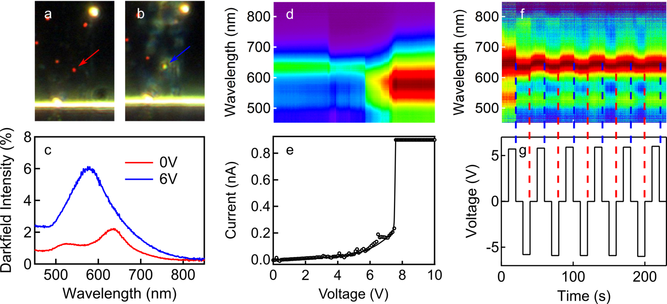
Figure 3. Optical evolution with applied potential. a,b, NP colour switching in dark field imaging, with c, corresponding scattering spectra from this NP. d, NP scattering spectrum for increasing voltages with e, corresponding measured current (line is guide to the eye). f, Scattering spectra when plasmon resonance switches under voltage cycling -$V$ $↔$ +$V$ over time sequence shown in g. Positive voltages trigger blueshifts while negative $V$ promptly recovers the initial condition.

The NP blueshifts can arise from three different scenarios: refractive index changes in the medium surrounding the NP (scenario S1), alterations in spacer conductivity (S2), or variations in distance from the mirror, where it is sensitive to nanometre displacements (S3). Scenario S1 requires an unfeasibly high refractive index variation (in excess of $Δn$=0.4) to account for a 50nm shift^{[18]}. Variations in conductivity (S2) can induce a shift due to shorting of the optical charge oscillations between the NP and the substrate^{[33]}, but requires a much larger increase in Al₂O₃ conductivity than measured. Similarly a vertical displacement of the NP (S3) could cause a shift of the coupled mode resonance^{[34]} needing the NP to be moved away from the mirror to induce the observed blueshift. Proving this latter scenario thus requires morphological analysis of the surface.
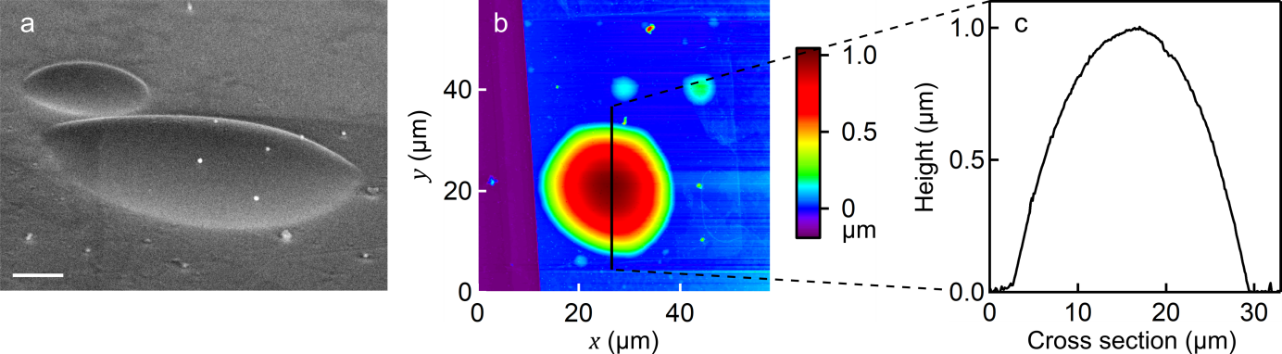
Figure 4. Bubble reservoir characterisation. a, SEM image of inflated reservoir, with NPs sitting on top. Scale bar 1µm. b, AFM topography image with c, cross section showing reservoir height along line.
Angled scanning-electron-microscopy (SEM) images of the bubbles reveal an inflation of the device surface with the AuNPs sitting on top (Figure 4a), confirming scenario S3. Atomic force microscopy (AFM) topography measurements are used to quantify the size of the larger bubble reservoirs (visible in dark-field microscopy), which can reach up to tens of µm in diameter and up to 1µm in height (Figure 4b,c, see Supporting Information). The bubbles observed in dark-field microscopy thus correspond to vertical displacements of the device surface, which match the blueshift in the NPoM scattering spectra^{[34]}. In the early stage of inflation, bubble actuation can only be detected in real time through the NP scattering spectra, sensitive to sub-nm displacements (see discussion in Supporting Information). The additional rise in scattering intensity of the NPoMs (Figure 3c) is caused by interference effects when the distance exceeds 100nm,^{[35]} which agrees with the height range measured using AFM.
The reservoir inflation could arise from several types of deformation. Bulging of the Au bottom contact due to electrostatic forces between the electrodes is ruled out since bubble formation is not observed for negative applied voltages, although electrostatic forces should be independent of voltage polarity. SLG corrugation alone would not cause the bright scattering regions observed in dark-field, because the SLG itself is barely visible in microscopy. The AuNPs play no active role, since the initial position of the bubbles is unrelated to the NP positions. We conclude that changes in the Al₂O₃ layer are therefore responsible for reservoir inflation.
Thin Al₂O₃ films are known to allow migration of oxygen ions^{[36]}, and have widely been used in resistive switching devices^{[14,37–40]}. In such devices, a voltage applied across an oxide layer such as TiO₂ or Al₂O₃ drives O²⁻ ions towards one of the electrodes. This leaves oxygen vacancies in the material, effectively doping the oxide and changing the resistivity of the layer, thus making it suitable for resistive switching applications. In the case of TiO₂, such O²⁻ ion migration and vacancy formation mechanisms have been confirmed by spatially resolved X-ray spectromicroscopy^{[41]}. When using inert Pt electrodes, the ions can then oxidise upon reaching the positive electrode via the reaction $2O^{2-}→4e^{-}+O_{2(g)}$, forming bubbles of oxygen gas^{[16]}. Until now however, bubbles have only persisted while the voltage is applied, rapidly disappearing once the bias is removed. Pt and Au are common choices for the inert electrode materials in this type of memristor, since they have good conductivity and are not affected by oxidation. There is no evidence that Au plays a catalytic role in the redox reaction occurring during switching^{[42]}. Modifications in the density of oxygen vacancies under applied voltage have also been studied in NiO films, where growth of a metallic Ni phase has been proposed as the switching mechanism^{[15]}, although with no direct evidence in working devices^{[43],[44]}. The exact oxide reduction mechanisms are therefore still unclear. Studying this mechanism in typical resistive switching devices based on planar metal/oxide/metal junctions is problematic as they prevent in-situ access for optical or electron microscopies.
Our devices share the same structure as such resistive switches. We conclude that reservoir inflation is similarly caused by drift of O²⁻ ions which move towards the positive electrode, there converting into oxygen gas. Our data thus confirm the observation of oxygen bubbles reported so far only for TiO_{2,}^{[16]} consistent with high-angle EDX (not shown). The dynamics of the reservoirs and the increased expansion speed with higher voltage also agrees with previous reports^{[16]}. The currently accepted view of the resistive switching mechanism in valence-change cells is that the high-conductivity state is due to a localised conductive filament^{[45]}, but its composition and structure have not yet been directly observed in situ. Formation of these filaments has often been associated with local deformation of the device in the form of crater-like structures^{[46]}, and this seems consistent with the formation of a gas reservoir bursting due to excessive pressure. In our devices, conduction through the Al₂O₃ film starts at a site where O²⁻ ion conductivity is likely higher than the surroundings. Rapidly this local migration of O²⁻ ions forms O₂ gas at the Au electrode which lifts the graphene/Al₂O₃ film away from the Au, interrupting the conduction path. Conduction can then only occur through the migration of O²⁻ at the boundaries of the reservoir via new migration paths formed in the Al₂O₃, thereby continually producing more O₂ gas and enlarging the reservoir laterally (Figure 5a). A corresponding solid-state electrochemical reaction is then driven at the graphene electrode, $Al^{3+}+3e^{-}→Al^{0}$ producing a thin metallic Al film. Rather than localised conductive filaments, found in most other memristors, which would be unable to grow the bubble, this scenario suggests a uniform Al film forms near the surface of the reservoir.
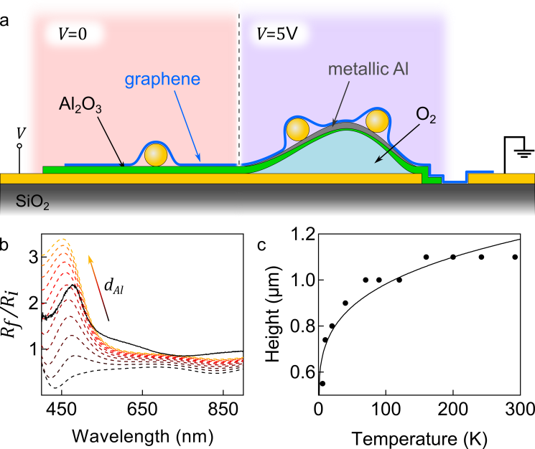
Figure 5. Al₂O₃ redox into Al and O₂. a, Thin Al₂O₃ film ($V=0$) separates into metallic Al and O₂ gas ($V>5$V) with a growing bubble reservoir. b, Ratio of measured reflectivity after ($R_{f}$) and before ($R_{i}$) reservoir inflation (solid line), compared to the thin film model (dashed) with increasing Al thickness $d_{Al}$, identifying $d_{Al}\sim 10$nm, and predicting the same inflation height as that found from AFM. c, Bubble height decreases as temperature is lowered, due to decreasing volume of internal O₂. Fit (line) shows ideal gas dependence $h∝T^{1/4}$.
To confirm this picture we compare reflectivity measurements on a bubble region before and after reservoir inflation. The transparent SLG electrode in our devices is crucial for enabling this real-time optical tracking of the redox underlayer. We collect initial bright-field reflectivity spectra $R_{i}$ before any voltage is applied on the top of each bubble with a x50 objective to focus broadband white light which is confocally collected at a detection fibre. After forming the reservoir the modified reflectivity $R_{f}$ is measured, and the ratio ${R_{f}/R}_{i}$ plotted to highlight spectral changes. We compare this experimental ratio with transfer matrix calculations using a multilayer model of the inflated reservoir structure^{[47]} (Figure 5b). By fitting the model parameters (thickness of metallic Al film, thickness of residual Al₂O₃ layer and height of gas reservoir, see Supporting Information section S3) to the experimental data, we find complete disagreement unless a metallic Al film is present. Optimising the fits resolves an Al thickness of 10nm, with Al₂O₃ residual film of 4.5nm, and reservoir height of 165nm (in good agreement with the 175nm average height from AFM for bubbles of this size, Figure S3). Similar reflectivity changes are seen on other bubbles. This optical modelling also confirms that the Al nanolayer separates from the Au substrate, storing the oxygen gas between them.
The presence of gas is further demonstrated by cooling down and optically tracking the changing size of a 1µm bubble from 292K to 6K in situ. Images taken at different temperatures are used to infer the bubble height by fitting the interference fringes from light reflected off the surface of the bubble and off the bottom gold substrate with a simple model (Supporting Information section S1). We observe a stronger decrease in reservoir height as the temperature is lowered below 150K (Figure 5c), reducing finally by about a factor of two, and matching well the ideal gas law prediction $h∝T^{1/4}$ (liquefaction is not achieved at these pressures, see also Supporting Information section S2). The shape and size of the reservoir are fully restored when the sample is heated back to 292K, suggesting that temperature control can also be used for nanoactuation and height fine-tuning, in addition to electrical driving. We exclude the presence of water in the devices since the ALD growth occurs at 180°C, and we do not observe any freezing signature at 0°C. To further prove the containment of pressurised gas, the tip of an AFM probe is used to pierce a hole in the surface of an inflated bubble, resulting in immediate deflation.
Given the presence of gas, we can infer its pressure from the geometrical parameters of each bubble and the material properties of its walls (Supporting Information section S2). The strain in the bubble surface film is found from^{[48]} $ε=2h^{2}/3a^{2}$, where $h$ is the bubble height and $a$ its base radius, and ranges from 0.35% to 1% depending on the aspect ratio of the bubble, corresponding to a stress level well below the ultimate tensile strength of either graphene^{[49]} or Al₂O₃^{[50]}. Raman spectroscopy is used to measure the strain in graphene through shifts in the G and 2D Raman peaks^{[25,26,51]}. Measuring these on SLG for a similar bubble, and comparing to the deflated junctions yields an observable shift (Figure S7) corresponding to a strain ~0.1% (Supporting Information sections S2, S8), consistent with the estimate for the full SLG/AL₂O₃ film. Such strain values imply typical internal bubble pressures in the range of 20±10atm (Supporting Information section S2). We find the amount of oxygen required to give this pressure is indeed a sizeable fraction of that locked up in the Al₂O₃ film (around 60%, see Supporting Information section S2). Generally, smaller bubbles have higher internal actuation stress, thus likely requiring an overpotential to initially drive the reaction. As a simple estimate, a typical current of 1nA applied for 1 minute across junctions such as these would correspond to the migration of 10¹¹ O^{2–} ions. This matches an equally simple estimate of the number of oxygen atoms trapped as O₂ in the bubbles assuming a pressure of 10 atmospheres and typical bubble sizes after inflation. This is thus consistent with oxygen migration being a major conduction mechanism in our film. Furthermore, it explains the failure mechanism of the devices, which is most likely caused by localised damage to one of the encapsulating layers (SLG and Al₂O₃), that allows O₂ escape during switching and thus inhibits the inverse reaction. Strain probably plays a key role in the process, and thus reducing the level of strain during actuation or increasing the encapsulating layer stiffness would improve the device cyclability. A feasible method to realise this is employing multilayer instead of SLG as top electrode, and the use of a surface treatment on top of the Al₂O₃ to reduce friction and aid conformal deformation of graphene to the surface. For bubble inflation, application of a low voltage (~5 to 7V depending on Al₂O₃ thickness) for a long time rather than a high voltage (>10V) for a short time also leads to better cyclability.
We thus show that at room temperature and low voltage we are able to reversibly convert >60% of thin Al₂O₃ films to metallic Al and back on demand. Our unique choice of electrode/electrolyte materials, forming chemically stable graphene/Al/Al₂O₃ and Au/O₂ interfaces, is what allows the reservoirs to remain stable for months when the bias is removed. A negative voltage triggers the oxygen to recombine with the Al thus reforming the Al₂O₃ film. This depends on the impermeability of graphene to O₂^{[51]}, while the strength of the graphene/Al/Al₂O₃ film allows O₂ gas to be locally stored at high pressures without rupturing its flexible container. The internal pressure can be tuned by choice of layer thicknesses.

3. Conclusion
We have shown that graphene/Au electrodes form a unique combination with solid-state electrolyte thin films of Al₂O₃ to produce nano-actuators capable of high stress which are electrically controlled. The applied electrical field drives O²⁻ drift, creating local chemical energy storage in the Al metal and O₂ gas which can be triggered to recombine, thereby deflating the actuator. This novel device geometry has much in common with memristive switches but with an optically accessible electrode and provides new insights into the switching mechanisms. Graphene electrodes improve the reliability and resilience of this resistive switching. Reversible redox of Al₂O₃ is possible at room temperature under benign conditions creating high-pressure oxygen micro-fuel reservoirs under the graphene encapsulation. Plasmonic rulers allow the dynamics of this process to be studied in real time. Both reactive species (Al and O₂) are stored in proximity for months. Further optimisation in the device architecture and the calibration of the electrical switching can improve the stability and repeatability of the system. This promises a wide range of applications in nano and micro actuation and local energy storage in pressurised reservoirs, while allowing integration with current thin film technologies.

4. Experimental section
Sample preparation. Device fabrication starts with 20nm of Ti for adhesion followed by 100nm of Au deposited by evaporation onto a 285nm thick SiO₂ on Si substrate in a pattern defined using optical lithography. The Al₂O₃ layer is deposited by ALD, without any prior adhesion layer, and using 60 and 90 layer deposition cycles to provide different thicknesses for comparison. The ALD is done at a temperature of 180°C in a vacuum chamber, which ensures a water-free Au-Al₂O₃ interface. The Al₂O₃ layer is subsequently patterned via optical lithography and chemically etched using Microposit MF-319. Gold nanoparticles (AuNPs, 80nm diameter) from BBI solutions are drop-cast on the substrate to obtain a number density of $\sim$0.1µm⁻² on the Al₂O₃ surface. SLG is grown by chemical vapour deposition (CVD)^{[17]} and then deposited onto the chip via wet transfer^{[52,53]} and subsequently patterned with lithography and reactive ion etching (see Supporting Information).

Optical microscopy and spectroscopy. Optical dark-field images are recorded on a custom-modified Olympus BX51. Samples are illuminated with a focussed white light source (halogen lamp). The scattered light is collected through a 100× dark-field objective (Olympus LMPLFLN100xBD, NA 0.8) and analysed with a fibre-coupled (50µm core diameter optical fibre) Ocean Optics QE65000 cooled spectrometer. We use a standard diffuser as a reference to normalize white light scattering. Reflectivity measurements are performed through a 50× objective (Olympus LMPLFLN100xBD, NA 0.5) using a reduced aperture size.

Atomic force microscopy. Topography of the sample is performed using an Asylum Research MFP-3D atomic force microscope in non-contact AC mode. Asylum Research AFM Software version 15 is used for instrument control and data post-processing.

Raman spectroscopy. Graphene is characterized by Raman spectroscopy after growth, after deposition on devices before measurement, and after activation of devices, through a Renishaw InVia spectrometer equipped with a 100× objective. The Raman spectra in Figure S7 are measured by using an excitation wavelength 514.5nm.

Acknowledgements
We acknowledge financial support from EPSRC grant EP/G060649/1, EP/L027151/1, EP/G037221/1, EP/K01711X/1, EP/K017144/1, EP/N010345/1, EP/M507799/1, EP/L016087/1, EPSRC NanoDTC, and ERC grant LINASS 320503, Hetero2D, MineGrace, EU Graphene Flagship
Corresponding Author
* Prof Jeremy J Baumberg
E-mail: jjb12@cam.ac.uk
Supporting Information
Supporting Information is available from the Wiley Online Library or from the author.
Author Contributions
The manuscript was written through contributions of all authors. ‡These authors contributed equally.
Conflict of Interest
The authors declare no conflict of interest.

References
[1] M. Sitti, in Proceedings of the 2001 1st IEEE Conference on Nanotechnology. IEEE-NANO 2001 (Cat. No.01EX516), 2001, pp. 75–80.
[2] B. F. Toler, R. A. C. Jr, J. W. McBride, J. Micromech. Microeng. 2013, 23, 103001.
[3] A. Jain, H. Qu, S. Todd, H. Xie, Sensors and Actuators A: Physical 2005, 122, 9.
[4] O. Sul, E.-H. Yang, Nanotechnology 2009, 20, 095502.
[5] S. Moya, O. Azzaroni, T. Farhan, V. L. Osborne, W. T. S. Huck, Angewandte Chemie International Edition 2005, 44, 4578.
[6] Y. Bar-Cohen, Q. Zhang, MRS Bulletin 2008, 33, 173.
[7] K Kaneto, Journal of Physics: Conference Series 2016, 704, 012004.
[8] Y. Ke, T. Meyer, W. M. Shih, G. Bellot, Nature Communications 2016, 7, 10935.
[9] S. Cho, Hyoung J. Roxana, Reviews in Nanoscience and Nanotechnology 2012, 1, 85.
[10] L. Chua, IEEE Transactions on Circuit Theory 1971, 18, 507.
[11] D. B. Strukov, G. S. Snider, D. R. Stewart, R. S. Williams, Nature 2008, 453, 80.
[12] M. K. Hota, M. K. Bera, B. Kundu, S. C. Kundu, C. K. Maiti, Advanced Functional Materials n.d., 22, 4493.
[13] F. Meng, B. Sana, Y. Li, Y. Liu, S. Lim, X. Chen, Small n.d., 10, 277.
[14] C. Chen, S. Gao, F. Zeng, G. S. Tang, S. Z. Li, C. Song, H. D. Fu, F. Pan, Journal of Applied Physics 2013, 114, 014502.
[15] D. S. Jeong, R. Thomas, R. S. Katiyar, J. F. Scott, H. Kohlstedt, A. Petraru, C. S. Hwang, Rep. Prog. Phys. 2012, 75, 076502.
[16] J. J. Yang, F. Miao, M. D. Pickett, D. A. A. Ohlberg, D. R. Stewart, C. N. Lau, R. S. Williams, Nanotechnology 2009, 20, 215201.
[17] X. Li, W. Cai, J. An, S. Kim, J. Nah, D. Yang, R. Piner, A. Velamakanni, I. Jung, E. Tutuc, S. K. Banerjee, L. Colombo, R. S. Ruoff, Science 2009, 324, 1312.
[18] B. de Nijs, R. W. Bowman, L. O. Herrmann, F. Benz, S. J. Barrow, J. Mertens, D. O. Sigle, R. Chikkaraddy, A. Eiden, A. Ferrari, O. A. Scherman, J. J. Baumberg, web-support@bath.ac.uk, Faraday Discussions 2015, 178, 185.
[19] S. Huang, T. Ming, Y. Lin, X. Ling, Q. Ruan, T. Palacios, J. Wang, M. Dresselhaus, J. Kong, Small 2016, 12, 5190.
[20] G. Di Martino, S. Tappertzhofen, S. Hofmann, J. Baumberg, Small 2016, 12, 1334.
[21] A. C. Ferrari, F. Bonaccorso, V. Fal’ko, K. S. Novoselov, S. Roche, P. Bøggild, S. Borini, F. H. L. Koppens, V. Palermo, N. Pugno, J. A. Garrido, R. Sordan, A. Bianco, L. Ballerini, M. Prato, E. Lidorikis, J. Kivioja, C. Marinelli, T. Ryhänen, A. Morpurgo, J. N. Coleman, V. Nicolosi, L. Colombo, A. Fert, M. Garcia-Hernandez, A. Bachtold, G. F. Schneider, F. Guinea, C. Dekker, M. Barbone, Z. Sun, C. Galiotis, A. N. Grigorenko, G. Konstantatos, A. Kis, M. Katsnelson, L. Vandersypen, A. Loiseau, V. Morandi, D. Neumaier, E. Treossi, V. Pellegrini, M. Polini, A. Tredicucci, G. M. Williams, B. H. Hong, J.-H. Ahn, J. M. Kim, H. Zirath, B. J. van Wees, H. van der Zant, L. Occhipinti, A. D. Matteo, I. A. Kinloch, T. Seyller, E. Quesnel, X. Feng, K. Teo, N. Rupesinghe, P. Hakonen, S. R. T. Neil, Q. Tannock, T. Löfwander, J. Kinaret, Nanoscale 2015, 7, 4598.
[22] L. G. Cançado, A. Jorio, E. H. M. Ferreira, F. Stavale, C. A. Achete, R. B. Capaz, M. V. O. Moutinho, A. Lombardo, T. S. Kulmala, A. C. Ferrari, Nano Lett. 2011, 11, 3190.
[23] D. M. Basko, S. Piscanec, A. C. Ferrari, Phys. Rev. B 2009, 80, 165413.
[24] A. Das, S. Pisana, B. Chakraborty, S. Piscanec, S. K. Saha, U. V. Waghmare, K. S. Novoselov, H. R. Krishnamurthy, A. K. Geim, A. C. Ferrari, A. K. Sood, Nature Nanotechnology 2008, 3, 210.
[25] T. M. G. Mohiuddin, A. Lombardo, R. R. Nair, A. Bonetti, G. Savini, R. Jalil, N. Bonini, D. M. Basko, C. Galiotis, N. Marzari, K. S. Novoselov, A. K. Geim, A. C. Ferrari, Phys. Rev. B 2009, 79, 205433.
[26] D. Yoon, Y.-W. Son, H. Cheong, Phys. Rev. Lett. 2011, 106, 155502.
[27] A. C. Ferrari, D. M. Basko, Nature Nanotechnology 2013, 8, 235.
[28] A. C. Ferrari, J. C. Meyer, V. Scardaci, C. Casiraghi, M. Lazzeri, F. Mauri, S. Piscanec, D. Jiang, K. S. Novoselov, S. Roth, A. K. Geim, Phys. Rev. Lett. 2006, 97, 187401.
[29] X. Cao, X. Li, X. Gao, W. Yu, X. Liu, Y. Zhang, L. Chen, X. Cheng, Journal of Applied Physics 2009, 106, 073723.
[30] G. Ma, X. Tang, H. Zhang, Z. Zhong, X. Li, J. Li, H. Su, J Mater Sci 2017, 52, 238.
[31] K. Yan, M. Peng, X. Yu, X. Cai, S. Chen, H. Hu, B. Chen, X. Gao, B. Dong, D. Zou, J. Mater. Chem. C 2016, 4, 1375.
[32] F. Hui, E. Grustan‐Gutierrez, S. Long, Q. Liu, A. K. Ott, A. C. Ferrari, M. Lanza, Advanced Electronic Materials n.d., 3, 1600195.
[33] F. Benz, C. Tserkezis, L. O. Herrmann, B. de Nijs, A. Sanders, D. O. Sigle, L. Pukenas, S. D. Evans, J. Aizpurua, J. J. Baumberg, Nano Lett. 2015, 15, 669.
[34] J. J. Mock, R. T. Hill, A. Degiron, S. Zauscher, A. Chilkoti, D. R. Smith, Nano Lett. 2008, 8, 2245.
[35] T. Ding, C. Rüttiger, X. Zheng, F. Benz, H. Ohadi, G. A. E. Vandenbosch, V. V. Moshchalkov, M. Gallei, J. J. Baumberg, Advanced Optical Materials 2016, 4, 877.
[36] C.-Y. Lin, C.-Y. Wu, C.-Y. Wu, C. Hu, T.-Y. Tseng, J. Electrochem. Soc. 2007, 154, G189.
[37] K. M. Kim, B. J. Choi, B. W. Koo, S. Choi, D. S. Jeong, C. S. Hwang, Electrochem. Solid-State Lett. 2006, 9, G343.
[38] L. Chua, Semicond. Sci. Technol. 2014, 29, 104001.
[39] A. G. Radwan, M. E. Fouda, in On the Mathematical Modeling of Memristor, Memcapacitor, and Meminductor, Springer, Cham, 2015, pp. 13–49.
[40] D. Ielmini, R. Waser, Resistive Switching: From Fundamentals of Nanoionic Redox Processes to Memristive Device Applications, John Wiley & Sons, 2015.
[41] D. Carta, A. P. Hitchcock, P. Guttmann, A. Regoutz, A. Khiat, A. Serb, I. Gupta, T. Prodromakis, Scientific Reports 2016, 6, 21525.
[42] Y. V. Khrapovitskaya, N. E. Maslova, Y. V. Grishchenko, V. A. Demin, M. L. Zanaveskin, Tech. Phys. Lett. 2014, 40, 317.
[43] K. M. Ostyn, C. B. Carter, Surface Science 1982, 121, 360.
[44] J. A. Rodriguez, J. C. Hanson, A. I. Frenkel, J. Y. Kim, M. Pérez, J. Am. Chem. Soc. 2002, 124, 346.
[45] D.-H. Kwon, K. M. Kim, J. H. Jang, J. M. Jeon, M. H. Lee, G. H. Kim, X.-S. Li, G.-S. Park, B. Lee, S. Han, M. Kim, C. S. Hwang, Nat Nano 2010, 5, 148.
[46] R. Muenstermann, T. Menke, R. Dittmann, R. Waser, Adv. Mater. 2010, 22, 4819.
[47] A. Kavokin, Ed. , Microcavities, Oxford University Press, Oxford ; New York, 2011.
[48] M. K. Small, W. D. Nix, Journal of Materials Research 1992, 7, 1553.
[49] C. Lee, X. Wei, J. W. Kysar, J. Hone, Science 2008, 321, 385.
[50] M. Berdova, T. Ylitalo, I. Kassamakov, J. Heino, P. T. Törmä, L. Kilpi, H. Ronkainen, J. Koskinen, E. Hæggström, S. Franssila, Acta Materialia 2014, 66, 370.
[51] J. Zabel, R. R. Nair, A. Ott, T. Georgiou, A. K. Geim, K. S. Novoselov, C. Casiraghi, Nano Lett. 2012, 12, 617.
[52] F. Bonaccorso, Z. Sun, T. Hasan, A. C. Ferrari, Nature Photonics 2010, 4, 611.
[53] F. Bonaccorso, A. Lombardo, T. Hasan, Z. Sun, L. Colombo, A. C. Ferrari, Materials Today 2012, 15, 564.

