Received 00th January 20xx,
- Department of Chemistry, University of Cambridge, Lensfield Road, CB2 1EW Cambridge, United Kingdom. E-mail: gb453@cam.ac.uk
- Instituto de Medicina Molecular, Faculdade de Medicina da Universidade de Lisboa. Av Prof Egaz Moniz, 1649-028 Lisboa, Portugal. E-mail: gbernardes@medicina.ulisboa.pt
Electronic Supplementary Information (ESI) available: Supplementary Figures, Data and Methods. See DOI: 10.1039/x0xx00000x
Accepted 00th January 20xx
DOI: 10.1039/x0xx00000x
www.rsc.org/
Development of a self-immolative linker for tetrazine-triggered release of alcohols in cells
Sarah Davies,ª Bruno L. Oliveira,^{a,b} and Gonçalo J. L. Bernardes*^{a,b}
Bioorthogonal decaging reactions are a promising strategy for prodrug activation because they involve bond cleavage to release a molecule of interest. The trans-cyclooctene (TCO)-tetrazine inverse electron-demand Diels–Alder reaction has been widely applied in vivo for decaging of amine prodrugs, however, the release of alcohol-containing bioactive compounds has been less well studied. Here, we report a TCO-carbamate benzyl ether self-immolative linker for the release of OH-molecules upon reaction with a tetrazine trigger. The benzyl ether linker proved to be highly stable and can rapidly liberate alcohols under physiological conditions upon reaction with tetrazines. The mechanism and decaging yield were systematically examined by fluorescence and HPLC analysis by using a fluorogenic TCO–benzyl ether-coumarin probe and different 3,6‐substituted tetrazine derivatives. This study revealed that decaging occurs rapidly (t_{1/2} = 27 min) and the cycloaddition step happens within seconds (t_{1/2} = 7 secs) with reaction rates of ≈100 M^{–1}s^{–1}. Importantly, the reaction is compatible with living organisms as demonstrated by the decaging of a prodrug of the antibacterial compound triclosan in the presence of live E. Coli, that resulted in complete cell killing by action of the released “OH-active drug”. Overall, this work describes a new linker for masking alcohol functionality that can be rapidly reinstated through tetrazine-triggered decaging.

Introduction
Inverse electron-demand Diels–Alder (IEDDA) reactions have been exploited to ligate a variety of reporters (e.g. fluorophores, affinity tags and PET isotopes) to biological entities for applications such as cell imaging,¹ PROTAC assembly in live cells,² labelling of post-PCR DNA³ and pretargeted imaging in vivo.^{1,4} Typically, these ligations are performed between a tetrazine and a strained dienophile,⁵ such as trans-cyclooctene (TCO) or its analogues d-TCO,⁶ s-TCO⁷ and oxoTCO⁸, with extremely fast kinetics (up to 3.3 x 10⁶ M^{–1}s^{–1}).⁹
Bioorthogonal decaging reactions, in which a bond is broken to release a molecule of interest, have increased the breadth of applications for bioorthogonal chemistry^{10,11} beyond the study of biomolecules through ligation reactions.^{12–14} Indeed, the cleavage of a bond allows the removal of a protecting group and therefore the selective activation of a protein, fluorophore or small molecule drug.^{10,11,15,16} Although several decaging reactions have been reported, many of them suffer from slow reaction rates that limit their application in vivo.^{10,11} In seminal work, Robillard et al. reported that the IEDDA reaction could be adapted for fast decaging by placing an alcohol substituent in the allylic position, where it is appropriately placed to eliminate upon tautomerisation of the 4,5-dihydropyridazine. They demonstrated that this strategy could be used to decage a TCO-carbamate-doxorubicin prodrug in cells¹⁷ and later in vivo, by site-specifically releasing amine-containing drugs from antibody-drug conjugates at the tumour site (doxorubicin¹⁸ and monomethyl auristatin E¹⁹). In another approach, Mejia Oneto used a tetrazine-modified hydrogel to site-selectively release Doxorubicin from a TCO-carbamate prodrug at the tumour.²⁰ Recently, prodrug activation was achieved by using an enzymatic self-assembly technique to install the tetrazine trigger inside cancer cells.²¹ These approaches demonstrate the in vivo potential of the TCO-tetrazine IEDDA reaction for prodrug activation of NH₂-containing compounds.
Since many drugs do not contain an amine functional group that is essential for their function, it is necessary to expand decaging reactions to the release of other functional groups. Although there are a large number of drugs that contain a hydroxyl group,²² bioorthogonal decaging for release of alcohols has been less extensively reported than for amines. Several groups have reported tetrazine-triggered release of alcohols from a vinyl ether handle (Figure 1a).^{22–24} This reaction has been applied in live cells for detection of RNA by using near-infrared fluorogenic probes²³, activation of a duocarmycin prodrug²² and release of doxorubicin-conjugated nanoparticles.²⁴ However, this reaction suffers from a slow reaction rate (t_{1/2} = 58 min),²² which limits the application of this reaction in vivo. A 3-isocyanopropyl handle for masking amines, alcohols and thiols has also been reported (Figure 1a).²⁵ The reaction was successfully applied to trigger the fast release (t_{1/2} = 3−7 min in 50% PBS/serum) of an alcohol-containing fluorophore and amine-containing drug (mexiletine) in zebra-fish embryos and cells, respectively. However, this reaction is limited for in vivo applications by the toxicity of the acrolein by-product. Therefore, additional methods for fast decaging of protected-alcohols are required to greatly expand the scope of drugs that can be used for in vivo prodrug activation.
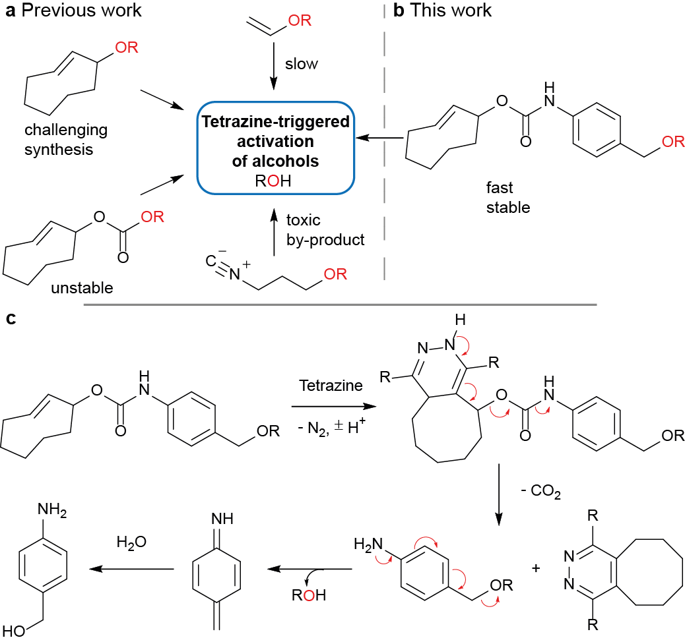
Attempts to apply the promising TCO-tetrazine IEDDA reaction to release other functional groups have recently been reported. Both our group²⁶ and that of Robillard²⁷ described TCO-ester prodrugs that were decaged with tetrazine to release carboxylic acids. Additionally, Robillard also showed that the TCO handle could be cleaved from carbonates and ethers to release alcohol-containing molecules (Figure 1a).²⁷ However, the reported approach is limited by the synthesis of the TCO-molecule that involves photoisomerization of the cis-cyclooctene-ether to the trans-isomer by using UV light. This final step is very low yielding (3−12% after 1.3–7 days under flow, to obtain, for example 144 mg from 5.5 g of cis-product) and requires a specialized flow set-up.²⁷ Although this route is achievable on the reported model compounds, it is not always feasible to obtain such a large quantity of cis-product, particularly if this reaction is to gain more widespread use in the area of drug activation. In addition, the synthesis of the ether bond is challenging and attempts to form the ether bond from trans-cycloocten-1-ol resulted in isomerisation to the cis-form.²⁷

Fig. 1. a. Reported decaging reactions for the release of alcohols: vinyl ether (limited by its slow reaction rate), TCO-ether (fast release, requires low yielding photoisomerisation in the final step), TCO carbonate (unstable), 3-isocyanopropyl handle (toxic by-product). b. This work: TCO-carbamate benzyl ether linker for the release of alcohols. c. Proposed mechanism of decaging for the TCO-carbamate benzyl ether linker: Release of the amine from the TCO-carbamate as previously reported,¹⁷ followed by 1,6-elimination to release the alcohol.
Here we report a novel strategy for the release of “alcohol-molecules” in which a TCO-carbamate is connected to a benzyl ether self-immolative linker. We rationalized that upon tetrazine reaction the formed aniline derivative could drive the release of the alcohol by a 1,6-elimination mechanism (Figure 1). Different TCO-benzyl ether derivatives were prepared directly from trans-cyclooct-2-en-1-ol (TCO-OH) via a convenient synthetic route without isomerisation ocurring (Figure 1b and 1c). The proposed synthesis results in 100% of trans-isomers and a late stage photochemical isomerisation step is not required, enabling incorporation of a wider variety of payloads. The TCO-carbamate benzyl ether linker is highly stable under biological conditions and was shown to react rapidly with tetrazines (cycloaddition complete within seconds and decaging half life ≈30 min). Importantly, the reaction is compatible with living organisms as demonstrated by prodrug activation in the presence of live E. Coli cells. The release of an antibacterial drug, triclosan, resulted in complete cell death due to reinstation of the original bactericidal activity.
Results and Discussion
Initially, taking inspiration from the reported TCO-carbamate linker, we proposed an analogous carbonate linker for the release of alcohols. Fluorescent compound 7-hydroxycoumarin (2) was chosen as the molecule of interest to enable the kinetics of release and the stability of the linker to be easily assessed by fluorescence. Model compound 1 was synthesised by activation of TCO-OH with para-nitrochloroformate followed by reaction with 2 (See the ESI). Next, the reaction of model compound 1 with tetrazine in 50% DMSO/H₂O at 30 °C was studied under second-order conditions by measuring the fluorescence intensity (λ_{ex} = 325 nm, λ_{em} = 460 nm, Figure 2a).
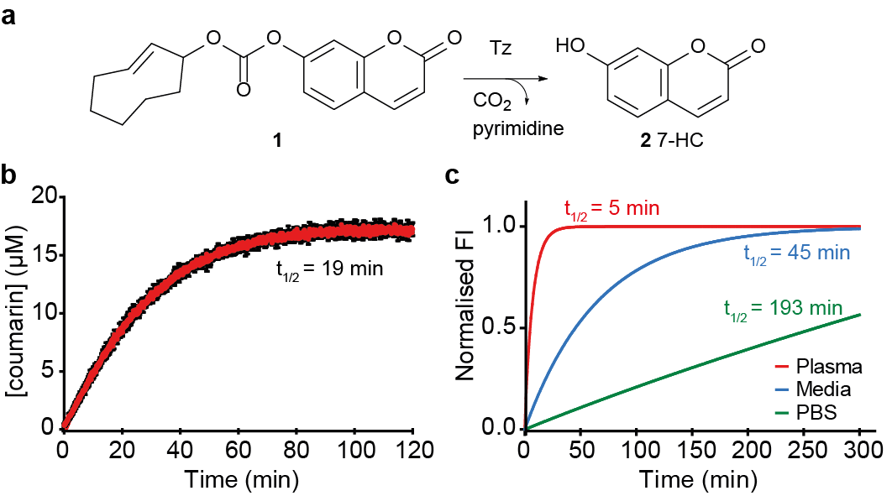
Fig. 2. TCO-carbonate linker for the release of alcohols a. Tetrazine-triggered release of 7-hydroxycoumarin (2) from carbonate 1. b. Release of 2 in 50% H₂O/DMSO at 30 °C monitored by following the increase in fluorescence (λ_{ex} = 320, λ_{em} = 465 nm). c. Fittings of the stability of 1 in PBS, complete cell culture media (DMEM) and 20% plasma/PBS, followed by the increase in fluorescence. Compound 1 was shown to be stable in 50% H₂O/DMSO over the time period of the decaging reaction (See Figure S1).

The increase in coumarin fluorescence was complete within 90 minutes (t_{1/2} = 19 min, Figure 2b), which is a similar order of magnitude to, but slower than, the release of doxorubicin from the carbamate linker (complete within 16 min).¹⁷ Importantly it was significantly faster than the previously reported vinyl ether decaging [with 350 fold excess of vinyl ether, the fastest tetrazine had a pseudo first-order rate constant (k_{obs}) of approximately 2x10^{–4} s^{–1} that corresponds to a half-life of 58 min].²² Carbonate 1 was, however, highly unstable in 20% plasma (t_{1/2} = 5 min) and cell media (t_{1/2} = 45 min) and presented moderate stability in PBS (t_{1/2} = 193 min, Figure 2c), which prevents its application in biological systems. This result was consistent with the work of Robillard who recently reported a TCO-carbonate linker and showed that it underwent 100% fragmentation after 5 h in 50% mouse serum at 37 °C.²⁷

Given these results, we considered the design of an alternative decaging reaction for the release of alcohols, in which TCO is connected to a self-immolative benzyl ether linker through a carbamate (Figure 1b). This carbamate was expected to eliminate CO₂ and the free amine of the self-immolative linker, which can then undergo 1,6-elimination to release the free alcohol (Figure 1c). In addition, use of the proposed TCO-carbamate benzyl ether linker for decaging should address the instability of the carbonate linker.
Initially, the proposed synthetic route attempted to attach the model compound, 7-hydroxycoumarin (2) in the final step (Figure 3, route 1), in order to minimise the amount of payload that is required. First, 4-aminobenzyl alcohol (3) was reacted with tert-butyl dimethylsilyl chloride (TBSCl) to give 4 in 77% yield. This was followed by reaction with triphosgene to generate isocyanate 5 and then reaction with TCO-OH to give desired carbamate 6 (10% yield over 2 steps). This yield is comparable to the previously reported one-step reaction of TCO-OH with commercial benzyl isocyanate, which gave yields of 21−37% with reaction times of ≥ 3 days.^{17,28}
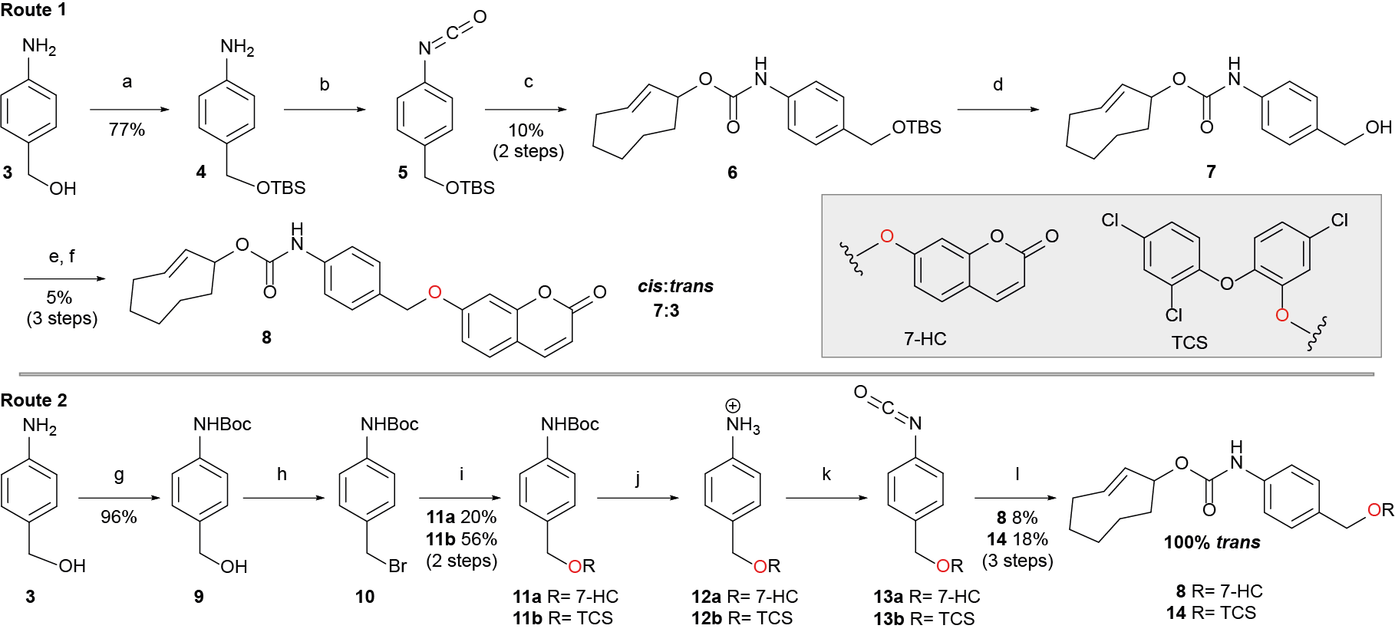
Fig. 3. Synthetic routes to TCO-carbamate benzyl ether linkers. Route 1. Conditions: a. TBSCl (1.1 equiv.), imidazole, CH₂Cl₂, rt, 24 h; b. triphosgene (0.4 equiv.), NEt₃ (1.1 equiv.), toluene, 70 °C, 3 h; c. TCO-OH (0.8 equiv.), NEt₃ (0.9 equiv.), toluene, rt, 16 h; d. HCl (1 M), MeOH, rt, 1 h; e. PBr₃ (0.8 equiv.), Et₂O, 0 °C, 16 h; f. 7-hydroxycoumarin (2) (1.5 equiv.), Cs₂CO₃ (2.0 equiv.), MeCN, rt, 10 min. Route 2. Conditions: g. Boc₂O (1.1 equiv.), N,N-diisopropylethylamine (1.0 equiv.), THF, 75 °C, 20 h; h. PBr₃ (0.4 equiv.), Et₂O, 0 °C, 20 h; i. 7-hydroxycoumarin (2) (1.5 equiv.), Cs₂CO₃ (4.5 equiv.), MeCN, rt, 30 min or triclosan (1.1 equiv.), Cs₂CO₃ (2.0 equiv.), MeCN, rt, 24 h; j. HCl (4 M in dioxane), rt, 1−5 h; k. triphosgene (0.5 equiv.), dioxane, 60 °C, 5−16 h; l. TCO-OH (0.5 equiv.), DABCO (3.0 equiv.), toluene, 100 °C, 16 h.

TBS deprotection resulted in 7 with no observable isomerisation of the double bond. However, in the following bromination step with PBr₃, the double bond isomerised to give the bromide as 70% cis-isomer. Isomerisation occurred after 5 min at 0 °C and no further isomerisation occurred after the reaction was left for 12 h. This highlights the difficulty of synthesis involving TCO because the double bond is highly unstable and readily isomerises. This behaviour interferes with the decaging kinetics because the cis-isomer is 7 orders of magnitude less reactive towards tetrazines than the trans-isomer.²⁹ It was not possible to separate the cis- and trans-isomers of the bromide (owing to its instability on silica), so the mixture of isomers was used in the subsequent step. Reaction with 7-hydroxycoumarin (2) and caesium carbonate gave final product 8 in 5% yield (over 3 steps) as a mixture cis:trans 7:3. It has been reported that the trans-isomer selectively binds to AgNO₃-impregnated silica and this is used to separate the trans-isomer during the photochemical synthesis of TCO-OH.³⁰ However, attempts to separate the isomers of 8 by trapping onto AgNO₃-coated silica were unsuccessful. Interestingly, the product mixture is stable to further isomerisation for 3 weeks in the light in CDCl₃ at room temperature (See Figure S3). With these results in hand we decided that this route was not synthetically useful since it required the use of a large amount of expensive TCO to give the final compound in low yield predominantly as the less active cis-isomer, which would then require separation by chiral HPLC.²⁶
In a second route, 4-aminobenzyl alcohol (3) was first protected with a tert-butyloxycarbonyl (Boc) group to give 9 in 96% yield (Figure 3, route 2). Reaction with PBr₃ resulted in bromide 10, which was subsequently reacted with 7-hydroxycoumarin (2) and caesium carbonate to give 11a in 20% yield over 2 steps. Next, Boc deprotection was attempted by using bromotrimethylsilane. Unfortunately, after removal of the Boc group, the self-immolative linker can undergo 1,6-elimination and although complete consumption of 11a occurred, no free aniline was observed. Alternatively, we found that it was possible to generate isocyanate 13a from 11a without isolating the free aniline intermediate. This step involved the reaction of 11a with HCl (4 M in dioxane) to generate intermediate 12a, followed by reaction with triphosgene to give isocyanate 13a.³¹ The formation of the anilinium chloride salt proved crucial to prevent elimination and generate the isocyanate from the Boc-protected amine, which may be a useful strategy in self-immolative linker synthesis. Finally, isocyanate 13a was reacted with TCO-OH. Dibutyltin dilaurate, a catalyst commonly used for isocyanate reactions, caused isomerisation of TCO. However, by using 1,4-diazabicyclo[2.2.2]octane (DABCO) as a catalyst, final compound 8 was obtained in 8% yield over 3 steps. Again, although this yield is fairly low, it is similar to previous reactions of TCO-OH with isocyanates^{17,28} and is an improvement on the one-step photochemical isomerisation (3−12% after 1.3–7 days under flow).²⁷ In addition, it does not require the alcohol in gram-scale, which is essential when working with expensive drug payloads. Importantly, the product was obtained entirely as the axial, trans-isomer.
The stability of 8 was then assessed by monitoring the fluorescence intensity (λ_{ex} = 325 nm, λ_{em} = 460 nm) over 15 h. The compound proved to be stable for 15 h in PBS, complete cell culture media (DMEM), LB media and 20% plasma/H₂O, with no increase in fluorescence observed (See Figure S4). Next, we studied the reaction of 8 with tetrazines 15−20 (Figure 4a and b). Quantitative NMR (qNMR) with benzoic acid as an external standard was used to accurately determine the concentration of stock solutions of each reagent (See Figure S5). This was shown to be important for the determination of the reaction rates by using second-order kinetics in which the reagents must be equimolar. qNMR can also be used to determine the concentration of saturated solutions, which is useful for compounds of low solubility (eg. tetrazine 16). With exact concentrations determined, the reactants were mixed in a 1:1 ratio in 50% H₂O/DMSO and the reaction mixture was analysed after 24 h by High-Performance Liquid Chromatography (HPLC). The highest decaging yield (39%) was observed with tetrazine 20. Tetrazines 16 and 19 showed particularly low yields (<10%) whereas 15, 17 and 18 resulted in yields of 22, 25 and 32%, respectively (Figure 4c). For this reason, along with its higher stability relative to other tetrazines (See Figure S6), tetrazine 20 was chosen for subsequent studies. It should be mentioned that decaging yields are often obtained from monitoring the fluorescence intensity and comparing it to the maximum obtained after complete decaging of the protected fluorophore.³² In our case we found that the reaction mixture can quench the coumarin fluorescence and therefore obtaining a yield by this method is unreliable (See Figure S7).
The kinetics of the reaction of 8 with tetrazine 20 (addition step) were then assessed by monitoring the decrease of the tetrazine absorbance at 530 nm using stopped-flow spectrometry (Figure 4d). The second-order rate constant was found to be 96.4 ± 12.3 M^{–1}s^{–1} (t_{1/2} = 7 s) in DMSO. In addition, the rate of decaging was determined by following the increase in fluorescence over time (Figure 4e). These studies revealed that the release of coumarin was complete within 120 minutes (t_{1/2} = 27 min), which is faster than the previously reported vinyl ether²² and similar to the release yield reported by Robillard (initial release is complete within 30 min and an additional 10% release occurs after 20 h).²⁷ Importantly, the reaction was also shown to occur in cell media (t_{1/2} = 120 min, See Figure S9). The release of coumarin was also monitored by HPLC coupled to a fluorescence detector (See Figure S10). Finally, the yield of the reaction was assessed under different conditions by HPLC analysis. The yield was shown to be highest in 50% H₂O/DMSO, although there was no clear correlation between water content and yield (Figure 4f). It should be noted that it was not possible to study the reaction in >50% H₂O owing to the limited solubility of 8. The reaction was also shown to be pH dependent (Figure 4f); similar yields (25−30%) were obtained for pH 4−7.4, however no reaction occurs at pH 9, which is consistent with previous reports.³³

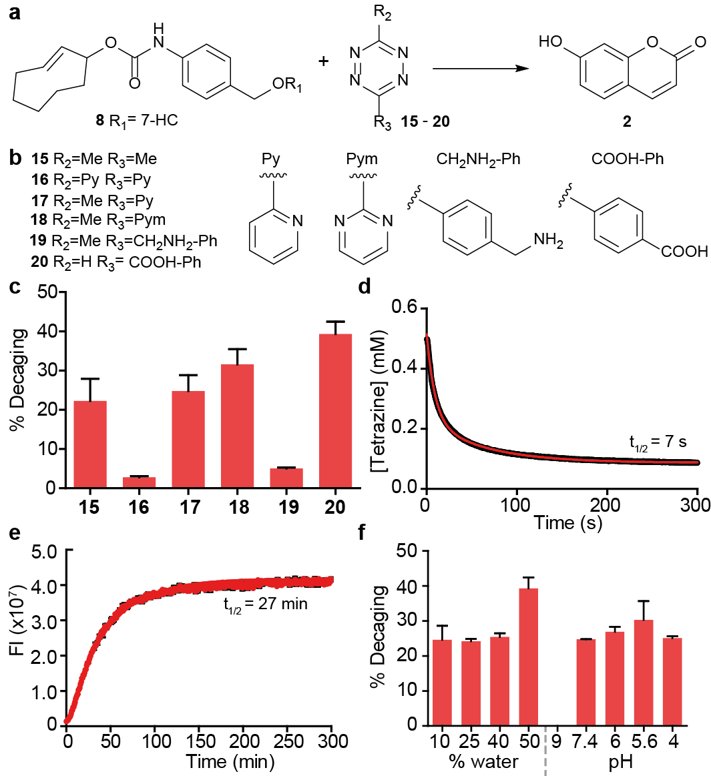
Fig. 4. Kinetics and yields of decaging. a. Tetrazine-triggered release of alcohol 2 from TCO-coumarin 8. b. Structures of tetrazines 15−20 used in this study. c. Decaging yield of the reaction of TCO-coumarin 8 with tetrazines 15−20 assessed by HPLC/UV. Concentration of the released coumarin was determined by using a calibration curve with known concentrations of coumarin and benzoic acid as an internal standard (See Figure S11). d. Rate of consumption of tetrazine upon reaction of 8 with 20, determined by following the decrease in absorbance (λ = 530 nm) by stopped-flow. e. Release of 2 by reaction of 8 with 20, determined by following the increase in fluorescence (λ_{ex} = 320, λ_{em} = 465 nm). f. Decaging yield of the reaction of TCO-coumarin 8 with 20 determined by HPLC under different conditions after reaction for 24h.
Next, we applied this linker for drug release. For proof of concept studies, we chose antibacterial drug triclosan (TCS, 21). Compound 14 was synthesised according to the previously reported protocol (Figure 3, route 2). Bromination and coupling of the drug gave 11b in 56% yield and conversion of 11b to 14 in the final 3 steps was achieved in 18% yield. Again, the product was obtained as the 100% axial, trans-isomer. The reaction was then studied by HPLC by using an internal standard and a decaging yield of 22% was observed (See Figures S12 and S13). In addition, detection of intermediate peaks by Liquid Chromatography-Mass Spectrometry (LC-MS) analysis confirmed our proposed mechanism of decaging (See Figure S14).

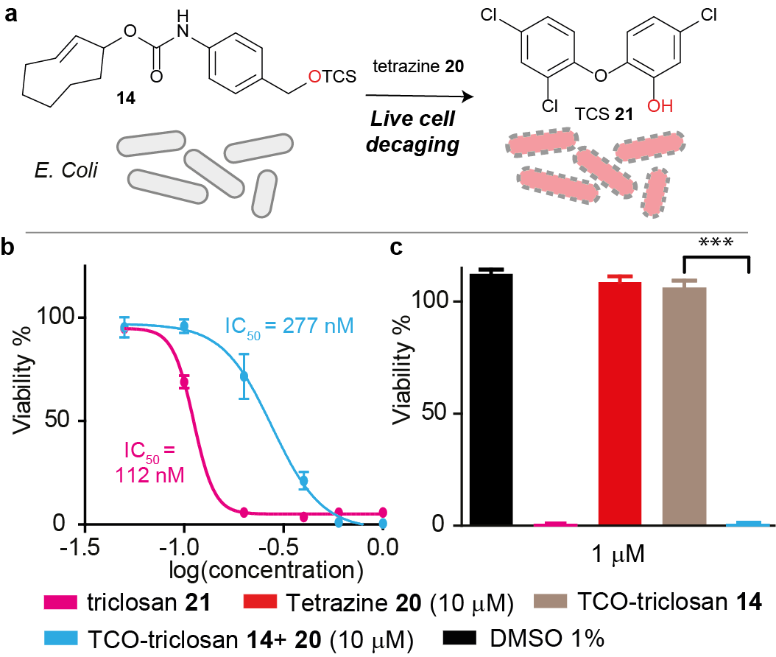

Fig. 5. Cell decaging experiments a. Representation of decaging in the presence of live E. Coli, which results in cell death from release of antibacterial drug, triclosan (21). b. Representative IC₅₀ curves of triclosan (21) and the reactant pair 14 + 20 obtained by measuring the viability using the cell titre blue assay. The experiment was repeated 3 times and similar results were obtained each time. Average values of IC₅₀ were found to be 122 ± 10 nM (21) and 298 ± 20 nM (reactant pair 14 + 20) c. Cell viability after treatment of E. Coli with either 21, 20, 14, 14 + 20. Treatment with bioorthogonal reactant pair 14 + 20 resulted in complete cell killing. The experiment was repeated 3 independent times.
Finally, the decaging reaction was carried out in the presence of live bacteria [E. Coli BL21(DE3), Figure 5a]. First, the bactericidal activity of triclosan (21) was determined by assessing the cell viability at concentrations of 50 nM−1 μM and the IC₅₀ was found to be 122 ± 10 nM (Figure 5b). The bioorthogonal reactant pair, TCO-triclosan 14 + tetrazine 20 (10 equiv.), was shown to be ≈3 times less active (IC₅₀ = 298 ± 20 nM) than triclosan (21) alone. This lower activity is due to the non-quantitative decaging yield. Both the prodrug TCO-triclosan 14 and tetrazine 20 were shown to be non-toxic at all these concentrations (See Figure S15). After the initial assessment of toxicity, the decaging reaction was then carried out and viability was assessed by both cell titre blue assay (Figure 5c) and by measuring OD₆₀₀ (See Figure S16). Consistent results were obtained by both assays. At a concentration of 1 μM, triclosan (21) resulted in complete cell killing whereas cells treated with either TCO-triclosan 14 or tetrazine 20 were 100% viable. Complete cell death occurred upon treatment with the bioorthogonal reactant pair 14 + 20. Therefore, the reinstation of the bactericidal activity of triclosan (21) was achieved upon decaging in the presence of live cells.
Conclusions
We have successfully developed a TCO-carbamate benzyl ether for the controlled release of alcohol-containing drugs and fuorophores. A synthetic route was developed that enabled generation of the products 8 and 14 as 100% the axial, trans-isomer by direct modification of (trans)-cyclooct-2-en-1-ol. The synthesis does not require a late stage photochemical isomerisation under flow. The linker was shown to be highly stable in media (DMEM and LB) and 20% plasma. Reaction with tetrazine was shown to be complete within 120 min and through observation of intermediates, the proposed 1,6-elimination mechanism from the aniline benzyl-ether derivative was confirmed. Finally, triggered release of an alcohol-containing antibacterial drug, triclosan (21), was carried out in the presence of live E. Coli cells and the bactericidal activity was reinstated, which resulted in complete cell killing. Overall this work provides a new linker for the release of alcohol-containing drugs. The significant improvement in kinetics from the previous vinyl ether handle²² suggests this reaction may hold potential for in vivo prodrug activation.
Conflicts of interest
There are no conflicts to declare.
Acknowledgements
We thank the EPSRC (PhD studentship to S.D.), the European Commission (Marie Sklodowska-Curie Fellowship to B.L.O., GA No. 702574) and FCT Portugal (iFCT IF/00624/2015 and 02/SAICT/2017, Grant 28333). G.J.L.B. is a Royal Society University Research Fellow (URF\R\180019). The authors thank Dr Vikki Cantrill for her help with the editing of this manuscript.
Notes and references
1 N. K. Devaraj and R. Weissleder, Acc. Chem. Res., 2011, 44, 816–827.
2 H. Lebraud, D. J. Wright, C. N. Johnson and T. D. Heightman, ACS Cent. Sci., 2016, 2, 927–934.
3 K. Wang, D. Wang, K. Ji, W. Chen, Y. Zheng, C. Dai and B. Wang, Org. Biomol. Chem., 2015, 13, 909–915.
4 M. Wang, D. Svatunek, K. Rohlfing, Y. Liu, H. Wang, B. Giglio, H. Yuan, Z. Wu, Z. Li and J. Fox, Theranostics, 2016, 6, 887–95.
5 M. L. Blackman, M. Royzen and J. M. Fox, J. Am. Chem. Soc., 2008, 130, 13518–13519.
6 A. Darko, S. Wallace, O. Dmitrenko, M. M. Machovina, R. A. Mehl, J. W. Chin and J. M. Fox, Chem. Sci., 2014, 5, 3770–3776.
7 M. T. Taylor, M. L. Blackman, O. Dmitrenko and J. M. Fox, J. Am. Chem. Soc., 2011, 133, 9646–9649.
8 W. D. Lambert, S. L. Scinto, O. Dmitrenko, S. J. Boyd, R. Magboo, R. A. Mehl, J. W. Chin, J. M. Fox and S. Wallace, Org. Biomol. Chem., 2017, 15, 6640–6644.
9 B. L. Oliveira, Z. Guo and G. J. L. Bernardes, Chem. Soc. Rev., 2017, 46, 4895–4950.
10 J. Li and P. R. Chen, Nat. Chem. Biol., 2016, 12, 129–137.
11 J. Tu, M. Xu and R. Franzini, ChemBioChem, 2019, DOI: 10.1002/cbic.201800810.
12 K. Lang and J. W. Chin, ACS Chem. Biol., 2014, 9, 16–20.
13 C. S. McKay and M. G. Finn, Chem. Biol., 2014, 21, 1075–1101.
14 D. M. Patterson, L. A. Nazarova and J. A. Prescher, ACS Chem. Biol., 2014, 9, 592–605.
15 S. Davies, B. J. Stenton and G. J. L. Bernardes, Chimia (Aarau)., 2018, 72, 771–776.
16 X. Ji, Z. Pan, B. Yu, L. K. De La Cruz, Y. Zheng, B. Ke and B. Wang, Chem. Soc. Rev., 2019, 48, 1077–1094.
17 R. M. Versteegen, R. Rossin, W. ten Hoeve, H. M. Janssen and M. S. Robillard, Angew. Chem. Int. Ed., 2013, 52, 14112–14116.
18 R. Rossin, S. M. J. van Duijnhoven, W. ten Hoeve, H. M. Janssen, L. H. J. Kleijn, F. J. M. Hoeben, R. M. Versteegen and M. S. Robillard, Bioconjug. Chem., 2016, 27, 1697–1706.
19 R. Rossin, R. M. Versteegen, J. Wu, A. Khasanov, H. J. Wessels, E. J. Steenbergen, W. ten Hoeve, H. M. Janssen, A. H. A. M. van Onzen, P. J. Hudson and M. S. Robillard, Nat. Commun., 2018, 9, 1484.
20 J. M. Mejia Oneto, I. Khan, L. Seebald and M. Royzen, ACS Cent. Sci., 2016, 2, 476−482.
21 Q. Yao, F. Lin, X. Fan, Y. Wang, Y. Liu, Z. Liu, X. Jiang, P. R. Chen and Y. Gao, Nat. Commun., 2018, 9, 5032.
22 E. Jiménez-Moreno, Z. Guo, B. L. Oliveira, I. S. Albuquerque, A. Kitowski, A. Guerreiro, O. Boutureira, T. Rodrigues, G. Jiménez-Osés and G. J. L. Bernardes, Angew. Chem. Int. Ed., 2017, 56, 243–247.
23 H. Wu, S. C. Alexander, S. Jin and N. K. Devaraj, J. Am. Chem. Soc., 2016, 138, 11429–11432.
24 K. Neumann, S. Jain, A. Gambardella, S. E. Walker, E. Valero, A. Lilienkampf and M. Bradley, ChemBioChem, 2017, 18, 91–95.
25 J. Tu, M. Xu, S. Parvez, R. T. Peterson and R. M. Franzini, J. Am. Chem. Soc., 2018, 140, 8410–8414.
26 S. Davies, L. Qiao, B. Oliveira, C. Navo, G. Jiménez-Osés and G. J. L. Bernardes, ChemBioChem, 2019, DOI: 10.1002/cbic.201900098.
27 R. M. Versteegen, W. ten Hoeve, R. Rossin, M. A. de Geus, H. M. Janssen and M. S. Robillard, Angew. Chem. Int. Ed., 2018, 57, 10494–10499.
28 M. S. Robillard, H. M. Janssen, W. ten Hoeve, R. M. Versteegen and R. Rossin, US Pat., 2016106859 (A1), 2016.
29 F. Thalhammer, U. Wallfahrer and J. Sauer, Tetrahedron Lett., 1990, 31, 6851–6854.
30 Maksim Royzen, A. Glenn P. A. Yap and J. M. Fox, J. Am. Chem. Soc., 2008, 130, 3760–3761.
31 K. Kurita, T. Matsumura and Y. Iwakura, J. Org. Chem., 1976, 41, 2070–2071.
32 X. Fan, Y. Ge, F. Lin, Y. Yang, G. Zhang, W. S. C. Ngai, Z. Lin, S. Zheng, J. Wang, J. Zhao, J. Li and P. R. Chen, Angew. Chem. Int. Ed., 2016, 55, 14046–14050.
33 J. C. T. Carlson, H. Mikula and R. Weissleder, J. Am. Chem. Soc., 2018, 140, 3603–3612.

