Hidden specificities in enzyme catalysis: substrate structure–selectivity relationship of a ketoreductase
Matthias Häckh,ª Xavier Lucas,ª Marija Marolt,ª Peter F. Leadlay,^{b} Michael Müller,ª Stefan Günther,ª and Steffen Lüdekeª*
[a] Dr. M. Häckh, Dr. X. Lucas, Prof. Dr. S. Günther, Prof. Dr. M. Müller, Dr. S. Lüdeke
Institute of Pharmaceutical Sciences
University of Freiburg, Albertstrasse 25, 79104 Freiburg (Germany)
Fax: (+49) 761-203-6351
E-mail: steffen.luedeke@pharmazie.uni-freiburg.de

[b] Prof. Dr. P. Leadlay
Department of Biochemistry, University of Cambridge
80 Tennis Court Road, Cambridge CB2 1GA (United Kingdom)
Supporting information for this article is given via a link at the end of the document.

Abstract: Enzymes often convert both physiological and non-physiological substrates with high stereoselectivity—yet for some enzymes opposite product chirality is observed. A possible explanation is the existence of hidden specificities becoming effective when non-physiological substrates confer different substrate-enzyme interactions than the physiological substrate. To test this hypothesis, we converted a series of α-methylated β-keto- esters with Tyl-KR1, a keto reductase from polyketide synthesis in Streptomyces fradiae. Conversions of six substrates with different physicochemical properties exhibited enantioselectivites from 84% ee for R,R- to 84% ee for S,S, yet high and uniform diastereoselectivity (anti, dr >9:1). The exchange of a single atom, oxygen ester instead of a thioester, led to almost complete loss of enantioselectivity (<5% ee). Through molecular docking and site-directed mutagenesis we identified an additional S,S-selective binding mode as a hidden specificity in Tyl-KR1.
Enzymes and substrates are considered to form a pair of complementary pieces, which, in the case of enantioselective enzymes, leads to their (sometimes misleading) classification as (R)- and (S)-selective enzymes. However, some enzymes switch stereoselectivity when non-physiological substrates are converted.^{[1]} This can be explained by a flipped or slightly altered binding conformation with respect to the active site.^{[2]} The transformation of chiral substrates, on the other hand, can also be stereospecific. Nevertheless, inverted stereospecificity along with enantio-complementarity can as well be observed, eventually leading to inverted stereochemistry at two chiral centers.^{[3]} This behavior is consistent with independent specificities for different substrates.^{[4]}
NAD(P)H-dependent ketoreductases (KRs) from polyketide biosynthesis pathways are categorized as A-type (S-selective) and B-type (R-selective) KRs; the sub-type categories A1 (R,S), A2 (S,S), B1 (R,R), B2 (S,R) take into account the KR’s stereospecificities for the introduction of a second stereocenter in the same reduction step.^{[5]} KRs are important for stereocontrol in polyketide biosynthesis:^{[6]} here, the enzyme’s preference for either an R- or an S-configured substrate leads to dynamic kinetic resolution (DKR) of a chiral substrate that racemizes through keto-enol tautomerization, which might occur either spontaneously, or is catalyzed by the epimerase activity of a KR.^{[7]}
The dynamic kinetic resolution of (R/S)-2-methyl-3-oxovaleric acid N-acetylcysteamine (SNAC) thioester (1) catalyzed by Tyl-KR1, a B1-type KR from Streptomyces fradiae involved in the biosynthesis of the macrolide antibiotic tylosin (Figure S1),^{[8]} delivers an R,R-configured product (Scheme 1).^{[9]} SNAC mimics the phosphopantetheine moiety of the acyl carrier protein being important for the accommodation of the physiological substrate in the active site.^{[10]} For non-physiological substrates, the situation is different: with lipophilic esters such as ethyl or tert-butyl (R/S)-2-methyl-3-oxovalerate, the enzymatic reduction yields the corresponding S,S-hydroxy esters suggesting that Tyl-KR1 also has hidden A2-type properties.^{[3b]} This finding somehow challenges the previously postulated correlation of the stereoselectivity of a KR and diagnostic motifs in its amino acid sequence^{[5]}—a paradigm considered a milestone for the long-term goal of identifying patterns that allow the prediction of the stereoselectivity of enzymatic reactions directly from genome sequencing data.^{[11]} Recently, such paradigms have also been incorporated as heuristics for computational PKS design.^{[12]} Deciphering the molecular reasons for substrate-dependent stereoselectivity could reconcile supposed violations of the sequence/selectivity paradigm as observed for Tyl-KR1 toward a unified concept of stereopromiscous behavior .

Scheme 1. Tyl-KR1-catalyzed dynamic kinetic resolution through reduction of the β-keto group of 1–6 (shown for 1 and 4) can result into four possible stereoisomers: anti-(2R,3R)-1a–6a, anti-(2S,3S)-1b–6b, syn-(2R,3S)-1c–6c, syn-(2S,3R)-1d–6d (enzyme activity: 3 U mL^{–1}; KPi pH 7.5; NADPH regeneration by ᴅ-glucose/GDH^{[13]}).
The grossly different behavior for the Tyl-KR1-catalyzed reduction of different lipophilic esters and 1 could be explained by competitive binding of substrates in binding modes with opposite stereoselectivity. While electrostatic substrate/enzyme interactions probably mediated by the amide group in SNAC ester 1 confer a geometry that favors R,R-selective reduction, the lipophilic derivatives possibly prefer binding in the second mode with a hitherto hidden specificity of Tyl-KR1. To test this idea, we synthesized thioesters 2 and 3, substrates with a gradually decreasing potential for electrostatic substrate/enzyme interactions, by replacement of NH and both NH and C=O of SNAC by methylene (Scheme 1).^{[14]} As Tyl-KR1 had previously also been used with oxygen esters,^{[3b]} compounds 4–6, the corresponding oxygen esters of 1–3, were also synthesized as putative model substrates.
All compounds were converted into the 3-hydroxy esters 1a/b–6a/b through reductions catalyzed by Tyl-KR1 from heterologous production in E. coli (see Supporting Information), albeit with varying overall conversion after incubation at room temperature for 24 hours (Table 1).
Table 1. Tyl-KR1-catalyzed reduction of isosteric substrate derivatives 1–6.
Substrate  (Product) | Conversion^{[a]}  [%] | d.r.^{[b]}  anti/syn | ee^{[b]}  [%] | Configuration^{[c]}
1 (1a)^{[d]} | >99 (2) | >99:1 | 84 | 2R,3R
2 (2a+2b) | 92 (2) | 97:3 | 52 | 2R,3R
3 (3a+3b) | 36 (<1) | 90:10 | 16 | 2S,3S
4 (4a+4b) | 52 (<1) | 93:7 | <5 | –
5 (5a+5b) | 92 (<1) | 95:5 | 46 | 2S,3S
6 (6b) | 55 (<1) | 90:10 | 84 | 2S,3S
[a] According to ¹H NMR spectroscopy. [b] According to chiral-phase GC analysis (Figure 1A). [c] According to VCD spectroscopy (Figure 1B). [d] Values taken from Ref.^{[3b]} Non-specific background conversions (in parentheses) were quantified by incubation of all substrates with Tyl-KR1-free lysate and GDH.

Scheme 2. Derivatization of enzymatic reduction products (shown for 1a). The reductive cleavage of thiosters and esters 2a–6a also yields diol 9 with the stereochemistry of the parent hydroxyester/thioester from keto reduction (the stereochemical descriptors change due to altered CIP priorities).

For stereochemical analysis, the purified reduction products were derivatized into the acetonides 8a–d according to a previously described protocol (Scheme 2 and Supporting Information).^{[3b]} This derivatization removes the ester/thioester moiety which would complicate a direct comparison. As it does not affect the stereochemistry, in compound numbering, the subcategories a, b, c, d refer to the same chirality as in the reduction products, even though the stereochemical descriptors differ due to altered CIP priorities. According to ¹H-NMR, all acetonide derivatives were unequivocally identified as 8a/b, meaning that all reduction products predominantly have the anti relative configuration (Figure S4).
The chiral phase gas chromatograms (Figure 1A) show two major peaks at t = 42.1 min and 44.5 min corresponding to the anti enantiomers a and b and only small amounts of the syn enantiomers c and d (t = 48.5 and 52.3 min), which indicates a high diastereoselectivity for the enzymatic reduction of all substrates (Table 1, see Figure S5B for a reference chromatogram of the diastereomeric mixture).
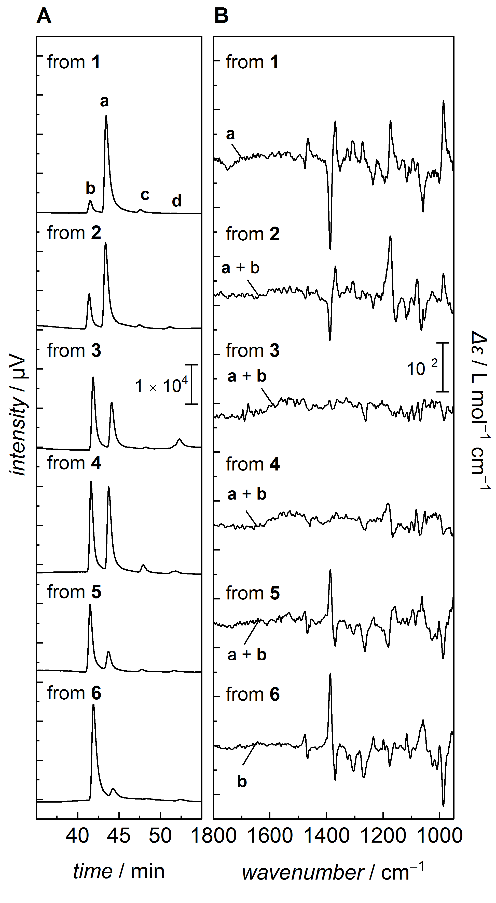
Figure 1. A) Chiral-phase gas chromatograms of derivatized reduction products 1a–6a. B) VCD spectra corresponding to the samples shown in A). Configurations refer to the reduction products 1a/b–6a/b, though recorded and determined for the corresponding acetonides 8.
For the assignment of the elution order of the anti-enantiomers we used vibrational circular dichroism (VCD) spectroscopy, a well-established method for the determination of the absolute configuration.^{[15]} In agreement with our previous assignment,^{[3b]} the spectral pattern of positive and negative bands in the top spectrum in Figure1B (“from 1”) allows the identification of 8a. For the reduction product obtained from 1, this corresponds to the anti-(2R,3R) configuration (1a). Hence, the major peak in chromatogram “from 1” in Figure 1A at t = 44.5 min (84% ee) corresponds to 8a and the minor peak at 42.1 min to 8b. Accordingly, after stereoselective synthesis of reference compounds and VCD determination of the absolute configuration (Figure S5A and B), the negligible peaks at 48.5 and 52.7 min were assigned to the cis-acetonides 8c and 8d formed from trace amounts of syn-diastereomers after enzymatic conversion. In the interpretation of the stereochemical analysis, we will treat the stereochemical compositions of 8a/b from 1–6 as equivalent to those of the reduction products 1–6a/b.
Compared to 1, substrates 2 (one hydrogen bond acceptor) and 3 (no hydrogen bonding) have a decreased propensity for electrostatic interactions. The chromatograms “from 2” and “from 3” indicate decreasing ee, but still a high diastereomeric ratio (Figure1A). Accordingly, the corresponding VCD spectra show considerably decreased signal intensities (Figure 1B). Therefore, hydrogen bonding with the amide moiety is an important parameter that discriminates between the two specificities of Tyl-KR1 and its loss results in nearly equal formation of the R,R- and the S,S-enantiomer. Surprisingly, a virtually complete loss in enantioselectivity is also observed for the conversion of 4 (Figure 1A, “from 4”), a substrate that still contains the potentially crucial amide group, but is an oxygen ester instead of a thioester (Scheme 1A). Combining the sulfur/ oxygen exchange effect with the increased hydrophobicity through methylene replacement of N–H (substrate 5) or N–H and C=O (pentyl ester 6) eventually leads to full inversion of the enantioselectivity, now for the anti-(2S,3S) configuration (46% for 5b and 84% ee for 6b, Figure 1A, “from 5” and “from 6”). This is also reflected by the opposite signs of the bands in the corresponding VCD spectra (Figure1B).
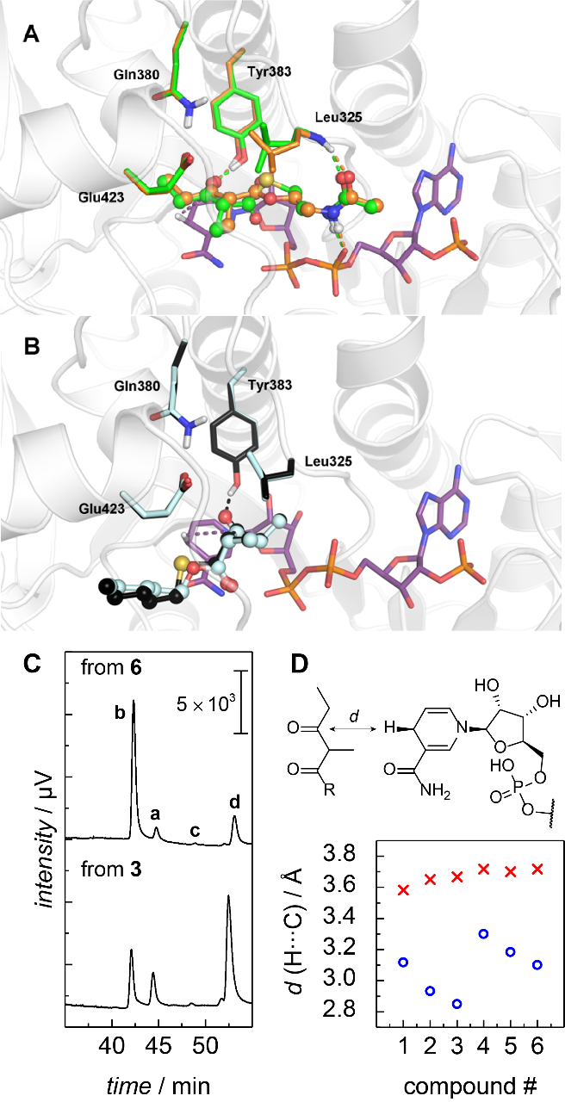
Figure 2. A) Substrates 1 (SNAC ester, green) and 4 (ONAC ester, orange) modeled in the ‘cofactor-aligned binding mode’ in the crystal structure of Tyl-KR1 (2Z5L).^{[8a]} B) Ester 6 (turquoise) and thioester 3 (black) in the ‘hydrophobic cavity mode’. C) Stereochemical outcome after conversion of 6 and 3 by Leu411Phe with increased proportion of 8d. D) Distance parameters for the 2R,3R-series (blue circles) and the 2S,3S-series (red crosses).
To associate the observed substrate-dependent selectivity switch with an altered binding geometry for different substrates we performed molecular docking of substrates 1–6 to the crystal structure of Tyl-KR1 (Figure S6).^{[8a]} Indeed, we found two preferred binding modes putatively competing for opposite selectivities: In the first mode, which prefers R-configured substrates 1–6, the relative orientation to NADPH is consistent with R,R-selectivity. Here, the SNAC moiety is positioned alongside the cofactor (Figure 2A, ‘cofactor-aligned binding mode’). Geometry optimization after replacement of sulfur by oxygen (replacement of (R)-1 by (R)-4) is concomitant with rotation of Leu325 and an increase in free binding energy (ΔΔG_{bind, 1→4} = 9.8 kcal mol^{–1}), This could account for the observed effect of sulfur/oxygen exchange on the stereochemical outcome. The second binding mode prefers S-configured substrates with the highest docking scores for lipophilic pentyl ester (S)-6. Far from the cofactor’s phosphate chain the pentyl terminus of (S)-6 occupies a large hydrophobic cavity formed by the residues Met417, Ala418, Ala419, Leu411, and Gly420 (Figure 2B, ‘hydrophobic cavity mode’). The binding of (S)-3 instead of (S)-6, i. e. replacement of oxygen by sulfur, increases ΔG_{bind} by 8.6 kcal mol^{–1} indicating that the substrate with the smaller oxygen ester atom better accommodates in the hydrophobic cavity mode
To verify this model, we mutated Leu411, an amino acid found close to the ‘hydrophobic cavity mode’, but far from the ‘cofactor-aligned binding mode’ (Figure S7). We expected replacement by phenylalanine to impose a mild perturbation on substrate binding, which should be reflected by an altered stereochemical composition of the ketoreduction products from Leu411Phe-catalyzed conversions in comparison to wildtype. Indeed, we observed considerably reduced diastereoselectivity upon conversion of substrate 6 (Figure 2C). The effect of Leu/Phe replacement was even more pronounced for thiopentyl ester 3. Here, the increase in the proportion of the syn-(2R,3S)-diastereomer denotes a considerable shift in the ratio ‘cofactor-aligned binding mode’:‘hydrophobic cavity mode’ from 40:60 for wild-type to 15:85 for Leu411Phe (calculated from adding the GC peak areas of 8a and 8c, and 8b and 8d, respectively). This confirms the existence of the ‘hydrophobic cavity mode’ and its interaction with S,S-prone substrates.
As the propensity to bind in these modes seems to be a function of specific electrostatic enzyme/cofactor/substrate interactions, and as these interactions are heavily disturbed by exchange from sulfur to oxygen, we performed an in silico perturbational analysis (see Supporting Information for details). We modeled substrates (R)-1–6 in the ‘cofactor-aligned binding mode’ and (S)-1–6 in the ‘hydrophobic cavity mode’ of the active site of Tyl-KR1 using the binding poses of (R)-1 and (S)-6 as templates, and performed a geometry optimization (Figure 2A). As a measure for the degree of perturbation that comes with the structural permutations in the ester moiety, we determined the distances between the carbonyl carbon (the hydride acceptor) and the hydride to be transferred from NADPH. For the ‘cofactor-aligned binding mode’ replacement of N–H and C=O by methylene groups is concomitant with changes in the distance indicating a reorientation of the substrate in respect to NADPH (blue circles, Figure 2D). The distance parameter changes similarly for the sulfur- and the oxygen-series, but in agreement with the results from the stereochemical analysis, the replacement of sulfur by oxygen seems to have the greatest impact on the binding geometry. This is also reflected by other parameter readouts such as dihedrals and angles in the substrates and the cofactor (Figure S8).
The altered binding conformation of oxygen esters 4–6 compared to sulfur esters 1–3 is accompanied by rotation of Leu325, a highly conserved residue in the active site of type B keto reductases,^{[16]} and an increase in free binding energy (ΔG(4) − ΔG(1) = 9.8 kcal mol^{–1}, Figure 2A). As a consequence, substrate 4 binds reluctantly in the ‘cofactor-aligned binding mode’, which results in only moderate conversion after 24 hours (52%) and low ee (<5%, Table 1). While large geometrical displacements are required to accommodate substrates 2–6 in the ‘cofactor-aligned binding mode’, the ‘hydrophobic cavity mode’ seems to be more robust toward substrate modifications and can therefore be considered the more promiscuous specificity of Tyl-KR1. None of the performed permutations seems to affect the geometry parameters in this binding mode (Figure 2B, red crosses in Figure 2D, Figure S8), despite an energetic preference for binding of oxygen-ester substrates compared to the corresponding sulfur-esters (ΔG(3) − ΔG(6) = 8.6 kcal mol^{–1}).
Taken together, these findings agree with a model in which the perturbation of one binding mode drives the substrate to an alternative binding mode that still allows for comparable enzymatic activity, stereoselectivity, and ?-specificity. At first sight, the occurrence of high ee of S,S-configured products challenges the sequence-selectivity paradigm, which categorizes Tyl-KR1 as a B1-type KR (Figure S9).^{[17]} However, previous bioinformatics studies have shown that this enzyme actually shares conserved motifs of both A- and B-type KRs (Figure S9).^{[5c]}
Our observations are consistent with an additional specificity that remains hidden in the context of the physiological biosynthesis. Previously, it has been shown that structurally similar enzymes can be inhibited by the same compound, even if they are performing completely unrelated tasks in different contexts.^{[18]} The results presented in this study indicate that Tyl-KR1 performs different tasks for related yet different substrates. Consequently, we expect many other enzymes to have redundant but hidden specificities, which contribute significantly not only to the processing of alternative substrates in biotransformation, but also help shape the course of natural enzyme evolution.
Acknowledgments
We thank P. Trenkle for help with the preparation of the Tyl-KR1 variant. This work was supported by the Deutsche Forschungsgemeinschaft, DFG (IRTG 1038, RTG 1976, DFG 1225/3-1). Calculations were performed on the bwForCluster JUSTUS supported by the state of Baden-Württemberg through bwHPC and the German Research Foundation (DFG) through Grant No. INST 40/467-1 FUGG.
Keywords: Enzyme catalysis • Enantioselectivity • Diastereoselectivity • Molecular modeling • Vibrational circular dichroism

[1] H. Zhou, Z. Z. Gao, K. J. Qiao, J. J. Wang, J. C. Vederas, Y. Tang, Nat. Chem. Biol. 2012, 8, 331–333.
[2] a) E. Brenna, F. G. Gatti, A. Manfredi, D. Monti, F. Parmeggiani, Adv. Synth. Catal. 2012, 354, 2859–2864; b) M. Hall, C. Stueckler, H. Ehammer, E. Pointner, G. Oberdorfer, K. Gruber, B. Hauer, R. Stuermer, W. Kroutil, P. Macheroux, K. Faber, Adv. Synth. Catal. 2008, 350, 411–418; c) E. L. Noey, N. Tibrewal, G. Jimenez-Oses, S. Osuna, J. Park, C. M. Bond, D. Cascio, J. Liang, X. Y. Zhang, G. W. Huisman, Y. Tang, K. N. Houk, Proc. Natl. Acad. Sci. U. S. A. 2015, 112, E7065–E7072.
[3] a) S. K. Piasecki, C. A. Taylor, J. F. Detelich, J. N. Liu, J. T. Zheng, A. Komsoukaniants, D. R. Siegel, A. T. Keatinge-Clay, Chem. Biol. 2011, 18, 1331–1340; b) M. Häckh, M. Müller, S. Lüdeke, Chem. Eur. J. 2013, 19, 8922–8928; c) P. Lehwald, O. Fuchs, L. A. Nafie, M. Müller, S. Lüdeke, ChemBioChem 2016, 17, 1207–1210.
[4] G. Christiansen, B. Philmus, T. Hemscheidt, R. Kurmayer, J. Bacteriol. 2011, 193, 3822–3831.
[5] a) P. Caffrey, ChemBioChem 2003, 4, 654–657; b) R. Reid, M. Piagentini, E. Rodriguez, G. Ashley, N. Viswanathan, J. Carney, D. V. Santi, C. R. Hutchinson, R. McDaniel, Biochemistry 2003, 42, 72–79; c) A. Kitsche, M. Kalesse, ChemBioChem 2013, 14, 851–861.
[6] A. T. Keatinge-Clay, Nat. Prod. Rep. 2016, 33, 141–149.
[7] A. Garg, C. Khosla, D. E. Cane, J. Am. Chem. Soc. 2013, 135, 16324–16327.
[8] a) A. T. Keatinge-Clay, Chem. Biol. 2007, 14, 898–908; b) R. Castonguay, C. R. Valenzano, A. Y. Chen, A. Keatinge-Clay, C. Khosla, D. E. Cane, J. Am. Chem. Soc. 2008, 130, 11598–11599.
[9] A. P. Siskos, A. Baerga-Ortiz, S. Bali, V. Stein, H. Mamdani, D. Spiteller, B. Popovic, J. B. Spencer, J. Staunton, K. J. Weissman, P. F. Leadlay, Chem. Biol. 2005, 12, 1145–1153.
[10] J. T. Zheng, A. T. Keatinge-Clay, Med. Chem. Commun. 2013, 4, 34–40.
[11] K. J. Weissman, Beilstein J. Org. Chem. 2017, 13, 348–371.
[12] C. H. Eng, T. W. H. Backman, C. B. Bailey, C. Magnan, H. G. Martin, L. Katz, P. Baldi, J. D. Keasling, Nucleic Acids Res. 2018, 46, D509–D515.
[13] C. H. Wong, D. G. Drueckhammer, H. M. Sweers, J. Am. Chem. Soc. 1985, 107, 4028–4031.
[14] Methylene replacement of only C=O would lead to an ethylaminoethyl ester, or thioester, respectively. These secondary amines were abandoned as possible model substrates due to their unfavorable physico-chemical properties and the observation of spontaneous rearrangement to the corresponding amide.
[15] T. B. Freedman, X. L. Cao, R. K. Dukor, L. A. Nafie, Chirality 2003, 15, 743–758.
[16] P. Caffrey, ChemBioChem 2003, 4, 654–657.
[17] P. Caffrey, Chem. Biol. 2005, 12, 1060–1062.
[18] a) R. Breinbauer, I. R. Vetter, H. Waldmann, Angew. Chem. Int. Ed. 2002, 41, 2879–2890; b) R. Breinbauer, I. R. Vetter, H. Waldmann, Angew. Chem. 2002, 114, 3002–3015.

Entry for the Table of Contents (Please choose one layout)

Layout 1:

COMMUNICATION
Text for Table of Contents |  | ((Insert TOC Graphic here)) |  | Author(s), Corresponding Author(s)*  Page No. – Page No.  Title

Layout 2:
COMMUNICATION
Text for Table of Contents  ((Insert TOC Graphic here)) |  | Author(s), Corresponding Author(s)*  Page No. – Page No.  Title

