In-situ fabrication of TiO₂-C core-shell particles for efficient solar photocatalysis
Aditya Chauhan*, Sundararajan Thirumalai*, and Ramachandran Vasant Kumar
Department of Materials Science and Metallurgy, University of Cambridge, CB3 0FS Cambridge, UK.
Abstract
A facile method is proposed for the in-situ synthesis of titania-carbon (TiO₂-C) core-shell composite structures with ameliorated photocatalytic properties. The particles were prepared through controlled hydrolysis of titanium alkoxides followed by calcination in a non-oxygenating atmosphere. To study the effect of fabrication technique on the size and morphology of the prepared catalyst, three different combinations of precursors and solvents were investigated. Phase purity, physical and chemical characterization of the as-synthesized catalysts were confirmed using X-ray diffraction, scanning electron microscopy, diffuse reflectance spectroscopy and Raman spectroscopy techniques. Photocatalytic activity of the catalyst was evaluated through monitoring mineralization of methylene blue solution under solar illumination. It was observed that compared to standard titania, samples containing carbon were up to eight times more efficient at achieving solar assisted mineralization of dye. Subsequent analysis revealed that choice of titanium alkoxide and solvent (alcohol) can significantly vary the crystallite size, color and surface area of the calcined samples. The enhanced photocatalytic activity of the TiO₂-C catalysts can be attributed to enhanced visible light absorption and a larger surface area.
Keywords: TiO₂-C fabrication; solvent-precursor selection; core-shell; photocatalysis.
*Corresponding author. Email: st655@cam.ac.uk, tsrajan91@gmail.com, aditya0chauhan@gmail.com; Phone: +44(0) 1223 331694.

- Introduction
According to a report by the Netherlands Environmental Assessment Agency (NEAA)[1], the global greenhouse gas emissions rose by 0.5% in the year 2016. The same year total CO₂ equivalent emissions reached 49.3 Gigatons which was mainly credited to non-CO₂ emission levels[1]. However, no net increment in the annual CO₂ generation was observed[1]. These figures reveal that it is imperative to further reduce our dependence on fossil reserves imminently and make increasing efforts to shift to cleaner and sustainable technologies. In this regard, photocatalysis is one such domain which has the potential to utilize abundant solar energy for a multitude of applications. These include air[2] and water treatment[3-5], hydrogen production[6], carbon capture[7] and chemical synthesis/conversion of organic compounds [8-10] among others. Hence, active research is being conducted towards the fabrication of efficient, stable and economic photocatalysts.
Among heterogeneous semiconductor photocatalysts, TiO₂ (anatase) has been widely investigated[11-16]. This can be credited to several desirable attributes of TiO₂ such as chemical stability, low toxicity, ease of fabrication and abundance[17, 18]. Hence, it still remains the largest studied photocatalytic material to date. However, pure TiO₂ suffers from several drawbacks[17, 18]: (1) TiO₂ being a wide bandgap semiconductor (3.2 eV) mainly absorbs in the UV region, which is less than 5% of the total solar energy and (2) suffers from fast recombination of photogenerated charge carriers. Other factors which affect the catalytic performance of TiO₂ are particle size/surface area, crystallinity, and phase. Significant efforts have been made to mitigate these shortcomings and increase the catalytic efficiency of TiO₂.[11] Some of the popular methods include metal and non-metal doping, surface sensitization and coupling with narrow band-gap semiconductors[11]. Each of these techniques has their own merits and demerits but primarily focus on improving visible light absorption of TiO₂.
From the view of enhancing light absorption, carbon (C) incorporation has been a popular technique[19-22]. Depending on the structure and fabrication strategy, doping/coupling with carbon can impart several benefits including band-gap shifting, enhanced absorption, and reduced trap sites[19]. C-TiO₂ based morphologies reported so-far include doping[23, 24], core-shell[20, 25], and Janus particles[26]. Similarly, various carbon-based structures have been investigated including amorphous C[26], reduced graphene oxide (r-GO)[27, 28], carbon nanotubes (CNTs)[29, 30] and recently graphitic carbon nitride[22]. Majority of these studies rely on an external carbon source for doping and a two-step process for making nanocomposites.
In this study, we report on a facile method to prepare TiO₂-C core-shell in-situ composite particles using titanium alkoxides as a single precursor for both C and TiO₂. Different combination of alkoxide and alcohols were investigated for their effect on particle morphology. The resulting sub-micron particles were analyzed for their size, surface area, and phase purity. Presence of surface carbon was confirmed using energy dispersive X-ray analysis (EDX) and X-ray photoemission spectroscopy (XPS) and corroborated by Raman spectroscopy. Diffuse reflectance spectroscopy (DRS) analysis revealed enhanced visible light absorption in the as-prepared catalyst. Photocatalytic activity of the composites was confirmed through monitoring sunlight-assisted (solar simulator) degradation of methylene blue. It was observed that selection of appropriate titanium precursor and alcohol had a significant effect on the particle morphology and corresponding catalytic activity.
- Experimental details
  - Materials
Titanium IV butoxide (99%, Acros Organics), titanium IV isopropoxide (>98%, Acros Organics) and titanium ethoxide (97%, Sigma Aldrich) were employed as organic precursors for TiO₂ and used without further purification. 1-butanol (anhydrous, Acros Organics), isopropanol (anhydrous, Acros Organics) and ethanol (anhydrous, Acros Organics) were used as solvents for the titanium alkoxides. Millipore water was used in all experiments. For the purpose of simplification, the following reference codes have been adopted to designate the reagents: titanium IV butoxide (T1), titanium IV isopropoxide (T2), titanium ethoxide (T3). Similarly, the alcohols will carry the following designation: ethanol (E), isopropanol (I) and butanol (B) unless specified otherwise.
  - Synthesis of C-TiO₂ particles
First, amorphous TiO₂ particles were prepared through controlled hydrolysis of titanium alkoxides, according to a previously reported method[31]. Briefly, a known quantity of titanium precursors T1 (4.3 mL), T2 (3.7 mL) and T3 (3.11 mL) were dissolved in 15 mL alcohol using a magnetic stirrer, for 10 min. To this additional 50 mL of alcohol was added and allowed to stir for another 10 minutes, until a clear solution was obtained. To achieve controlled hydrolysis, water (1.5 mL) was added dropwise to the solution under vigorous stirring. Depending upon the alcohol and precursor used, precipitation started to occur after several seconds or minutes. The stirring was discontinued after 30 minutes and the mixture was allowed to stand for 120 minutes for the reactions to complete. The suspended particles were recovered through centrifuging and washed repeatedly with water and designated alcohol to remove any unreacted components. These particles, which were found to be amorphous, were then left to dry overnight in a vacuum furnace at 60 ºC. As per the combination of alkoxide and alcohol, nine samples were prepared designated as T1-E/I/B, T2- E/I/B and T3- E/I/B (Table 1). To obtain TiO₂-C composite configuration, the particles were calcined at 500 ºC for three hours in an N₂ atmosphere (5 mL.min⁻¹) with a heating and cooling ramp rate of 5 ºC.min⁻¹. As a control experiment, the T1-I amorphous particles were also calcined in air at 500 ºC for three hours.
  - Characterization
Phase purity and crystallinity of the powders were confirmed using powder X-ray diffraction analysis (Bruker D8 Gen 10) theta/theta system employing Cu Kα radiation (1.5406 Å wavelength). The surface area of the particles was analyzed through nitrogen absorption-desorption isotherms (Micromeritics TriFlex). Morphology and the average size were determined using a high-resolution scanning electron microscope (FEI NovaNano). X-ray photoemission spectroscopy (ESCALAB 250Xi) was utilized to confirm the chemical composition; while surface analysis was conducted using Raman spectroscopy (Renishaw inVia). The optical absorptivity of the powders was measured using diffuse reflectance spectroscopy (Ocean Optics).
  - Photocatalytic experimental setup
Photocatalytic activity of the powders was measured by observing the photo-assisted dye degradation of Methylene blue (MB) solution. In a standard experiment, 50 mg of catalyst was added to 50 mL of MB solution (10 mg.L⁻¹). The mixture was transferred in a 250 mL flask and observed to achieve adsorption-desorption equilibrium after 30 minutes of constant stirring in dark. Consequently, the setup was illuminated using a solar simulator (Newport Oriel class A flood exposure source) fitted with an optical filter (AM 1.5G). The output power at the surface of the liquid was measured to be 100 mW.cm⁻² using a standard Si solar cell (Fraunhofer-ISE RS-OD4) after correcting for the spectral mismatch. Sample aliquots (1 mL) were collected at two-minute intervals and centrifuged twice at 8000 rpm for four minutes to remove any suspended particles. The supernatant was then analyzed using a UV-visible spectrophotometer (Agilent/HP 8453). To measure the change in intensity over time, absorbance at 664 nm was selected. The change of concentration with respect to a stock solution was used to indicate the percentage degradation achieved over a period of 12 minutes.
- Results and discussions
  - Powder X-ray diffraction and compositional analysis
Figures 1(a), (b) and (c) display the XRD patterns of T1-E, T1-I, and T1-B, respectively. High-resolution diffraction graphs for all samples are provided in supplementary file (S1). Figure 1(a) utilizes the symbols (A) and (R) to indicate the peaks corresponding to anatase and rutile phase, respectively. For all the catalysts, major peaks could be indexed to anatase phase (JCPDS file No. 21-1272) while a few minor peaks associated with rutile phase (JCPDS file No. 03-0380) could also be observed. This is particularly significant in samples T1-E, T3-E, and T3-I. Apart from T1-I, sharp and well-defined peaks were observed in all samples, indicating high crystallinity of the samples. In case of T1-I, the presence of peak broadening and a high background could be attributed to reduced crystallite size as indicated by the broadening observed for (101) peak. Employing the Debye-Scherrer equation for (101) revealed that T1-I has the smallest crystallite size of ~1.59 nm while the biggest was observed for T3-E (8.15 nm). All other calculated crystallite sizes are presented in Table 2. Another important observation that can be made from the XRD data is lack of any peaks associated with Ti-C or free-standing carbon. This could be either due to the low weight % of carbon in the composite, which is below the detection limit of the instrument, or its amorphous nature. In either case, XRD data could not be used to either characterize or confirm the presence of carbon in the powders. Typically, the presence of interstitial carbon does not generate any additional peaks, especially at lower concentrations. However, significant Ti-C bonding does induce a slight shift (~0.08) in the peaks observed at (101)[32]. For the present study, no appreciable shift could be observed. Hence, another plausible explanation for the lack of Ti-C bonding is indicated through the absence of bulk-doping.
  - SEM imaging
Figures 2(a), (b) and (c) display the microstructure of the calcined particles for T1-E, T1-I, and T1-B, as observed using an SEM. SEM images acquired for all the remaining samples are provided in supplementary file (S2). It can be visualized that T1-E, T2-E, T2-B, T3-E and T3-I exhibit spheroidal geometry with an average agglomerated particle size ranging from 300 to 500 nm. T1-I displays shapes resembling agglomerated spheres with an average size of ~500 nm. However, upon further magnification, it was observed that these spherical lumps were composed of a network of much finer particles displaying a porous structure (figure 2(d)). T1-B consists of irregular particles of varying size ranges and a clear trend or average particle size could not be determined even under higher magnifications. T2-I also resembles a micro-porous structure, as observed for T1-I. However, here the constituent smaller particles are observed to be more densely packed. T3-B was observed to be composed of irregularly shaped particles resembling plate-like structures, decorated with smaller particles. However, in the case of T3-B, the particle size was found to be extremely large with an average cross-section of ~10 µm. These images indicate that depending upon the participating alkoxide and alcohols, the particle size and geometry can be significantly influenced. Further, the EDX spectrum of 3 samples T1-B, T2-E and T3-B were also collected and analyzed for elemental composition (S2). However, the percentage composition could not be determined with a high accuracy and shifted with respect to the area of imaging. Nevertheless, the presence of elemental C on the surface of the samples could be easily identified.
  - Nitrogen absorption-desorption isotherms
In order to assess the effective surface area of the as-prepared catalysts, nitrogen absorption-desorption isotherms were measured. Brunauer–Emmett–Teller (BET) theory was used to calculate the net surface area of the samples. Figures 3(a), (b) and (c) contain the isotherm graphs as observed for T1-E, T1-I, and T1-B, respectively. The corresponding (calculated) surface areas have been listed in Table 2. It was observed that sample T1-I possessed an exceptionally high surface area of ~96.84 m²g⁻¹. This could be attributed to the highly porous surface of T1-I, as also observed under SEM imaging. Correspondingly, a moderately high surface area of ~12.33 m²g⁻¹ was also observed in T2-I, which also correlates to the observation of a porous structure in its SEM image (S2). These numbers were followed by T1-E, T2-E and T3-E displaying an effective surface area of 4.85, 4.37 and 4.04 m²g⁻¹, respectively. The least specific surface area was observed for T3-B (1.33 m²g⁻¹) due to its relatively larger particle size. Isotherms for the remaining samples have been included in S3.
  - Chemical composition
XPS was utilized to study the chemical composition and oxidation states of the species present in calcined powders. Figures 4 (a), (b) and (c) display the high-resolution XPS spectra corresponding to C 1s, O 1s, and Ti 2p, respectively for sample T1-E. Similar peaks were observed for the remaining samples and therefore, have not been shown. In figure 4(a), the peak corresponding to a binding energy of 284.8 eV can be credited to a thin layer of adventitious carbon, resulting from atmospheric exposure. However, the peaks of interest are observed for the bonding energy of ~285.9 eV, signaling the presence of C-O. This indicates that C atoms are bonded to lattice O either on the surface or in the interstitial position of TiO₂. Furthermore, the evolution of peaks in the range of 288.5 to 288.9 eV can be credited to a small quantity of metal carbonate. Since the precipitated powders contain a surface of graphitic carbon, some of it could react with ambient water and oxygen to form metallic carbonate. Another important observation is the lack of a peak in the proximity of ~283 eV, signifying the absence of Ti-C bonding. This confirms that the calcination temperature of 500 ºC is insufficient for the formation of metallic carbide. Furthermore, it also helps to eliminate the possibility of bulk-doping where C atoms may replace O in the TiO₂ matrix. Similarly, in-depth analysis of Ti 2P spectra in figure 4 (b) reveals two major peaks at 458.5 and 464.2 eV, which can be attributed to Ti 2p_{3/2} and Ti 2p_{1/2} of the TiO₂ phase, respectively. Again, a distinct lack of peaks corresponding to binding energies of ~455 and 460 eV indicates the lack of Ti-C bond, which corroborates the results from C 1s analysis. In the case of O 1s, only well-defined peaks corresponding to TiO₂ (529 eV) and carbonate (530.4 eV) could be observed. These results combined with the information gathered from XRD graphs helps us establish the fact that the majority of the C is present on the surface of the catalyst. Hence, the following mechanism can be proposed to elucidate the formation of TiO₂-C core-shell structure as observed in the present study (figure 5).
Titanium alkoxides, in the presence of excess water, hydrolyze to form amorphous Ti(OH)₄ precipitates, while the function group reacts with water to produce alcohol. However, upon restricting the amount of water available, only partial hydrolysis is achieved. Consequently, the precipitates still contain some functional groups attached. When such particles are calcined, the water of hydration is lost, and densification is initiated ultimately followed by the onset of crystallization. During the process, the functional group is first converted to amorphous C which is then bonded to the surface of compacting TiO₂ particles, as depicted in figure 5.
  - Raman spectroscopy
Raman spectral information (figure 6) corroborates well with the XRD and XPS results. Titania content in all samples was mostly anatase phase with a trace amount of rutile phase as indexed in the spectra. The two peaks at about 1330 cm⁻¹ and 1590 cm⁻¹ wavenumbers, indexed towards the end of the spectra correspond to the frequencies of the stretching and breathing modes of carbon. Differing peak widths and the intensity ratios indicate a disorder in the carbon structures. Furthermore, there is a minor peak at about 800 cm⁻¹ which are attributed to the C-O stretching vibrations. This confirms the composite structure of C-TiO₂ with some carbon atoms coordinated with oxygen in the lattice of titania, see figure 5.
  - Photocatalytic activity measurement
In order to evaluate the photocatalytic activity of the prepared samples, solar simulator-assisted degradation of MB was selected. For each sample, the experiment was allowed to run for 12 minutes and data collected at two-minute intervals. Figures 7(a) and (b) display the time-dependent degradation profiles for all samples under study.
It can be clearly observed that there appears to be a correlation between the surface area of the prepared catalysts and the corresponding degradation profile. The highest degradation of ~92% was achieved with T1-I, followed closely by T1-E (87%), T2-I (76%) and T3-E (70%); while least degradation was achieved with T3-B (28%). Negligible degradation was recorded for controlled experiments in the dark and blank dye (without any catalysts) under illumination. Further, tests were also carried out for T1-I sample calcined in air (W); whereby no appreciable change in dye concentration was observed. When combined, these results clearly indicate that the time-dependent change in adsorption can be credited to the enhanced photocatalytic activity of the C-TiO₂.
The degradation of MB solution closely follows the first order kinetics which can be described with the following expression:
$-Ln\left(\frac{C}{C_{0}}\right)=k*t$ (1)
Where $C_{0}$ is initial concentration, $C$ is the concentration at time $t$ and $k$ is the apparent reaction rate constant. In this study, the rate constant has been calculated by measuring the slope of a line having the best fit with the data points. Table 2 lists the rate constants for all samples under the experimental study. It was observed that T1-I has the highest reaction rate constant of (0.101 min⁻¹) followed closely by T1-E (0.087 min⁻¹) and T2-I (0.055 min⁻¹). Compared to the rate constant of the T1-I sample calcined in air (0.012 min⁻¹) carbon incorporation improves the photocatalytic activity by 8.35 times. Even with a significantly reduced surface area of sample T2-I, the activity is still 4.58 times higher than sample containing no carbon. From the presented results it can be easily inferred that incorporation of C at the surface of TiO₂ can readily enhance the photocatalytic activity of the material.
  - Discussion
Controlled hydrolysis of titanium precursors with the method described in this study yields amorphous hydrated titania particles as confirmed by powder XRD and thermal analysis. Thermogravimetric analysis (TGA) revealed the hydrated particles to be composed of 20% water by weight and differential scanning calorimetry (DSC) indicated the onset of crystallization to be located at ~ 410 ºC (figure 8(a)).
The amorphous samples appear to lose water rapidly with incrementing temperature and the weight stabilizes around 350 ºC signaling a complete loss of water. When calcined in air, the powders all have the distinct white color associated with TiO₂. However, when calcined under a nitrogen atmosphere, the lack of oxygen prevents complete oxidation of carbon present from the alkoxide precursor. Upon reaching crystallization temperature, compaction of the particles starts to occur with the residual carbon diffusing outwards due to its lower density. Consequently, this residual carbon imparts a range of color to the prepared TiO₂ samples (figure 9).
In order to correctly determine the weight percentage of carbon in the prepared catalysts, all the calcined samples were analyzed for weight change by heating in the air up to a temperature of 600 ºC. Figure 8(b) displays the DSC and TGA curves obtained for sample T1-E; similar curves were also recorded for the remaining samples. We proceeded under the assumption that any negative change in weight could be directly correlated to the oxidation of carbon; since XPS analysis indicated a lack of Ti-C bonding. The obtained results lack a clear pattern, with the weight change varying between <1% to 4% for all the samples as listed in Table 2.
Further, upon arranging the samples according to their measured surface areas, an important observation can be made. With the exception of T3-I, when isopropanol is used as a solvent, a relatively higher surface area is achieved. The converse is true when employing Butanol as a solvent, which yields the lowest specific surface area. Similarly, among precursors, particles synthesized using butoxide possess a higher surface area; followed by isopropoxide and ethoxide, respectively. This phenomenon could be credited to two major factors. The first being the relative molecular weight and viscosity of the different titanium organometallic precursors. For a given alcohol, increasing molecular weight and viscosity of alkoxide reduces the rate of hydrolysis. This slower mixing allows the number of nucleation site to be increased giving rise to a number of smaller particles. Alternately, a lower molecular weight precursor (ethoxide) tends to get hydrolyzed very quickly resulting in fewer nucleation sites. Hence, the reaction results in lesser particles with a relatively larger cross-section. Another important factor which could determine the particle formation and growth is the zeta-potential of the initial colloidal solution. It has been previously reported that the particle size of TiO₂ during precipitation can be controlled by carefully varying the zeta-potential[31]. It is quite possible that depending upon the alcohol used, the zeta-potential of the nucleated particles might be significantly different. However, further work is required to analyze and confirm the role of changing zeta-potential on the size and surface area of the calcined particles.
Diffuse reflectance spectroscopy was performed on all samples to measure any change in absorption characteristics. The LabSphere spectral reference standard was used to calibrate the photometer for 100% reflectance. DRS data for all the samples indicate that compared to standard TiO₂, the reflectivity has decreased by 50-90% in all the samples (figure 10, S5). This confirms that the black color imparted by surface deposited C helps to increase the absorptivity of the material in the visible region. For a common titanium precursor, the largest drop in reflectivity is observed when butanol is used as a solvent, with all three samples displaying <10% reflectivity compared to standard TiO₂. However, the reflectance data also presents a further dip in absorptivity corresponding to λ= 380 nm. This indicates that the presence of C has not altered the band gap of the material. It is also possible that incorporation of surface C could also help with efficient separation of photogenerated charge carriers along with enhanced adsorption of pollutant species. However, further tests are required to confirm this phenomenon. Since the current article mainly deals with the effect of solvent and precursor selection on the size and morphology of prepared catalyst, such discussions are beyond its scope and will be reported in a subsequent study.
To confirm the beneficial effect of TiO₂-C core-shell structure, photocatalytic dye degradation of aqueous MB was selected. It is to be noted that the use of colored dyes for photocatalytic testing runs the risk of sensitizing TiO₂ based catalyst, which could result in a slight increment of degradation rate[14]. However, photodegradation of colored dye is still a standard test employed for establishing the relative catalytic performance of many TiO₂ based materials. Even with respect to C-doped TiO₂ samples, the use of such dyes has been widely reported[5, 20, 22, 33, 34] including MB[25, 35]. Hence, photo-assisted dye degradation can be safely employed for comparative analysis of catalytic performance in the present study. Degradation profile for all samples understudy has a good correlation with their specific surface area. This is to be expected as the photocatalysis is mainly a surface phenomenon and hence, a larger surface area would equate to faster degradation. However, we see that the degradation profile is not directly proportional to the BET surface area. Sample T1-I has the highest specific surface area of 96 m².g⁻¹ and achieves ~91% degradation in 12 minutes. However, the second-highest degradation rate is observed for sample T1-E (~87%) despite having a significantly lesser surface area (4.85 m².g⁻¹) than both T1-I and T2-I (12.3 m².g⁻¹). In order to explain this phenomenon, SEM images of the samples can be helpful. In each of the above three samples, the average particle size is of the order of 500 nm, indicating that the samples are polycrystalline. In samples T1-I and T2-I, the individual particles are porous in nature. It can be theorized that at the inception of crystallization, the primary crystallites for samples T1-I and T2-I are relatively smaller. Given their larger surface energy, upon calcination, these primary particles form agglomerates resulting in a porous structure. It is also a possibility that some of these porosities are sub-surface and interconnected, which could result in the large surface area being observed by BET analysis. However, given the black color and opaque nature of the samples, only the sites directly exposed to irradiation participate in photocatalysis. Therefore, despite having a significantly larger surface area, the materials are unable to deliver concomitant degradation rates. A succinct summary of some key findings in this study is tabulated in Table 2. Furthermore, Table 2 also lists the area-normalized rate constants for all powders understudy. From this new parameter, it can be observed that T1-E has the highest normalized k of 0.018 min⁻¹.m⁻² followed closely by T1-B (0.015 min⁻¹.m⁻²) and T2-B (0.013 min⁻¹.m⁻²). The now differing value of k indicates that there might other factors such as enhanced surface adsorption, increased trap sites or efficient separation of photogenerated charge carriers which could determine the overall mechanism for photocatalysis. It also indicates that for the same amount of surface area present, T1-E has the highest rate constant of all the prepared samples. This number could be further enhanced by reducing the primary particle size of the amorphous powders which in-turn could lead to a further enhancement of catalytic activity. This is an important observation and a follow-up study dealing with size optimization and in-depth investigation of catalytic performance would be undertaken in this area.
- Conclusions
In this article, we report a facile method for preparing C-TiO₂ core-shell in-situ composites through controlled hydrolysis of titanium alkoxides. To study the effect of preparation conditions on the size and morphology of the resulting particles three different combinations of titanium precursors (ethoxide, isopropoxide, and butoxide) along with three alcohols (ethanol, isopropanol, and butanol) were investigated. The hydrolyzed particles were amorphous in nature, containing 20 wt.% water and exhibiting a crystallization onset at 410 ºC. Upon calcination in a nitrogen atmosphere, the residual carbon from organic precursor diffuses outwards to form a shell around the titania particles. XPS analysis of the sample indicates that the carbon is present in the interstitial locations of the titania matrix; while no peaks corresponding to TiC were observed. SEM images revealed that some particles resemble spheroidal agglomerates with an average cross-section of 300-500 nm, while others are irregular and up to 50 µm in size. BET and XRD analysis indicate that for a given alcohol, samples prepared using titanium butoxide possessed the largest surface-area and smallest crystallite size. The largest surface area of 96.84 m².g⁻¹ was reported for sample designated T1-I with a correspondingly high rate constant of 0.101 min⁻¹, for sunlight assisted mineralization of methylene blue dye. However, the highest activity per unit surface area was recorded for T1-E samples with an effective k of 0.018 min⁻¹.m⁻². Compared to the controlled sample calcined in air, the photocatalytic activity is improved by eight times through carbon incorporation. Optical inspection shows that carbon incorporation might enhance absorption of light in the visible spectrum. This was confirmed using DRS analysis which reveals that carbon-containing samples are 60 to 90% less reflective than commercial titania. However, no change in band-gap was observed signifying that the material can efficiently utilize both UV and visible light. Results indicate that the as-prepared TiO₂-C in-situ composites having core-shell structure can be employed for efficient future-generation solar photo-catalysis. Further improvement of catalytic performance could be obtained by reducing the particle size, and a follow-up study will be conducted in this regard.
Acknowledgments
AC would like to acknowledge the support of SERB, India in the form of the Cambridge-India Ramanujan fellowship. ST is most grateful to the financial support extended by the European Commission Agency to support his stay at Cambridge as a part of a Marie Curie H2020 ITN Fellowship programme (acronymed, ‘SELECTA’, grant number: 642642); and to Prof. A. L. Greer for approving ST’s fellowship and for his kind permission to let ST carry out independent research.
Data availability
The raw/processed data required to reproduce these findings cannot be shared at this time as the data also forms part of an ongoing study.
Reference:
[1] J.G.J. Olivier, K.M. Schure and J.A.H.W. Peters, Trends in global CO₂ and total greenhouse gas emissions, (2017).
[2] A.H. Mamaghani, F. Haghighat, C.-S. Lee, Photocatalytic oxidation technology for indoor environment air purification: The state-of-the-art, Applied Catalysis B: Environmental 203 (2017) 247-269.
[3] M.N. Chong, B. Jin, C.W. Chow, C. Saint, Recent developments in photocatalytic water treatment technology: a review, Water research 44(10) (2010) 2997-3027.
[4] O.A. Osin, T. Yu, X. Cai, Y. Jiang, G. Peng, X. Cheng, R. Li, Y. Qin, S. Lin, Photocatalytic Degradation of 4-Nitrsophenol by C, N-TiO2: Degradation Efficiency vs. Embryonic Toxicity of the Resulting Compounds, Frontiers in Chemistry 6(192) (2018).
[5] Y. Li, K. Lv, W. Ho, F. Dong, X. Wu, Y. Xia, Hybridization of rutile TiO2 (rTiO2) with g-C3N4 quantum dots (CN QDs): An efficient visible-light-driven Z-scheme hybridized photocatalyst, Applied Catalysis B: Environmental 202 (2017) 611-619.
[6] X. Chen, S. Shen, L. Guo, S.S. Mao, Semiconductor-based photocatalytic hydrogen generation, Chemical reviews 110(11) (2010) 6503-6570.
[7] S.C. Roy, O.K. Varghese, M. Paulose, C.A. Grimes, Toward solar fuels: photocatalytic conversion of carbon dioxide to hydrocarbons, ACS Nano 4(3) (2010) 1259-1278.
[8] J.M. Narayanam, C.R. Stephenson, Visible light photoredox catalysis: applications in organic synthesis, Chemical Society Reviews 40(1) (2011) 102-113.
[9] T. Shi, Y. Duan, K. Lv, Z. Hu, Q. Li, M. Li, X. Li, Photocatalytic Oxidation of Acetone Over High Thermally Stable TiO2 Nanosheets With Exposed (001) Facets, Frontiers in Chemistry 6(175) (2018).
[10] K. Lv, X. Guo, X. Wu, Q. Li, W. Ho, M. Li, H. Ye, D. Du, Photocatalytic selective oxidation of phenol to produce dihydroxybenzenes in a TiO2/UV system: Hydroxyl radical versus hole, Applied Catalysis B: Environmental 199 (2016) 405-411.
[11] R. Daghrir, P. Drogui, D. Robert, Modified TiO2 for environmental photocatalytic applications: a review, Industrial & Engineering Chemistry Research 52(10) (2013) 3581-3599.
[12] S.G. Kumar, L.G. Devi, Review on modified TiO2 photocatalysis under UV/visible light: selected results and related mechanisms on interfacial charge carrier transfer dynamics, The Journal of physical chemistry A 115(46) (2011) 13211-13241.
[13] M. Ni, M.K. Leung, D.Y. Leung, K. Sumathy, A review and recent developments in photocatalytic water-splitting using TiO2 for hydrogen production, Renewable and Sustainable Energy Reviews 11(3) (2007) 401-425.
[14] I.K. Konstantinou, T.A. Albanis, TiO2-assisted photocatalytic degradation of azo dyes in aqueous solution: kinetic and mechanistic investigations: a review, Applied Catalysis B: Environmental 49(1) (2004) 1-14.
[15] L. Liang, K. Li, K. Lv, W. Ho, Y. Duan, Highly photoreactive TiO2 hollow microspheres with superthermal stability for acetone oxidation, Chinese Journal of Catalysis 38(12) (2017) 2085-2093.
[16] R. Yang, J. Cai, K. Lv, X. Wu, W. Wang, Z. Xu, M. Li, Q. Li, W. Xu, Fabrication of TiO2 hollow microspheres assembly from nanosheets (TiO2-HMSs-NSs) with enhanced photoelectric conversion efficiency in DSSCs and photocatalytic activity, Applied Catalysis B: Environmental 210 (2017) 184-193.
[17] K. Nakata, A. Fujishima, TiO2 photocatalysis: Design and applications, Journal of Photochemistry and Photobiology C: Photochemistry Reviews 13(3) (2012) 169-189.
[18] K. Hashimoto, H. Irie, A. Fujishima, TiO2 photocatalysis: a historical overview and future prospects, Japanese journal of applied physics 44(12R) (2005) 8269.
[19] A. Surenjan, B. Sambandam, T. Pradeep, L. Philip, Synthesis, characterization, and performance of visible light active C-TiO2 for pharmaceutical photodegradation, Journal of Environmental Chemical Engineering 5(1) (2017) 757-767.
[20] G. Zhang, F. Teng, C. Zhao, L. Chen, P. Zhang, Y. Wang, C. Gong, Z. Zhang, E. Xie, Enhanced photocatalytic activity of TiO2/carbon@ TiO2 core-shell nanocomposite prepared by two-step hydrothermal method, Applied Surface Science 311 (2014) 384-390.
[21] R. Liu, Y. Ren, Y. Shi, F. Zhang, L. Zhang, B. Tu, D. Zhao, Controlled synthesis of ordered mesoporous C− TiO2 nanocomposites with crystalline titania frameworks from organic− inorganic− amphiphilic coassembly, Chemistry of Materials 20(3) (2007) 1140-1146.
[22] Z. Lu, L. Zeng, W. Song, Z. Qin, D. Zeng, C. Xie, In situ synthesis of C-TiO2/g-C3N4 heterojunction nanocomposite as highly visible light active photocatalyst originated from effective interfacial charge transfer, Applied Catalysis B: Environmental 202 (2017) 489-499.
[23] Q. Xiao, L. Ouyang, Photocatalytic activity and hydroxyl radical formation of carbon-doped TiO2 nanocrystalline: Effect of calcination temperature, Chemical Engineering Journal 148(2) (2009) 248-253.
[24] Y. Park, W. Kim, H. Park, T. Tachikawa, T. Majima, W. Choi, Carbon-doped TiO2 photocatalyst synthesized without using an external carbon precursor and the visible light activity, Applied Catalysis B: Environmental 91(1) (2009) 355-361.
[25] P. Zhang, C. Shao, Z. Zhang, M. Zhang, J. Mu, Z. Guo, Y. Sun, Y. Liu, Core/shell nanofibers of TiO 2@ carbon embedded by Ag nanoparticles with enhanced visible photocatalytic activity, Journal of Materials Chemistry 21(44) (2011) 17746-17753.
[26] B. Jurado‐Sánchez, S. Sattayasamitsathit, W. Gao, L. Santos, Y. Fedorak, V.V. Singh, J. Orozco, M. Galarnyk, J. Wang, Self‐Propelled Activated Carbon Janus Micromotors for Efficient Water Purification, Small 11(4) (2015) 499-506.
[27] P. Wang, J. Wang, X. Wang, H. Yu, J. Yu, M. Lei, Y. Wang, One-step synthesis of easy-recycling TiO2-rGO nanocomposite photocatalysts with enhanced photocatalytic activity, Applied Catalysis B: Environmental 132 (2013) 452-459.
[28] G. Nagaraju, G. Ebeling, R.V. Goncalves, S.R. Teixeira, D.E. Weibel, J. Dupont, Controlled growth of TiO2 and TiO2–RGO composite nanoparticles in ionic liquids for an enhanced photocatalytic H2 generation, Journal of Molecular Catalysis A: Chemical 378 (2013) 213-220.
[29] K. Zhang, F.J. Zhang, M.L. Chen, W.C. Oh, Comparison of catalytic activities for photocatalytic and sonocatalytic degradation of methylene blue in present of anatase TiO2–CNT catalysts, Ultrasonics sonochemistry 18(3) (2011) 765-772.
[30] K. Byrappa, A. Dayananda, C. Sajan, B. Basavalingu, M. Shayan, K. Soga, M. Yoshimura, Hydrothermal preparation of ZnO: CNT and TiO2: CNT composites and their photocatalytic applications, Journal of Materials Science 43(7) (2008) 2348-2355.
[31] S. Eiden-Assmann, J. Widoniak, G. Maret, Synthesis and characterization of porous and nonporous monodisperse colloidal TiO2 particles, Chemistry of Materials 16(1) (2004) 6-11.
[32] A. Rajamanickam, P. Thirunavukkarasu, K. Dhanakodi, A simple route to the synthesis of carbon-doped TiO 2 nanostructured thin film for enhanced visible-light photocatalytic activity, Journal of Materials Science: Materials in Electronics 26(6) (2015) 4038-4045.
[33] L. Zhao, X. Chen, X. Wang, Y. Zhang, W. Wei, Y. Sun, M. Antonietti, M.-M. Titirici, One-Step Solvothermal Synthesis of a Carbon@TiO2 Dyade Structure Effectively Promoting Visible-Light Photocatalysis, Advanced Materials 22(30) (2010) 3317-3321.
[34] W. Ren, Z. Ai, F. Jia, L. Zhang, X. Fan, Z. Zou, Low-temperature preparation and visible light photocatalytic activity of mesoporous carbon-doped crystalline TiO2, Applied Catalysis B: Environmental 69(3) (2007) 138-144.
[35] D. Chen, Z. Jiang, J. Geng, Q. Wang, D. Yang, Carbon and Nitrogen Co-doped TiO2 with Enhanced Visible-Light Photocatalytic Activity, Industrial & Engineering Chemistry Research 46(9) (2007) 2741-2746.

Figures:
Figure 1:
Figure 1: Powder X-ray diffraction patterns for (a) T1-E, (b) T1-I and (c) T1-B (A-anatase; R-rutile)

Figure 2:
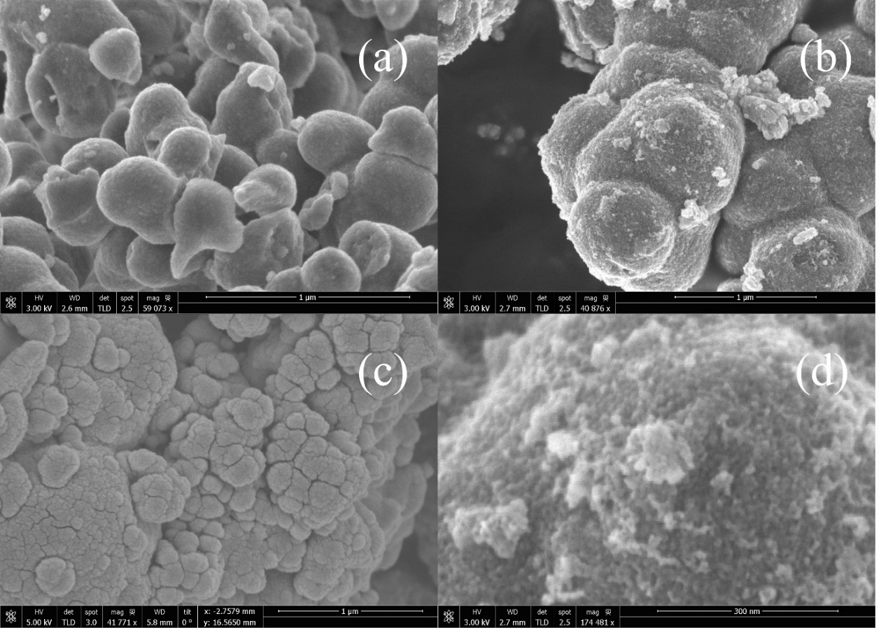
300 nm
1 μm
1 μm
1 μm
Figure 2: Scanning electron microscope images for (a) T1-E, (b) T1-I and (c) T1-B; (d) high magnification image for T1-I.

Figure 3:
Figure 3: Nitrogen absorption-desorption isotherms for samples prepared using titanium IV butoxide (T1) for (a) T1-E, (b) T1-I and (c) T1-B samples.

Figure 4:
Figure 4: In-depth X-ray photoemission spectroscopy analysis for (a) C 1s, (b) O 1s and (c) Ti 2p as obtained for sample T1-E

Figure 5:
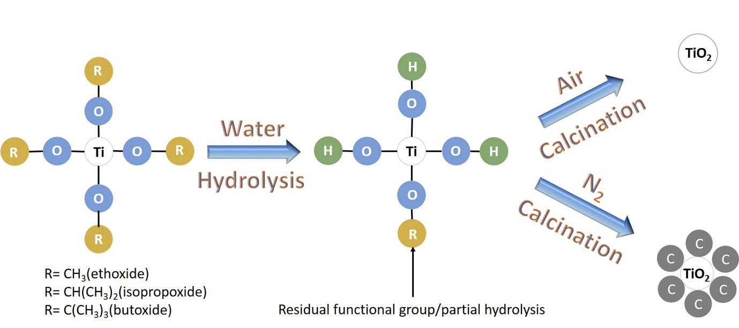
Figure 5: Schematic displaying the formation mechanism for TiO₂-C particles

Figure 6:
Figure 6: Raman spectra for samples prepared using titanium IV butoxide (T1). (Labels: A-Anatase, R-Rutile, C- Carbon)
Figure 7:
Figure 7: (a) time-dependent degradation profiles for all samples and control experiments and (b) corresponding natural log of degradation profiles (line of best fit provided as a guide for eyes only)

Figure 8:

Figure 8: Simultaneous TGA and DSC graphs as obtained for T1-E (a) amorphous and (b) calcined phases

Figure 9:
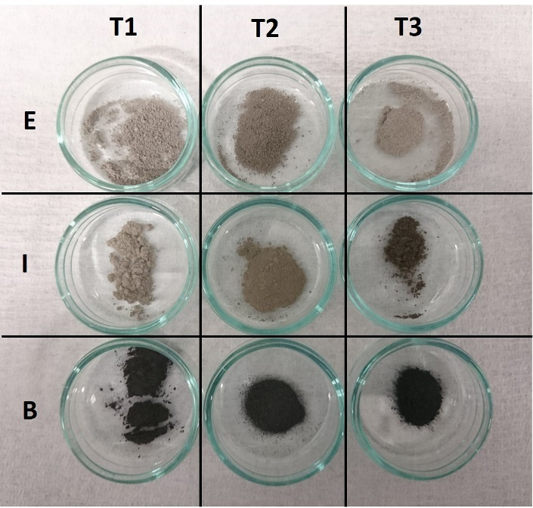
Figure 9: Optical photograph demonstrating the color of calcined samples

Figure 10:
Figure 10: Diffuse reflectance spectroscopy graphs for samples prepared using titanium IV butoxide (T1) and commercial titania.

Tables:
Table 1: Sample codes used in this work
Sample code | Precursor | Solvent
T1-E | Titanium (IV) butoxide | Ethanol
T1-I | Titanium (IV) butoxide | Isopropanol
T1-B | Titanium (IV) butoxide | Butanol
T2-E | Titanium isopropoxide | Ethanol
T2-I | Titanium isopropoxide | Isopropanol
T2-B | Titanium isopropoxide | Butanol
T3-E | Titanium (IV) ethoxide | Ethanol
T3-I | Titanium (IV) ethoxide | Isopropanol
T3-B | Titanium (IV) ethoxide | Butanol

Table 2: Experimental matrix summarizing the key quantifiable results obtained in this study.
Sample | Surface area  (m².g⁻¹) | Crystallite size  (nm) | Rate constant k  (min⁻¹) | Surface-area normalized k (min⁻¹.m⁻²) | Weight loss  (%)
T1-E | 4.85 | 4.02 | 0.088 | 0.018144 | 2.3
T1-I | 96.84 | 1.59 | 0.101 | 0.001043 | 4.0
T1-B | 2.33 | 4.35 | 0.035 | 0.015021 | 0.54
T2-E | 4.37 | 5.83 | 0.044 | 0.010069 | 1.32
T2-I | 12.33 | 3.89 | 0.055 | 0.004461 | 0.76
T2-B | 2.25 | 4.57 | 0.030 | 0.013333 | 0.63
T3-E | 4.05 | 8.16 | 0.047 | 0.011605 | 3.4
T3-I | 2.44 | 8.02 | 0.022 | 0.009016 | 0.5
T3-B | 1.33 | 5.03 | 0.012 | 0.009023 | 0.5

