DOI: 10.1002/((please add manuscript number))
Article type: Communication

Dynamic- and Light-Switchable Self-Assembled Plasmonic Metafilms

Sean Cormier, Tao Ding*, Vladimir Turek and Jeremy J. Baumberg*

S. Cormier, Prof. Tao Ding, Dr. V. Turek, Prof. Jeremy J. Baumberg
NanoPhotonics Centre, Cavendish Laboratory, University of Cambridge, Cambridge, CB3 0HE, United Kingdom
E-mail: jjb12@cam.ac.uk
Prof. Tao Ding
School of Physics and Technology, Wuhan University, Wuhan, 430072, China
E-mail: t.ding@whu.edu.cn

Keywords: gold, poly(N-isopropylacrylamide), metafilm, metamaterial, composite metallo-dielectric

Large-area dynamic switchable plasmonic metafilms composed of a network of gold nanoparticles (Au NPs) and the thermo-responsive polymer poly(N-isopropylacrylamide) (PNIPAM) are self-assembed by casting Au@PNIPAM core-shell nanoparticles. These dense plasmonic films present an unusual optical behaviour arising from the macroscale effective medium response of the film and the microscopic interactions of the gold nanoparticles. Such intensely-coloured plasmonic metafilms can be thermally actuated on large areas via direct heating, allowing extraction of how the effective dielectric permittivity of this metamaterial is tuned. By contrast, local plasmonic heating by illuminating the Au NPs in these metafilms enables sub-second and highly reversible contraction of the plasmonic metafilms, capable of pumping water. This work provides an paradigm for switchable metafilms and metasurfaces that can be harnessed for different applications such as sensing, imaging optics, and image displays.

Thin-films composed of organized sub-wavelength optically-resonant nanostructures produce unusual optical properties. Known as meta-surfaces or meta-films, they are capable of delivering ultrathin optical components such as high-numerical-aperture lenses,^{[1]} achromatic gratings,^{[2]} holographic images,^{[3]} and mode filters.^{[4]} Typically, their fabrication utilizes lithography of high refractive index semiconductor or metallic components, producing elements operating in the near-IR spectral region. A major challenge is to create tunable versions of these meta-films, thus capable of real-time optimisation and controllable performance, of tremendous utility for applications from biomedicine to displays. Although electrical gating of inorganic materials is being explored using top-down processing,^{[5-7]} the application of metamaterials in devices operating at optical frequencies has been hindered by high losses, high dispersion, and complex lithographic fabrication with features at subwavelength scales. The cost of such devices can be greatly reduced by exploiting the optical resonances of large-area self-assembled plasmonic nanoparticles, however their actuation has been problematic as they consist of noble metals combined with dielectrics.^{[8-10]}

The integration of stimuli-responsive soft materials, such as polymers and liquid crystals, can bring about significant changes in size, geometry, and refractive index.^{[11]} Since the optical properties of the interacting plasmonic particles are highly sensitive to the interparticle separation, strong colour changes can be achieved by harnessing these polymers to tune the spacing between particles. Optical switching of the plasmonic systems is especially interesting because it allows for development of more complex integrated plasmonic systems that can be optimised in real time. Plasmonic particles have high absorption cross-sections and thus efficiently convert irradiation into heat. Much research has thus explored combinations of plasmonic nanoparticles and temperature-responsive polymers.^{[12-14]} In particular, there has been strong interest in using poly(N-isopropylacrylamide) (PNIPAM), a well-studied thermo-responsive polymer with a lower critical solution temperature (LCST) around 32 °C in aqueous solution. PNIPAM undergoes a phase transition to a hydrophobic state when the temperature is raised above the LCST, causing the polymer chains to contract. Upon cooling below the LCST, PNIPAM becomes hydrophilic and the chains extend into the water.

This PNIPAM phase transition has been used in colloidal, 2D, and 3D structures for switchable SERS detection,^{[15-17]} drug delivery,^{[18]} tunable colour,^{[19-21]} and micro-actuation.^{[22]} However almost no work has explored light-tunable plasmonic thin-films or meta-surfaces consisting of gold nanoparticles (AuNPs) using this thermo-responsive actuation. A volume phase transition of gold nanorod-embedded PNIPAM hydrogel micro-cylinders was studied under near-infrared irradiation,^{[22]} but showed rather slow response times $\sim$20 seconds. Other studies on AuNP-PNIPAM composite films have focused on 2D nanoparticle mats assembled at liquid-liquid interfaces,^{[19]} and superlattices formed with >50nm-thick PNIPAM shells, thicker than useful for AuNP plasmonic coupling,^{[21]} for which light-induced actuation remains unexplored.

Here we show a simple method to form large area thermo-responsive plasmonic films which achieve the fastest switching time reported for large-area composite metafilms, and exhibit fully reversible dynamic colour changes. Their dried optical properties are studied by casting them on silicon substrates, while deposition onto water-permeable porous membranes allows characterisation of their fast switching.

Methods
Au@PNIPAM particle synthesis: Au@PNIPAM particles are prepared via the ligand exchange method. The 16 nm AuNPs are synthesized using Turkevich's method.^{[23, 24]} Briefly, an 86 mg L⁻¹ aqueous solution of gold(III) chloride trihydrate (≥99.9% trace metal basis, Sigma Aldrich) is stirred and heated to steady-state reflux conditions and then 200 mg L⁻¹ of trisodium citrate dehydrate is added quickly. The trisodium citrate dehydrate reduces and stabilizes the AuNPs at a diameter of 16±2 nm, confirmed by dynamic light scattering (Malvern ZetaSizer) and electron microscopy (Zeiss LEO 1530VP). The citrate-capping of the AuNPs is exchanged with PNIPAM by adding 20 µM of 5.5 kDa NH₂-terminated PNIPAM (Sigma-Aldrich) whilst heating at 40 °C. The successful ligand exchange is clearly identified by the heat-induced reversible colour-change of the Au@PNIPAM particle solution from red to violet as reported in detail elsewhere.^{[25]}

Film preparation: The Au@PNIPAM films are prepared by highly concentrating the Au@PNIPAM particle solution using two centrifugation steps and then casting. The synthesized Au@PNIPAM particle solution is spun at 14,500 rpm in a micro-centrifuge (Eppendorf miniSpin) for 10 min and the supernatant is decanted. Chloroform is added to the centrifuge tube, which is immiscible with the aqueous Au@PNIPAM particle solution. A subsequent centrifugation at 14,500 rpm for 10 min forces the Au@PNIPAM particles into the chloroform phase. After decanting the aqueous phase, the chloroform phase is dried. The resulting dried Au@PNIPAM particles are redispersed in chloroform for casting on silicon wafers and aluminium oxide membranes (Whatman Anodisc, 0.02 µm pore size).

Characterisation: The dried structure of the Au@PNIPAM films is characterized with electron microscopy. Focused ion beams are used to mill wedge structures in the films for cross-sectional electron imaging. Prior to imaging, the films are coated with 100 nm of gold by e-beam evaporation and in situ 80 nm of platinum by ion-beam-induced gas deposition. The gold layer serves to reduce charging during imaging and the platinum improves the perpendicularity of the cross-section. The milling and imaging are both performed in an FEI Helios NanoLab instrument.

The reflectivity of the films is measured with a customized Olympus BX51 microscope equipped with a 50 µm fibre-coupled QE65000 Ocean Optics spectrometer, a single-mode fibre-coupled 447 nm continuous wave laser, and a Prior translation stage, which are automated. This laser wavelength can be conveniently filtered out to allow real-time monitoring of the local film reflectivity at longer wavelengths. The temperatures of the films deposited on aluminium oxide membranes are precisely regulated by heating the water below the samples with a hot stage (TMS 92, Linkam). For studying the light-induced response of the films, the laser power is electronically controlled and calibrated. A $λ$>500 nm long pass filter is used to remove the scattered laser from the light collected by the spectrometer.

Results and Discussion
We first look at the optical properties of dried Au@PNIPAM metafilms on silicon substrates (Figure 1). These are composed of randomly dispersed AuNPs in a dry non-crosslinked PNIPAM matrix (Figure 1a). The reflected colour differs considerably from the colour of the constituent parts. Notably, the surface appears bright green (inset Figure 1a) while the 16 nm Au@PNIPAM particles in solution are dark red and PNIPAM films are transparent. This coloured reflection arises from the interface between air and an effective medium of AuNP@PNIPAM particles randomly dispersed on a scale much smaller than the wavelength of visible light, forming a meta-material. The cross section of the dried Au@PNIPAM films (Figure 1b) clearly resolves a uniform film with densely packed AuNPs inside the PNIPAM matrix.

The reflection spectrum of the Au@PNIPAM film on a silicon substrate shows a broad peak around 580 nm, which is not easy to reconcile with any combination of spectra from PNIPAM, bulk gold, and AuNPs (Figure 1c). This peak can however be reproduced using a Maxwell-Garnett (MG) effective medium model (red line). This simplifying approximation applies to optical systems with uniform spherical inclusions randomly dispersed inside a matrix with different refractive index.^{[26,27]} The effective permittivity of the film, $ε_{eff}$, is determined by the permittivity of the film matrix, $ε_{m}$, the interstitial particles,$ε_{i}$, and relative volume fill fraction, $f_{i}$, of the particles in the film,

$$ε_{eff}= ε_{m}\frac{2f_{i}\left(ε_{i}-ε_{m}\right)+ε_{i}+2ε_{m}}{2ε_{m}+ ε_{i}+f_{i}(ε_{m}-ε_{i})} (1)$$

The resulting optical properties of the Au@PNIPAM film are controlled by its thickness, gold fill fraction and PNIPAM refractive index. Our modelling (Figure 1c) shows the close packed film has $f$=16%, implying a mean AuNP@PNIPAM separation of 5.3nm, and thus a PNIPAM coating thickness of $\sim$3nm (when dry).
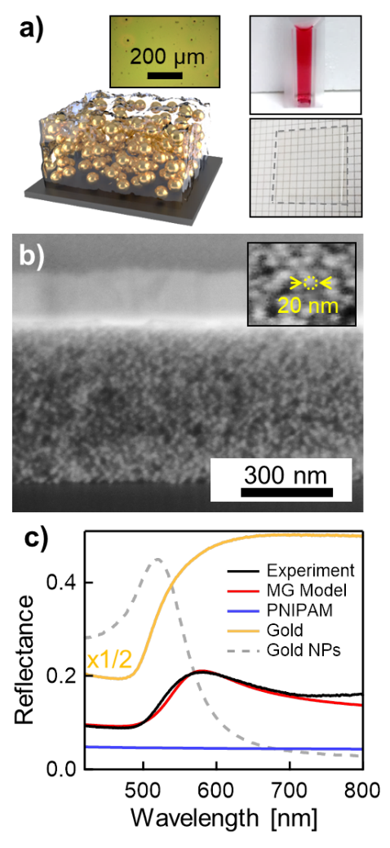
Figure 1. Dried Au@PNIPAM film. (a) Schematic of dried Au@PNIPAM film on silicon substrate. Insets: (top-left) bright field image of Au@PNIPAM film (20X magnification, 0.45 NA), (top-right) photo of Au@PNIPAM NPs in cuvette, (bottom) photo of PNIPAM film on glass substrate without AuNPs (within dashed area, 2 mm grid). (b) Scanning electron microscope (SEM) image of a thin-film cross-section milled with a focused ion beam, captured at 54° vertical tilt. Inset: Expanded SEM image of the film cross-section with a single nanoparticle circled with a dashed line. (c) Reflection spectra of Au@PNIPAM (black), gold (yellow) and dry PNIPAM (blue) films, together with fitted Maxwell-Garnet (MG) effective medium model (red, see text) with $f$=16% gold fill fraction. Dashed curve is the normalized extinction curve of 16 nm Au NPs.

Reducing the gold fill fraction and total film thickness allows incident light to pass through the film and efficiently reflect back, giving rise to thin-film interference effects. A low fill-fraction Au@PNIPAM film on silicon is prepared by tripling the concentration of PNIPAM to increase the coating thickness on the AuNPs (Figure 2). Spectral line scans across the film (Figure 2a) clearly show periodic microcavity modes from the interference of light reflected from the top and bottom of the Au@PNIPAM layer. These interference bands are well fit using the Maxwell-Garnett effective medium approximation and Rouard’s method for solving the optical response of thin-films (Figure 2b).^{[28]} The gold fill fraction of the film is determined by fitting the position of the constant reflection band around 570 nm where strong absorption and scattering prevent thin-film interference effects with the MG model. Both the position and width of the reflection band depends on the gold fraction as shown in Figure 2c, giving $f$=3.5%, implying a mean AuNP@PNIPAM separation of 14.1nm, and thus a PNIPAM coating thickness of $\sim 7$nm as expected from the modified protocol. The measurements consistently show broadened peaks which can only be modelled by introducing an additional small extinction coefficient in the polymer matrix ($Im\{n\}=0.02)$. This correction is attributed to scattering from density fluctuations, observed directly from films of the dried polymer without AuNPs present. Increasing the thickness of the film shifts the interference modes in the spectra and decreases their separation (Figure 2d), allowing the film thickness to be precisely fit under the assumption that its refractive index remains independent of thickness. This system thus forms a 3D metallo-dielectric composite metamaterial, whose optical properties we will now show can be tuned.
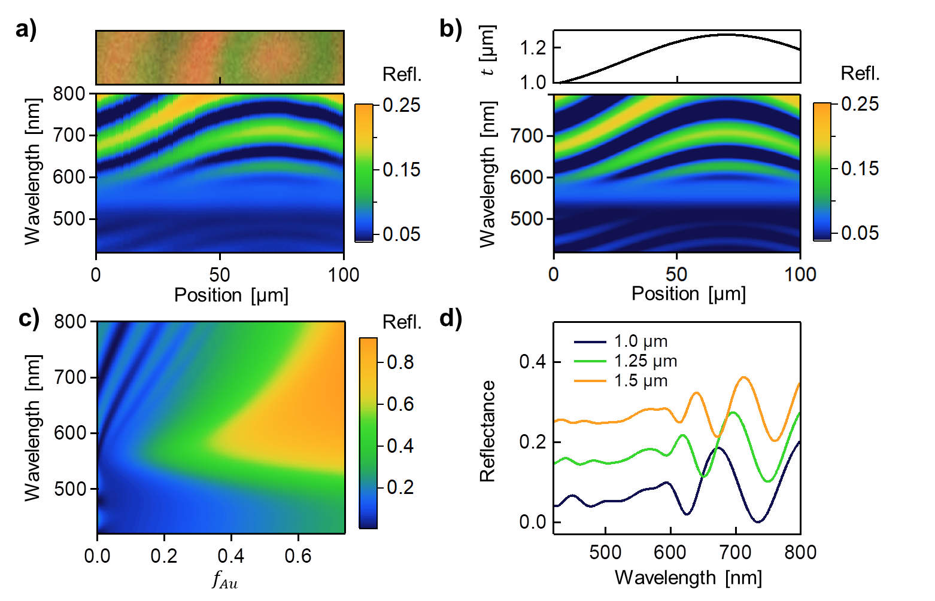
Figure 2. Reflectivity of low-$f$ Au@PNIPAM thin-films. (a) Experimental line scans of bright-field reflectivity spectra along the Au@PNIPAM film surface, image of scanned area shown above. (b) Thin-film model with MG effective medium model for Au@PNIPAM film using gold fill fraction, $f_{Au}$=3.5%, and fitted thickness, $t,$ profile shown above. (c) Reflectivity model of Au@PNIPAM thin-films as a function of $f_{Au}$ for a thickness of 1 µm. (d) Modelled reflectivity of films with 1.0, 1.25, and 1.5 µm thicknesses and $f_{Au}$=3.5%. Spectra are vertically offset.

PNIPAM exhibits temperature-induced volume changes only in aqueous solution. The Au@PNIPAM films are thus deposited on porous aluminium oxide membranes that are water permeable but impermeable to the nanoparticles (Figure 3). The membranes are then placed on top of a water reservoir, ensuring the top surface of the sample is not covered by water, in order to prevent dissolution of the non-crosslinked Au@PNIPAM films. Cycling the temperature of the water reservoir above and below the LCST of PNIPAM, correspondingly expels and absorbs water out of/into the Au@PNIPAM film from the reservoir below (Figure 3a). This swelling and collapse of the films give a strong optical response. Thin-film interference is not observed for these films as the underlying aluminium oxide membrane is highly optically diffusive. The change in colour of the films is thus a result of changing the interparticle distance of the plasmonic AuNPs. Upon heating the water reservoir, the peak reflectivity red shifts from $\sim$570 nm to $\sim$600 nm and the scattering strength doubles (Figure 3b) as the PNIPAM collapses, reducing the AuNP separation thus strengthening the coupling between the AuNPs, as well as increasing the refractive index of the PNIPAM matrix from 1.33 to 1.42.^{[29]} In addition to the strong colour change, the film also undergoes a change in reflection amplitude due to the increase in effective refractive index of the composite film upon heating. This thermal-induced colour change of the plasmonic metafilms is reproducible (Figure 3c) as seen by tracking the resonance peak over several heating and cooling cycles.
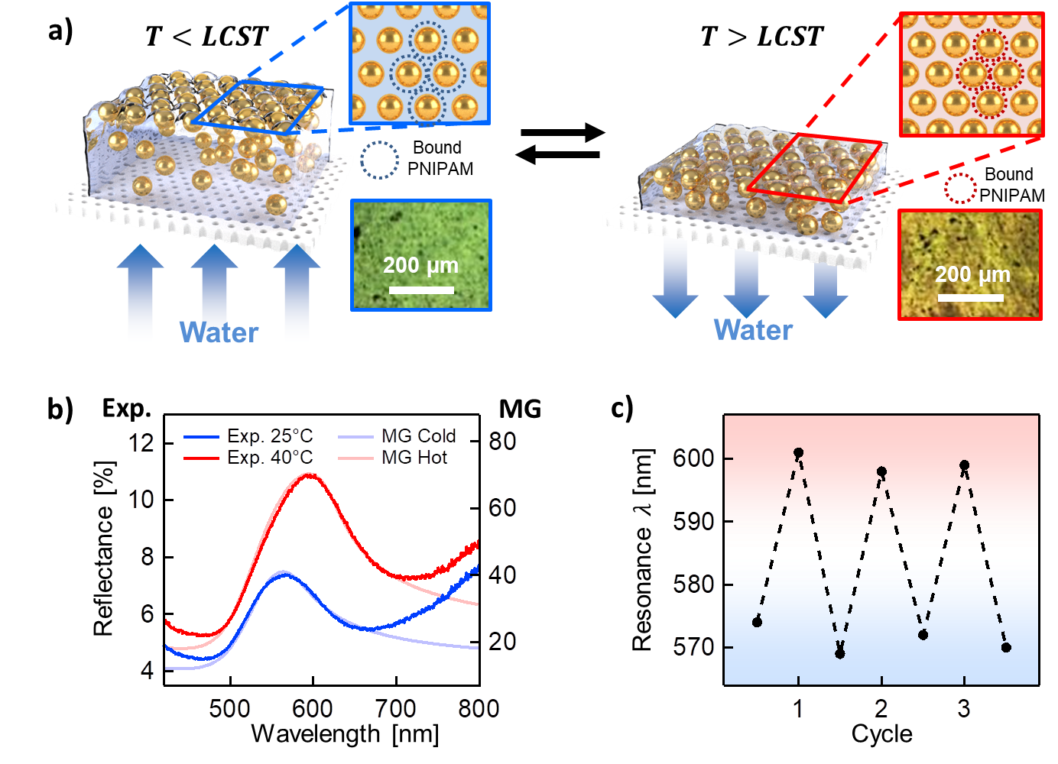
Figure 3. Temperature response of Au@PNIPAM films on porous anodized aluminium membranes. (a) Schematic of Au@PNIPAM film actuation in response to temperature cycling, corresponding microscope images to lower-right (5X magnification, 0.15 NA). (b) Reflection spectra of Au@PNIPAM film above and below the LCST, with MG fits plus background scattering contributions. (c) Peak resonance shifts over several temperature cycles from 25°C to 40°C.

These experiments thus allow the effective refractive indices and gold fill fractions to be extracted for metafilms in expanded and collapsed states. The MG model is used to fit the observed reflectance and extract information on the composition of the films. The peak positions and shapes fit well (Figure 3b), but do not capture the tails of increased reflectance attributed to additional scattering from the porous aluminium oxide membrane. The model implies that the fill fraction of gold is significantly higher when the film is wet, although the reflected intensity peak is smaller than expected from the model (likely due to diffusive scattering losses from the rough substrate). The gold fill fractions are $\sim$35% for the swollen state and $\sim$50% for the collapsed state, suggesting AuNP mean separations of 2.3 nm and 1.1 nm. Accounting for these results suggests that a very dense, nearly close-packed layer of AuNPs accumulates at the air-film interface and dominates the reflectance of the wetted films. Using these MG model results, provides the effective complex refractive index of the switchable metafilms in the swollen (cold) and contracted (hot) states (Figure 4). Both real and imaginary parts roughly double, with $n$>6 on resonance in the hot collapsed state. We however note that at the high fill fractions in this top layer, the MG formalism is less reliable, but analytic models are not yet available for such random metafilm organisation.
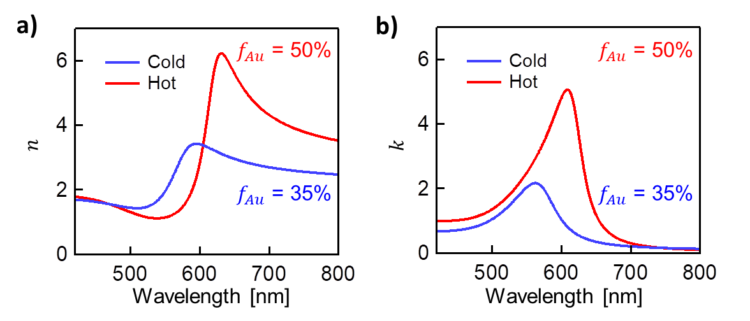
Figure 4. Maxwell-Garnett model of effective metafilm complex refractive index. Extracted effective (a) real and (b) imaginary parts of refractive index at temperatures above (hot) and below (cold) the LCST of 32°C.

The colour change in response to global heating is relatively slow due to the time required to heat and passively cool the entire water reservoir below the film. In order to improve the switching speed of the films, plasmonic heating is used. Cycling the 447 nm laser irradiation causes the film to rapidly collapse and swell. Light-induced heating occurs locally at the beam spot without heating the water reservoir, reducing the switching time from minutes to milliseconds compared to global heating. Here we define the switching time as the time elapsed between 10-90% of the full optical changes either from the swollen state to the collapsed state or vice versa. The metafilm now acts as a light-driven water pump, expelling the water on heating above the LCST via the enhanced optical cross section of the AuNP metafilm, and sucking back in the water on cooling.

The transition of the film is clearly observed with laser power (Figure 5). Due to the large absorption cross-section of these dense nanoparticle films, powers densities as low as 0.5 W/cm² induce resonance shifts >20 nm and double the reflectivity in the red (Figure 5a). The switching of the peak reflection during cycling is highly robust. We see full recovery of the films after irradiation (Supporting Information, Figure S1). Six cycles of laser switching every 30 seconds demonstrates this reproducible shifting of peak reflectivity (Figure 5b), from 554±1 nm (dark) to 585±3 nm. The redshift timescale after switching on the laser is sub-second, while the recovery of the film when the laser is switched off is slower (of order seconds). The discrepancy between the rates of contraction and recovery can be understood in terms of the molecular kinetics of water expulsion from the swollen PNIPAM matrix and its re-absorption back into the contracted PNIPAM matrix. Large pores in the swollen PNIPAM matrix allow water to quickly escape the matrix as the metafilm contracts, whereas the smaller pores in the collapsed PNIPAM matrix limit the rate of re-absorption during swelling. This suggests that further tuning of the pore microstructure of these composite films can further enhance their switching speeds.
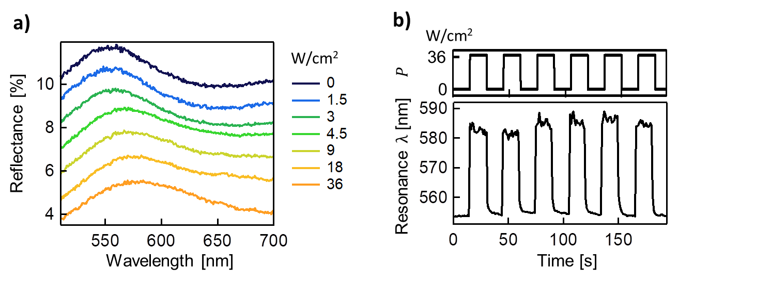
Figure 5. Light-induced actuation of the Au@PNIPAM films on porous anodized aluminium membranes. (a) Power dependence of Au@PNIPAM film reflectivity spectra under increasing 447 nm irradiation (spectra offset for clarity). (b) Resonance peak wavelength shift metafilm reflection spectra over seven irradiation cycles at$P$=36 W/cm² with 447 nm light focused to a 42 µm diameter spot.

Conclusion
In summary, we demonstrate the ability to dynamically tune the reflectance of simply-deposited plasmonic metafilms by both direct heating and light-induced heating. Combining the coil-to-globule temperature response of PNIPAM with the plasmonic properties of Au NPs, we show the dynamic thin-film colouration of the composite metallo-dielectric metamaterial. Direct heating of the film results in complete actuation of the films, whereas light-induced heating enables local control of the film actuation. Furthermore, we demonstrate that porous membranes such as aluminium oxide can enable the wetting and de-wetting of such polymer-plasmonic particle composite films. This avoids complicated crosslinking of the gel and enables large swelling ratios and faster switching rates. The resulting changes in surface topography, roughness, and colour exhibited by these metafilms can be harnessed for applications such as large-scale tunable coloured wallpapers and coatings, and real-time switchable patterned surfaces such as for bioscaffolds or meta-lenses. In addition, such films hold significant potential for a variety of functional applications, such as temperature sensors, local wetting transformations, and for tunable SERS sensors.

Supporting Information
Supporting Information is available from the Wiley Online Library or from the author.

Acknowledgements
J.J.B. and T.D. conceived the idea, S.C. fabricated and characterized the films. All authors contributed to the discussion, analysis, and writing up of this work. This research was supported by UK Engineering and Physical Sciences Research Council grants EP/G060649/1 and EP/L027151/1, ERC grant LINASS 320503, and Leverhulme Trust (ECF2016-606). The authors acknowledge the Cavendish Laboratory Electron Microscopy Suite for their support and expertise. T.D. thanks the support of start-up grant from Wuhan University and 1000-talents Programme (Youth) from Chinese government. S.C. is grateful for the support from the Winton Programme for the Physics of Sustainability.

References:
[1] X. Zhang, Z. Liu, Nat. Mater. 2008, 7, 435.
[2] M. Khorasaninejad, F. Capasso, Nano Lett. 2015, 15, 6709.
[3] X. Li, L. Chen, Y. Li, X. Zhang, M. Pu, Z. Zhao, X. Ma, Y. Wang, M. Hong, X. Luo, Sci. Adv. 2016, 2, 11.
[4] V. A. Fedotov, J. Wallauer, M. Walther, M. Perino, N. Papasimakis, N. I. Zheludev, Light. Sci. Appl. 2015, 4, 306.
[5] J. Lee, S. Jung, P.-Y. Chen, F. Lu, F. Demmerle, G. Boehm, M.-C. Amann, A. Alù, M. A. Belkin, Adv. Opt. Mater. 2014, 2, 1057.
[6] Y.-W. Huang, H. W. H. Lee, R. Sokhoyan, R. A. Pala, K. Thyagarajan, S. Han, D. P. Tsai, H. A. Atwater, Nano Lett. 2016, 16, 5319.
[7] S. Kim, M. S. Jang, V. W. Brar, Y. Tolstova, K. W. Mauser, H. A. Atwater, Nat. Commun. 2016, 7, 12323.
[8] F. Huang, S. Drakeley, M. G. Millyard, A. Murphy, R. White, E. Spigone, J. Kivioja, J. J. Baumberg, Adv. Opt. Mater. 2016, 4, 328.
[9] K. J. Si, D. Sikdar, Y. Chen, F. Eftekhari, Z. Xu, Y. Tang, W. Xiong, P. Guo, S. Zhang, Y. Lu, Q. Bao, W. Zhu, M. Premaratne, W. Cheng, ACS Nano 2014, 8, 11086.
[10] J. B. Edel, A. A. Kornyshev, A. R. Kucernak, M. Urbakh, Chem. Soc. Rev. 2016, 45, 1581.
[11] I. Tokarev, S. Minko, Soft Mat. 2009, 5, 511.
[12] I. Tokarev, S. Minko, Soft Mat. 2012, 8, 5980.
[13] M. Nguyen, N. Felidj, C. Mangeney, Chem. Mater. 2016, 28, 3564.
[14] W. Lewandowski, M. Fruhnert, J. Mieczkowski, C. Rockstuhl, E. Górecka, Nat. Commun. 2015, 6, 6590.
[15] M. Nguyen, A. Kanaev, X. Sun, E. Lacaze, S. Lau-Truong, A. Lamouri, J. Aubard, N. Felidj, C. Mangeney, Langmuir 2015, 31, 12830.
[16] R. Contreras-Cáceres, J. Pacifico, I. Pastoriza-Santos, J. Pérez-Juste, A. Fernández-Barbero, L. M. Liz-Marzán, Adv. Funct. Mater. 2009, 19, 3070.
[17] H. Gehan, L. Fillaud, M. M. Chehimi, J. Aubard, A. Hohenau, N. Felidj, C. Mangeney, ACS Nano 2010, 4, 6491.
[18] M. Nguyen, X. Sun, E. Lacaze, P. M. Winkler, A. Hohenau, J. R. Krenn, C. Bourdillon, A. Lamouri, J. Grand, G. Lévi, L. Boubekeur-Lecaque, C. Mangeney, N. Félidj, ACS Photonics 2015, 2, 1199.
[19] T. Ding, A. W. Rudrum, L. O. Herrmann, V. Turek, J. J. Baumberg, Nanoscale 2016, 8, 15864.
[20] T. Ding, C. Rüttiger, X. Zheng, F. Benz, H. Ohadi, G. A. E. Vandenbosch, V. V. Moshchalkov, M. Gallei, J. J. Baumberg, Adv. Opt. Mater. 2016, 4, 877.
[21] M. Karg, T. Hellweg, P. Mulvaney, Adv. Funct. Mater. 2011, 21, 4668.
[22] A. Shiotani, T. Mori, T. Niidome, Y. Niidome, Y. Katayama, Langmuir 2007, 23, 4012.
[23] J. Kimling, M. Maier, B. Okenve, V. Kotaidis, H. Ballot, A. Plech, J. Phys. Chem. B 2006, 110, 15700.
[24] J. Turkevich, P. C. Stevenson, J. Hillier, J. Phys. Chem. 1953, 57, 670.
[25] T. Ding, V. K. Valev, A. R. Salmon, C. J. Forman, S. K. Smoukov, O. A. Scherman, D. Frenkel, J. J. Baumberg, Proc. Nat. Aca. Sci. 2016, 113, 5503.
[26] J. C. M. Garnett, Phil. Trans. R. Soc. A 1904, 203, 385.
[27] O. Zhuromskyy, Crystals 2017, 7, 1.
[28] P. Lecaruyer, E. Maillart, M. Canva, J. Rolland, Appl. Opt. 2006, 45, 8419.
[29] B. W. Garner, T. Cai, S. Ghosh, Z. Hu, A. Neogi, Appl. Phys. Express. 2009, 2, 057001.

The Au@PNIPAM films show large-area, reversible tunability in reflectance by direct- and light-induced heating of a few degrees Celsius. Combining the coil-to-globule phase transition of the thermo-reponsive polymer PNIPAM and the plasmonic properties of gold nanoparticles, we demonstrate dynamic thin-film colouration of a composite metallo-dielectric metamaterial.
Sub-second switching rates are found for these plasmonic smart polymer composite films.

Keywords: gold, poly(N-isopropylacrylamide), metafilm, metamaterial, composite metallo-dielectric

S. Cormier, T. Ding*, V. Turek and J. J. Baumberg*

Dynamic- and Light-Switchable Self-Assembled Plasmonic Metafilms

TOC figure:
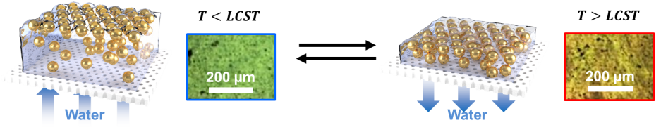

Copyright WILEY-VCH Verlag GmbH & Co. KGaA, 69469 Weinheim, Germany, 2016.
Supporting Information

Dynamic Switchable Self-Assembled Plasmonic Metafilms

Sean Cormier, Tao Ding*, Vladimir Turek and Jeremy J. Baumberg*

NanoPhotonics Centre, Cavendish Laboratory, University of Cambridge, Cambridge, CB3 0HE, United Kingdom
School of Physics and Technology, Wuhan University, Wuhan, 430072, China

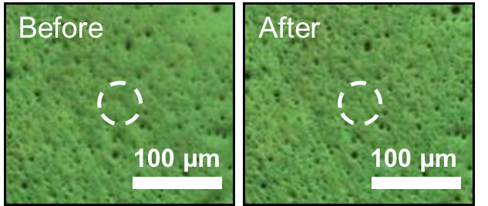
Figure S1. Images showing the recovery of the Au@PNIPAM films on porous anodized aluminium membranes before and after 1 min. exposure to 447 nm irradiation at 36 W/cm² (5X magnification, 0.15 NA). Overlaid white circles indicate the irradiated region.

