Frequency vs. Length of Hot Spots Patrols: A Randomized Controlled Trial

Simon Williams ‡
Timothy Coupe†

‡ Western Australia Police, Police Innovation & Improvement Division, 141, St Georges Terrance, Perth,
Western Australia, 6000 & Institute of Criminology, University of Cambridge, Sidgwick Avenue Cambridge
CB3 9DA UK
† Corresponding author, Institute of Criminology, University of Cambridge, Sidgwick Avenue Cambridge CB3 9DA UK

Plain Language Summary
This experiment compared two different patterns of foot or bicycle patrol by the same 7 officers at the same 7 “hot spots” of crime and disorder over 100 days in Birmingham, England’s third-largest city. With almost identical amounts of total patrol time each day, the sergeant who led the experiment found that there was 20% less crime and disorder on days when the patrol visits were longer but less frequent, compared to days in which the visits were more frequent but shorter. Without spending any more money or assigning any more officers, this local policing team carried out its own study to learn how it could prevent crime more effectively. One key element of the test was measuring patrols with GPS data from the officers’ body-worn radios. Enabling patrol sergeants to get access to GPS data on a daily basis could encourage many other experiments done in partnership with front-line officers.
Abstract
Research Question: Do shorter but more frequent patrol visits to the same crime hot spots reduce daily crime and anti-social behaviour (ASB) totals more effectively than less frequent but longer patrols, if the total time that police are present each day is held roughly constant?
Data: GPS measures from patrol officer body-worn radios tracked the time each officer spent within 7 geo-fenced crime “hot spots” of 150 X 150 metres, summing the number of both individual officer-minutes and patrol-minutes (with one or more officers present simultaneously) per day per hot spot, as well as number of visits and minutes per visit. Activity reports were used to detect the simultaneous presence of more than one officer, yielding the key independent variables of number and length of patrol visits in which one or more police officer was present. The dependent variable was total reports of crime and anti-social behaviour (ASB) identified within the hot spot boundaries each day of the experiment.
Method: All 7 hot spots of crime and ASB were randomly allocated each day to one of two patrol duration conditions for a period of 100 days (43 “short” visit days and 57 “long” visit days) between June and November 2015, with patrol time measures reported back to officers on the number and length of patrols conducted daily. The “long visit” model required three visits daily of 15 minutes duration each; the “short visit” model required nine visits daily of five minutes each. On all days, a target of 45 minutes of total patrol time was required.
Results: Actual patrol delivery measured by GPS and activity reports produced a mean of just over 24 patrol minutes (of one or more officers present) on “long” days and just under 26 minutes on “short” days, so that dosage was approximately held constant to test the independent effect of more or fewer visits. The treatment as delivered on “long” days was a mean of 2.5 visits averaging 9.6 minutes each; on “short” days the same officers delivered a mean of 5 visits averaging 5.2 minutes each. The less-frequent “long visit” model was more effective than the more-frequent “short visit” model, with mean counts of crime and ASB incidents 19.51% lower on long visit days = 0.697 incidents per day compared to 0.561 incidents per day on short visit days (d = -.175; p = .018).
Conclusion. Controlling for the total patrol time spent at a hot spot each day, the difference between 2.5 longer visits and 5 shorter visits causes about 20% less crime when longer visits are delivered. These findings of the deterrent effect of increasing patrol visit length by 85% are consistent with Koper’s (1995) correlational observation that longer units of 10-15 minutes duration appeared optimal in creating a residual deterrent effect at a hot spot immediately after police leave the vicinity. Although this study cannot distinguish between crime reductions immediately after vs. long after police have left the scene, this is the first experiment to randomly assign a substantial difference (twice as many) in the number of visits daily to a hot spot, with almost twice as much time per visit when fewer visits are made. The use of random assignment of two different patrol models with the same total time in the same 7 geographic units gives great confidence that using that time in fewer visits of longer duration causes less crime and anti-social behaviour than more visits of shorter duration.
Key Words: Hot Spots, Foot Patrol, Policing, Deterrence, Evidence-Based-Policing, Residual Deterrence

Introduction
It is now widely accepted that, put crudely, placing more cops on the “dots” of high crime locations reduces crime and anti-social behaviour (ASB) at hot spot locations of crime. The growing body of research into hot spots policing and its overall success in reducing crime and disorder has been attributed to deterrence theory (Sherman & Weisburd, 1995; Nagin, 2013; Sherman et al., 2014). Put simply, deterrence is a combination of certainty of apprehension, severity of punishment and celerity (swiftness) in being brought to justice. Beccaria (1763) and Bentham (1948) long ago theorised that to deter crime, the cost had to outweigh the benefits, the risk of apprehension had to be certain and the severity of punishment had to be great and swiftly imposed (Ratcliffe, et al., 2013). However, increasingly severe punishments over time may have contributed comparatively less to the aggregate deterrent effect of the criminal justice system (Durlauf & Nagin, 2011).
What appears far more promising is the increased certainty of apprehension communicated by having police increase patrol time in places where crime is most likely to occur (Sherman and Weisburd 1995). A Campbell Collaboration systematic review (Braga et al., 2012) confirms an earlier review by Weisburd & Eck (2004) that hot pots policing is effective in reducing crime and disorder. Although it is worth stating that whilst not every hot spot study has yielded statistically significant results, the majority report noteworthy reductions in crime and ASB.
What no review of hot spots tests has been able to address, however, is the difference that duration vs. frequency of hot spot patrols can make in the amount of crime prevented, especially when police are not present—which is most of the time. Few studies have even measured exact amounts of total police presence in relation to crime prevention. Koper (1995) discovered a curve of increased deterrence after police leave in relation to increasing length of each visit (up to 15 minutes), but could not control for total patrol time at each hot spot. Only Ariel et al (2016) and Mitchell (2017) have measured both number of visits and the total time of patrols, both in correlational, non-experimental analyses. No previous study has randomly assigned more visits of shorter length compared to fewer visits of longer length, while holding total patrol time constant at each hot spot. That is the central question of this study.

General Hypothesis
Based on Sherman’s (1990) theory of police crackdowns, one might predict that shorter but more frequent patrols of hot spots will result in greater deterrence of street crime and ASB calls for service when compared to longer but less frequent patrols. Shorter but more frequent patrols, such as 5 minutes in length conducted 9 times during a shift compared with longer less frequent patrols of 15 minutes conducted 3 times during a shift would create more of what Sherman (1990) called “initial deterrence” with every new police arrival—9 versus 3 chances for initial deterrence. Shorter patrols might arguably allow less time for what Sherman calls “deterrence decay” to kick in, so that there would be less crime. Recent evidence from the Peterborough foot patrol experiment (Ariel, et al. 2016) suggests, contrary to the implications of the Koper Curve, that the frequency of visits may have more of an influential role in crime reduction than the length of each visit.
Hot Spot Policing & Patrol Dosage
The 1995 Minneapolis experiment (Sherman & Weisburd, 1995: 638) saw police double police patrol in treatment hot spots in comparison with controls, from an average of 7.5% to 15% of high-crime time, with a reported statistically significant reduction in crime and disorder of up to an absolute difference of 13% and a relative reduction of 70%. As the first hot spots experiment, it remains the only experiment to have used live observers to record, analyse and report in detail time spent by officers actually patrolling a hot spot. Many other experiments or quasi-experiments (see Braga, 2012) have used directed patrols, but only three have reported any precise measures of patrol time dosage (Sherman & Weisburd 1995; Telep et al 2014; Mitchell 2017). All three showed that more total patrol time caused less crime and ASB within the hot spots compared to hot spots with less measured patrol time.
Koper (1995) followed up the Sherman and Weisburd (1995) Minneapolis Hot Spot experiment by reanalysing data from 17,000 recorded observations of police patrol with the specific purpose of measuring residual deterrence and identifying the optimal time that patrol officers should spend in a hot spot. Survival analysis identified that each additional minute of time spent patrolling a hot spot resulted in a 23% increase in the amount of time before crime or disorder took place after officers had left. Survival time relates to the amount of time that a hot spot “survives” as crime-free between the officers’ departure from the hot spot to the point at which a criminal or disorderly event occurs. Koper found that 10 minutes of patrol dosage during each patrol visit to a hot spot was the critical threshold; this was the point at which residual deterrence benefits were greater than those generated by an officer driving through the hot spot. Koper found that the optimal patrol time in a hot spot was 14-16 minutes and, that after the 15 minute threshold had been passed there were diminishing returns in crime reduction. We know from this research that increased time beyond 16 minutes did not lead to greater improvements in residual deterrence. This phenomenon is often referred to as the “Koper curve” as graphing the duration response curve shows the benefits of increased officer time spent in the hot spot until a plateau point is reached at around 15 minutes Koper, 1995).
Although the Koper Curve’s contribution to hot spots policing is widely known, there is little discussed in relation to the frequency of visits to hot spots. Surprisingly, the closest approximations of a test of the ‘Koper Curve’ did not compare different lengths of patrol visits; they simply required all visits to be 15 minutes in length (Telep et al 2012; Ariel, et al, 2012, 2014, 2016) For example, a randomised, agency-directed field trial by the Sacramento Police Department identified 42 hot spots, matched them into 21 pairs, and randomly assigned one member of each pair treatment or control status for 90 days. In treatment hot spots officers randomly rotated between hot spots, spending about 15 minutes patrolling in each. The results in Sacramento show statistically significant reductions in crime and disorder in the 15-minute spots compared to the no-minute spots.
As well as the Telep, Mitchell and Weisburd (2012) Sacramento study, there have been other experiments conducted in the United Kingdom which have focused on the 15-minute recommendation from the Koper (1995) analysis of the Minneapolis (Sherman & Weisburd, 1995) experiment. In 2011, London Underground platforms were subject to 1 hour of directed patrol each day, where the hour of directed patrol was split into 15 minute patrols conducted four times per shift (Ariel, et al, 2012). The preliminary analysis of this study indicated that there was a 25% reduction in crime on treatment platforms compared to control platforms.
A further UK experiment by Ariel, et al. (2016) reports on a randomised control trial conducted in the city of Peterborough that utilised 15 minute patrols to target 34 treatment hot spots. This research sought to determine whether crime reduction effects of hot spot policing were dependant on the threat of warranted Police Officers (PC’s) versus non-warranted Police Community Support Officers (PCSO’s). PCSOs are non-warranted officers with limited police powers compared with their warranted police constable colleagues, their primary role being to provide reassurance, engagement and a visible on street presence to their local community. This experiment used PCSOs to deliver 15-minute patrols three times between the hours of 3pm and 10pm in treatment hot spots. Results showed that calls for service were reduced by 20% and public-generated crime reports were reduced by 39% when using increased PCSO patrols, even while regular Police Constable patrols were held constant. These results were achieved by PCSOs who delivered approximately two additional 10 minute patrols per day in treatment hot spots compared to controls. This finding leads us to our key question: is it frequency of visits or time spent on each visit that matters most?

Just as the Peterborough study (Ariel et al 2016) tested 15 minute patrols conducted 3 times each day in hot spots of crime and disorder, so did a similar UK experiment in South Birmingham (Ariel et al 2014) using 50 control and 50 treatment hot spots. This study targeted hot spots identified as High, Medium or Low in demand. The overall reduction of crime and disorder at medium and high hot spots was 40%, however at low frequency hot spots of crime and disorder there was a backfiring effect which saw a considerable increase in demand. However, when considering the available evidence of substantive hot spots research, the majority of experiments indicate that overall, more patrol leads to overall less crime (Ariel, et al, 2014)

Size and Identification of Hotspots
A hot spot is a geographic space in which there has been an increased concentration of crime, over time, per square foot relative to other space in the larger jurisdiction (Sherman, 2015). This is a very broad definition that answers the simple question; what is a ‘hot spot?’ However, is it clear that relative to each police agencies geography, its population and history of crime and disorder in that place, hot spots look and feel very different across the place based policing spectrum. ‘Hot spots’ or areas of land subject to disproportionate amounts of crime and disorder are described in the rich literature relating to hot spots as street segments, blocks, unique addresses or intersections or in more recent UK studies are defined by a certain size and number of crimes. Recent UK studies such as those in Birmingham (Ariel, 2014), Peterborough and London (Ariel, 2016) have all used a similar methodology where officers’ conduct 3 random 15 minute patrols during peak hours of demand at hot spots.
It is also important to be clear in our approach to place based, or hot spots policing, of what is not a hot spot of crime, this is particularly important when assessing the number of resources available to an agency to actually carry out targeted hot spot patrols. Weisburd, Groff and Yang (2012) discuss the significance of focusing resources into smaller ‘micro’ locations in contrast to larger areas, a common sense approach when considering deterrence theory and the Sherman et al (2014) definition of a hotspot; a place that the police can see the public and the public can see the police. These authors also warn against targeting larger geographic areas of crime and disorder as they may experience scattered resources that do not focus on those specific locations that drive local crime and ASB. In this research the definition of a hot spot is as follows: more than 75 street level crimes and calls for service that relate to anti-social behaviour must have occurred within the past two years and be contained within a 150m x 150m grid overlaying the West Midlands Police area. While the size of these hot spots may exceed what can be seen by one police officer standing in the centre of it, it is also big enough to generate crimes or ASB incidents on a weekly to bi-weekly basis. Whether that is “hot enough” is not a question that can be answered in theory; arguably it can only be answered by testing.
The phenomenon that crime and disorder is intensively grouped in small areas of space led to the discovery of the ‘law of concentration of crime in places’ as described by Weisburd, Telep & Braga (2010). If places were offenders then we would be describing the ‘power few’ offenders or what has been loosely described as the 80:20 rule in which 20% of the population are responsible for 80% of crime outcomes (Kock, 1999). This rule of the ‘power few’ holds true in the context of places, where relatively few hot spots produce most calls to the police. In the case of Minneapolis this figure was reported at 50% of calls in just 3% of places (Sherman, Gartin & Buerger, 1989).
In respect of this law of concentration of crime in place (Weisburd, Telep & Braga, 2010) it would be understandable to assume that identification of hot spots is a fairly simple process; one in which crimes and calls for service data is simply run through a mapping system which informs an agency of where they ought to focus their directed patrols. However, this is not the case. As Buerger, Cohn and Petrosino (1995) discuss, there are three main issues to overcome when operationalising the theoretical definition of a hotspot into meaningful police outputs. They categorise these issues as; the human techniques used in assigning crime activities to location, attribution of crime and calls for service to public or private locations and the conflict of boundaries that are generally distinct in computer mapping but imperceptible in field operations.
Recent hotspot studies in the U.K have used grid squares of 150 metres or polygons with a radius of 150 metres. Why? Because the purpose of targeted foot patrol in these studies was to increase visibility and accessibility to large audiences (Ariel, 2016). This approach allows officers a degree of discretion in where they patrol within the hot spot; most U.K hot spots are not grid-like in their layout but more a disordered jumble of linked streets, roads and cul-de-sacs. In addition to the issue of U.K geography and officer discretion, the methodology of using a street segment approach is more challenging as the number of identified hot spots would be diminished and the Sherman & Weisburd (1995) approach of seeing and being seen would also suffer. Despite the varying methods described in the literature on how hotspots are identified, it appears that the size of a hot spot does not change the overall pattern of the concentration of crime events in hot spots compared to the surrounding area (Ariel, 2016).
Setting & Context
The present report is on experiment conducted in Birmingham, UK, commonly referred to as the ‘second-city’ of England in reference to its standing compared with the capital city London. The greater Birmingham area is covered by four policing units, one of which was the setting for this experiment. The Perry Barr Sector area covers approximately a third of Birmingham West & Central (BWC) local policing unit (LPU) where one Inspector, four Sergeants, 47 Constables and Police Community Support Officers are responsible for delivering local policing. Perry Barr is located to the north-west of central Birmingham, in the heart of the West Midlands Police geographic force area. The area is policed by three Neighbourhood Policing Teams responsible for dealing with medium to long term issues of threat, risk and harm. Birmingham has a growing population of over 1.1 million residents (ONS News Release, July 2012). Perry Barr is one of the largest districts in both geographic size and boasts the most culturally diverse district within the West Midlands; black and minority ethnicity (BME) groups account for more than 50% of the community.
Implementation
This experiment began in June 2015 when 7 hot spots became treatment locations to test the difference between randomly allocated “long” (15-minute patrols) and “short” days (5-minute patrols). Additionally, separate control hot spots were also identified and randomly matched in pairs to the 7 treatment hot spots from the wider Birmingham West-Central Local Policing Unit. Control hot spots were used to provide a comparison of policing ‘business as usual’ against a high fidelity approach to patrolling treatment hot spots for 45 minutes each day. Local officers in control hot spots were given access to the same maps as treatment officers and were expected to patrol as outlined in the demand management policy described earlier. Yet because we lacked sufficient resources, we were not able to analyse GPS data by local officers in control locations generating hundreds of thousands of individual officer radio GPS ‘ping’ signals. The experiment we report took place entirely within the 7 “treatment” hot spots receiving additional resources for the 150-day period, in which two kinds of treatment were compared with identical people staffing the patrol operations.
On each of the 100 experimental days, the duty late shift local policing team received a brown A4 envelope containing a briefing pack for officers tasked with patrolling hot spots. This included a double sided A4 sheet stating the date, team expected to be on duty and the type of patrols to be conducted, i.e. 9 x 5 minutes (“short”) or 3 x 15 minutes (“long”). The packs also included a colour map of each hot spot location and activity sheets for officers to complete as they patrolled. The colour maps provided officers with the specific area to be patrolled and highlighted the top three crime and antisocial behaviour (ASB) locations by street address along with a breakdown of crime and ASB types driving demand. All officers were either on foot or on bicycles.
Figure 1: Treatment & Control Hot Spots across Birmingham West & Central
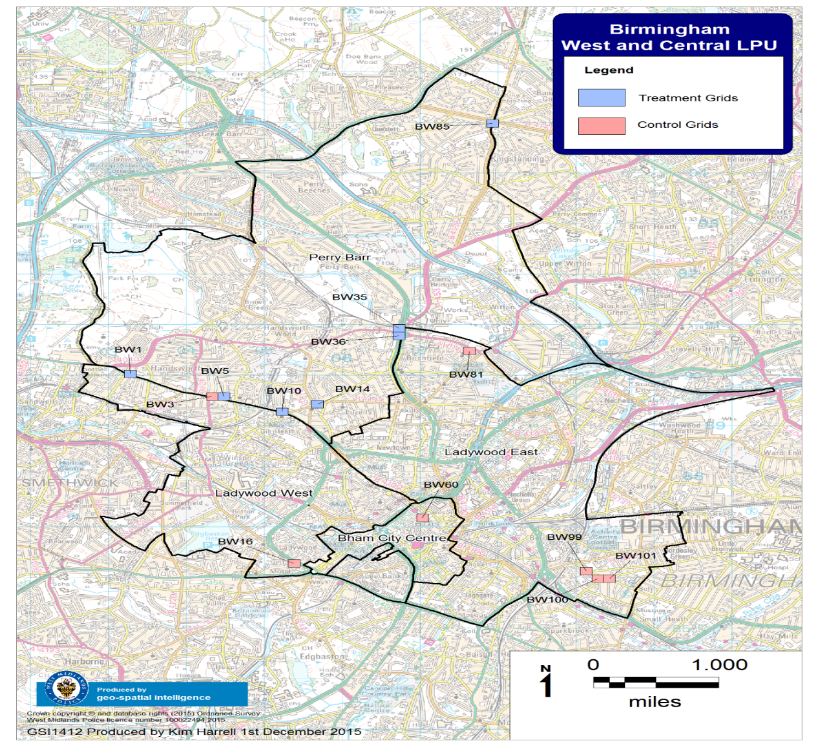

Independent Variable Differences
The 7 treatment hot spots received extra patrol for 150 days. Due to technical failures of GPS measurement, only 100 days survived with measurement of patrol time and visits. Of those 100 days, 43 had been randomly assigned to be “short;” 57 had been assigned to be “long.” For these 100 days, this section reports the treatment-as-delivered differences in an “intention-to-treat” (ITT) analysis that keeps each unit of analysis (the 24-hour day) in its originally assigned group—no matter what treatment was delivered, as is widely recommended for experimental analysis (Sherman 2010). The measures analysed include GPS data, officer activity reports, frequency and length of one-or-more-officers at any given time, and total officer-visits and their length.

Patrol Minutes vs. Officer Minutes Per Hot Spot
We faced a dilemma in reporting patrol dosage of average time spent and average number of visits made by officers to hot spots each day. While the conceptual framework envisions “Patrol minutes,” defined as minutes in which there was a patrol presence of one or more police officers, the GPS measures were made from individual officer radios, thus measuring total officer minutes. Had we not ‘double tracked’ officers using both GPS and their activity sheets we would have only reported on the GPS data. With both measures in hand, we can separately measure two officers entering a hot spot for half the required time, whose GPS data indicates that dosage is extremely close to the required amount, and total patrol time, that was half the required amount—which is a fair summary of what was delivered.
What we cannot do, empirically, is to determine whether the public, including potential offenders, who see two officers enter a hot spot together are any more deterred than by seeing one officer patrolling in the same area? Alternatively, is the condition of having two separate police officers in different parts of a 150 by 150 metre hot spot (not visible to each other) providing the same or twice as much deterrence? These questions can only be resolved by further research. What we can address here is the difference in describing the implementation of the independent variables, depending on whether we define the test as examining patrol minutes vs. officer minutes.
One of the most important questions to answer is that of patrol dosage and the level of compliance in both treatment conditions. During the course of this experiment we analysed over 200,000 individual GPS location ‘pings’ where officers had entered and then exited each hot spot. These pings were then filtered to officers responsible for hot spot patrolling, all other GPS pings were a result of normal policing. Using GPS data we are able to report that during 43 days of 5 minute patrols, officers conducted an average of 39 minutes and 42 seconds of officer-minutes per hot spot per day, resulting in an 86% compliance in expected dosage. There was an even greater degree of GPS compliance on 15 minute days where officers conducted an average of 42 minutes 51 seconds of officer-minutes per hot spot per day; a 93% dosage compliance. Thus using the officer-minute measure, these GPS findings suggest that compliance with the experimental design was very high.
However, the GPS analysis did not take into account officers being what UK police call “double-” or “single-crewed:” officers patrolling alone, in pairs, and sometimes in larger teams. In order to focus a tighter lens over patrol dosage compliance we applied over 2000 individual officer activity analysis returns to the GPS data, which provided a somewhat different result when we calculated the number of single and double crewed patrols. Given the high prevalence of double-crewed patrols, the levels of patrol minute (rather than officer-minute) were dramatically lower, at an average of 25 minutes 42 seconds on “short” (5 minute patrol visit) days and 24 minutes 16 seconds on “long” (15 minute patrol visit) days. This provides 55% compliance with the patrol minute targets on 5 minute days and 53% compliance with patrol minute targets on 15 minute days as shown in Figure 5 below.
Do these differences matter? Whichever lens we choose to look at compliance, comparatively, there is a very similar level of patrol dosage provided in both 5 and 15 minute patrol days. Although we had asked officers to conduct 45 minutes patrol on all patrol days, the fact that dosage was lower than 100% is tempered by the fact that average patrol dosage is almost equal when considering both GPS and GPS/Activity data combined.
Figure 2: Average Daily Officer-Minutes Vs. Patrol-Minutes per Hot Spot
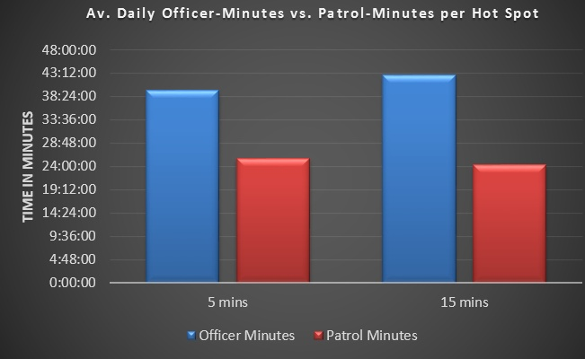

High Variance: A heartbeat of Hot Spot Patrol?
In Figure 3 we see the high amount of variance when attempting to deliver a constant dosage of visible officer patrol across a period of 100 days. The red horizontal line represents the required 5 hours and 15 minutes of patrol time if officers patrolled all 7 hot spots every day for 45 minutes. As we can see there are a small number of days where no patrols were conducted, likewise there were a small number of days where the required overall patrol time almost doubled.
One of the biggest hurdles to overcome in implementing this experiment was challenging a culture where there had been some, but very little accountability and feedback, of patrol delivery. Initially it was clear that officers did not want to engage with shorter more frequent patrols; annecdotaly they believed they were spending more time travelling between hot spots that than they were actually patrolling. In summary this data demonstrates the difficulty in acheving a constant level of complinace in overall time spent at hotspots regardless of patrol length specified. This is undoubtedly linked to local leaders responsible for officers being unwilling to act on poor performance in hot spot patrol dosage, as recently demonstrated during the implementation of a hot spots strategy in London (De Brito, 2016).
Figure 3: The Heartbeat of Hot Spot Patrol in Birmingham
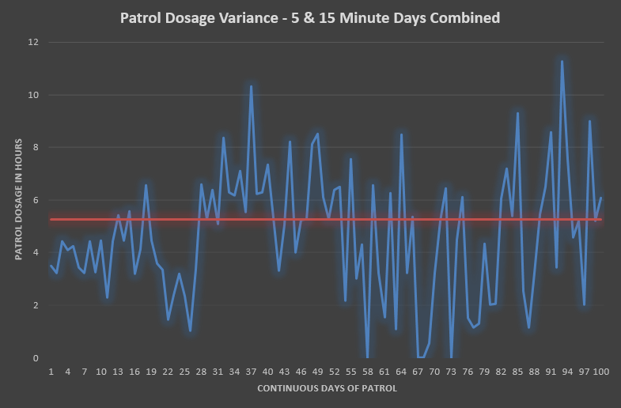
Frequency of Visits
Figure 4 presents the average number of patrols conducted across treatment hot spots per day. On 5 minute days, officers were asked to conduct 9 patrols whilst on 15 minute days they were asked to conduct 3 patrols. GPS-only data (on officer-visits) revealed that on ”short-visit” days, individual officers had made a average of just under 7 visits per hot spot on 5 minute days, under-dosing by over 2 patrols per day. In contrast, officers conducting 15 minute patrols conducted 4 ½ officer-visits per day, overdosing by 1 ½ patrols per day. When we combined GPS/Activity data this revealed the difference in patrol-visits that officers had conducted: on average, officers delivered 5 patrol-visits (of one or more officer) per hot spot on “short” (5 minute) days and just under 2 ½ patrol-visits per hot spot on 15 minute days (Figure 4).
Figure 4: Average Number of Officer Visits and Patrol Visits per Day
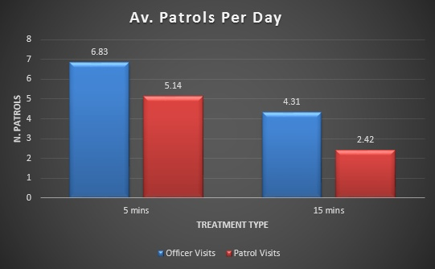

Time Spent on Each Patrol Visit
Figure 5 displays the data on average time of each officer-visit, and of each patrol-visit (of one or more officers). Both raw GPS data and GPS/Activity data combined shows that both patrol types have a comparatively similar total daily dosage of visible patrol across hotspots regardless of the measure (see Figure 5). Officers spent an average of exacty 5 minutes per visit during “short” (5-minute) patrol days and an average of 9 minutes 42 seconds during “long” (15 minute) patrol days.
Figure 5: Average Time Spent per Patrol Visit and Officer Visit
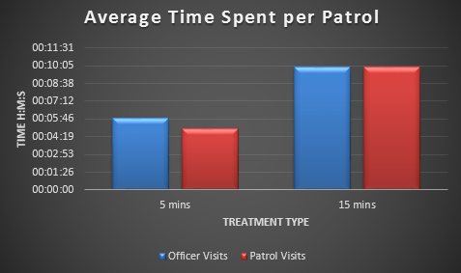

Activity Analysis: Patrol Outputs
One of the objectives of this experiment was to capture patrol outputs of both warranted constables and non-warranted police community support officers; a key element to consider when comparing two differing patrol types. There is a gap in the literature around hot spots policing that does not cover officer outputs in any satisfactory detail, although Ariel (2016) does make a distinction between patrol outcomes of warranted and non-warranted officers (see also Mitchell 2017). However, no study contained within the literature review for this paper conducted a detailed activity analysis of officer outputs whilst on patrol. This is an important area to understand. The implication of patrol outputs is significant. If targeted patrol outputs in hot spots cause a reduction in demand, as we witnessed in Birmingham (Ariel, et al 2014) and Peterborough (Ariel, 2016) and patrol activities do not require specific powers or arrest, detention or search, this really opens up the debate on what kind of capable guardianship is most appropriate to target hot spots of street level crime.
In total there were 12 activity categories that officers were asked to report on; offender management visit or contact, dealing with pedestrians, stop search of pedestrian, dealing with motorists, stop search of motorist, arrests made, dealing with calls for service ordinarily dealt with by response officers (including being called away from the hot spot to attend an incident), dealing with an incident in view, intelligence gathering, community engagement, visit to a top 3 demand location (based on crime) within a hot spot and finally a visit to a top 3 ASB call for service location. There were four additional categories added for officers to report on; whether they were single or double crewed and whether their patrol was on foot or using a bicycle. To ensure consistency in reporting patrol outputs, officers agreed on the following definitions where there was ambiguity around the category title; dealing with pedestrian or motorist: person or vehicle of policing interest relating to crime, disorder or intelligence; community engagement: an unfocussed encounter (Goffman, 1961) with a member of the public not of policing interest; visits to crime and demand locations: physical entry of shops, micro-locations or contact with repeat victim.
Analysis of over 2000 activity reports (Figure 6) shows that the most frequent patrol outputs on both 5 and 15 minute days were community engagement, visits to demand crime micro-locations and visits to demand ASB micro-locations. This is not surprising given that officers were briefed, as part of their hot spots tasking, to pay visits to businesses or public places where repeat calls for service were generated.
However, there is a notable difference between community engagement and visits to micro-locations when comparing 5 and 15 minutes. On days targeting nine 5-minute patrols, where officers spend less time but visit hot spots more frequently, community engagement and visits to crime and ASB micro-locations accounted for 57.21% of patrol outputs. On days targeting three 15- minute patrols, 88.16% of patrol outputs fell into the community engagement category. This difference may have produced heightened visibility of the patrols when they were present, thereby making each minute more effective in communicating a deterrent threat.

Figure 6: Overall Patrol Activity Analysis
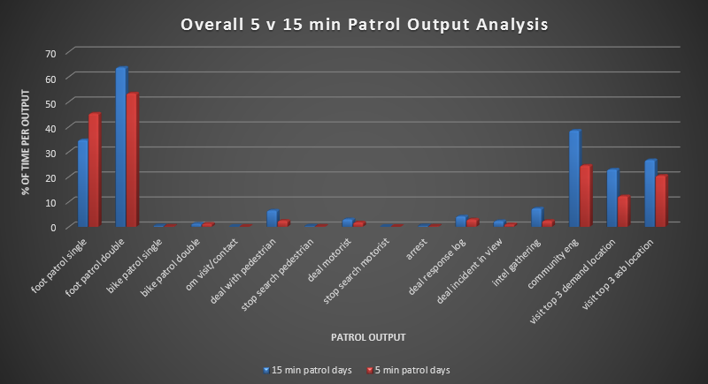

On the other hand, as Figure 7 shows, the low frequency outputs taken together tend to be more assertive forms of public contact than the high-frequency outputs—and these assertive outputs occupied over twice as high a proportion of the contacts on days with fewer patrols of longer duration. These more assertive actions comprised offender management contacts, dealing with pedestrians and motorists, stop and searches, arrests, dealing with response logs, incidents in view and intelligence. These activities accounted for only 10.75% of outputs on 5 minute patrol days, but comprised 24.09% of outputs during 15 minute patrol days. This creates another hypothesis: that more assertive policing was associated with longer but fewer patrol visits.
The rarest of all low frequency patrol outputs were those categories that we generally associate with the most assertive police enforcement; stop-searches and arrests of suspected offenders. In fact, there were only 3 persons subjected to a stop and search and 5 suspected offenders arrested whilst officers patrolled hot spots across 100 days. When we consider the intrusive use of policing powers here, there is no strong case that the causal mechanism for reduced crime and ASB in hot spots across both days were the differences in activities officers conducted rather than any particular length of patrol; both seem plausible.
Figure 7: Differences between low freq. and high freq. patrol outputs
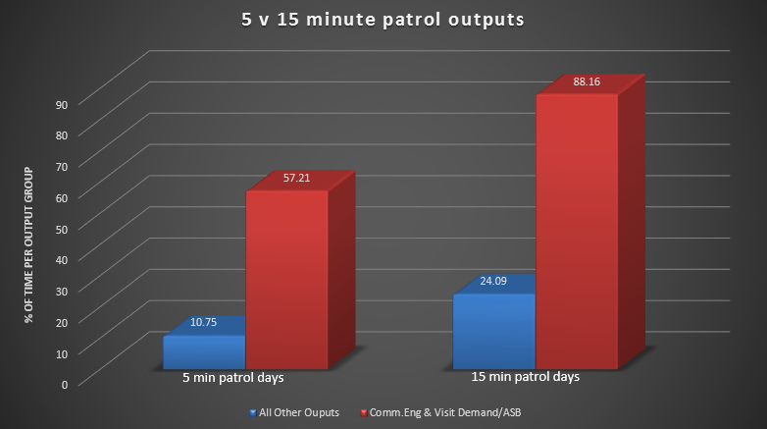

Impact on Safety: Street Crime & ASB Outcomes
The results in Figure 8 below show the average number of street crimes and ASB calls for service per day in both 15 minute and 5 minute days. In total there were 62 recorded street crimes and ASB calls for service across this 100 day period. Total recorded street crimes and ASB on 15 minute days averaged 0.561 per day, with a standard deviation of 0.824, compared to total recorded street crimes and ASB on 5 minute days averaging 0.697 per day, with a standard deviation of 0.741. This represents, on average, a 19.51% reduction in street crime and ASB calls for service associated with 15 minute patrol days. Further to this, a Cohen’s effect size value (d = 0.175) suggests a small yet practical significance favouring longer less frequent patrols.
Additionally, an independent-samples t-test was run to determine if there were differences in crime and ASB outcomes between 5 minute and 15 minute days. Fifteen minute patrols provided less crime and ASB incidents (m=0.561, SD=0.824) than 5 minute days (m=0.697, SD=0.741), a statistically significant difference, m=0.26, 95% CI (0.0204, 0.2536), t=2.2732, p=.0117.
Figure 8: Average Crime & ASB; 5 minute vs. 15 Minute Patrol Days
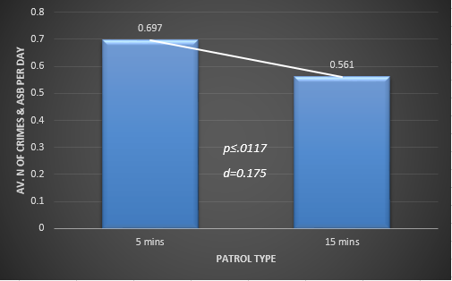

Theoretical Implications
During this experiment, Koper’s (1995) non-experimental finding that 15 minutes was the optimal time to spend on patrol has been robustly tested against shorter more frequent patrols. This hot spots experiment was designed to use treatment hot spots as their own controls over the course of 700 individual place-days, 301 with short patrols and 399 with fewer but longer patrols. Koper’s finding that 10 minutes of patrol time is a tipping point in achieving greater deterrence appears to have survived contact with this experiment with results supporting his 20 year old finding.
In relation to the Sherman et al (2014) strategy for ‘Causing the Causes of Crime Reduction’ this study supports the need for formal feedback to frontline patrol officers about the duration and frequency of their patrols. Whilst this experiment did not isolate and test this feedback to officers, it was an integral feature of both treatment conditions. The first author can say with certainty that hot spot patrols taking place in other hot spots outside of these 7, during the same time period did not have the degree of scrutiny (if any at all) imposed on them that the treatment hot spots received during this experiment. Additionally, treatment areas in 2013 and 2014 were not subject to directed patrol of this nature. The methodology of targeted patrols using specific duration and number of visits was not part of business as usual at this time. It was created expressly to conduct the experiment. Whether that management method can become embedded as “business as usual” (BAU) is an entirely different research question.
This experiment has shown that it is possible to implement and track in detail a hot spots strategy capable of reducing demand across a busy metropolitan policing area in a relatively short time period whilst, at the same time, experimenting with two very different types of patrol delivery. This research should now act as a catalyst for any other agency aiming to target hot spot locations of crime, to drive a wedge of culture change through existing patrol activities.
There are a number of key findings from this study for consideration by leaders responsible for delivery of local policing in any agency;
- Koper’s (1995) threshold of 10 minutes patrol time producing greater deterrence returns is supported when directly compared to shorter (5 minute) more frequent patrols. In this study they were associated with 20% less Street Crime and ASB.
- The hotspot patrols we tested were not highly intrusive. Patrol outputs associated with the use of more intrusive police powers, such as stop and search or arrest, were low in frequency in both treatment conditions. The majority of patrol outputs (on average over 72% of all patrols) were associated with visibility and engagement requiring no specific police powers, which could, at least in theory, be done entirely by PCSOs without full police powers.
- If officers conducting patrols, and supervisors managing patrols, can be supported by IT software for added accountability, feedback and engagement in the process, the capability for policing to use precision management can be enhanced. Officers routinely, verbally at least, reported conducting 15 minute patrols yet on average for these patrols only conducted 10 minutes patrol within a hot spot. With real-time reports on the actual time measured, such conversations between sergeants and constables can become more candid. These data are now widely generated but rarely analyzed, let alone fed back to the people they track. This study creates evidence that operational uses of evidence itself can help to reduce crime.

References
Ariel, B. with British Transport Police (2012). Operation Beck: A Randomised Trial of Police Patrols on Platforms in the London Underground. Address to the 5th International Conference on Evidence-Based Policing, University of Cambridge, July.
Ariel, B, The Birmingham Hot Spots Experiment, address to the 7th International Conference on Evidence Based Policing, University of Cambridge, July 2014.
Ariel, B, Weinborn, C & Sherman, LW (2016). Soft Policing at Hot Spots – do police community officers work? A Randomised Control Trial. Journal of Experimental Criminology, 12: 277-317.
Braga, A. A. (2007). The effects of hot spots policing on crime. Campbell Collaboration systematic review final report.
Braga, A. A., Papachristos, A. V., & Hureau, D. M. (2012). Hot spots policing effects on crime. Campbell Systematic Reviews, 8, 1–96.
Birmingham City Council. (2013). Perry Barr District Profile. https://fairbrum.files.wordpress.com/2012/10/perry-barr-district-profile_nov-131.pdf.
Buerger, M.E, Sonn, E.G, & Petrosino, A.J (1995). Defining the "Hot Spots of Crime": Operationalizing Theoretical Concepts for Field Research (From Crime and Place, P 237-257).
Cohen, L. E., & Felson, M. (1979). ‘Social change and crime rate trends: A routine activity approach’. American sociological review, 588-608
De Brito, C. (2016). Will providing tracking feedback on Hot Spot patrols Affect the Amount of Patrol Dosage Delivered? Unpublished Master’s Thesis in criminology & Police Management, The University of Cambridge.
Durlauf, S. N. and Nagin, D. S. (2011), Imprisonment and crime. Criminology & Public Policy, 10: 13–54
Kahneman. D, 2011, Thinking Fast and Slow, London, Penguin.
Goffman, E. (1961), Encounters: Two Studies in the sociology of interaction. Oxford, England.
Kock, R. (1999). 80-20 principle: The secret to success by achieving more with less. New York: Doubleday.
Koper, C. S. (1995). Just Enough Police Presence: Reducing Crime and Disorderly Behaviour by Optimizing Patrol Time in Crime Hot Spots. Justice Quarterly, 12(4), 649–672.
Murray. A (2015). Unpublished address to MSt students at The University of Cambridge.
Nagin, D. S. (2013). ‘Deterrence in the Twenty-first Century’. Crime and Justice, 42(1), 199-263.
ONS (Office for National Statistics. (2012). News Release: Census shows increase in population of the West Midlands. www.ons.gov.uk.
Ratcliffe.J, Groff. E, Johnson’s, and Wood.J (2013). Exploring the relationship between foot and car patrol in violent crime areas. Policing: An International Journal of Police Strategies & Management Vol. 36 No. 1, 2013 pp. 119-139
Sherman, L. W. (1990). Police Crackdowns: Initial and Residual Deterrence. In M. Tonry & N. Morris (Eds.), Crime and justice: A review of research (Volume 12) (Vol. 12, pp. 1–48). Chicago: University of Chicago Press.
Sherman, L. W., & Weisburd, D. (1995). General deterrent effects of police patrol in crime “hot spots”: A randomized, controlled trial. Justice Quarterly, 12, 625-648.
Sherman, L. W. (2013). ‘The Rise of Evidence-Based Policing: Targeting, Testing, and Tracking’. Crime and Justice, 42(1), 377-451.
Sherman, L.W (2015). Lecture to MSt course in applied criminology and police management. Targeting Places. University of Cambridge April 2015.
Sherman, L. W., Gartin, P. R., & Buerger, M. E. (1989). Hot Spots of Predatory Crime: Routine Activities and the Criminology of Place. Criminology, 27(1), 27–56.
Sherman, L. W., & Weisburd, D. (1995). General deterrent effects of police patrol in crime “hot spots”: A randomized, controlled trial. Justice Quarterly, 12, 625-648.
Sherman, L. W., Williams, S., Ariel, B., Strang, L., Wain, N., Slothower, M., & Norton, A. (2014). An Integrated Theory of Hot Spots Patrol Strategy: Implementing Prevention by Scaling Up and Feeding Back. Journal of Contemporary Criminal Justice, 1–28.
Simon, H.A., 1957, Models of Man, New York, Wiley & Sons.
Telep, C. W., & Weisburd, D. (2012). What is known about the effectiveness of police practices in reducing crime and disorder? Police Quarterly, 15(4), 331-357.

Telep, C. W., Mitchell, R. J., & Weisburd, D. L. (2012). How Much Time Should the Police Spend at Crime Hot Spots? Answers from a Police Agency Directed Randomized Field Trial in Sacramento, California. Justice Quarterly, 1–29.
Weisburd, D. and Braga, A.A. (eds) (2006) Police Innovation: Contrasting perspectives. Cambridge: Cambridge University Press. (Read ‘Introduction: Understanding police innovation’, pp. 1-26.)
Weisburd, D., & Britt, C. (2007). Statistics in criminal justice (3rd ed.). New York, NY: Springer.
Weisburd, D. L., Bushway, S. D., Lum, C., & Yang, S.-M. (2004). Trajectories of Crime at Places: A Longitudinal Study of Street Segments in the City of Seattle. Criminology, 42(2), 283–321.
Weisburd, D.L & Eck, J.E (2004). What Can Police Do to Reduce Crime, Disorder, and Fear? ANNALS, AAPSS, 593, May 2004
Weisburd, D. L., Groff, E. R., & Yang, S.-M. (2012). The Criminology of Place: Street Segments and Our Understanding of the Crime Problem (p. 167). New York: Oxford University Press.
Weisburd, David, Cody Telep and Anthony Braga (2010). The Importance of Place in Policing: Empirical Evidence and Policy Recommendations. Stockholm: The Swedish Crime Prevention Council.

