Optoelectronics
Solution-processed diodes become dual functional

Standfirst: A metal halide perovskite diode can switch between emission and detection modes, offering over 21% external quantum efficiency for light emission and sub-picowatt limit for light detection.

Miguel Anaya

The fast, efficient, and reliable exchange of information often depends on the transmission and reception of modulated optical signals. The standard approach to make such communication bidirectional is to use a pair of devices at both nodes of the transferring channel: one device of the pair sends information and the other detects incoming light encoded with data. However, combining transmit and receive capabilities into a single device would allow miniaturised and compact architectures to be developed, and would reduce material consumption. While dual-functional devices have been created using III–V materials^{1,2}, such capabilities have proved difficult to achieve using solution-processed semiconductors. Writing in Nature Electronics, Wenjing Zhang, Wei Huang, Feng Gao and colleagues now report an optical communication system based on a low-temperature solution-processed semiconductor that is capable of switching — on demand — between emission and detection modes (Fig. 1a)³.

In order to have an efficient bidirectional communication function, a semiconductor material must be able to absorb light at wavelengths matching those of its own emission profile. This occurs when the material has a small Stokes shift (the energy difference between the absorption onset and the emission maximum), which is a property that traditional solution-processed systems, such as organic semiconductors, lack, hampering their adoption in optical signal transmission applications. The researchers — who are based at Linköping University, Shenzhen University, Nanjing Tech University, Nanjing University of Aeronautics and Astronautics, the Chinese University of Hong Kong and Northwestern Polytechnical University — overcome this challenge by using a metal halide perovskite semiconducting film. Such perovskite materials are currently of considerable interest in terms of developing solution-processed optoelectronic devices because of their versatility, small Stokes shift and defect tolerance, as well as other valuable properties⁴.

Zhang, Huang, Gao and colleagues developed, in particular, a formamidinium lead triiodide (FAPbI₃)-based light-emitting diode (LED) that offers an external quantum efficiency (the ratio of the emitted photons to the number of injected electrons) of more than 21 % and a radiance of over 300 W sr⁻¹m⁻². This high performance is a result of the passivation of the perovskite structure by an organic molecule (2,2′-[oxybis(ethylenoxy)]diethylamine; ODEA), which heals surface defects caused by iodide vacancies, removing loss pathways for charge carriers⁵. Furthermore, the band alignment, with low energy barriers at each interface of the device stack, allows the diode to operate in reverse mode and for the researchers to create an efficient photodetector with a low dark current (around 10⁻¹⁰ A) and a high maximum specific detectivity (5.3×10¹² Jones) in the visible wavelength region. The trap passivation of ODEA on the FAPbI₃ perovskite has a positive impact on the static picture of the LED and photodetector devices, and also on their response speed, through a reduction of the parasitic capacitance of the system. Due to the small Stokes shift of the FAPbI₃ perovskite, a specific detectivity of 2x10¹² Jones can be maintained even at near-infrared wavelengths of 800 nm (Fig. 1b).

Zhang, Huang, Gao and colleagues use the capabilities of the system to fabricate dual-functional transmitter/receiver devices. Bidirectional light communicators are shown to be capable of exchanging digital signals at bit rates of 1 Mbit s⁻¹ and 100 kbit s⁻¹ in intra-chip and inter-chip device configurations, respectively. To illustrate the practical capabilities of the approach, the researchers also show that monolithic dual-functional diode can be used to sense heart pulse rates. Here, light emitted by the LED node is absorbed by the haemoglobin present in blood. Variations in the haemoglobin due to variations in blood pressure can be detected by the photodiode node allowing the cardiac cycles to be visualised and important features, such as systolic peaks and diastolic notches, to be resolved (Fig. 1c). This pulse monitor leverages both the high sensitivity of the device and its emission wavelength around 800 nm, which critically allows light to be transmitted through the near-infrared window of biological tissue.

The work of Zhang, Huang, Gao and colleagues is a relevant new direction for metal halide perovskites and their applications in optoelectronic technologies, opening avenues for the realisation of lightweight and flexible optical communication systems. However, the response speeds of the devices — 21 MHz — are still low for high-speed optical communication applications, such as fibre optic systems; for comparison III–V semiconductor LEDs and InGaAs photodiodes have demonstrated modulation speeds close to 1 GHz and above 100 GHz, respectively^{6,7}. Efforts to increase the quality of the perovskite film and miniaturise the device active area will be required in order to reduce the parasitic capacitance of the system and subsequently decrease its response time. In order for practical applications to become a reality, issues related to the limited stability of the devices under ambient conditions, as well circumventing lead-related toxicity issues, will also have to be addressed, particularly if biomedical devices are to be developed.

Miguel Anaya
Cavendish Laboratory, University of Cambridge, Cambridge, UK
e-mail: ma811@cam.ac.uk

References
1. Shi, Z. et al. Appl. Phys. Lett. 111, 241104 (2017).
2. Jiang, Y. et al. IEEE Electron Device Lett. 38, 1684–1687 (2017).
3. Bao C. et al. Nat. Electron. X, XX–XX (2020).
4. Collection: Perovskites for Optoelectronics. Nature. (https://www.nature.com/collections/fnnxcznnbb/physics)
5. Xu, W.et al. Nat. Photonics. 13, 418-424 (2019).
6. Ferreira, R. X. G. et al. IEEE Photonics Technol. Lett. 28, 2023–2026 (2016).
7. Shimizu, N., Watanabe, N., Furuta, T. & Ishibashi, T. IEEE Photonics Technol. Lett. 10, 412–414 (1998).

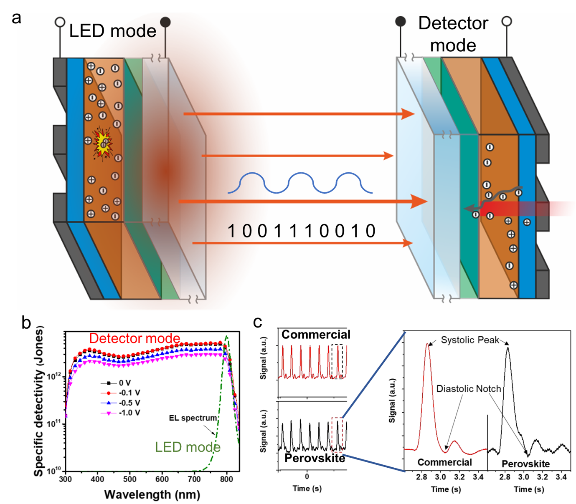
Figure 1. Dual-functional metal halide perovskite diodes. a, Schematic of the bidirectional optical signal communication system based on a metal halide perovskite semiconductor. b, Specific detectivity and electroluminescence spectrum of the same perovskite diode in detector and light-emitting mode, respectively. c, Comparison of the heart pulse cycles obtained using a commercial and the perovskite sensor. The zoom in shows the precision with which the systolic peak and diastolic notch are resolved. Figure 1b and 1c reproduced with permission from ref. 3, Springer Nature Ltd.

