Birth weight to placenta weight ratio and its relationship to ultrasonic measurements, maternal and neonatal morbidity: a prospective cohort study of nulliparous women.

N. Salavatiª
Dr. S.J. Gordijnª
Dr. U. Sovio^{b,c}
Dr. R. Zill-E-Huma^{b}
Dr. A. Gebril^{b,d}
Prof. D.S. Charnock-Jones^{b,c}
Prof. S.A. Scherjonª
Prof. G.C.S. Smith^{b,c,1}

ªDepartment of Obstetrics and Gynaecology, University Medical Centre of Groningen, University of Groningen, The Netherlands.
^{b}Department of Obstetrics and Gynaecology, University of Cambridge; NIHR Cambridge Comprehensive Biomedical Research Centre, Cambridge, UK.
^{c}Centre for Trophoblast Research (CTR), Department of Physiology, Development and Neuroscience, University of Cambridge, Cambridge, UK.
^{d}Current address: Department of Obstetrics and Gynaecology, Cairo University, Egypt.

¹Corresponding author:
Prof GCS Smith, Department of Obstetrics and Gynaecology, University of Cambridge, Box 223 The Rosie Hospital, Cambridge, CB2 0SW, UK.
Tel: +44 (0)1223 336871, Fax: +44 (0)1223 215327, E-mail: gcss2@cam.ac.uk

Email addresses: n.salavati@umcg.nl (NS), s.j.gordijn@umcg.nl (SJG), us253@medschl.cam.ac.uk (US), rabia.zill-e-huma@nhs.net (RH), amrgebril@kasralainy.edu.eg (AG), dscj1@cam.ac.uk (DSCJ), s.a.scherjon@umcg.nl (SAS), gcss2@cam.ac.uk (GCS).

Abstract
Introduction: Birth weight to placenta weight (BWPW)-ratio is an indicator of the ability of the placenta to maintain adequate nutrient supply to the fetus. We sought to investigate the relationship between BWPW-ratio with fetal growth, utero-placental Doppler and neonatal and maternal morbidity.
Methods: We studied a group of 3311 women recruited to a prospective cohort study of nulliparous women (Rosie Hospital, Cambridge, UK) who delivered a live born infant at term and whose placental weight and birth weight were known. Ultrasonic indices and BWPW ratio were converted to gestational age adjusted z scores. Analysis of continuous variables was by multivariable linear regression. BWPW ratio was also categorized (lowest or highest quintile, both referent to quintiles 2 to 4) and associations with adverse outcomes analyzed using multivariable logistic regression.
Results: Lowest quintile of BWPW-ratio was associated (adjusted odds ratio [95% CI], P) with both neonatal morbidity (1.55 [1.12-2.14], 0.007) and maternal diabetes (1.75 [1.18-2.59], 0.005). Highest quintile of BWPW ratio was associated with a reduced risk of maternal obesity (0.71 [0.53 to 0.95], 0.02) and preeclampsia (0.51 [0.31 to 0.84], 0.008), but higher (adjusted z score [95% CI], P) uterine artery Doppler mean pulsatility index (PI) at 20 weeks of gestation (0.09 [0.01-0.18], 0.04) and umbilical artery Doppler PI at 36 weeks of gestation (0.16 [0.07-0.25], <0.001).
Conclusion: BWPW-ratio is related to ultrasonic measurements and both neonatal and maternal morbidity. Therefore, this ratio may be an indicative marker of immediate and longer term health risks for an individual.
Keywords: birth weight, placenta weight, Doppler flow velocimetry, fetal growth, human
Abbreviations. AC, abdominal circumference; AGA, appropriate for gestational age; BW, birth weight; CI, confidence interval; EFW, estimated fetal weight; FGR, fetal growth restriction; GA, gestational age; GV, growth velocity; LGA, large for gestational age; PW, placenta weight; PI, pulsatility index; POP, Pregnancy Outcome Prediction; SD, standard deviation; SGA, small for gestational age; UmA, umbilical artery; UtA, uterine artery.

Introduction
Appropriate nutrient supply to the fetus, via the placenta, is essential for optimal fetal growth. The ability of the placenta to maintain adequate nutrient supply is commonly described by birth weight to placenta weight-ratio (BWPW-ratio) i.e., the grams of the fetus per gram placenta [1]. Changes in BWPW-ratio, in literature often described as “placental efficiency” [2], can occur in response to either maternal or fetal stimuli that cause morphological and functional placental adaptations. These adaptations take place in order to maintain appropriate fetal growth, and failure of placental adaptation may result in a fetus that is either too small or too large with regards to its genetic growth potential. A previous study has already described that a small BWPW-ratio was associated with higher risk of delivering a term small for gestational age (SGA) infant [3].
It is known that fetal growth restriction (FGR), a condition in which the fetus fails to achieve its genetic growth potential, is associated with placental dysfunction. The placenta in FGR may exhibit altered nutrient transfer capacity to compensate for sub-optimal function [4]. In current clinical practice, fetuses with a birth weight below the 10th centile are either constitutionally small (SGA) or growth restricted. However, fetuses with an estimated fetal weight (EFW) or birth weight above the 10th centile can also be growth restricted due to insufficient nutrient supply, despite their weight being above the 10th percentile. Correct classification of these fetuses as FGR is a major challenge but it is of great importance as this ‘hidden’ FGR is also associated with an increased risk of neonatal morbidity and mortality [5].
In this study we set out to investigate the relationship between both a relatively smaller placenta and a relatively larger placenta, with ultrasonic measurements of utero-placental blood flow (indicating high resistance flow in the placenta and thus maternal vascular malperfusion) and neonatal and maternal morbidity using data from the Pregnancy Outcome Prediction study [6–8]. We hypothesized that failure of placental development manifested in smaller placental size, relative to the fetus, is associated with (1) fetal growth restriction and (2) raised umbilical artery (UmA) pulsatility index. In addition, we hypothesized that selective stimulation of fetal growth compared to placental growth leads to relative placental insufficiency and will be associated with (i) pathological determinants of excessive fetal growth, (ii) an increased risk of adverse perinatal outcome, (iii) raised UmA PI.

Methods

Ethical approval
Ethical approval for the study was obtained by the Cambridgeshire 2 Research Ethics Committee (reference number 07/H0308/163). All participants gave written informed consent.

Study design
The Pregnancy Outcome Prediction (POP) study was conducted at the Rosie Hospital, Cambridge (UK) and has been previously described in detail [6,7]. It was a prospective cohort study of nulliparous women with a viable singleton pregnancy who attended the hospital’s ultrasound department between 14/01/2008 and 31/07/2012 for their dating ultrasound scan. Women included in the study underwent sequential research ultrasound scans at 20, 28 and 36 weeks of gestation. The results of the scans were blinded to both women and clinicians. After the delivery, results of the research scans were unmasked.

Study group
Among the participants of the POP study, the inclusion criteria for the present analysis were women who attended all planned antenatal research scans and delivered a live-born infant after 36 weeks of gestation where both the birth weight and placental weight had been recorded. We excluded women who withdrew or were lost to follow up and women who had ultrasonic measurements missing from the 20 or 36 week scans.

Definitions
The birth weight to placenta weight-ratio (BWPW-ratio) was defined as the birth weight (in grams) divided by trimmed placental weight (in grams, whereby membranes and cord were removed and placentas were cleaned from excess blood). This ratio was log-transformed and converted into gestational age (GA)-adjusted z-score to adjust for variation in gestational age. Quintiles were calculated from GA-adjusted z-scores, generated by use of the distribution of the study, whereby quintile 1 was defined as ‘low’ BWPW-ratio (lowest 20% in this cohort), quintiles 2 to 4 as ‘normal’ BWPW-ratio (middle 60% of this cohort and used as the referent category) and ‘high’ BWPW-ratio was based on quintile 5 (20% highest BWPW-ratio in this cohort).
Analysis with the outcome variables were performed within the complete cohort and within stratified groups of small-for-gestational age (SGA), appropriate-for-gestational age (AGA) and large-for-gestational age (LGA), where SGA was defined as birth weight less than the 10th percentile for sex and gestational age, calculated from a UK reference [9]. AGA was defined as birth weight between the 10th and 90th percentile for sex and gestational age. LGA was defined as birth weight above the 90th percentile for sex and gestational age.

Outcomes
Neonatal morbidity was defined as one or more of the following criteria: a 5 min Apgar score of less than 7, delivery with metabolic acidosis (defined as arterial cord blood pH <7.1 and base deficit >10 mmol/L [7,10]), or admission to the neonatal unit at term (defined as admission <48 h after birth at ≥37 weeks’ gestational age and discharge ≥48 h after admission).

Quantification of Uterine artery (UtA) and Umbilical artery (UmA) Doppler flow velocity waveforms was done by the pulsatility index (PI). UtA PI was quantified at the 20 weeks scan as the mean PI of the left and right uterine arteries [11]. UmA PI was measured at the 36 week scan. Measurements were converted into GA-adjusted z-scores defined within the POP study [7], to adjust for minor variation in the exact GA at the scan. Abdominal circumference growth velocity (ACGV) was obtained by calculating the difference in AC z-score between the 20 week and 36 week scans [7] and negative values indicate slowing of fetal abdominal growth over this time interval. For UtA and UmA Doppler flow velocity waveforms and ACGV, quintiles were generated by use of the distribution of the study cohort. High resistance UtA and UmA Doppler flow velocity waveforms were defined as the highest quintile of uterine Doppler and umbilical Doppler, when treated categorically. When ACGV was used as a binary variable, reduced ACGV was defined as the lowest quintile and compared with all other quintiles.

Obesity and diabetes are maternal characteristics associated with pathological growth. Body mass index (BMI) at the 12 week scan was used as a proxy measurement for pre-pregnancy BMI. Maternal obesity is defined as a body mass index (BMI) above 30 kg/m². The WHO categories of BMI (i.e. <18.5, 18.5-24.99, 25-29.99, ≥30) being ≥30 classified as obese, were used, plus a sub-division of the obese group into WHO class I, II and III (30-34.99, 35-39.99, ≥40). Maternal diabetes was defined as either pre-gestational diabetes (Type 1 or Type 2) or gestational diabetes (based on an abnormal OGTT), see Sovio et al 2016 for details of definitions employed [12].
Preeclampsia was defined on the basis of the 2013 ACOG Guideline [13] as hypertension and at least one of the following: proteinuria, low platelets, elevated transaminase, elevated creatinine, pulmonary oedema, severe cerebral/visual symptoms. Severe preeclampsia was defined as preeclampsia and at least one of the following: severe hypertension, low platelets, elevated transaminase, elevated creatinine, pulmonary oedema, severe cerebral/visual symptoms [14].

Maternal characteristics
Maternal age was defined as age at recruitment. Maternal ethnicity, age at leaving full-time education (FTE), smoking and alcohol consumption were defined by self-report at the 20 week questionnaire. Birth weight was measured directly after delivery.

Statistical analysis
Continuous variables were summarized by the median and IQR, and comparisons between groups were made by the Kendall’s tau rank correlation test. Distributions of categorical variables were compared using a Wilcoxon-type test for trend. Continuous variables were compared using Student's t-test where the outcome data were normally distributed and the determinant was dichotomous. Relative risks were calculated between binary adverse outcome variables and binary BWPW-ratio (high vs. normal, and low vs. normal). Interactions were assessed using the likelihood-ratio test. The associations between BWPW-ratio (exposure) and ultrasonic measurements (outcome) were estimated by linear regression. The associations with adverse outcomes were estimated and odds ratios were calculated using logistic regression. Maternal characteristics were considered as possible confounders when they were significantly associated with both BWPW-ratio and the outcome variables. Adjusted analyses were performed using multivariable linear or logistic regression, as appropriate. Statistical significance was assumed at P < 0.05. Analysis was performed using Stata software (version 13.1).
Results
A total of 8028 women were eligible for inclusion of which 4512 (56%) provided written informed consent. After excluding women delivered prior to their 36 week scan, who had a preterm birth or stillbirth, or who did not have placenta weight or birth weight of their infant available, 3315 remained available for analysis. After excluding four outliers (cases with GA-adjusted z-scores of BWPW ratio above 5), 3311 women were included for analysis. Among these women there were two with missing data on preeclampsia as their status on preeclampsia could not be confirmed. We obtained GA-adjusted z-scores for BWPW-ratios, as BWPW-ratio varied with GA, whereby the log-transformed birth weight to placental weight ratio was on average 0.1 SD higher for each week increase in GA (p<0.001) (Supplementary Figure 1). However, the association was slightly stronger before 40 weeks than after 40 weeks of GA. Birth weight was 0.4 SD higher for each week increase in GA (p<0.001), and this association was linear (Supplementary Figure 2). On average, the placental weight was 0.1 SD higher for each week increase in GA (p<0.001) (Supplementary Figure 3). The association was slightly stronger after 40 than before 40 weeks of pregnancy.
The characteristics of the study cohort, presented as three groups of BWPW-ratio; 1. lowest quintile (n=663), 2. middle three quintiles (n=1986), and 3. highest quintile (n=662), are summarized in Table 1. Increasing BWPW-ratio was associated with decreasing BMI, smoking status and alcohol consumption of the mother, ethnicity of the mother, and sex of the infant (Table 1).
Figure 1 and Figure 2 present the relative risks of, respectively, a high BWPW-ratio (Q5 vs. Q2-Q4) and a low BWPW-ratio (Q1 vs. Q2-Q4) in relation to several binary outcome variables within the complete cohort. There was no evidence for interaction with birth weight category (SGA, AGA, LGA), therefore only the results of associations between BWPW-ratio and outcome variables within the complete cohort are shown. Relative risks are given for either high or low BWPW-ratio in relation to the binary outcome variables, whereby ultrasonic measurements were defined as the extreme quintile and compared with the other four quintiles. For UtA PI and UmA PI this was the highest quintile (increased UmA/UtA PI) and for ACGV it was the lowest quintile of ACGV (reduced ACGV).
Linear regression analyses showed that high BWPW-ratio had weak associations with all three ultrasonic measurements, specifically both increased UmA PI and UtA PI, and reduced ACGV (Table 2). The associations for high BWPW-ratio with UtA PI and UmA PI remained statistically significant after adjustment for maternal characteristics. Low BWPW-ratio was associated with a reduced UmA PI (Table 2). Adjustments for maternal characteristics did not materially affect these results. In accordance with Table 2, Figure 3 illustrates the comparison in ultrasonic measurements between high and low BWPW-ratio with normal BWPW-ratio.

When the binary outcome variables were analyzed in relation to both high and low BWPW-ratio (Table 3), we found that neonatal morbidity was more common when BWPW-ratio was low (adjusted odds ratio 1.55 [95%CI 1.12-2.14, p=0.007]). Furthermore, diabetes (pre-gestational or gestational) was significantly associated with low BWPW-ratio: the adjusted odds ratio was 1.75 (95% CI 1.18-2.59, p=0.005). It was also shown that high BWPW-ratio was associated with a reduced risk of maternal obesity (adjusted odds ratio of 0.71 [95% CI 0.53-0.95, p=0.02]) and preeclampsia (adjusted odds ratio of 0.51 [95% CI 0.31-0.84, p=0.008]).

Discussion

The aim of this study was to investigate the relationship between birth weight to placenta weight (BWPW) ratio, ultrasonic measurements and both neonatal and maternal morbidity. We observed two key patterns. First, low BWPW-ratio was associated with both neonatal and maternal morbidity, including maternal obesity (BMI>30 kg/m²), diabetes (pre-gestational and gestational) and preeclampsia. Second, high BWPW-ratio was associated with both higher umbilical artery PI (36 weeks of gestation) and higher uterine artery PI (20 weeks of gestation).
BWPW-ratio is thought to be a measure of how placental development and function have adapted to meet fetal nutritional requirements and maternal supply [2]. An increased BWPW-ratio (a relatively smaller placenta), implies that nutrient transfer per gram placenta must have increased. Accordingly, the converse is true: a reduced BWPW-ratio suggests that nutrient transfer, per gram placenta is reduced.
Obesity and diabetes are maternal characteristics associated with pathological fetal and placental growth, and are the most common problems in obstetrics that affect both the mother and her offspring [15,16]. Previous studies have shown that placentas of obese women are significantly heavier at birth [17,18], and that there is an association with fetal overgrowth, which may be related to increased placental system A amino acid transporters 1 and 2 (SNAT1 and SNAT2) and insulin growth factor (IGF-1) signaling [19]. There are also extensive previous studies which have demonstrated that birth weight is greater in the infants of obese women[15,17]. In addition, a recent study of a cohort of women with gestational diabetes found that diabetes related factors were associated with both BW and PW, with a larger effect on PW [20]. This is consistent with the results of the present study that, in the presence of maternal obesity, the placenta is proportionally larger in size compared to the size of the fetus (a relatively larger placenta). This could either be due to placentas failing to adapt placental nutrient transfer according to fetal demand, or that in obese women growth factors (e.g. IGF-1) are driving excessive placental growth [19].
Interestingly, one of the placental histopathological findings which is associated with both maternal obesity and maternal diabetes is villous immaturity [21]. Immature chorionic villi are larger and have more central blood vessels and thus a larger diffusion distance for gas and nutrient exchange. Our findings suggest that abnormal growth and development of the placenta in obese women may explain some of the epidemiological associations of maternal obesity, such as increased risks of stillbirth and preeclampsia. This interpretation is supported by the observation that a low BWPW-ratio was associated with an increased risk of neonatal morbidity, even after adjusting for the associations with maternal diabetes and obesity. These observations were also consistent with a previous study [22]. Finally, maternal smoking was significantly associated with lower BWPW-ratio, again consistent with previous studies [23]. Smoking is also a major risk factor for stillbirth, and there is a large body of evidence supporting associations between stillbirth and placental dysfunction [24].
We also made a series of observations regarding high BWPW-ratio. First, we found that it was associated with a higher UmA PI and there was a similar but weaker association with UtA PI. In a previous study on the same cohort, we found that low placenta weight was associated with higher UmA PI and higher UtA PI [25]. The present study indicates that not only absolute placenta size, but also a reduced relative placenta size is associated with higher resistance in the vascular bed, reflected by higher values of UtA and UmA Doppler flow velocity waveforms by the PI [11]. Edwards et al. also focused on the relation between feto-placental Dopplers and BWPW-ratio [26]. They compared the BWPW-ratio in 87 fetuses with absent or reversed end diastolic (AREDF) flow in the umbilical artery with normal singleton deliveries. However, these groups are not directly comparable with our cohort as, for example, 85 out of 87 fetuses with AREDF delivered preterm.
We also found that BWPW-ratio was higher in male infants compared to female infants, suggesting a higher nutrient transfer per gram of placenta in male infants. This has also been described by other studies where it was hypothesized that males prioritize body growth and invest less in placental growth, thereby making them more vulnerable to become undernourished [26–30]. In addition, our results showed that there was no difference in birth weight and the proportion of SGA, AGA and LGA infants across the groups of low, normal and high BWPW-ratio (quintiles Q1, Q2-Q4 and Q5). Since placental weight was significantly different among the groups, this indicates that variation in the placental weight determined whether there was low, normal or high BWPW-ratio.
Our results show that high BWPW-ratio was associated with lower risk of pre-eclampsia, as well as with higher UtA and UmA Doppler flow velocity waveforms by the PI. This seems paradoxical since higher UtA PI is expected to predict pre-eclampsia. We have previously shown that a smaller placental surface area is associated with higher UtA PI. We interpreted this as indicating that the number of maternal resistance vessels invaded by the trophoblast may be a determinant of the reduction in resistance in the uterine circulation, as well as the depth of the invasion. Hence, a smaller placental weight (relative to birth weight) could also be associated with higher UtA PI. In relation to UmA Doppler, the cardiac output of the fetus will vary according to its weight. With higher BWPW-ratios, it is plausible that there will be a greater fetal blood flow per unit of placental weight and this could lead to alteration in the flow velocity waveform. Moreover, release of factors from the placenta, including soluble fms-like tyrosine kinase 1, has a key role in the etiology of preeclampsia. Consistent with this, clinical conditions associated with a greater mass of placental tissue, such as multiple pregnancy, are associated with an increased risk of preeclampsia. The apparent protective effective of high BWPW ratio for preeclampsia could be related to smaller placental size. Finally, although the BWPW ratio is a relatively easy measurement which provides some information about placental function, it has to be acknowledged that the determinants of any given placental function are highly complex and either increased or decreased ratios could vary with these factors in multiple ways. For example, considering placental oxygen transfer, determinants include uterine blood flow, maternal and fetal hemoglobin (concentration and affinity), matching and mismatching of maternal and fetal placental perfusion, the diffusion capacity of the placental surface, including the extent and thickness of the vasculo-syncytial membranes, and the oxygen utilization of the placenta itself (see Carter 2015 [31] for review). Given the underlying complexity of the function of the organ and the relatively crude nature of the BWPW ratio, it is unsurprising that associations are complex [32,33].
Our study has strengths and weaknesses. One of the strengths of this study is that it includes blinded ultrasonographic assessment in a large cohort through all trimesters of pregnancy. The strength of this approach is that disclosure of the scan results could have led to differential treatment of the women based on the information of the scans, which could have biased the results. Another key feature of our study is that we wrote a prospective analysis plan (available from authors by request), where we pre-specified the primary hypotheses and the analytic approach before we approached the resource of data available. Many of the previous studies addressing BWPW-ratio have lacked this rigor. The only addition we have made to our initial analysis plan is that we have included the data on preeclampsia. Furthermore, other additional analyses were performed as requested by reviewers. A limitation of this report is the fact that this study was confined to nulliparous women who were largely of white ethnicity. This constrains extrapolation of the results to other ethnicities. However, the homogeneity of the study population makes the risk of possible confounding less likely. The number of stillbirths in this cohort was too small to study it as an outcome. Stillbirths were excluded from the analyses as there is uncertainty about post mortem weight changes in both the placenta and fetus [34].
One of the possible limitations is that reference values for low and high BWPW-ratio were created within this cohort (quintiles). Although the cohort is unselected and large in size, in future, general applicable cut-off values for pathological BWPW-ratio (both low and high) need to be determined to facilitate application in clinic. Furthermore, in future studies larger sample sizes are needed to show possible differences in the association between BWPW-ratio and outcomes within the groups of SGA, AGA and LGA. Finally, the current analysis is based on measurements (birth weight and placental weight) which can only be measured following birth. Identifying clinical markers in the antenatal period which predict abnormal BWPW ratio may help in antenatal risk assessment.

In conclusion, we showed that BWPW-ratio is related to ultrasonic measurements and both neonatal and maternal morbidity. This study indicates that a smaller placenta relative to fetal size is related to higher values of UtA and UmA Doppler flow velocity waveforms PI. Furthermore, a larger placenta relative to fetal size is a risk factor for maternal and neonatal morbidity. Our study suggests that BWPW-ratio may be an indicative marker of immediate and longer term health risks for an individual.

References
[1] M.E. Wilson, S.P. Ford, Comparative aspects of placental efficiency., Reprod. Suppl. 58 (2001) 223–32. http://www.ncbi.nlm.nih.gov/pubmed/11980192 (accessed January 17, 2017).
[2] A.L. Fowden, A.N. Sferruzzi-Perri, P.M. Coan, M. Constancia, G.J. Burton, Placental efficiency and adaptation: endocrine regulation., J. Physiol. 587 (2009) 3459–72. doi:10.1113/jphysiol.2009.173013.
[3] M.A. Luque-Fernandez, C. V Ananth, V.W. V Jaddoe, R. Gaillard, P.S. Albert, M. Schomaker, P. McElduff, D.A. Enquobahrie, B. Gelaye, M.A. Williams, Is the fetoplacental ratio a differential marker of fetal growth restriction in small for gestational age infants?, Eur. J. Epidemiol. 30 (2015) 331–41. doi:10.1007/s10654-015-9993-9.
[4] J.D. Glazier, I. Cetin, G. Perugino, S. Ronzoni, A.M. Grey, D. Mahendran, A.M. Marconi, G. Pardi, C.P. Sibley, Association between the Activity of the System A Amino Acid Transporter in the Microvillous Plasma Membrane of the Human Placenta and Severity of Fetal Compromise in Intrauterine Growth Restriction, Pediatr. Res. 42 (1997) 514–519. doi:10.1203/00006450-199710000-00016.
[5] B.J. Voskamp, D.H. Beemsterboer, C.J.M. Verhoeven, K. Oude Rengerink, A.C.J. Ravelli, J.J.H. Bakker, B.W.J. Mol, E. Pajkrt, Potential improvement of pregnancy outcome through prenatal small for gestational age detection. [correction]., Am. J. Perinatol. 31 (2014) 1093–104. doi:10.1055/s-0034-1371360.
[6] D. Pasupathy, A. Dacey, E. Cook, D.S. Charnock-Jones, I.R. White, G.C.S. Smith, Study protocol. A prospective cohort study of unselected primiparous women: the pregnancy outcome prediction study., BMC Pregnancy Childbirth. 8 (2008) 51. doi:10.1186/1471-2393-8-51.
[7] U. Sovio, I.R. White, A. Dacey, D. Pasupathy, G.C.S. Smith, Screening for fetal growth restriction with universal third trimester ultrasonography in nulliparous women in the Pregnancy Outcome Prediction (POP) study: a prospective cohort study., Lancet (London, England). 386 (2015) 2089–97. doi:10.1016/S0140-6736(15)00131-2.
[8] F. Gaccioli, S. Lager, U. Sovio, D.S. Charnock-Jones, G.C.S. Smith, M. Sennstrom, M. Olovsson, S.P. Brennecke, H. Stepan, D. Allegranza, P. Dilba, M. Schoedl, M. Hund, S. Verlohren, M.S. Esplin, M.A. Elovitz, T. Foroud, A.M. Peaceman, G.R. Saade, M. Willinger, U.M. Reddy, M. b. s. NuMo, C. Ravaldi, A. Vannacci, J. Cassidy, P. Cassidy, C. Farquhar, E. Wallace, D. Siassakos, A.E. Heazell, C. Storey, L. Sadler, S. Petersen, J.F. Froen, R.L. Goldenberg, The pregnancy outcome prediction (POP) study: Investigating the relationship between serial prenatal ultrasonography, biomarkers, placental phenotype and adverse pregnancy outcomes, Placenta. 374 (2016) 13–22. doi:10.1016/j.placenta.2016.10.011.
[9] J. V Freeman, T.J. Cole, S. Chinn, P.R. Jones, E.M. White, M.A. Preece, Cross sectional stature and weight reference curves for the UK, 1990., Arch. Dis. Child. 73 (1995) 17–24. http://www.pubmedcentral.nih.gov/articlerender.fcgi?artid=1511167&tool=pmcentrez&rendertype=abstract (accessed January 17, 2017).
[10] G.L. Malin, R.K. Morris, K.S. Khan, Strength of association between umbilical cord pH and perinatal and long term outcomes: systematic review and meta-analysis., BMJ. 340 (2010) c1471. doi:10.1136/bmj.c1471.
[11] A. Bhide, G. Acharya, C.M. Bilardo, C. Brezinka, D. Cafici, E. Hernandez-Andrade, K. Kalache, J. Kingdom, T. Kiserud, W. Lee, C. Lees, K.Y. Leung, G. Malinger, G. Mari, F. Prefumo, W. Sepulveda, B. Trudinger, ISUOG practice guidelines: use of Doppler ultrasonography in obstetrics., Ultrasound Obstet. Gynecol. 41 (2013) 233–39. doi:10.1002/uog.12371.
[12] U. Sovio, H.R. Murphy, G.C.S. Smith, Accelerated Fetal Growth Prior to Diagnosis of Gestational Diabetes Mellitus: A Prospective Cohort Study of Nulliparous Women., Diabetes Care. 39 (2016) 982–7. doi:10.2337/dc16-0160.
[13] American College of Obstetricians and Gynecologists, Task Force on Hypertension in Pregnancy, Hypertension in Pregnancy, Obstet. Gynecol. 122 (2013) 1122–1131. doi:10.1097/01.AOG.0000437382.03963.88.
[14] U. Sovio, F. Gaccioli, E. Cook, M. Hund, D.S. Charnock-Jones, G.C.S. Smith, Prediction of Preeclampsia Using the Soluble fms-Like Tyrosine Kinase 1 to Placental Growth Factor RatioNovelty and Significance, Hypertension. 69 (2017) 731–738. doi:10.1161/HYPERTENSIONAHA.116.08620.
[15] P.M. Catalano, K. Shankar, Obesity and pregnancy: mechanisms of short term and long term adverse consequences for mother and child., BMJ. 356 (2017) j1. http://www.ncbi.nlm.nih.gov/pubmed/28179267 (accessed March 15, 2017).
[16] K.M. Flegal, M.D. Carroll, B.K. Kit, C.L. Ogden, Prevalence of Obesity and Trends in the Distribution of Body Mass Index Among US Adults, 1999-2010, JAMA. 307 (2012) 491. doi:10.1001/jama.2012.39.
[17] P.M. Catalano, L. Presley, J. Minium, S. Hauguel-de Mouzon, Fetuses of Obese Mothers Develop Insulin Resistance in Utero, Diabetes Care. 32 (2009) 1076–1080. doi:10.2337/dc08-2077.
[18] S.M. Leon-Garcia, H.A. Roeder, K.K. Nelson, X. Liao, D.P. Pizzo, L.C. Laurent, M.M. Parast, D.Y. LaCoursiere, Maternal obesity and sex-specific differences in placental pathology, Placenta. 38 (2016) 33–40. doi:10.1016/j.placenta.2015.12.006.
[19] N. Jansson, F.J. Rosario, F. Gaccioli, S. Lager, H.N. Jones, S. Roos, T. Jansson, T.L. Powell, Activation of placental mTOR signaling and amino acid transporters in obese women giving birth to large babies., J. Clin. Endocrinol. Metab. 98 (2013) 105–13. doi:10.1210/jc.2012-2667.
[20] A. Ramos, F. Caimari, I.M. Pujol, A. García-Patterson, G. Ginovart, J.M. Adelantado, R. Corcoy, In women with gestational diabetes mellitus factors influencing growth have a larger effect on placental weight than on birth weight., Eur. J. Obstet. Gynecol. Reprod. Biol. 202 (2016) 60–5. doi:10.1016/j.ejogrb.2016.04.022.
[21] J. Huynh, D. Dawson, D. Roberts, R. Bentley-Lewis, A systematic review of placental pathology in maternal diabetes mellitus, Placenta. 36 (2015) 101–114. doi:10.1016/j.placenta.2014.11.021.
[22] F. Shehata, I. Levin, A. Shrim, B. Ata, B. Weisz, R. Gamzu, B. Almog, Placenta/birthweight ratio and perinatal outcome: A retrospective cohort analysis, BJOG An Int. J. Obstet. Gynaecol. 118 (2011) 741–747. doi:10.1111/j.1471-0528.2011.02892.x.
[23] N. Wang, G. Tikellis, C. Sun, A. Pezic, L. Wang, J.C.K. Wells, J. Cochrane, A.-L. Ponsonby, T. Dwyer, The effect of maternal prenatal smoking and alcohol consumption on the placenta-to-birth weight ratio., Placenta. 35 (2014) 437–41. doi:10.1016/j.placenta.2014.04.006.
[24] G.C.S. Smith, R.C. Fretts, Stillbirth., Lancet (London, England). 370 (2007) 1715–25. doi:10.1016/S0140-6736(07)61723-1.
[25] N. Salavati, U. Sovio, R.P. Mayo, D.S. Charnock-Jones, G.C.S. Smith, The relationship between human placental morphometry and ultrasonic measurements of utero-placental blood flow and fetal growth., Placenta. 38 (2016) 41–8. doi:10.1016/j.placenta.2015.12.003.
[26] A. Edwards, A. Megens, M. Peek, E.M. Wallace, Sexual origins of placental dysfunction, Lancet. 355 (2000) 203–204. doi:10.1016/S0140-6736(99)05061-8.
[27] J.G. Eriksson, E. Kajantie, C. Osmond, K. Thornburg, D.J.P. Barker, Boys live dangerously in the womb., Am. J. Hum. Biol. 22 (2010) 330–5. doi:10.1002/ajhb.20995.
[28] J.M. Wallace, S. Bhattacharya, G.W. Horgan, Gestational age, gender and parity specific centile charts for placental weight for singleton deliveries in Aberdeen, UK, Placenta. 34 (2013) 269–274. doi:10.1016/j.placenta.2012.12.007.
[29] C. Mandò, S. Calabrese, M.I. Mazzocco, C. Novielli, G.M. Anelli, P. Antonazzo, I. Cetin, Sex specific adaptations in placental biometry of overweight and obese women., Placenta. 38 (2016) 1–7. doi:10.1016/j.placenta.2015.12.008.
[30] A.M. Thomson, W.Z. Billewicz, F.E. Hytten, The weight of the placenta in relation to birthweight., J. Obstet. Gynaecol. Br. Commonw. 76 (1969) 865–72. http://www.ncbi.nlm.nih.gov/pubmed/5386828 (accessed July 31, 2017).
[31] A.M. Carter, Placental Gas Exchange and the Oxygen Supply to the Fetus., Compr. Physiol. 5 (2015) 1381–403. doi:10.1002/cphy.c140073.
[32] T. Hod, A.S. Cerdeira, S.A. Karumanchi, Molecular Mechanisms of Preeclampsia, Cold Spring Harb. Perspect. Med. 5 (2015) a023473. doi:10.1101/cshperspect.a023473.
[33] D. Smith, A. Merriam, J. Jung, C. Gyamfi-Bannerman, Effect of Maternal Age and Fetal Number on the Risk of Hypertensive Disorders of Pregnancy, Am. J. Perinatol. (2017). doi:10.1055/s-0037-1607297.
[34] J. Man, J.C. Hutchinson, A.E. Heazell, M. Ashworth, I. Jeffrey, N.J. Sebire, Stillbirth and intrauterine fetal death: role of routine histopathological placental findings to determine cause of death, Ultrasound Obstet. Gynecol. 48 (2016) 579–584. doi:10.1002/uog.16019.
[35] J. Cuzick, A Wilcoxon-type test for trend., Stat. Med. 4 (n.d.) 87–90. http://www.ncbi.nlm.nih.gov/pubmed/3992076 (accessed August 31, 2017).

Additional Information

Competing interests. The authors have no competing interests.

Acknowledgements GE donated two ultrasound machines for use in the project. We
are extremely grateful to all the women who participated in the study, and to all the
staff in the Rosie Hospital and NIHR Cambridge Clinical Research Facility who
provided assistance for the study by hosting all research visits for the cohort
members. None of the bodies providing direct or indirect support for the project was
involved in any aspect of preparation of this work for publication.

Funding. This study was funded by the NIHR Cambridge Comprehensive Biomedical Research Centre (Women’s Health theme) and Stillbirth and Neonatal Death Society (SANDS).

Author contributions. GCSS and DSCJ designed the study and managed the teams who collected the data. RH and AG assisted with the data collection and reviewed the preeclampsia clinical case records. NS and US analysed the data and NS, SJG, US, SAS, GCSS contributed to the interpretation of the data.
NS, SJG and GCSS drafted the manuscript and which all authors revised critically. All authors approved the final version of the manuscript. We confirm that all persons designated as authors qualify for authorship and that all persons who qualify for authorship are listed as authors.

Legends for Figures

Figure 1. Relative risks for high BWPW-ratio (Q5 vs. Q2-Q4).
UtA denotes uterine artery (20 weeks), UmA denotes umbilical artery (36 weeks), PI denotes pulsatility index, ACGV denotes abdominal circumference growth velocity (20-36 weeks). Points are relative risks with 95% confidence intervals.

Figure 2. Relative risks for low BWPW-ratio (Q1 vs. Q2-Q4).
UtA denotes uterine artery (20 weeks), UmA denotes umbilical artery (36 weeks), PI denotes pulsatility index, ACGV denotes abdominal circumference growth velocity (20-36 weeks). Points are relative risks with 95% confidence intervals.

Figure 3. Ultrasonic measurements in quintiles of birth weight placenta weight (BWPW)-ratio (mean z scores with 95% confidence intervals): A. Abdominal Circumference Growth Velocity (ACGV) (20-36 weeks), B. Umbilical Artery Doppler PI (36 weeks), C. Uterine Artery Doppler PI (20 weeks). Q1=lowest quintile, Q2-Q4=’normal’ quintiles, Q5=highest quintile. See Table 2 for statistical analysis.

Figure 1.
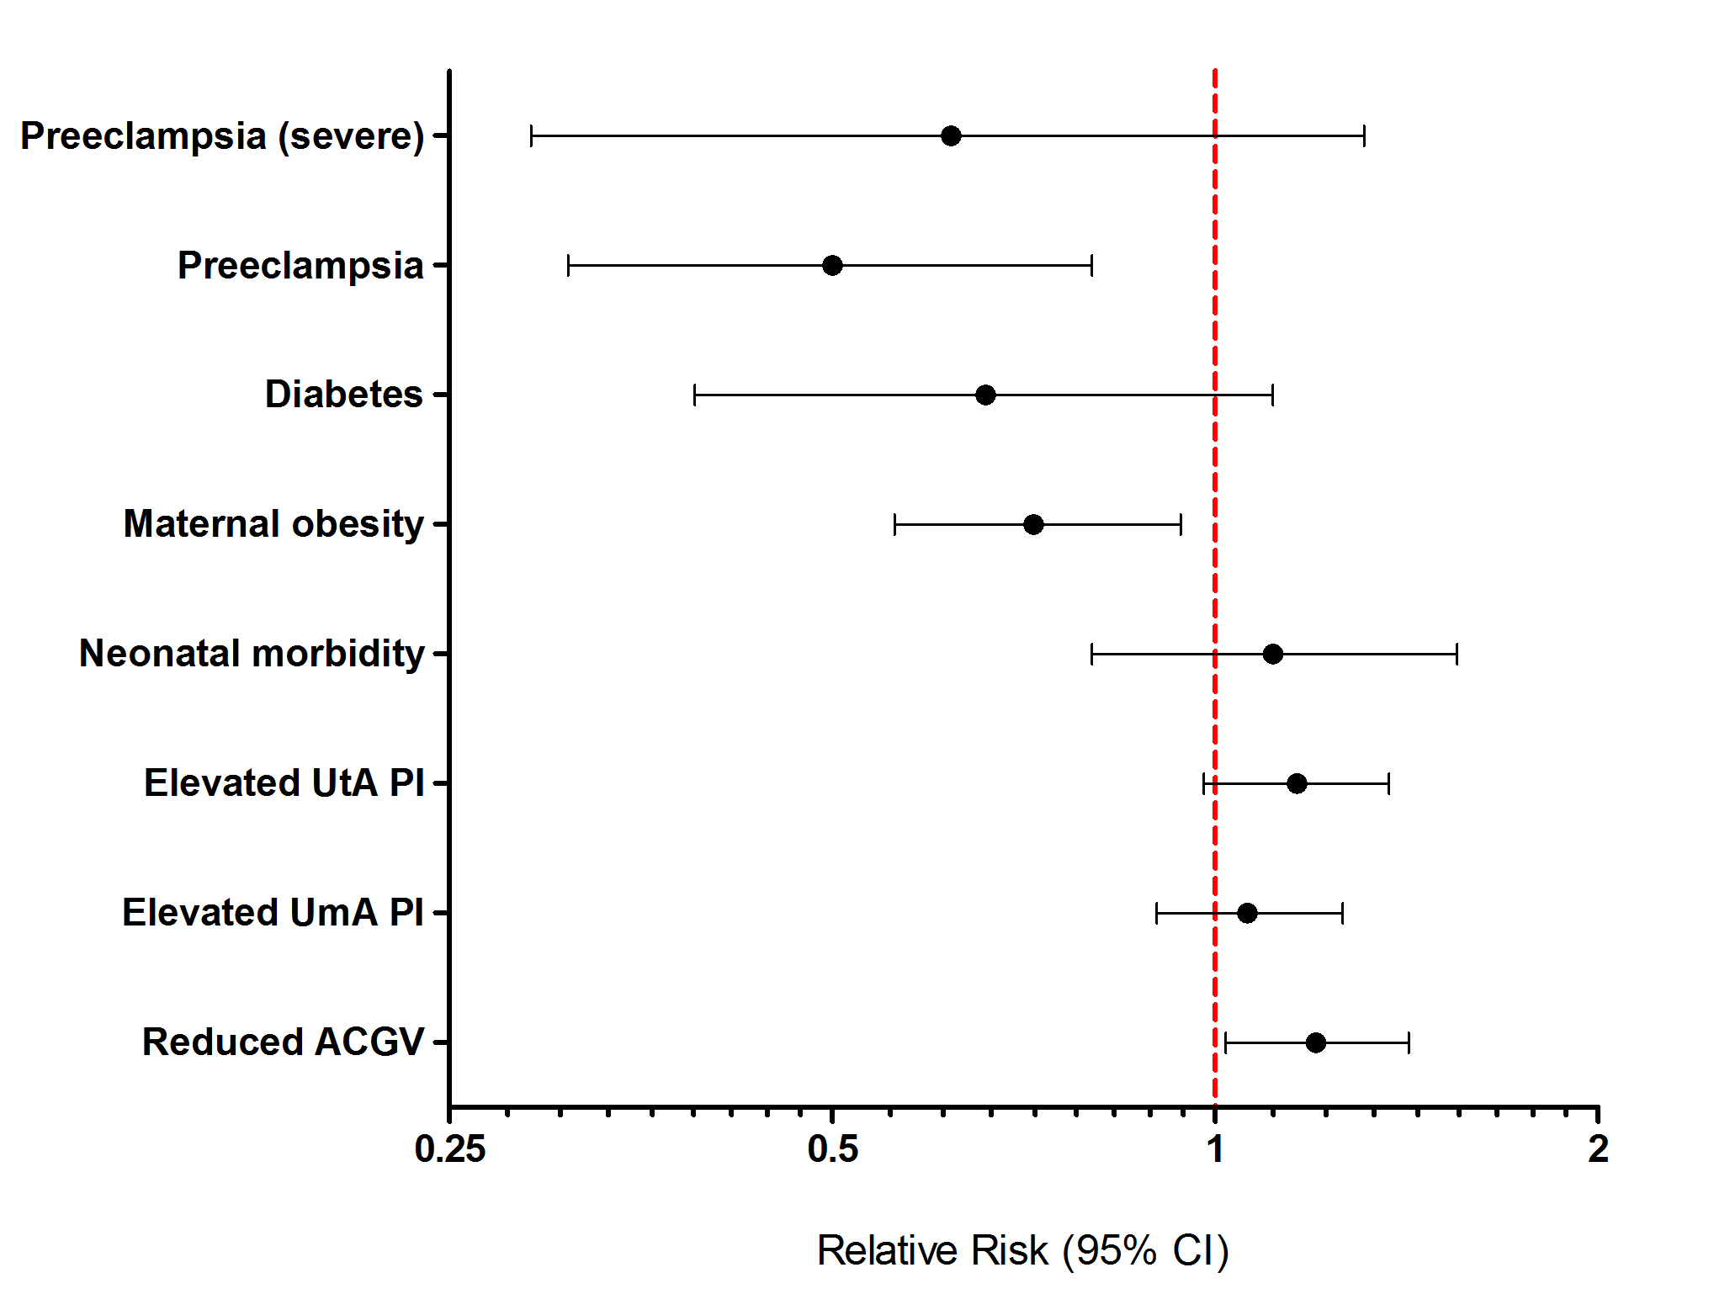

Figure 2.
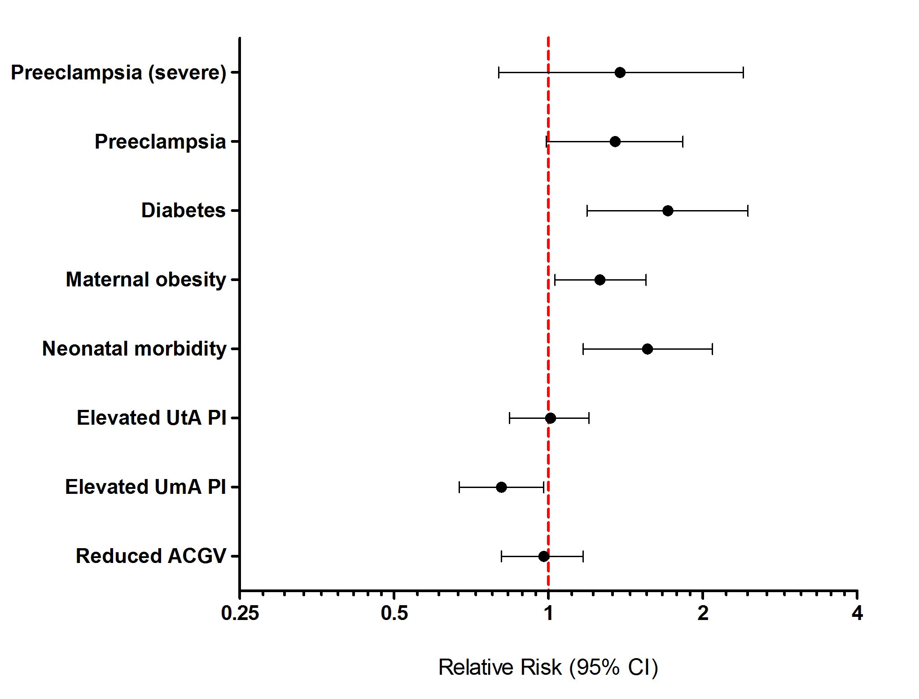

Figure 3.

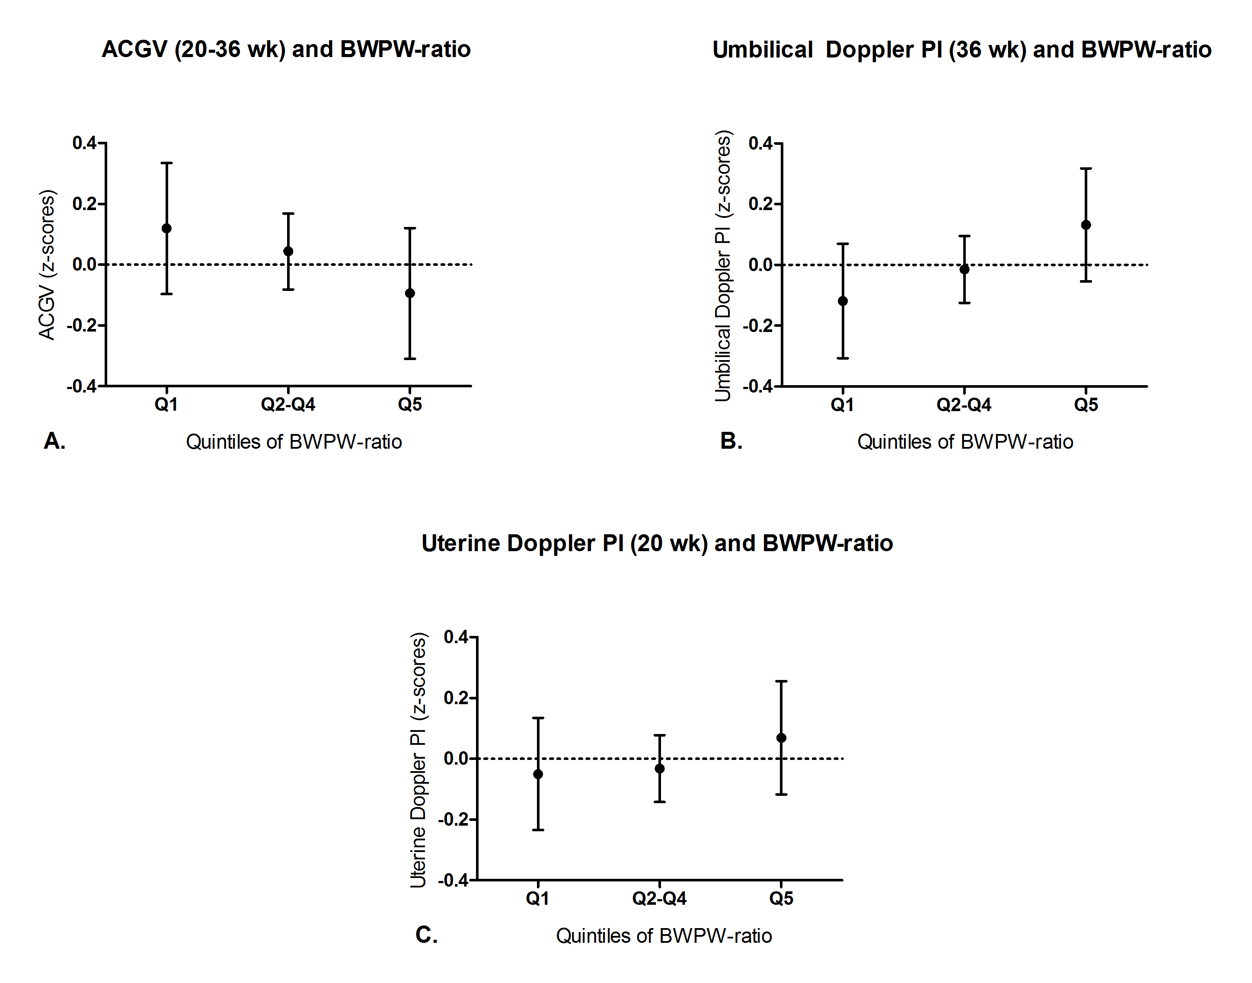

Table 1. Characteristics of the cohort according to the quintile of birth weight to placenta weight (BWPW) ratio.

Characteristics | Low BWPW-ratio (Q1)  N=663 (100%) | Normal BWPW-ratio (Q2-Q4)  N=1986  (100%) | High BWPW-ratio (Q5)  N=662 (100%) | P* | Overall baseline characteristics (n=3311)  (100%)
Maternal
Age (years) | 30 (26-34) | 30 (27-33) | 31 (28-34) | 0.02 | 30 (27-33)
Age stopped FTE (years) | 21 (18-23) | 21 (18-23) | 21 (18-23) | 0.76 | 21 (18-23)
Age stopped FTE (years) |  |  |  | 0.98
<19 | 234 (35.29) | 663 (33.38) | 227 (34.29) |  | 1124 (33.95)
19-22 | 226 (34.09) | 719 (36.20) | 240 (36.25) |  | 1185 (35.79)
≥23 | 203 (30.62) | 604 (30.41) | 195 (29.46) |  | 1002 (30.26)
BMI, kg/m² | 24.7 (22.1-28.0) | 24.0 (21.9-27.3) | 23.5 (21.3-26.3) | <0.0001 | 24.0 (21.8-27.2)
BMI WHO classification |  |  |  | <0.001
<18.5 | 7 (1.06) | 28 (1.41) | 18 (2.72) |  | 53 (1.60)
18.5-<25 | 342 (51.58) | 1155 (58.16) | 414 (62.54) |  | 1911 (57.72)
25-<30 | 204 (30.77) | 542 (27.29) | 167 (25.23) |  | 913 (27.57)
≥ 30 | 110 (16.59) | 261 (13.14) | 63 (9.52) |  | 434 (13.11)
Smoker | 50 (7.54) | 74 (3.73) | 17 (2.57) | <0.001 | 141 (4.26)
Any alcohol consumption | 40 (6.03) | 89 (4.48) | 23 (3.47) | 0.03 | 152 (4.59)
White ethnicity | 606 (93.66) | 1855 (94.59) | 631 (96.48) | 0.02 | 3092 (94.79)
Other | 41 (6.34) | 106 (5.41) | 23 (3.52) |  | 170
Missing | 16 | 25 | 8 |  | 49
Fetal or neonatal
Sex of infant |  |  |  | <0.001
Male | 300 (45.25) | 960 (48.34) | 391 (59.06) |  | 1651 (49.86)
Female | 363 (54.75) | 1026 (51.66) | 271 (40.94) |  | 1660 (50.14)
Birth weight (grams) | 3460 (3170-3770) | 3450 (3160-3750) | 3428 (3115-3740) | 0.19 | 3450 (3150-3725)
Mode of delivery |  |  |  | 0.03
Vaginal | 309 (46.68) | 948 (47.85) | 351 (53.18) |  | 1608 (48.57)
Assisted vaginal | 155 (23.41) | 494 (24.94) | 153 (23.18) |  | 802 (24.22)
Intrapartum caesarean | 154 (23.26) | 359 (18.12) | 91 (13.79) |  | 604 (18.24)
Pre-labour caesarean | 44 (6.65) | 180 (9.09) | 65 (9.85) |  | 289 (8.73)
Missing | 1 | 5 | 2 |  | 8
SGA (birth weight <10th percentile) | 58 (8.75) | 169 (8.51) | 62 (9.37) | 0.69
LGA (birth weight >90th percentile) | 39 (5.88) | 87 (4.38) | 26 (3.93) | 0.09
Placental weight (grams) | 576 (518-629) | 458 (416-505) | 366 (327-399) | <0.0001 | 458 (399-525)
Adverse outcomes
Neonatal morbidity | 63 (9.50) | 121 (6.09) | 45 (6.80) | 0.05 | 229 (6.92)
Diabetes (pre-gestational or gestational) | 44 (6.64) | 77 (3.88) | 17 (2.57) | <0.001 | 138 (4.17)
Preeclampsia (all) | 54 (8.14) | 120 (6.04) | 20 (3.02) | <0.001 | 194 (5.86)
Severe, non-superimposed preeclampsia | 18 (2.71) | 39 (1.96) | 8 (1.21) | 0.05 | 65 (1.96)
Data are median (IQR) or n(%). FTE= full time education, BMI=body mass index. Maternal age was defined as age at recruitment. All other maternal characteristics were defined by self-report at 20 weeks questionnaire, from examination of the clinical case cord, or linkage to the hospital’s electronic databases. Neonatal morbidity was defined as one or more of the following criteria: a 5 min Apgar score of less than 7, delivery with metabolic acidosis (defined as cord blood pH <7.1 and base deficit >10 mml/L), or admission to the neonatal unit at term (defined as admission <48h after birth at ≥ 37 weeks’ gestational age and discharge ≥48 h after admission). Preeclampsia and severe, non-superimposed, preeclampsia were defined according to the ACOG Guideline 2013 [13].
Data were complete where there is no missing row presented.
* Two sided p value; Kendall’s tau rank correlation test for continuous characteristics or Wilcoxon-type test for trend for categorical characteristics [35].

Table 2. Linear regression analysis of birth weight to placenta weight ratio (BWPW) in relation to abdominal circumference growth velocity, umbilical artery Doppler PI and uterine artery Doppler PI.

 |  | Unadjusted analysis |  | Adjusted analysis*
Analysis | N | Coeff (95% CI)** | P | Coeff (95% CI)** | P
ACGV (20-36 weeks)
Low BWPW-ratio (Q1, <20th percentile) | 2649 | 0.08 (-0.02 to 0.18) | 0.14 | 0.06 (-0.04 to 0.16) | 0.23
High BWPW-ratio (Q5, >80th percentile) | 2648 | -0.14 (-0.24 to -0.04) | 0.007 | -0.09 (-0.19 to 0.01) | 0.08
UmA PI (36 weeks)
Low BWPW-ratio (Q1, <20th percentile) | 2649 | -0.10 (-0.19 to -0.02) | 0.02 | -0.12 (-0.21 to -0.03) | 0.007
High BWPW-ratio (Q5, >80th percentile) | 2648 | 0.15 (0.06-0.23) | 0.001 | 0.16 (0.08-0.25) | <0.001
UtA PI (20 weeks)
Low BWPW-ratio (Q1, <20th percentile) | 2649 | -0.02 (-0.11 to 0.07) | 0.69 | -0.02 (-0.11 to 0.07) | 0.67
High BWPW-ratio (Q5, >80th percentile) | 2648 | 0.10 (0.01-0.19) | 0.02 | 0.09 (0.01-0.18) | 0.04
ACGV denotes abdominal circumference growth velocity, UmA denotes umbilical artery, UtA denotes uterine artery, PI denotes pulsatility index and BWPW-ratio denotes birth weight placenta weight-ratio.
* Adjusted for sex of the infant, maternal age, BMI, diabetes and smoking status.
**Coefficients are the difference in z-score given for either the lowest quintile (low BWPW-ratio) or highest quintile (high BWPW-ratio) compared to the middle three quintiles (middle 60% of the population), i.e. positive values indicate higher levels of UtA or UmA PI in the highest or lowest quintile of BWPW-ratio. These are expressed as z-scores, i.e. the unit for the coefficient is one standard deviation (SD).

Table 3. Unadjusted and adjusted odds ratio (OR) for several binary outcome variables by groups of high and low birth weight to placenta weight (BWPW) ratio (exposure).

 |  | Unadjusted analysis |  | Adjusted for sex of the infant, maternal age, BMI, diabetes and smoking status
Analysis | N | Odds ratio (95% CI) | P | Odds ratio (95% CI) | P
Neonatal morbidity (outcome)
Low BWPW-ratio (Q1, <20th percentile) | 2649 | 1.62 (1.18-2.22) | 0.003 | 1.55 (1.12-2.14) | 0.007
High BWPW-ratio (Q5, >80th percentile) | 2648 | 1.12 (0.79-1.60) | 0.52 | 1.17 (0.81-1.67) | 0.40
Maternal obesity* (outcome)
Low BWPW-ratio (Q1, <20th percentile) | 2649 | 1.31 (1.03-1.68) | 0.03 | 1.25 (0.98-1.60) | 0.08
High BWPW-ratio (Q5, >80th percentile) | 2648 | 0.70 (0.52-0.93) | 0.01 | 0.71 (0.53-0.95) | 0.02
Diabetes** (pre-gestational or gestational)
(outcome)
Low BWPW-ratio (Q1, <20th percentile) | 2649 | 1.76 (1.20-2.58) | 0.004 | 1.75 (1.18-2.59) | 0.005
High BWPW-ratio (Q5, >80th percentile) | 2648 | 0.65 (0.38-1.11) | 0.12 | 0.66 (0.39-1.14) | 0.14
Preeclampsia (all)
(outcome)
Low BWPW-ratio (Q1, <20th percentile) | 2647 | 1.38 (0.99-1.92) | 0.06 | 1.32 (0.93-1.87) | 0.12
High BWPW-ratio (Q5, >80th percentile) | 2646 | 0.48 (0.30-0.78) | 0.003 | 0.51 (0.31-0.84) | 0.008
Severe, non-superimposed preeclampsia
(outcome)
Low BWPW-ratio (Q1, <20th percentile) | 2647 | 1.39 (0.79-2.45) | 0.25 | 1.36 (0.77-2.42) | 0.29
High BWPW-ratio (Q5, >80th percentile) | 2646 | 0.61 (0.28-1.31) | 0.21 | 0.59 (0.27- 1.29) | 0.19
* Adjusted for sex of the infant, maternal age, smoking and diabetes
** Adjusted for sex of the infant, maternal age, smoking and BMI
Q1; n= 663, Q2-Q4; n=1986, Q5; n=663.
Maternal obesity: BMI>30 kg/m²
Any diabetes (pre-gestational and gestational)
Neonatal morbidity was defined as one or more of the following criteria: a 5 min Apgar score of less than 7, delivery with metabolic acidosis (defined as cord blood pH <7.1 and base deficit >10 mml/L), or admission to the neonatal unit at term (defined as admission <48h after birth at ≥ 37 weeks’ gestational age and discharge ≥48 h after admission). Diabetes was presence of any diabetes (pre-gestational or gestational). Maternal obesity was defined as BMI>30 kg/m ².
Preeclampsia and severe, non-superimposed, preeclampsia were defined according to the ACOG Guideline 2013 [13].

